**DAILY ONLINE ACTIVITIES SUMMARY**

|  |  |  |  |  |  |  |  |  |
| --- | --- | --- | --- | --- | --- | --- | --- | --- |
| **Date:** | **21/06/2020** | | | | | **Name:** | **Karthik S** | |
| **Sem & Sec** | **4th sem &A section** | | | | | **USN:** | **4AL18CS034** | |
| **Online Test Summary** | | | | | | | | |
| **Subject** | | **-** | | | | | | |
| **Max. Marks** | | **-** | | **Score** | | | **-** | |
| **Certification Course Summary** | | | | | | | | |
| **Course** | **The complete power point and presentation skills masterclass** | | | | | | | |
| **Certificate Provider** | | | **udemy** | | **Duration** | | | **34 hours** |
| **Coding Challenges** | | | | | | | | |
| **Problem Statement: Write a C Program to rotate a Matrix by 90 Degree in Anticlockwise Direction.** | | | | | | | | |
| **Status: completed** | | | | | | | | |
| **Uploaded the report in Github** | | | | | **yes** | | | |
| **If yes Repository name** | | | | | <https://github.com/karthik0932/lockdown-coding> | | | |
| **Uploaded the report in slack** | | | | | **yes** | | | |

**Course Details: (Attach the snapshot and briefly write the report for the same)**

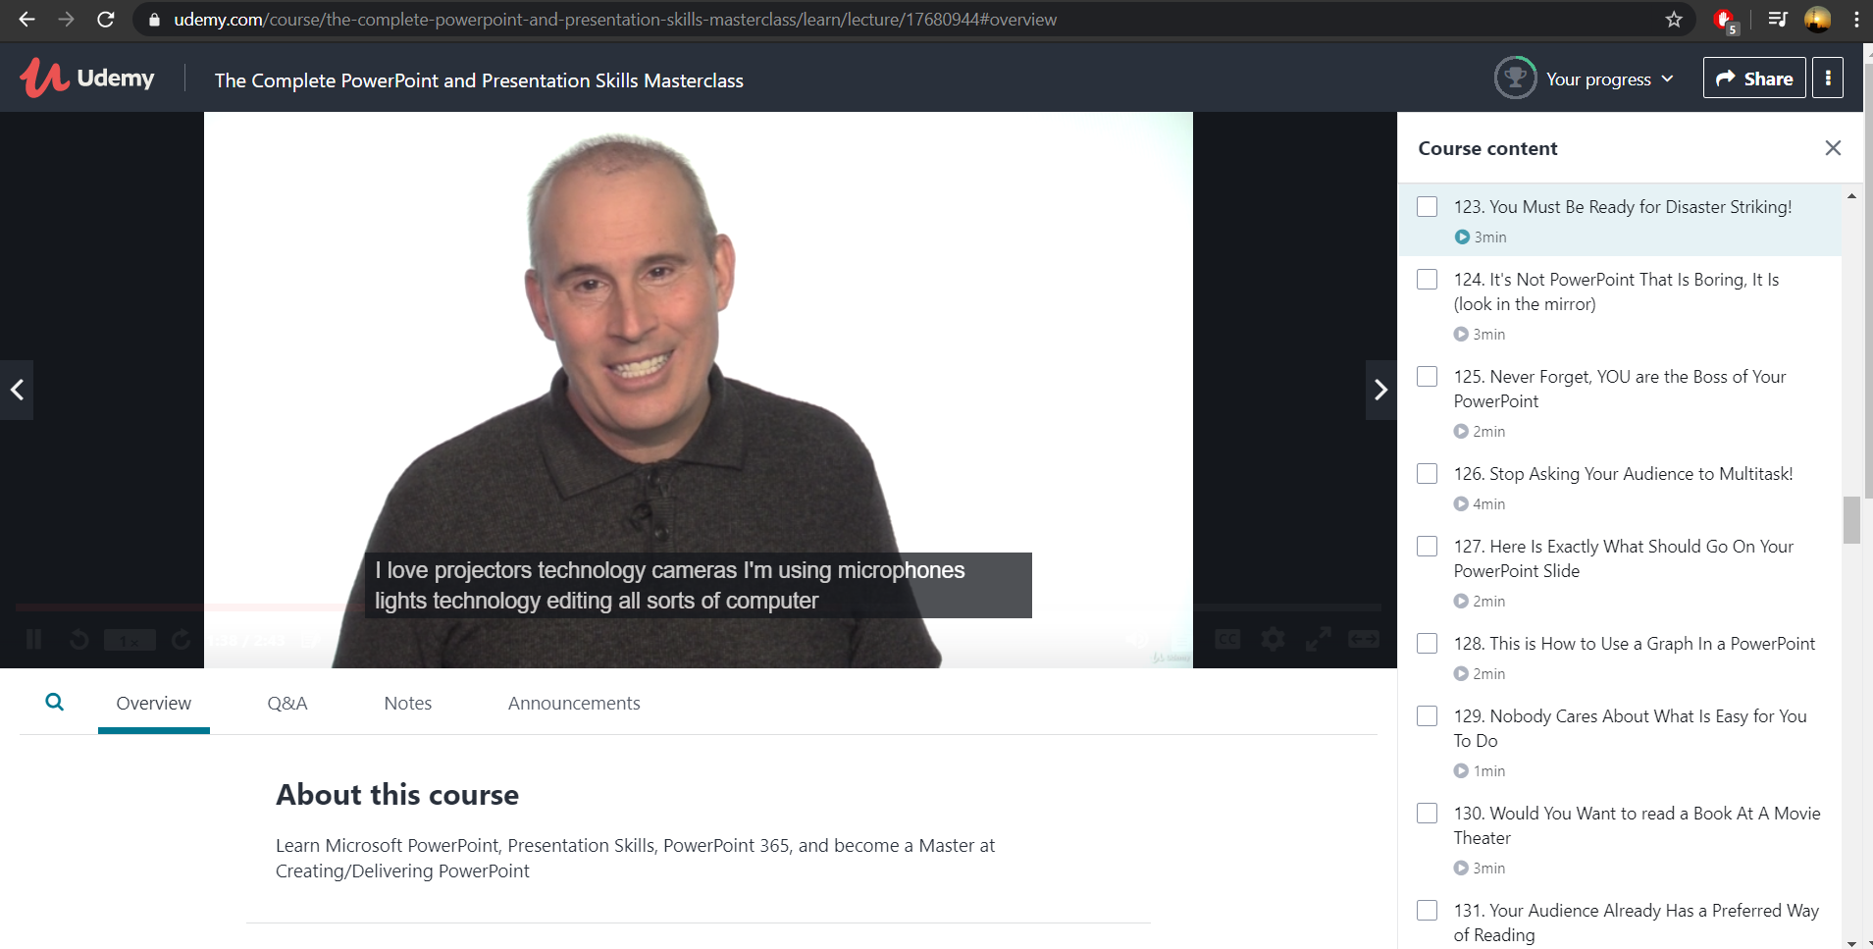

I have choosen this course to learn how to design **PowerPoint Presentations**AND Create Compelling **PowerPoint slides** AND Deliver **PowerPoint Presentations** in a compelling, memorable and engaging manner. Most Important: we will learn how to communicate effectively with ever aspect of our visual and verbal tools.

**Coding Challenges Details: (Attach the snapshot and briefly write the report for the same)**

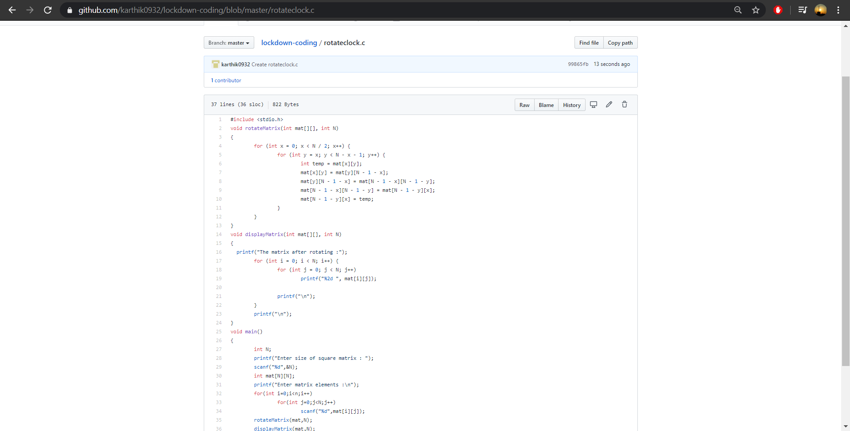

**Probem Statement :**

**Write a C Program to rotate a Matrix by 90 Degree in Anticlockwise Direction.**

**Code:The above snapshot is the code which I have uploaded in my github repository.**