**DAILY ONLINE ACTIVITIES SUMMARY**

|  |  |  |  |  |  |  |  |  |
| --- | --- | --- | --- | --- | --- | --- | --- | --- |
| **Date:** | **21/05/2020** | | | | | **Name:** | **Karthik S** | |
| **Sem & Sec** | **4th sem, A sec** | | | | | **USN:** | **4AL18CS034** | |
| **Online Test Summary** | | | | | | | | |
| **Subject** | | **Micro-controller and Embedded Systems** | | | | | | |
| **Max. Marks** | | **30** | | **Score** | | | **20** | |
| **Certification Course Summary** | | | | | | | | |
| **Course** | **Detecting and mitigating cyber threads and attacks** | | | | | | | |
| **Certificate Provider** | | | **coursera** | | **Duration** | | | **5 weeks** |
| **Coding Challenges** | | | | | | | | |
| **Problem Statement: program in python :- Enter number 5**  **5 4 3 2 1 4 3 2 1 3 2 1 2 1 1** | | | | | | | | |
| **Status: completed** | | | | | | | | |
| **Uploaded the report in Github** | | | | | **Yes** | | | |
| **If yes Repository name** | | | | | <https://github.com/karthik0932/lockdown-coding> | | | |
| **Uploaded the report in slack** | | | | | **Yes** | | | |

Online Test Details: (Attach the snapshot and briefly write the report for the same)

18CS44(MES) test was scheduled from 10:00 am to10:30am .The portion for the IA was module 1 and there were 30 questions and the time assigned was 30 minutes the questions were of mcq type

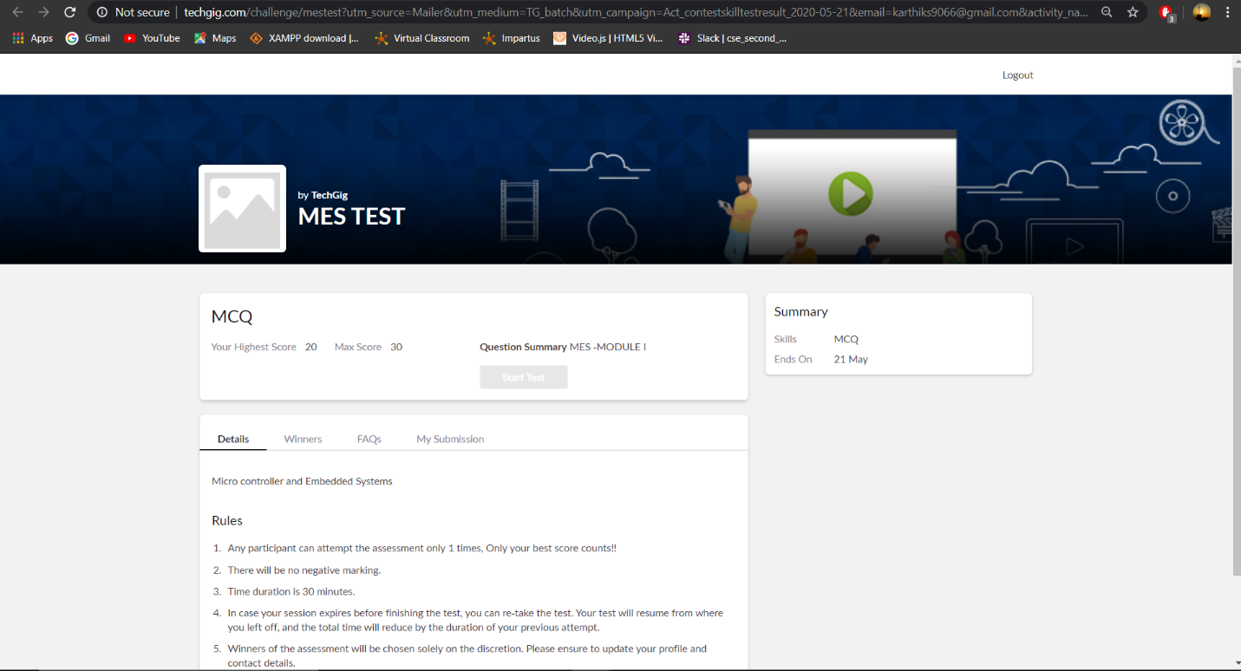

Certification Course Details: (Attach the snapshot and briefly write the report for the same)

Today I had a weekly test of the course and I did 100% and completed the week 2 course successfully

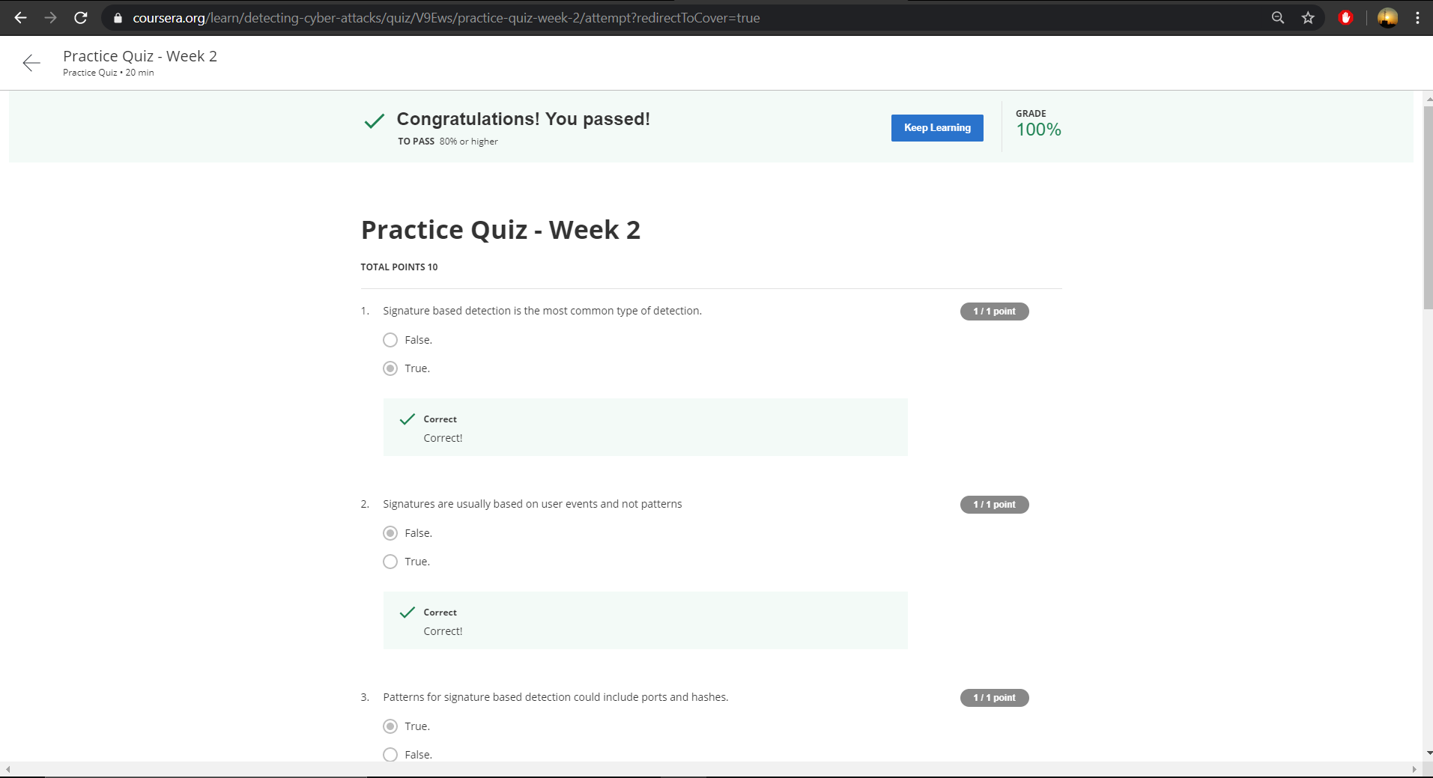

Coding Challenges Details: (Attach the snapshot and briefly write the report for the same)

This was the challenge given to us to write a code in python. This is a simple program and we started to do simple program and try to understand the coding part of it.

Question :- enter the number 5

5 4 3 2 1 4 3 2 1 3 2 1 2 1 1

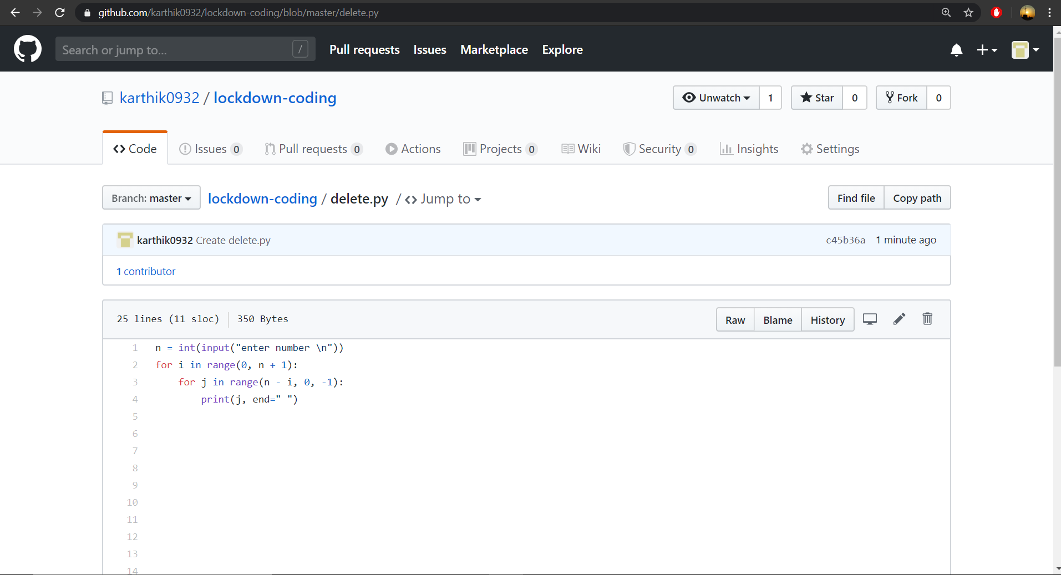

Thank you