**DAILY ONLINE ACTIVITIES SUMMARY**

|  |  |  |  |  |  |  |  |
| --- | --- | --- | --- | --- | --- | --- | --- |
| **Date:** | **26/05/2020** | | | | **Name:** | **Karthik S** | |
| **Sem & Sec** | **4th sem A section** | | | | **USN:** | **4AL18CS034** | |
| **Online Test Summary** | | | | | | | |
| **Subject** | | **Design Analysis and Algorithm** | | | | | |
| **Max. Marks** | | **30** | | **Score** | | **27** | |
| **Certification Course Summary** | | | | | | | |
| **Course** | **Detecting and mitigating cyber threads and attacks** | | | | | | |
| **Certificate Provider** | | | **Coursera** | **Duration** | | | **5 weeks** |
| **Coding Challenges** | | | | | | | |
| **Problem Statement:** **Return a version of the given array where all the 10's have been removed. The remaining elements should shift left towards the start of the array as needed, and the empty spaces a the end of the array should be 0. So {1, 10, 10, 2} yields {1, 2, 0, 0}. You may modify and return the given array or make a new array. withoutTen({1, 10, 10, 2}) → {1, 2, 0, 0} withoutTen({10, 2, 10}) → {2, 0, 0} withoutTen({1, 99, 10}) → {1, 99, 0}** | | | | | | | |
| **Status: Completed** | | | | | | | |
| **Uploaded the report in Github** | | | | **YES** | | | |
| **If yes Repository name** | | | | <https://github.com/karthik0932/lockdown-coding> | | | |
| **Uploaded the report in slack** | | | | **YES** | | | |

**Online Test Details: (Attach the snapshot and briefly write the report for the same)**

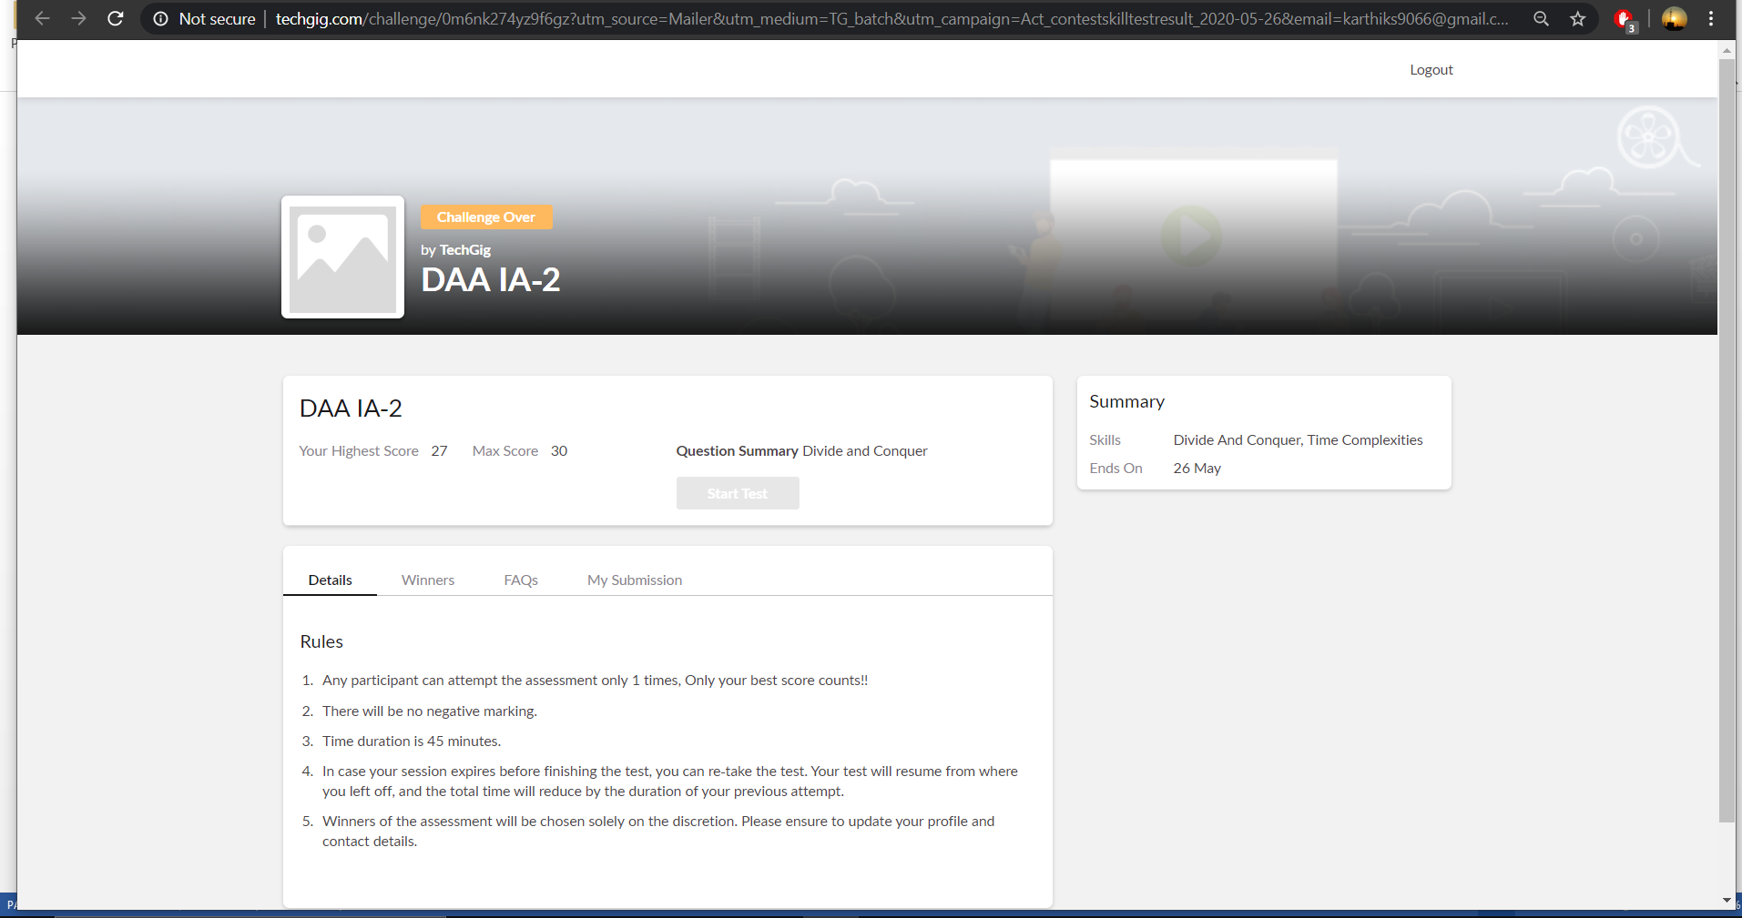

**Design Analysis and Algorithm internals was conducted. A total of 30 questions were there in which all the 30 of them were Multiple Choice Questions.**

**The above snapshot is the result sheet which was mailed to us by the Techgig team**

**Certification Course Details: (Attach the snapshot and briefly write the report for the same)**

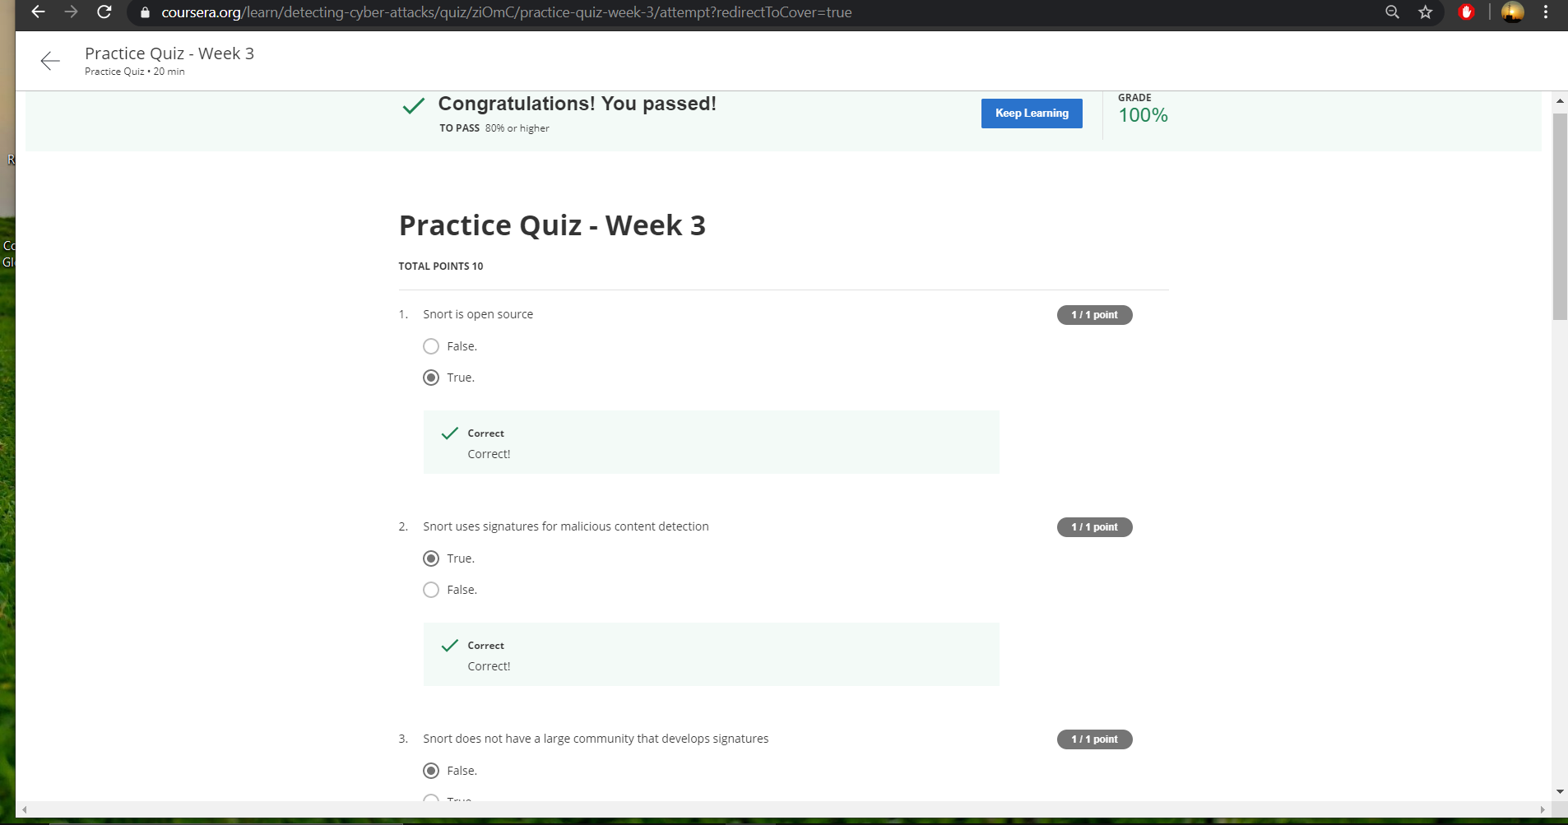

**The course I have chosen during the lockdown period is Detecting and mitigating cyber threads and attacks. Since I had learned about basics of cyber security last time so I am continuing this course.to know more about the securities**

**This was the weekend test based on how we understand the course and I got 100% on it.**

**Coding Challenges Details: (Attach the snapshot and briefly write the report for the**

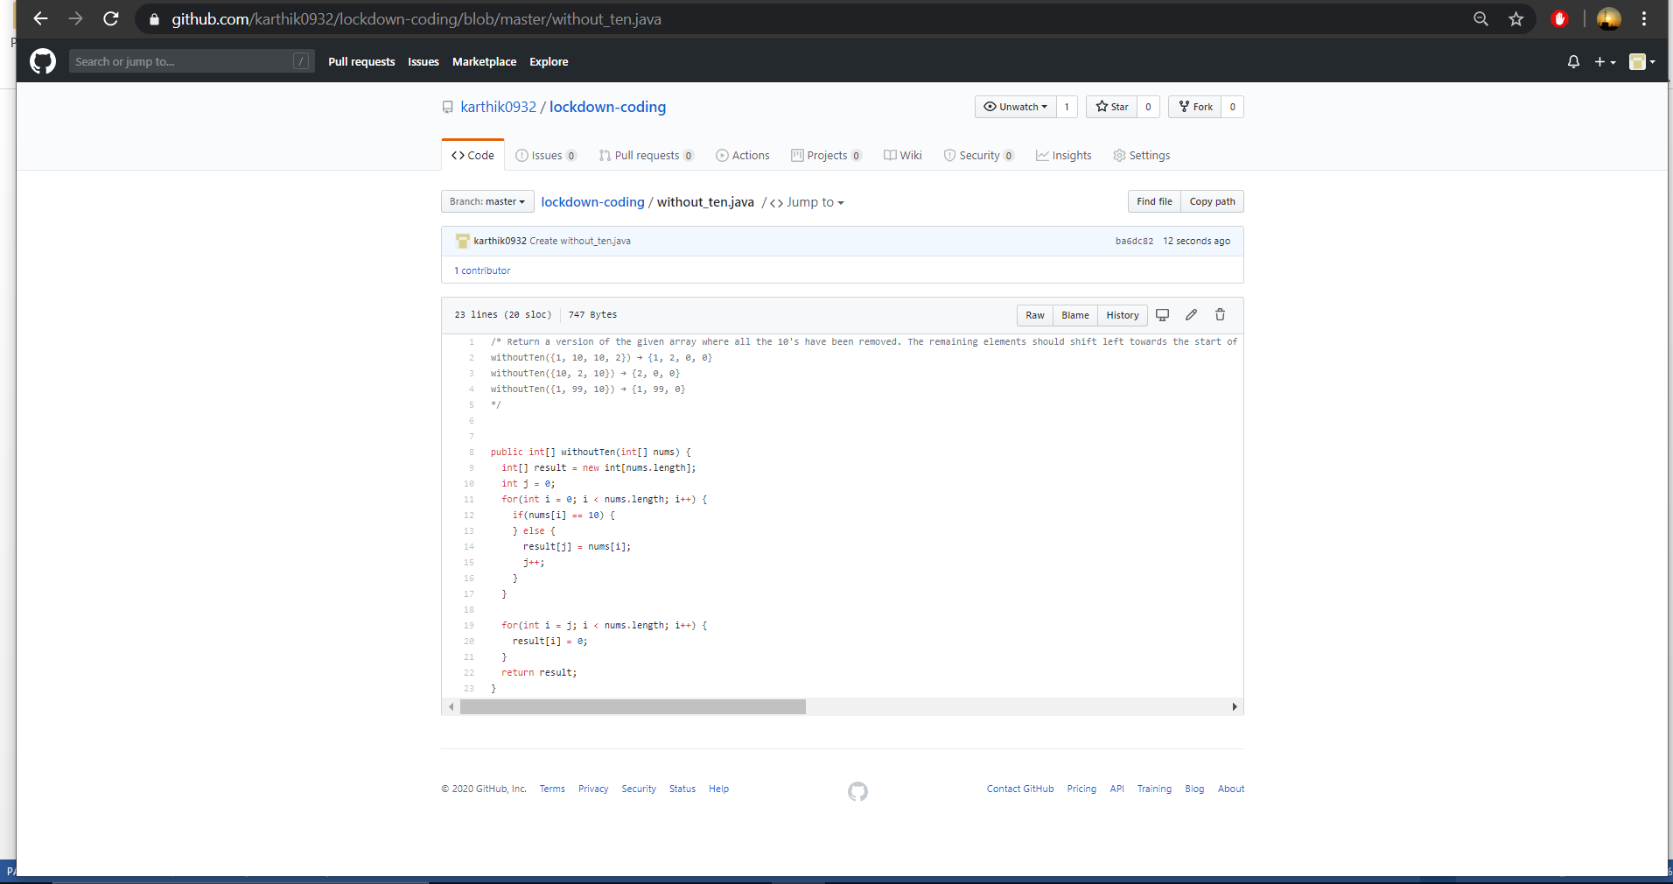

**The question I took to code is:**

**Return a version of the given array where all the 10's have been removed. The remaining elements should shift left towards the start of the array as needed, and the empty spaces a the end of the array should be 0. So {1, 10, 10, 2} yields {1, 2, 0, 0}. You may modify and return the given array or make a new array.**

**withoutTen({1, 10, 10, 2}) → {1, 2, 0, 0} withoutTen({10, 2, 10}) → {2, 0, 0} withoutTen({1, 99, 10}) → {1, 99, 0}**

**Solution: The above snapshot is the code which I have uploaded in my Github repository**