**DAILY ONLINE ACTIVITIES SUMMARY**

|  |  |  |  |  |  |  |  |  |
| --- | --- | --- | --- | --- | --- | --- | --- | --- |
| **Date:** | **27/06/2020** | | | | | **Name:** | **Karthik S** | |
| **Sem & Sec** | **4th sem &A section** | | | | | **USN:** | **4AL18CS034** | |
| **Online Test Summary** | | | | | | | | |
| **Subject** | | **Data Communication** | | | | | | |
| **Max. Marks** | | **30** | | **Score** | | | **25** | |
| **Certification Course Summary** | | | | | | | | |
| **Course** | **The complete power point and presentation skills masterclass** | | | | | | | |
| **Certificate Provider** | | | **udemy** | | **Duration** | | | **34 hours** |
| **Coding Challenges** | | | | | | | | |
| **Problem Statement: Write a c program to print k digit.** | | | | | | | | |
| **Status: completed** | | | | | | | | |
| **Uploaded the report in Github** | | | | | **yes** | | | |
| **If yes Repository name** | | | | | <https://github.com/karthik0932/lockdown-coding> | | | |
| **Uploaded the report in slack** | | | | | **yes** | | | |

**Online Test Details: (Attach the snapshot and briefly write the report for the same)**

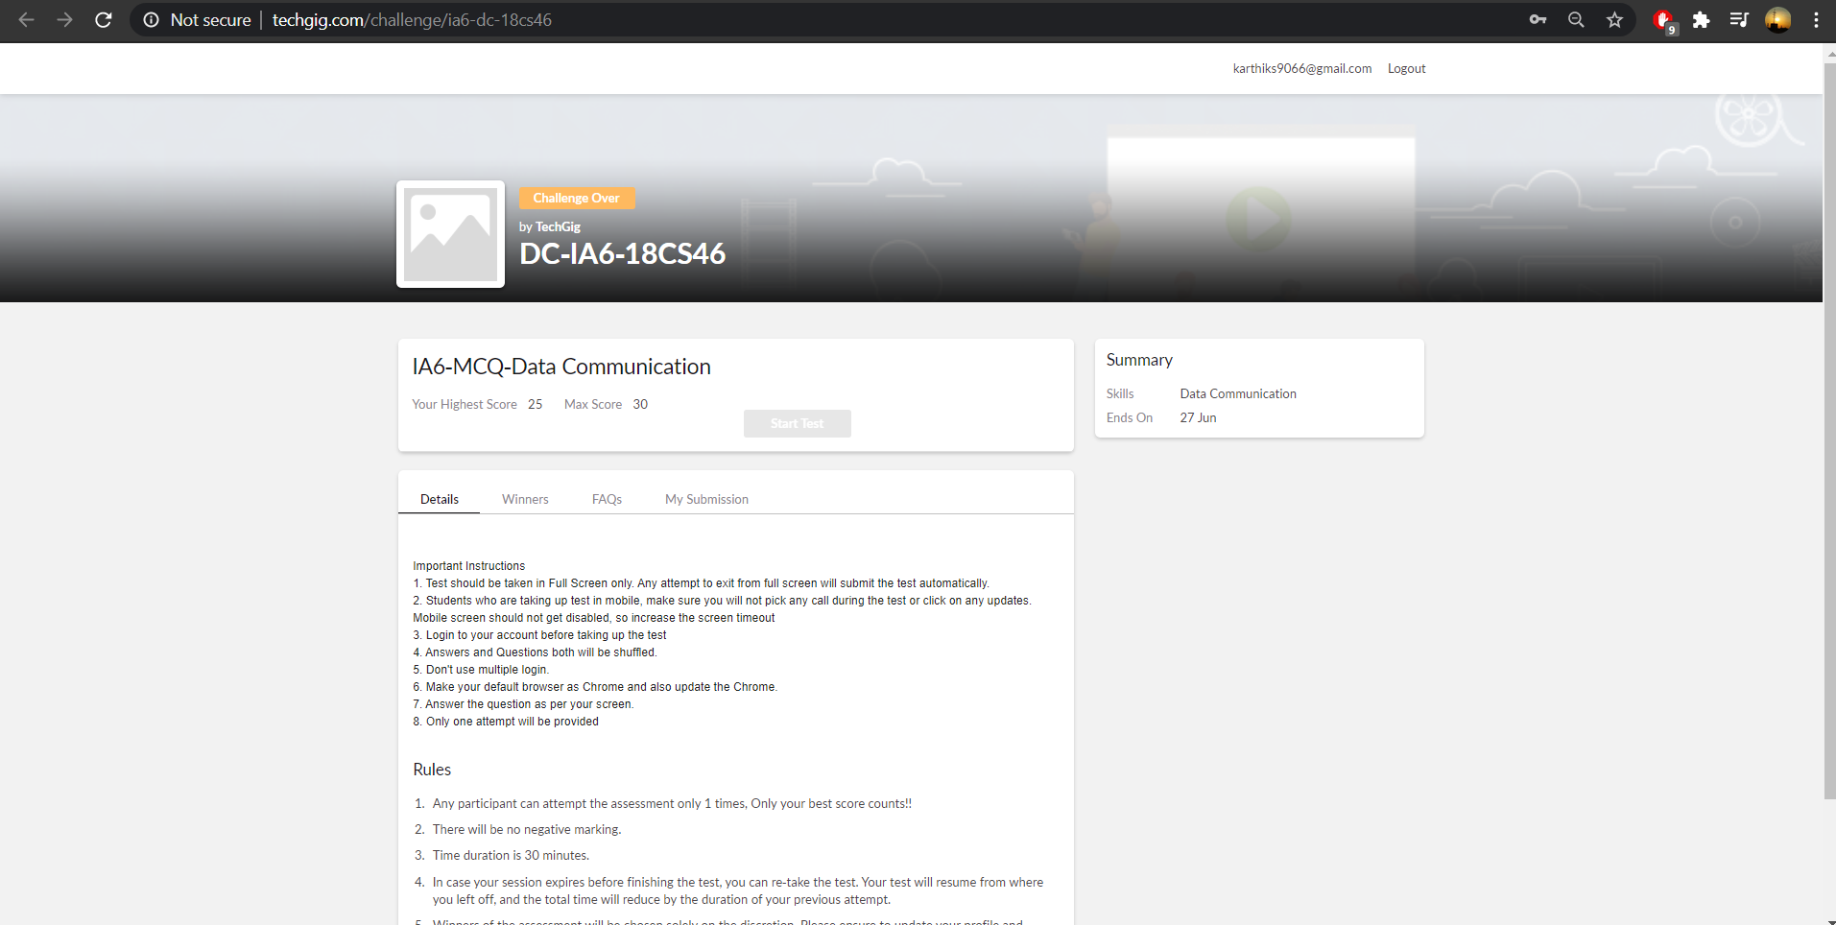

**Online test of data communication was conducted for 30 marks each carrying 1mark.There were 30 questions and the duration was 30 minutes. The questions were optimal and were easy. The score that I got in the test is 25/30.**

**Above screenshot has been send by techgig.**

**Course Details: (Attach the snapshot and briefly write the report for the same)**

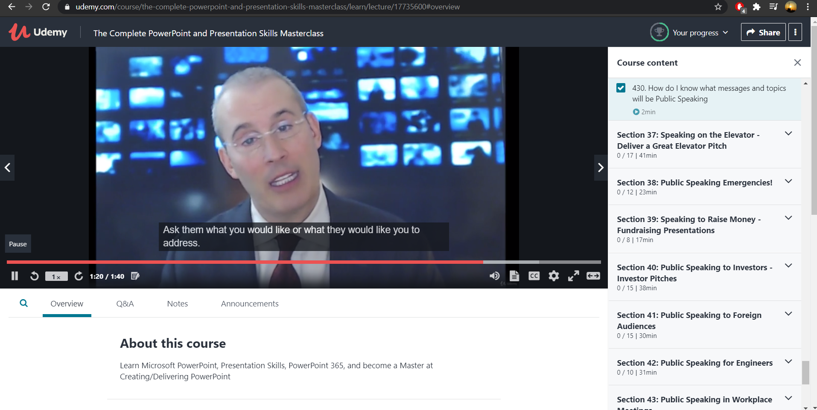

I have choosen this course to learn how to design **PowerPoint Presentations**AND Create Compelling **PowerPoint slides** AND Deliver **PowerPoint Presentations** in a compelling, memorable and engaging manner. Most Important: we will learn how to communicate effectively with ever aspect of our visual and verbal tools.

**Coding Challenges Details: (Attach the snapshot and briefly write the report for the same)**

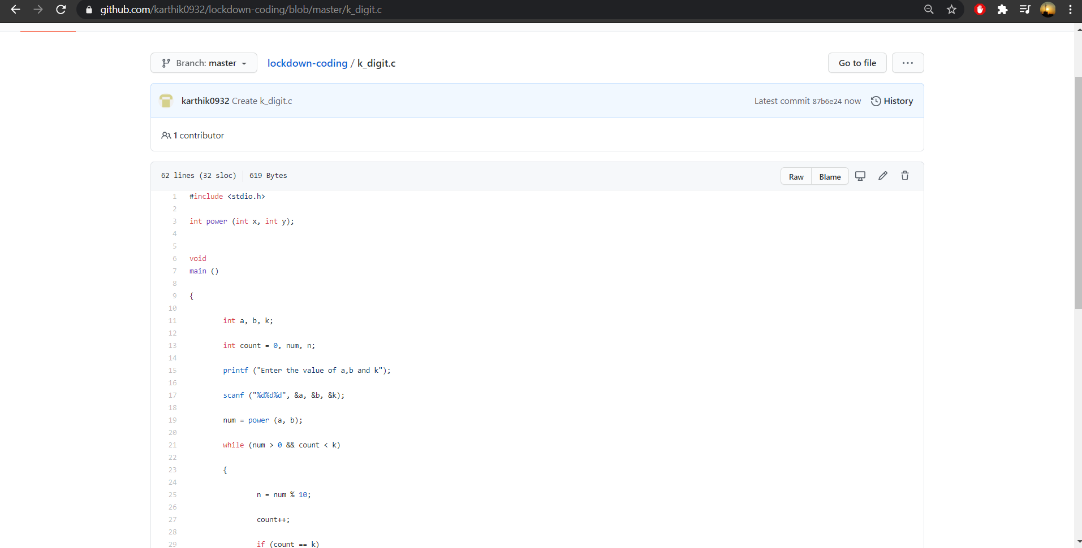

**Probem Statement :**

**Write a c program to print k digit.**

**Code:The above snapshot is the code which I have uploaded in my github repository.**