**DAILY ONLINE ACTIVITIES SUMMARY**

|  |  |  |  |  |  |  |  |
| --- | --- | --- | --- | --- | --- | --- | --- |
| **Date:** | **27/05/2020** | | | | **Name:** | **Karthik S** | |
| **Sem & Sec** | **4th sem A section** | | | | **USN:** | **4AL18CS034** | |
| **Online Test Summary** | | | | | | | |
| **Subject** | | **Object Oriented Concepts** | | | | | |
| **Max. Marks** | | **30** | | **Score** | | **27** | |
| **Certification Course Summary** | | | | | | | |
| **Course** | **Detecting and mitigating cyber threads and attacks** | | | | | | |
| **Certificate Provider** | | | **Coursera** | **Duration** | | | **5 weeks** |
| **Coding Challenges** | | | | | | | |
| **Problem Statement:**  **Input:**  **Enter the Input String: abcd Expected Result:**  **The permutations of the string are : abcd abdc acbd acdb adcb adbc bacd badc bcad bcda bdca bdac cbad cbda cabd cadb cdab cdba dbca dbac dcba dcab dacb dabc** | | | | | | | |
| **Status: Completed** | | | | | | | |
| **Uploaded the report in Github** | | | | **YES** | | | |
| **If yes Repository name** | | | | <https://github.com/karthik0932/lockdown-coding> | | | |
| **Uploaded the report in slack** | | | | **YES** | | | |

**Online Test Details: (Attach the snapshot and briefly write the report for the same)**

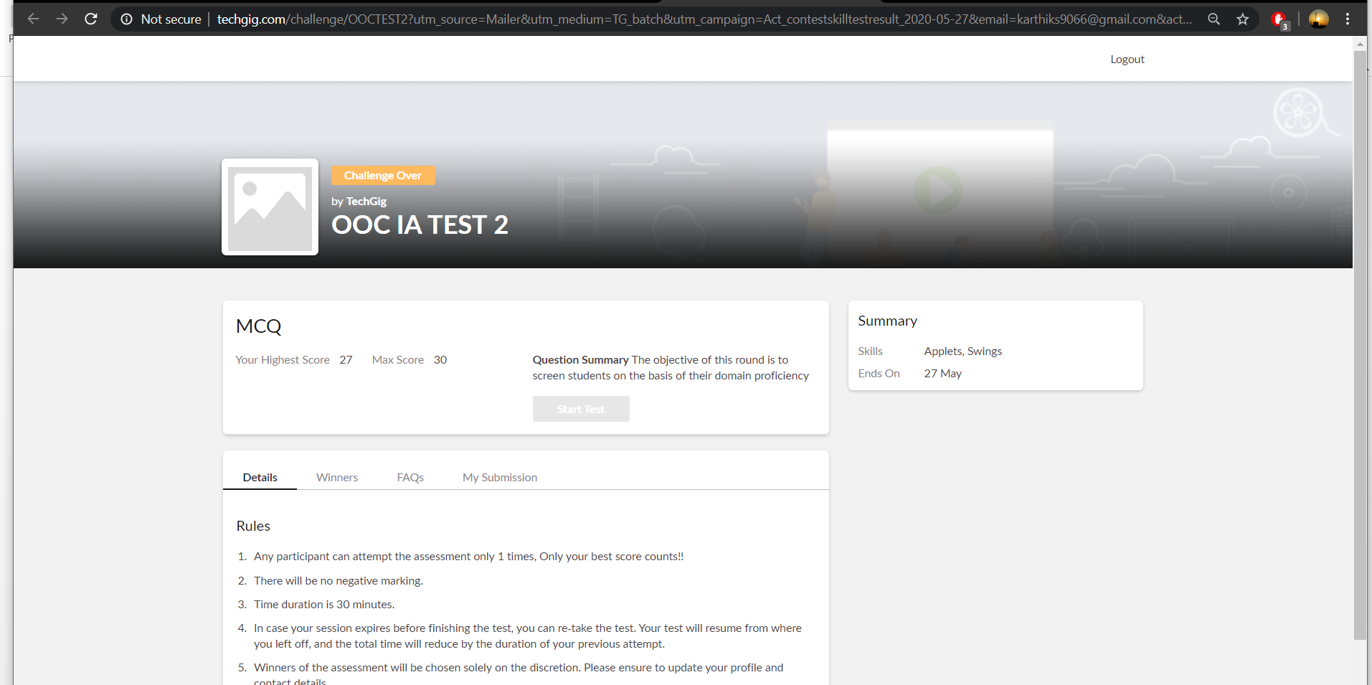

**Object Oriented Concepts internals was conducted. A total of 30 questions were there in which all the 30 of them were Multiple Choice Questions.**

**The above snapshot is the result sheet which was mailed to us by the Techgig team**

**Certification Course Details: (Attach the snapshot and briefly write the report for the same)**

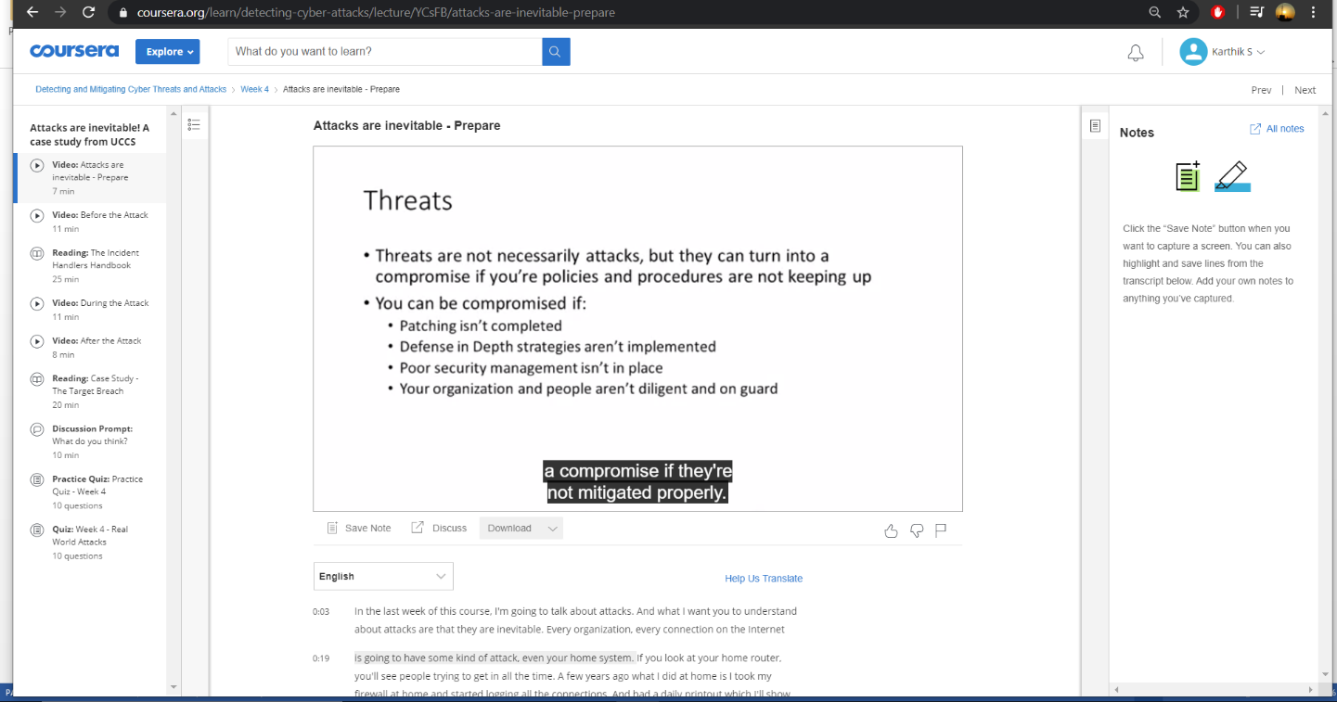

**The course I have chosen during the lockdown period is Detecting and mitigating cyber threads and attacks. Since I had learned about basics of cyber security last time so I am continuing this course.to know more about the securities**

**Coding Challenges Details: (Attach the snapshot and briefly write the report for the**

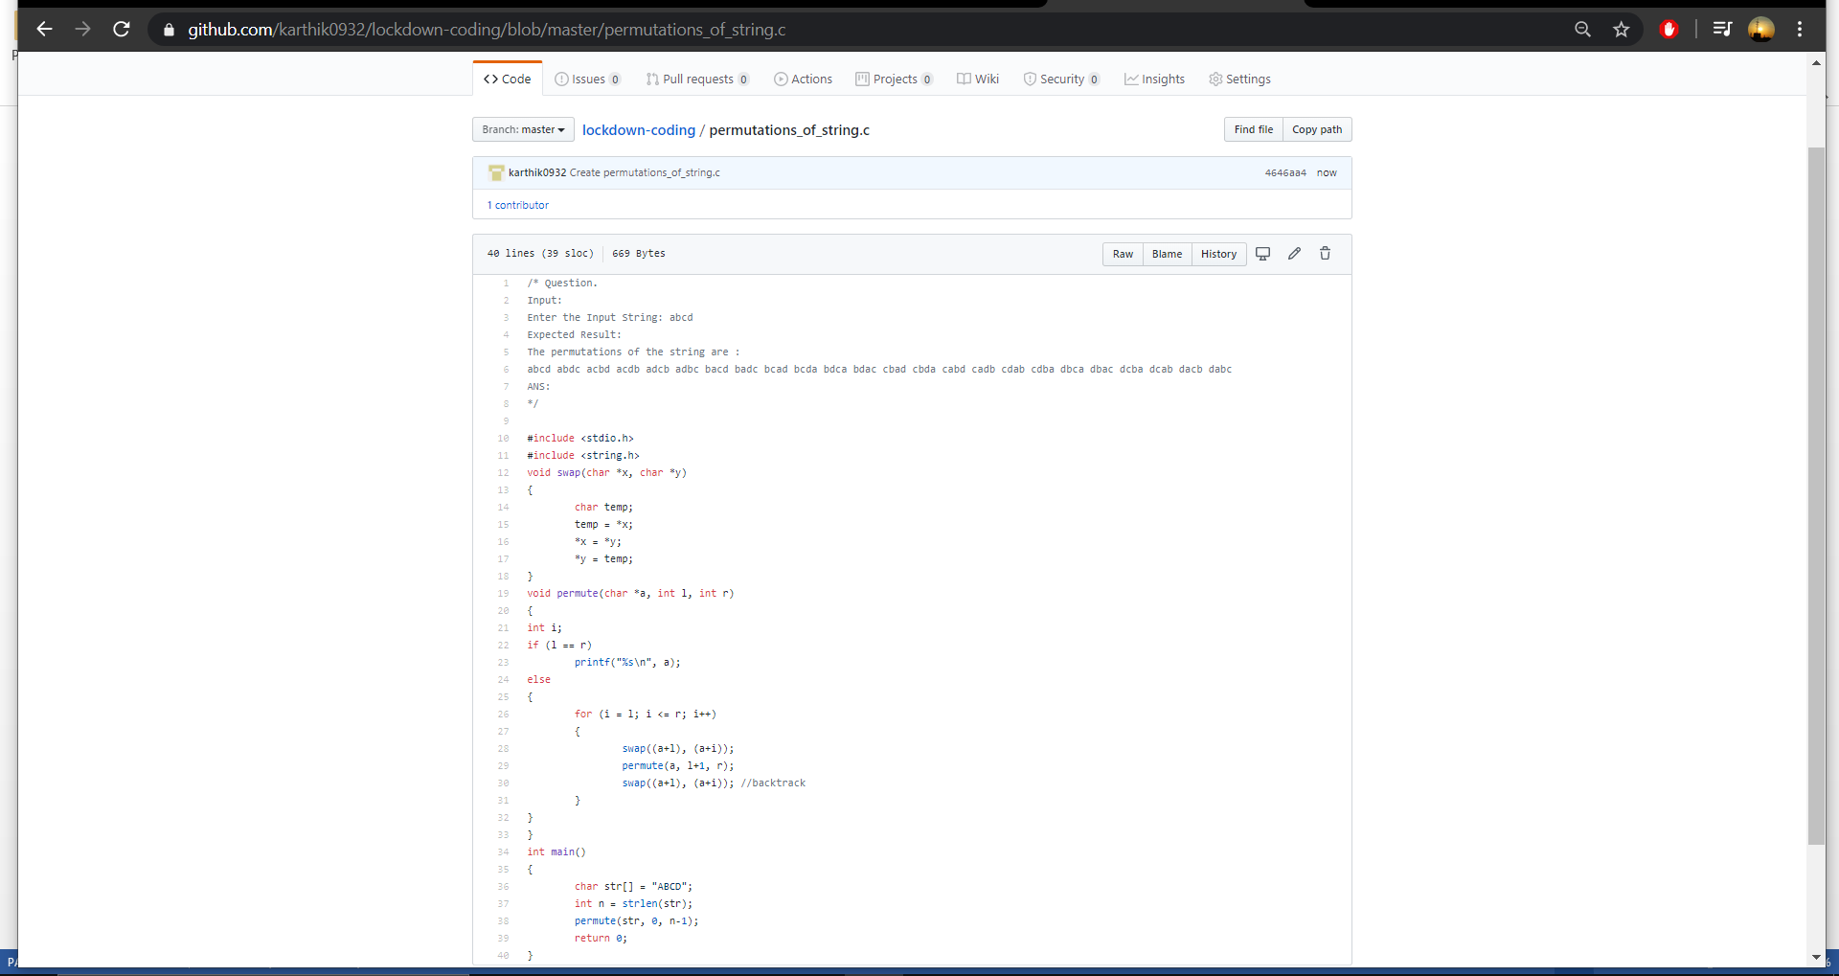

**The question I took to code is:**

**Input:**

**Enter the Input String: abcd Expected Result:**

**The permutations of the string are :**

**abcd abdc acbd acdb adcb adbc bacd badc bcad bcda bdca bdac cbad cbda cabd cadb cdab cdba dbca dbac dcba dcab dacb dabc**

**Solution: The above snapshot is the code which I have uploaded in my Github repository**