**DAILY ONLINE ACTIVITIES SUMMARY**

|  |  |  |  |  |  |  |  |  |
| --- | --- | --- | --- | --- | --- | --- | --- | --- |
| **Date:** | **28/05/2020** | | | | | **Name:** | **Karthik S** | |
| **Sem & Sec** | **4th SEM 'A' Section** | | | | | **USN:** | **4AL18CS034** | |
| **Online Test Summary** | | | | | | | | |
| **Subject** | | **1. Microcontroller and Embedded Systems**  **2. Aadalitha Kannada** | | | | | | |
| **Max. Marks** | | **1. 20**  **2. 50** | | **Score** | | | **1. 18**  **2. 23** | |
| **Certification Course Summary** | | | | | | | | |
| **Course** | **Detecting and mitigating cyber threads and attacks** | | | | | | | |
| **Certificate Provider** | | | **Coursera** | | **Duration** | | | **5 weeks** |
| **Coding Challenges** | | | | | | | | |
| **Problem Statement:1. Digital root of a number** | | | | | | | | |
| **Status: completed** | | | | | | | | |
| **Uploaded the report in Github** | | | | | **yes** | | | |
| **If yes Repository name** | | | | | <https://github.com/karthik0932/lockdown-coding> | | | |
| **Uploaded the report in slack** | | | | | **yes** | | | |

Online Test Details: (Attach the snapshot and briefly write the report for the same)

ONLINE TEST DETAILS:

1. **MES :The portion for the test was module 2 which is about the introduction to ARM instruction set and ARM programming using assembly language. There were 20 questions and the duration was 40 minutes. The questions were optimal and were easy. The score that I got in the test is 19/20.**

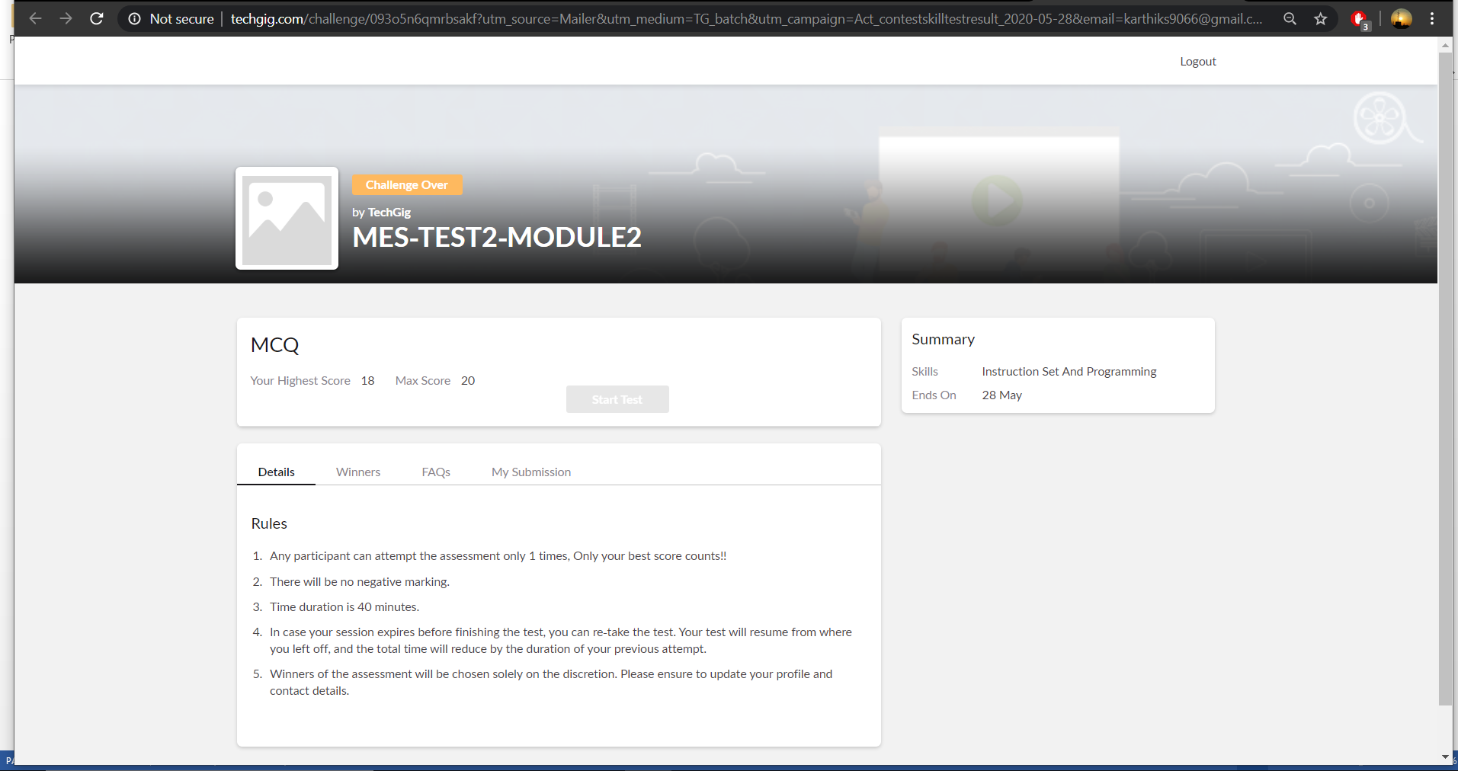

1. **Aadalitha Kannada: The portion for the test was all 10 chapters. All were objective type questions and were optimal. There were 50 questions and the duration was 50 minutes. The score that I got is 40/50**

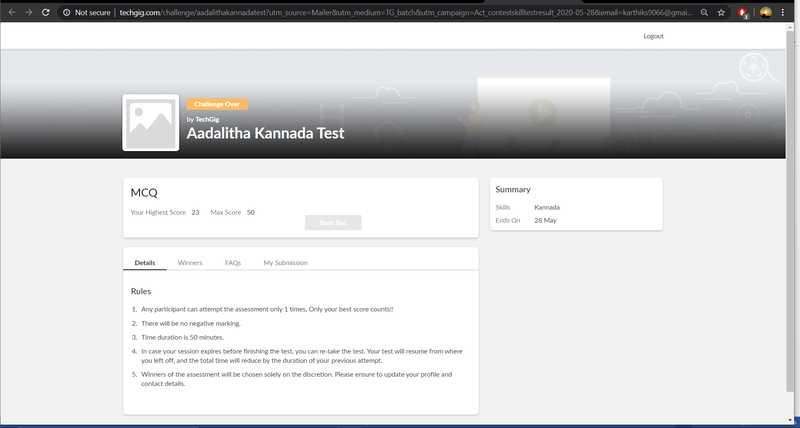

Certification Course Details: (Attach the snapshot and briefly write the report for the same)

**The course I have chosen during the lockdown period is Detecting and mitigating cyber threads and attacks. Since I had learned about basics of cyber security last time so I am continuing this course.to know more about the securities**

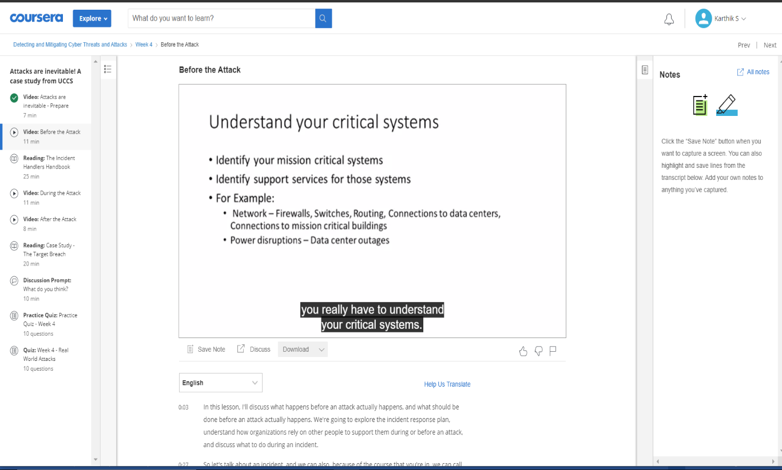

Coding Challenges Details: (Attach the snapshot and briefly write the report for the same)

Problem statement 1:

**Write a program to print the digital root of a number.**

Solution: Uploaded in github.

