**DAILY ONLINE ACTIVITIES SUMMARY**

|  |  |  |  |  |  |  |  |  |
| --- | --- | --- | --- | --- | --- | --- | --- | --- |
| **Date:** | **29/05/2020** | | | | | **Name:** | **Karthik s** | |
| **Sem & Sec** | **4th sem &A section** | | | | | **USN:** | **4AL18CS034** | |
| **Online Test Summary** | | | | | | | | |
| **Subject** | | **Operating Systems.** | | | | | | |
| **Max. Marks** | | **30** | | **Score** | | | **28** | |
| **Certification Course Summary** | | | | | | | | |
| **Course** | **Detecting and mitigating cyber threads and attacks** | | | | | | | |
| **Certificate Provider** | | | **Coursera** | | **Duration** | | | **5 weeks** |
| **Coding Challenges** | | | | | | | | |
| **Problem Statement: Write a Java program to Find size of the largest â€˜+â€™ formed by all ones in a binary matrix.** | | | | | | | | |
| **Status: completed** | | | | | | | | |
| **Uploaded the report in Github** | | | | | **yes** | | | |
| **If yes Repository name** | | | | | <https://github.com/karthik0932/lockdown-coding> | | | |
| **Uploaded the report in slack** | | | | | **yes** | | | |

**Online Test Details: (Attach the snapshot and briefly write the report for the same)**

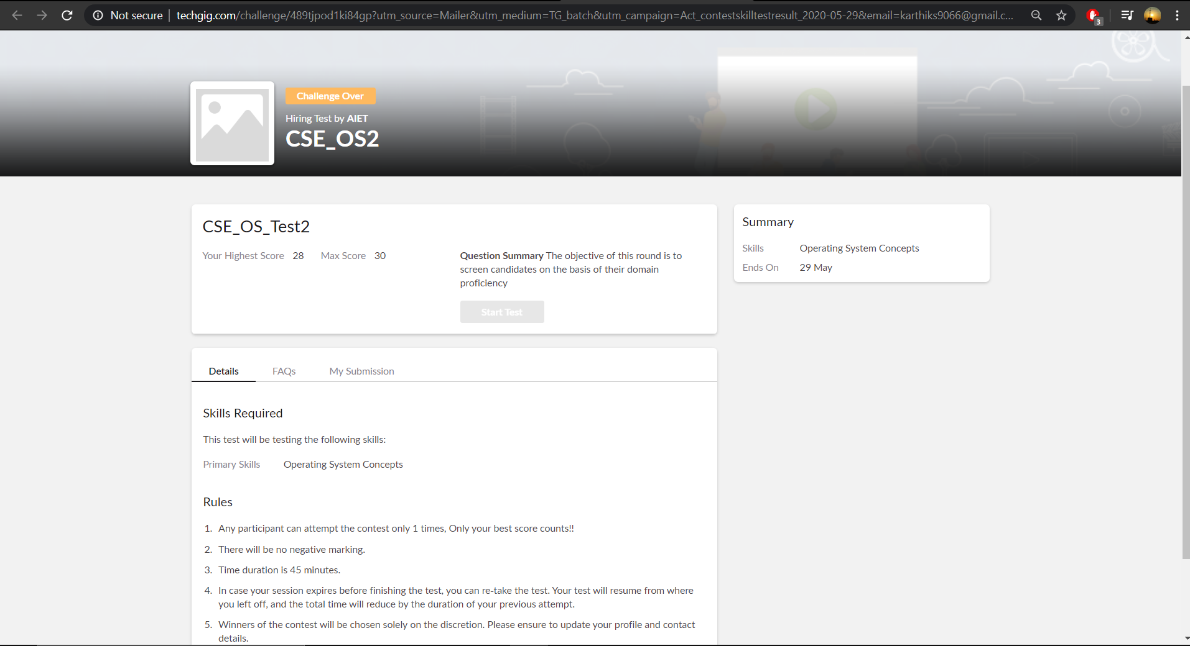

**Operating systems internals was conducted today. A total of 30 questions which is of mcq. Started at 9:00 AM and ended at 9:45 each carries one mark. It is on the topic of operating systems concepts.**

**The above snapshot is the result sheet which was sent to us by the Techgig team.**

**Certification Course Details: (Attach the snapshot and briefly write the report for the same)**

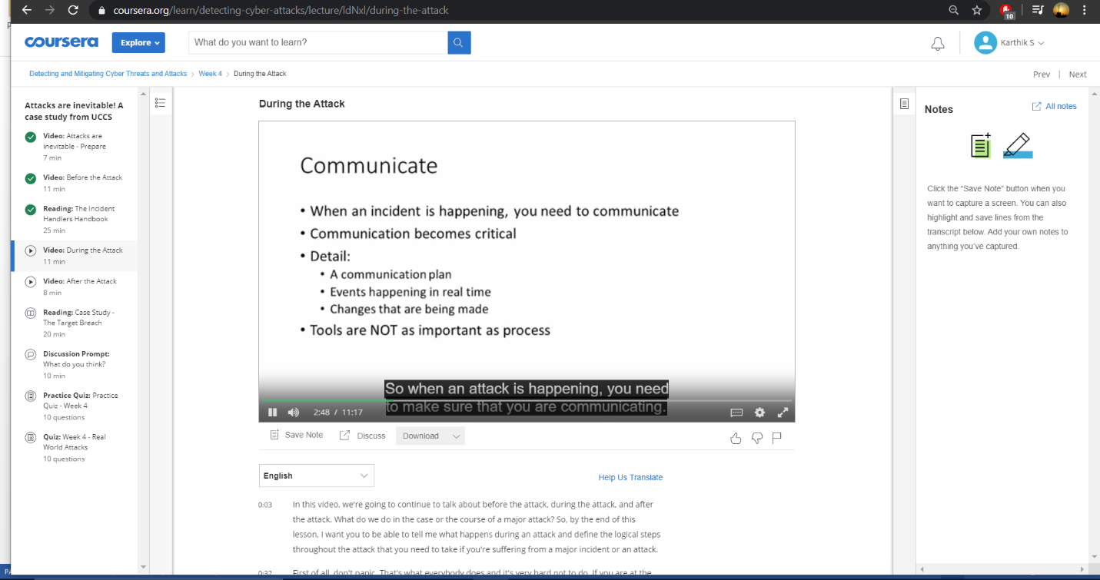

**The course I have chosen during the lockdown period is Detecting and mitigating cyber threads and attacks. Since I had learned about basics of cyber security last time so I am continuing this course.to know more about the securities**

**Coding Challenges Details: (Attach the snapshot and briefly write the report for the same)**

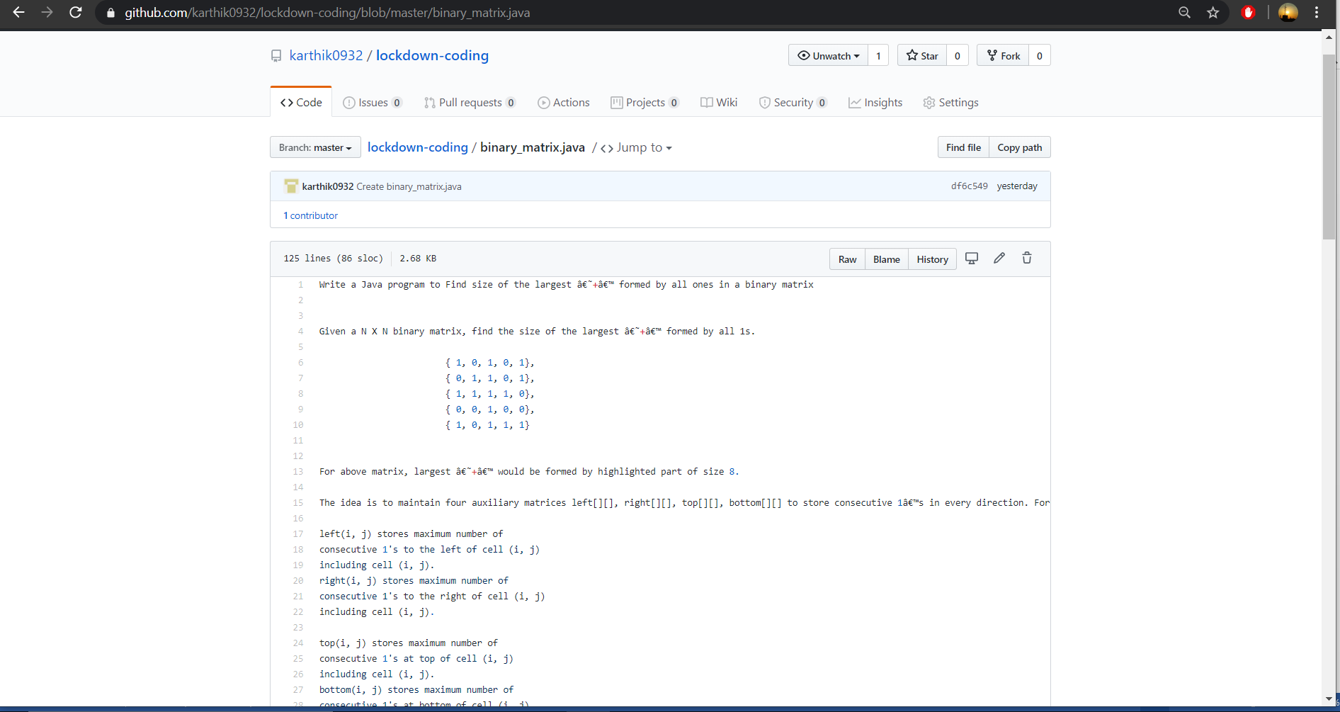

**The question we had received today was :**

**Write a Java program to Find size of the largest â€˜+â€™ formed by all ones in a binary matrix**

**Given a N X N binary matrix, find the size of the largest â€˜+â€™ formed by all 1s.**

**{ 1, 0, 1, 0, 1},**

**{ 0, 1, 1, 0, 1},**

**{ 1, 1, 1, 1, 0},**

**{ 0, 0, 1, 0, 0},**

**{ 1, 0, 1, 1, 1}**

**For above matrix, largest â€˜+â€™ would be formed by highlighted part of size 8.**

**Code:The above snapshot is the code which I have uploaded in my github repository.**