**DAILY ONLINE ACTIVITIES SUMMARY**

|  |  |  |  |  |  |  |  |  |
| --- | --- | --- | --- | --- | --- | --- | --- | --- |
| **Date:** | **30/05/2020** | | | | | **Name:** | **Karthik S** | |
| **Sem & Sec** | **4th sem &A section** | | | | | **USN:** | **4AL18CS034** | |
| **Online Test Summary** | | | | | | | | |
| **Subject** | | **1. Data communication.**  **2. Complex analysis, probability and statistical methods.** | | | | | | |
| **Max. Marks** | | **30** | | **Score** | | | **27** | |
| **Max. Marks** | | **30** | | **Score** | | | **29** | |
| **Certification Course Summary** | | | | | | | | |
| **Course** | **Detecting and mitigating cyber threads and attacks** | | | | | | | |
| **Certificate Provider** | | | **Coursera** | | **Duration** | | | **5 weeks** |
| **Coding Challenges** | | | | | | | | |
| **Problem Statement: Write a c program to count uppercase, lowercase, special character and numeric values for a given string.**  **Input : Read a String (combination of character, numeric, special character) from keyboard. Ex: #HaaGs01fOr@haaks07** **Output : Upper case letters : 5 Lower case letters : 8 Numbers : 4 Special Characters : 2** | | | | | | | | |
| **Status: Completed** | | | | | | | | |
| **Uploaded the report in Github** | | | | | **yes** | | | |
| **If yes Repository name** | | | | | <https://github.com/karthik0932/lockdown-coding> | | | |
| **Uploaded the report in slack** | | | | | **yes** | | | |

Online Test Details: (Attach the snapshot and briefly write the report for the same)

1.Data communication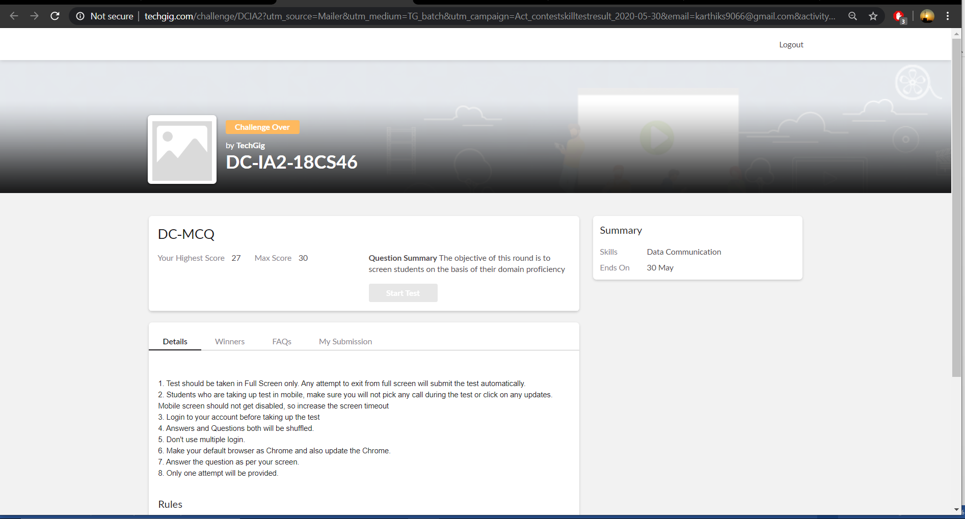

2. Complex analysis ,probability and statistical methods.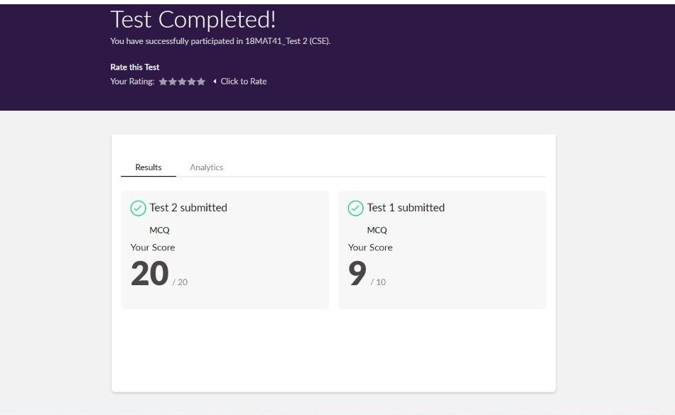

**Today we had dc and mat41 internals .Dc was from 9:15 to 9:55 and Mat41 was from 3:0 to 3:40.**

**The above snapshot is the result sheet which was sent to us by the Techgig team.**

Certification Course Details: (Attach the snapshot and briefly write the report for the same)

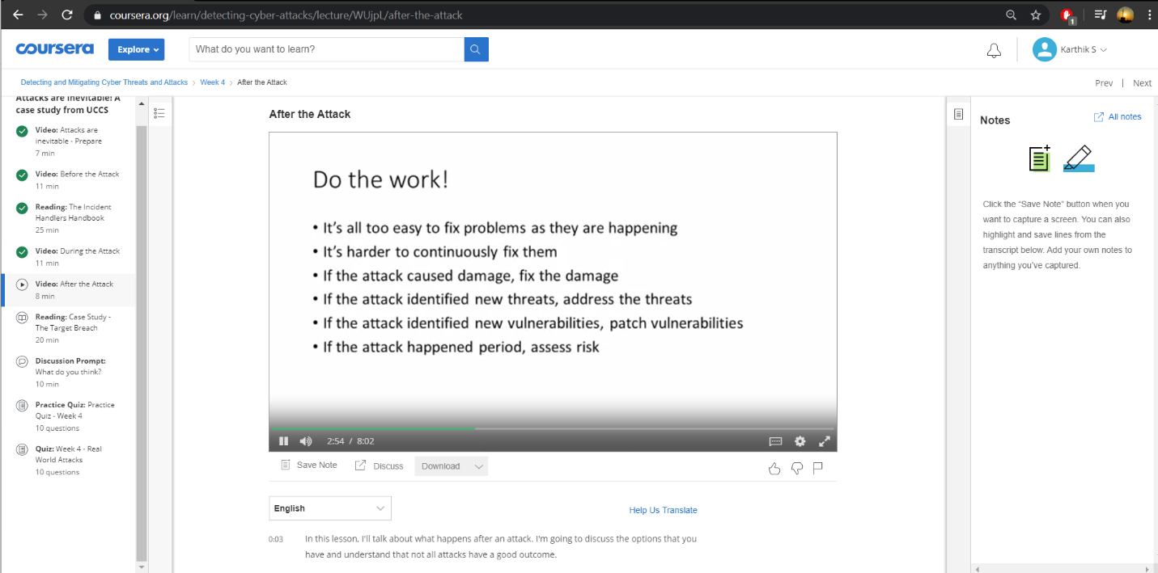

**The course I have chosen during the lockdown period is Detecting and mitigating cyber threads and attacks. Since I had learned about basics of cyber security last time so I am continuing this course.to know more about the securities**

Coding Challenges Details: (Attach the snapshot and briefly write the report for the same)

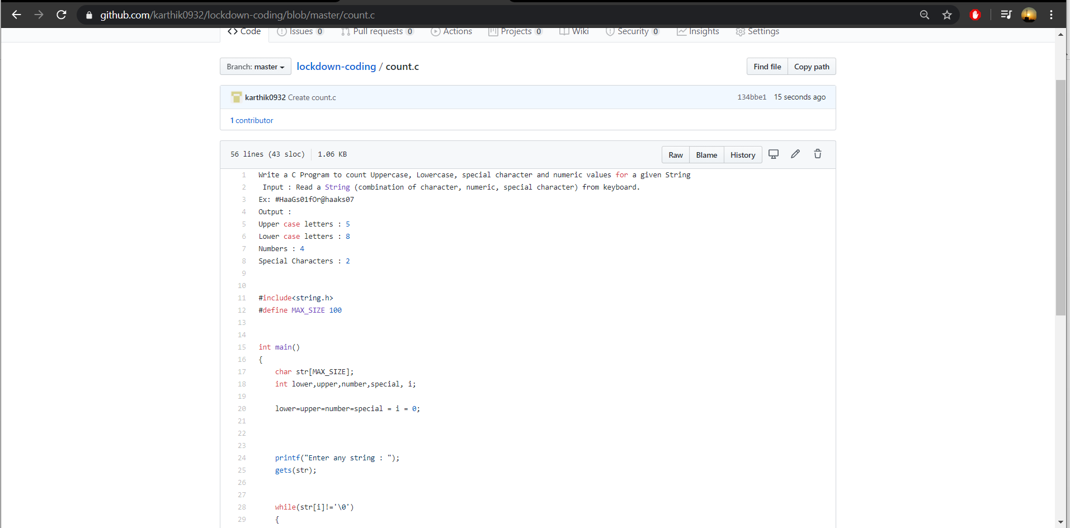

**The question we had received today was :**

**Write a c program to count uppercase, lowercase, special characters and numeric values for a given string.**

**Input : Read a String (combination of character, numeric, special character) from keyboard.  
Ex: #HaaGs01fOr@haaks07  
Output :  
Upper case letters : 5  
Lower case letters : 8  
Numbers : 4  
Special Characters : 2**

**Code:The above snapshot is the code which I have uploaded in my github repository.**