Department of Computer Science, NMAMIT, Nitte, Karkala, Udupi

chandavarkar@gmail.com

Naveen D. Chandavarkar1

**DYNAMIC PRICING WITH HISTORICAL DATA BASED ANALYSIS FOR ONLINE BARGAINING**

**Abstract: -** This paper proposes bargaining for online transaction or for online purchase of a particular product that plays an important role in the benefit of the online retailers and customer as well, keeping profit margin into consideration. Customers get benefited by purchasing the product at its best possible value. Price of a particular product is set for a particular day, totally depends on the analysis made on the historical data of a product sold i.e. last seven days or last week, which is called as dynamic pricing. Online bargain is continuously ongoing process for which the price of the product for next day to be set is calculated at the end of each day. Calculation of the price to be set is done by the data gathered from different website into the main server. Wherein the processing takes place and compares the price set with amount entered by the customer for negotiation. Customer has two attempts for bargain that offers best price so as to deal or exit from the process. Process of bargain takes place if amount entered by the customer falls in the range of bargaining frame. In this proposed paper two types of profit will be attained by the retailer.

**Keywords:** Historical data, Negotiation, Dynamic pricing, online bargaining.

### **INTRODUCTION**

### 

The concept of Online Bargain describes the bargaining process that undergoes customer interaction with the online website for some transactions or purchases. This process will set different level of price for different products, on the basis of analysis of frequency and product sold for last seven days. The price of a particular product will be set for a particular day as per the result of analysis of that product for last seven days. Customer enters the bargain amount for a particular product, that bargaining amount is compared with the selling price of that product. In this case the result will be either of two cases. Firstly, the product will be dealt if the amount entered is within the context of deal. If not, Customer will be asked to bargain again for the second attempt. In either cases customer is free to deal anytime or exit the process. Maximum of two attempts are provided so as to bargain and deal on that product. So different customer will get a benefit of different amount, It is similar to the customer of a shop wherein different individual will bargain for different amount. Each transaction here is considered has separate thread which is totally independent of other thread.

This concept is implemented keeping benefit of the online retailers in mind. The database maintained for this purpose extracts data from different websites, on hourly basis, from which the products are dealt. With these data the price is calculated for each product for each day. In this process we have to keep a track on some issues like:

* Collection of the data of each product.
* Dealing with different websites for the different product data.
* Analysis of profit amount to be added to the actual amount.
* No of bargaining attempts available for the individual.
* Comparison of bargained amount with product price.

### **LITERATURE SURVEY**

Various researches has been done in this area of dynamic pricing and online bargaining, which include work done by Fu-Ming Lee, Li-Hua Li and Pao-Hsiao Chen[1], which overcomes the time constraints issue, so as the strategies of the offers and reservation price is not revealed to the customer. So the dynamic bargaining concept is utilized, wherein the offers are dynamically offered. But as per this paper is concern customer has only two attempt of bargain then, he has to deal or exit from the process. Offers on each product are totally based on the analysis of historical data which is not predictable or guessed so easily. These data are available in the server wherein the rate of a particular product is set. If the server has enough security, revealing of data can be avoided.

Paper on genetic algorithm based bargaining by Kumar Ujjwal and Jay Aronson [2] has signified that change of price of a product is superior to the fixed product price. As to benefit the retailer and make the customer feel that he is also benefited, there are different ways of dynamic pricing, The work presented in this paper purposes simple and elegant way to implement online bargaining using genetic algorithm and mutation operators.

Work done by Saeed Jamali and Karim Faez [4] on SAQ learning algorithm describes that the dynamic pricing is done on RL (Reinforcement Learning), which is a method that trains agent to reach a goal. It is considered that SAQ learning is adapted to recover the problem of Q-Learning, which was inefficient in the bargaining area.

Paper on An Extensible Framework for Automatic Negotiation in Distributed Online Bargaining Applications by Ambroise Ncho and EsmaAi'meur [6] works on web application based on trading through a distributed architecture internally operated by agent system using CAAT interaction protocol. This paper focuses on collaborative agreement for automated trading by the agent system for bargaining on a particular product.

### **ARCHITECTURE**

The architecture shown in Fig. 1 pictures all the components in this process of online bargain. It is three layered architecture wherein the first layer is for the interaction of customers with system. Second layer is owned by the online retailer will work as an interface between the customer and online retailer. This layer displays all the products in the online store to be sold with price amount set on that product. Third layer is heart of this process wherein all the major processing takes place. This layer is used by seller while the processing in the back end i.e. manager manages each and every transactions in the process in the form of logs. Pattern Database maintains all the data that is extracted from different websites. Price matching is a component wherein two amount i.e. the amount entered by the buyer and price set for a particular product, for bargain, is compared.

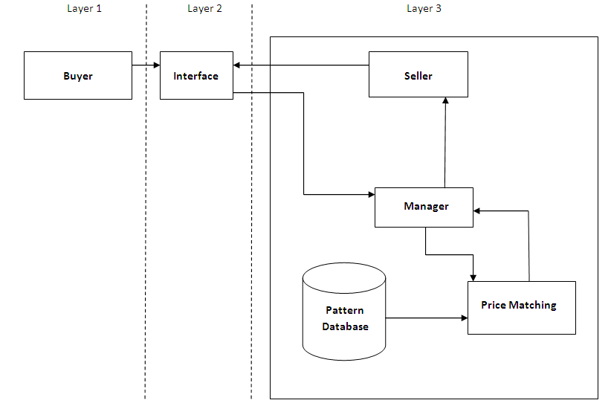

**Fig.** **1** Architecture of Online Bargain

The designed application shows a web page with certain products available for sale for which the price is preset. The customer will opt for bargain for that product, so whatever amount the customer will suggest is read by the manager and is matched in price matching section with the margin price that is the result of analysis of sales details of that product in last seven days. After the calculation, an amount will be suggested by system after processing which is displayed in the interface via manager, so as to keep a log.

### **ONLINE BARGAIN METHODOLOGY**

Concept proposed here is to target the maximum benefit for the online retailers. The product sold in this framework will give a varying benefit to the online retailer, which is achieved by the process of continuous analysis on the data that is received by the server.

The data entered by the customer is compared with the price set for the product by analyzing that product sold in the last seven days, which is shown in the graphs Fig 2 and Fig 3.

Fig. 2 shows the detailed analysis graph of a particular product P sold on a certain day. This graph shows the number of product sold in every three hours. The line VD1 represents the average product sold on that day.

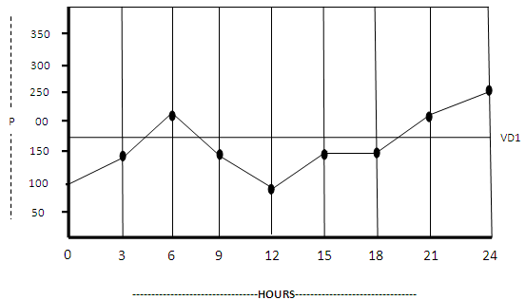

**Fig. 2** Graph showing product sold ina day

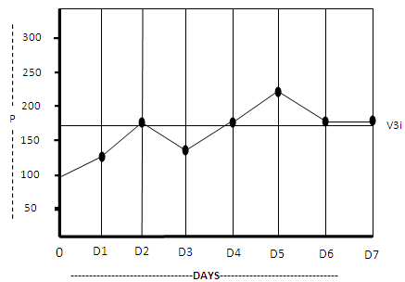

**Fig. 3**Graph showing product sold in seven days

Fig. 3 shows the graph of the variation in the product sold for seven days and the line V3i indicates the average number of product sold in seven days.

This value V3 is converted into smaller measureable value X = V3 * 0.05, (1)

where X is the measure of V3 in smaller unit. 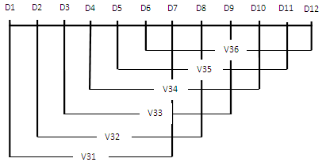

**Fig. 4** Graph for Setting the Margin rate

Fig. 4 shows how the analysis is done for the Y i.e. margin rate to set for each day. The margin rate of the present day is set on the basis of the analysis of previous seven days i.e. V3i.

The graph in Fig. 5 points to the amount Y to be added to the actual amount A of the product.

i.e. Z = A + Y, (2)

where Z is the margin amount. The amount Y is fixed for a product throughout a day and will change for the next day as per the sales of that product on the present day and previous six days.

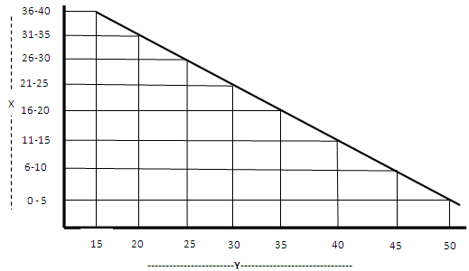

**Fig. 5** Graph for selecting Y

The selling price S is calculated as

S = Z + (0.10 * Z), (3)

by adding 10 % of the margin amount, and is offered to the customer.

In the case, when the customer attempts to bargain on a particular product which is displayed with S as the selling price, customer has to suggest the best amount he wants to pay for that product i.e. U1, during the first bargain attempt. This U1 is compared with several aspects so as to deal the product or continue with second attempt of bargain. The aspects are follows:

Condition 1: U1 == S

“Product Dealt”

Condition 2: U1 < S && U1 >= Z

“Product Dealt “

Condition 3: U1 < (A – (0.05 * A))

“Deal not possible”

Condition 4: U1 > S

“Invalid amount”

Condition 5: U1 > (A- (0.05 * A) && U1 < Z)

P1 = (Z – U1) / 2

NP1 = Z + P1

Where P1 is average of the difference between margin amount Z and Customer’s first attempt bargain amount.

NP1 is new price set after the calculation and is suggested to the customer. On the basis of NP1 customer has to decide if he want to deal or bargain for the second attempt.

In the second attempt, U2 is the bargain amount suggested by the customer. This U2 is compared with few aspects for deal or exit from the thread as follows:

Condition 1: U2 == Z

“Product Dealt”

Condition 2: U2 >= Z && U2 < NP1

“Product Dealt”

Condition 3: U2>U1 && U2 < Z

P2 = (Z – U2)

NP2 = Z + P2

Where P2 is the difference between the margin amount and customer’s second attempt of bargain amount.

NP2 is the new price set after the calculation, which is suggested to customer. On the basis of NP2 customer has to decide if he wants to deal or exit from the process.

### **EFFICIENCY**

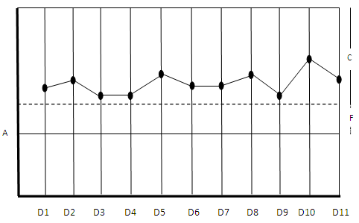

**Fig. 6** Profit attained by the Online Retailer

Efficiency of this project deals with what amount the online retailer is benefited. In fig. 6 two types of profits are shown. The range F is the fixed profit which will be set for each day after the analysis for a particular product. C is varying profit on the product that is totally dependent on customer bargain. Because one customer may bargain for C-i amount and the other customer may bargain for C – j amount for the same product. i and j are different amount suggested by the customer for a particular product. In this graph, A is the mean line of each product purchased initially. If incase the profit graph shown touches or goes below line A it indicates loss in the business. But as per algorithm discussed, the graph never touches line A. This indicates that this concept is efficient in terms of profit to the online retailer.

### **CONCLUSION**

Online Bargaining concept is developed keeping in mind the mentality of the customer and online retailer who will be naturally benefited. It is been noticed that the performance with different product and different individual is performed considering variant frame of constraints. Each individual interacting with this process will be dealing independent of other individual. Here the same product may be sold for different price. As the profit of the online retailer on a particular product for the seven days increases, the price of that product decrease the next day in a particular ratio.

This project set three prices for a particular product which will be displayed in different levels with an option for the customer to deal or bargain again. If amount entered by the customer is out of the range of bargain then error message will be displayed.

### **FUTURE WORK**

This project is having few scopes for improvement: timer will be introduced so as to take care of time utility. The experiment is conducted considering a single product; implementing of multiple product bargain and multiple user access simultaneously will be a future work.

**REFERENCES**

[1] Fu-Ming Lee, Li-Hua Li and Pao-Hsiao Chen, A Study on Dynamic Bargaining Strategy under Time Constraints and with Incomplete Information, Proceedings of the 2005 IEEE/WIC/ACM International Conference on Intelligent Agent Technology (IAT’05), 2005.

[2] Kumar Ujjwal, and Jay Aronson, Genetic Algorithm based bargaining agent for Implementing Dynamic Pricing on Internet, Proceedings of the 2007 IEEE Symposium on Foundations of Computational Intelligence, 2007.

[3] Jiawei Han and Micheline Kamber, Morgan Kaufmann, [Data Mining: Concepts and Techniques](http://www.albionresearch.com/ibook/1558604898).

[4] Saeed Jamali and Karim Faez Applying SAQ-Learning Algorithm for Trading Agents in Bilateral Bargaining,, 14th International Conference on Modelling and Simulation, 2012.

[5] Fu-ren Lin and Kuang-yi Chang ,A Multiagent Framework for Automated Online Bargaining, ,National Sun Yat-sen University, july/august 2001.

[6]. Ambroise Ncho and EsmaAi'meur, An Extensible Framework for Automatic Negotiation in Distributed Online Bargaining Applications, Universite de Montreal, 2005.