REATIL CUSTOMER 360 PERFORMANCE DASHBOARD RISK

PROFESSIONAL TRAINING I

Submitted in partial fulfillment of the requirements for the award of Bachelor of Engineering degree in Computer Science and Engineering
By

Karthik P(Reg.No–44111076)



DEPARTMENT OF COMPUTER SCIENCE AND ENGINEERING SCHOOL OF COMPUTING

SATHYABAMA
INSTITUTE OF SCIENCE AND TECHNOLOGY (DEEMED TO BE UNIVERSITY)
CATEGORY-1 UNIVERSITY BY UGC
Accredited “A++” by NAAC I Approved by AICTE JEPPIAAR NAGAR, RAJIVGANDHI SALAI CHENNAI-600119
NOVEMBER-2026

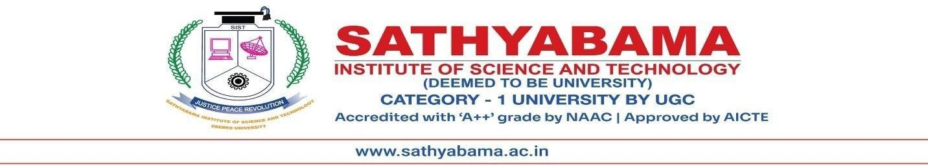
DEPARTMENT OF COMPUTER SCIENCE AND ENGINEERING BONAFIDE CERTIFICATE

This is to certify that this Professional Training I Report is the bonafide work of Karthik P (4411076) who carried out the Project Phase-1 entitled “RETAIL CUSTOMER 360 PERFORMANCE DASHBOARD” under my supervision from July 2026 to November 2026.

Internal Guide Dr.G.Subathra, ME, Ph.D.,

Head of the Department
Dr.L. LAKSHMANAN,M.E,Ph.D.,

Submitted for Professional Training I Viva Voce Examination held on

Internal Examiner External Examiner

DECLARATION

I, Karthik P (Reg. No- 4411076), hereby declare that the Professional Training-1 Report entitled “RETAIL CUSTOMER 360 PERFORMANCE DASHBOARD” done by me under the guidance of Dr.G. Subathra, ME, Ph.D., is submitted in partial fulfillment of the requirements for the award of Bachelor of Engineering degree in Computer Science and Engineering.

DATE:
PLACE: Chennai SIGNATURE OF THE CANDIDATE

ACKNOWLEDGEMENT

I am pleased to acknowledge my sincere thanks to BOARD OF MANAGEMENT of Sathyabama Institute of Science and Technology for their kind Department encouragement in doing this project and for completing it successfully. I am grateful to them.
I convey my thanks to Dr. L. Lakshmanan, M.E., Ph.D., Dean and Head, School of Computing, Department of Computer Science and Engineering for providing me with necessary support and details at the right time during the progressive reviews.
I would like to express my sincere and deep sense of gratitude to my Project Guide Dr.G. Subathra,ME, Ph.D., for her valuable guidance, suggestions, and constant encouragement paved the way for the successful completion of my project work.
I wish to express my thanks to all Teaching and Non-teaching staff members of the Department of Computer Science and Engineering who were helpful in many ways for the completion of the project.

TRAINING CERTIFICATE

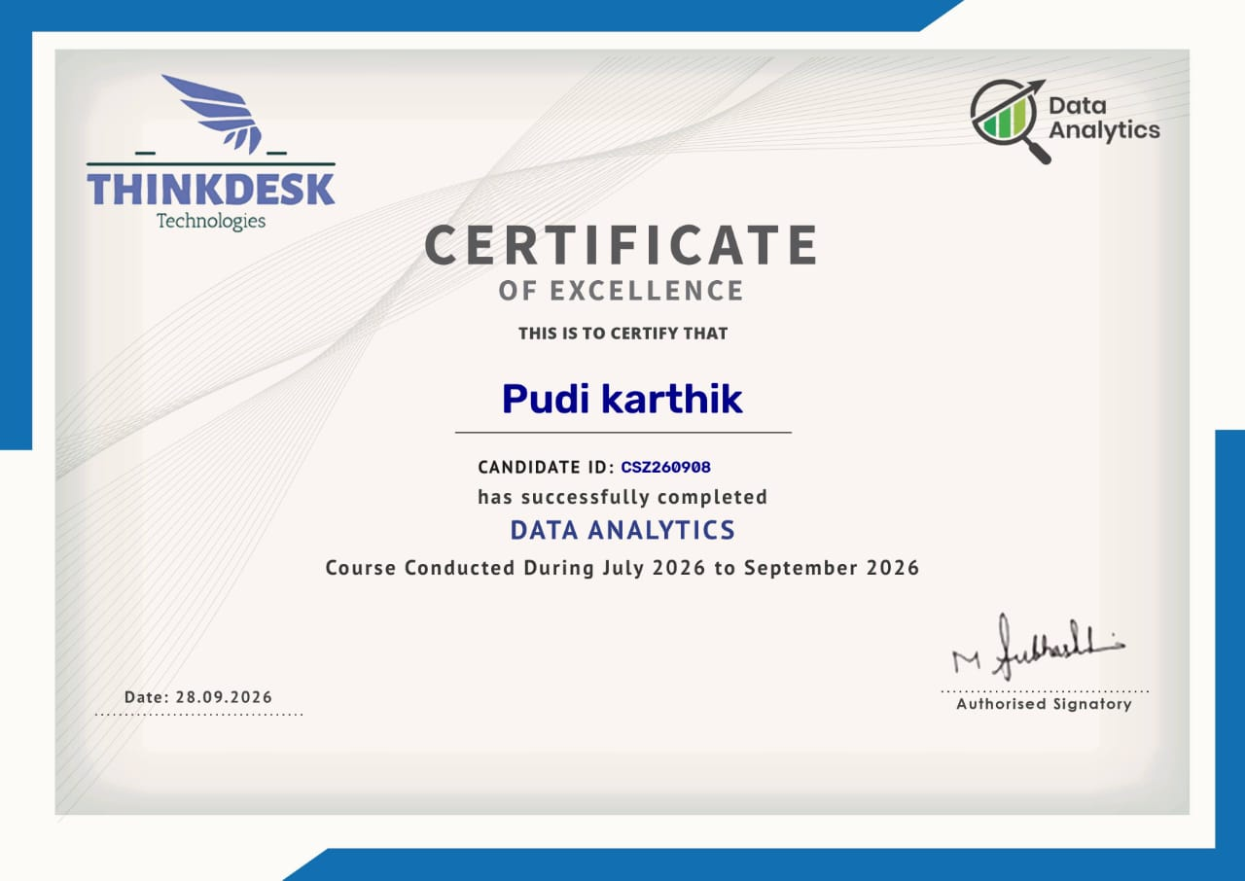

ABSTRACT

The Retail Customer 360 Performance Dashboard is a data analytics project designed to analyze retail customer behaviour and evaluate overall business performance. Retail businesses generate large amounts of data through customer transactions, product purchases, and sales activities. Analyzing this data helps businesses understand customer preferences, identify purchasing patterns, and make better business decisions. However, analyzing raw data manually can be time-consuming and make it difficult to identify useful insights.
The proposed system provides a centralized dashboard to present important customer and sales information in a clear and organized format. It uses data analysis techniques and graphical visualizations to examine customer purchasing habits, sales trends, product performance, and transaction patterns. Key performance indicators, charts, tables, and interactive filters help users explore the available data and compare business performance across different categories and time periods.
The dashboard aims to simplify the analysis of retail data, reduce the effort required for manual reporting, and improve the understanding of customer and sales performance. The insights obtained from the dashboard can help businesses identify popular products, understand customer activity, monitor sales performance, and support effective business planning. Overall, the Retail Customer 360 Performance Dashboard demonstrates how data analytics and visualization can transform raw retail data into meaningful information and support data-driven decision-making.

TABLE OF CONTENTS

Chapter  No. |  | Title | Page No.
 | ABSTRACT |  | vi
 | LIST OF FIGURES |  | viii
 | LIST OF TABLES |  | ix
1 | INTRODUCTION |  | 1
 | 1.1 | Introduction | 1
 | 1.2 | Problem Statement | 1
 | 1.3 | Objectives | 1
 | 1.4 | Scope of the Project | 2
2 | LITERATURE SURVEY |  | 3
 | 2.1 | Introduction | 3
 | 2.2 | Review of Literature | 3
 | 2.3 | Inferences from Literature Survey | 4
 | 2.4 | Open Problems in Existing System | 4
 | 2.5 | Comparison of Existing and Proposed Systems | 4
3 | REQUIREMENTS ANALYSIS |  | 6
 | 3.1 | Feasibility Study | 6
 | 3.2 | Software Requirements Specification | 6
4 | DESCRIPTION OF PROPOSED SYSTEM |  | 9
 | 4.1 | Selected Methodology or Process Model | 9
 | 4.2 | Architecture | 9
 | 4.3 | Description of Software Implementation and  Testing Plan | 11
 | 4.4 | Project Management Plan | 16
 | 4.5 | Financial Report on Estimated Costing | 17
 | 4.6 | Software to Operations Plan | 17
 | 4.7 | Limitations of the Project | 18
 | REFERENCES |  | 19

LIST OF FIGURES

FIGURE  NO. | FIGURE NAME | PAGE NO.
4.1 | System Architecture | 9
4.2 | Purchase-Order and Risk Prediction Workflow | 10
4.3 | Retail Customer 360 Executive Dashboard | 11
4.4 | Product Category Performance Analysis  Interface | 13
4.5 | Customer Value Segmentation (RFM & CLV) | 13
4.6 | Monthly Sales Velocity & Profit Growth Trends | 14
4.7 | Top 10 High-Value Customer Accounts Analysis | 15

LIST OF TABLES

TABLE NO. | TABLE NAME | PAGE NO.
2.1 | Comparison of Existing and Proposed Systems | 5
3.1 | Functional Requirements of the Proposed System | 7
3.2 | Software Requirements of the Proposed System | Error!  Bookmark not  defined.
4.1 | System Modules | 10
4.2 | Indicative Test Cases | 16
4.3 | Project Management Plan | 17

CHAPTER 1
INTRODUCTION

INTRODUCTION
Retail customer analysis is an important part of business operations, as organizations depend on customer purchasing behaviour and sales performance to make effective business decisions. Understanding customer preferences, spending patterns, and product demand helps businesses improve customer engagement and identify opportunities for growth. Traditional methods based on manual calculations and separate reports make it difficult to analyze large volumes of retail data and identify meaningful insights.
The Retail Customer 360 Performance Dashboard is a data analytics application that integrates customer analysis, sales monitoring, purchasing-pattern evaluation, and performance visualization. It uses retail customer and transaction data to provide a comprehensive view of customer behaviour and overall business performance. The dashboard presents key performance indicators, charts, and interactive visualizations to help users analyze sales trends, identify popular products, understand customer purchasing habits, and compare performance across different categories and time periods. These features support efficient data exploration and help users identify important business patterns.

PROBLEM STATEMENT

Retail businesses collect large amounts of customer, sales, and transaction data through their daily operations. However, this information is often maintained in separate files or systems, making it difficult to obtain a complete view of customer behaviour and business performance. Traditional methods of analysing retail data require considerable manual effort and may not provide timely insights into customer purchasing patterns.

The absence of a centralized analytical dashboard makes it challenging to identify valuable customers, understand product preferences, monitor sales trends, and evaluate customer purchasing frequency. Businesses may also find it difficult to compare customer segments and identify opportunities for improving customer retention. Therefore, a Retail Customer 360 Performance Dashboard is required to consolidate retail data, analyse customer behaviour, visualize key performance indicators, and generate meaningful insights that support effective business decisions.

OBJECTIVES

To consolidate retail customer and transaction data for analysis.

To analyse overall sales and revenue performance.

To identify customer purchasing patterns and preferences.

To segment customers based on their purchasing behaviour.

To identify high-value and frequent customers.

To evaluate customer retention and purchasing frequency.

To analyse product-wise and category-wise sales performance.

SCOPE OF THE PROJECT

The Retail Customer 360 Performance Dashboard focuses on analysing customer information, transaction records, and retail sales data to provide a consolidated view of business performance. The project uses data analytics techniques to identify customer purchasing patterns, sales trends, product preferences, and customer segments.

The dashboard presents key performance indicators and graphical visualizations that help users understand customer behaviour and business outcomes. It can support the identification of high-value customers, frequently purchased products, and changes in sales performance. The project aims to reduce manual data analysis and improve the accessibility of retail insights. Future enhancements may include machine-learning-based customer segmentation, sales forecasting, customer churn prediction, and personalized product recommendations.

CHAPTER 2
LITERATURE SURVEY

INTRODUCTION
Customer analytics plays an important role in understanding consumer behaviour and improving retail business performance. Retail organizations use sales records, transaction histories, and customer information to identify purchasing patterns and product preferences. Data visualization techniques help transform large datasets into meaningful graphical representations. Customer segmentation enables businesses to group customers according to similarities in their purchasing behaviour.This project applies data analytics and visualization techniques to develop a Retail Customer 360 Performance Dashboard.

REVIEW OF LITERATURE

Kotler and Keller discussed customer relationship management and the importance of understanding customer needs, preferences, and purchasing behaviour. Their work highlights the value of analyzing customer information to improve customer satisfaction, strengthen customer relationships, and support effective marketing strategies. These concepts support the development of the proposed Retail Customer 360 Performance Dashboard, which focuses on understanding customer behaviour and purchasing patterns.

Han, Kamber, and Pei studied data mining techniques for discovering useful patterns from large datasets. Their work explains how data analysis can identify relationships, trends, and meaningful information hidden within raw data. These concepts support the analysis of retail transactions, customer purchasing frequency, and product demand in the proposed dashboard.

Fader discussed customer-base analysis and the importance of understanding customer purchasing activity and long-term customer value. His work highlights how customer transaction histories can help businesses identify valuable customer groups and understand differences in purchasing behaviour. These findings support the use of customer-level analysis to gain insights into retail customer performance.

Few discussed the principles of effective information dashboard design and emphasized presenting important business information through clear visualizations and key performance indicators. His work highlights the importance of arranging data in an understandable format to support monitoring and decision-making. These principles support the proposed dashboard's use of charts, tables, and performance indicators to present retail sales and customer information.

INFERENCES FROM LITERATURE SURVEY
The literature survey leads to the following inferences:
- Customer data analysis helps understand purchasing behaviour.
- Customer segmentation supports targeted marketing strategies.
- Sales analysis helps identify business trends.
- Data visualization improves the interpretation of complex datasets.
- Key performance indicators support business performance monitoring.
- Centralized dashboards improve access to analytical information.
- Data-driven insights can support customer retention and business growth.

OPEN PROBLEMS IN EXISTING SYSTEM

Traditional retail analysis methods may involve separate spreadsheets, manual calculations, and static reports. These methods can make it difficult to obtain a unified view of customer activity and sales performance. Identifying high-value customers and comparing customer segments may also require additional manual analysis. The proposed dashboard addresses these challenges by integrating customer analytics, sales metrics, and visual reporting into a single analytical platform.

COMPARISON OF EXISTING AND PROPOSED SYSTEMS

Existing manual or disconnected systems may have the following limitations:

Customer records are maintained in separate locations.

Sales and customer performance analysis requires manual effort.

Identifying valuable customers and popular products may be difficult.

Real-time performance monitoring and interactive data visualization.
Table 2.1 compares the key features of the existing manual and proposed system
Table 2.1: Comparison of Existing and Proposed Systems

FEATURE | EXISTING MANUAL  APPROACH | PROPOSED SYSTEM
Customer data | Scattered records | Consolidated customer information
Sales analysis | Manual calculations | Dashboard-based analysis
Customer segmentation | Limited manual grouping | Data-driven segmentation
Performance monitoring | Static reports | Visual KPI monitoring
Customer behaviour | Difficult to analyse | Customer purchasing insights
Product analysis | Separate reports | Product-wise visual analysis
Reporting | Time-consuming | Centralized analytical dashboard

CHAPTER 3
REQUIREMENTS ANALYSIS

FEASIBILITY STUDY

The feasibility study evaluates whether the Retail Customer 360 Performance Dashboard can be developed using the available technologies, tools, and resources.

Technical Feasibility: The project can be developed using data analytics tools, data-processing techniques, and visualization software. The selected tools enable the processing of retail datasets and the creation of interactive dashboards.

Economic Feasibility: The project can be developed using freely available datasets and software tools, reducing implementation costs. Additional expenses may arise if paid services or cloud platforms are used.

Operational Feasibility: The dashboard presents customer and sales information through charts, tables, and key performance indicators. Its visual interface enables users to understand retail performance and customer purchasing behaviour without manually analysing large amounts of data.

SOFTWARE REQUIREMENTS SPECIFICATION

The Retail Customer 360 Performance Dashboard requires suitable software tools to analyze retail data and present meaningful business insights. The system uses a dataset containing customer details, transaction records, and sales information. Data analysis tools are used to process the data, identify purchasing patterns, and calculate key performance indicators. Visualization tools help display sales trends, customer behaviour, and product performance through charts and graphs. The system should provide a user-friendly interface for exploring data and understanding analytical results. The software must support efficient data processing, accurate calculations, and clear visualization of results. These requirements help ensure the effective development and operation of the proposed dashboard.

Table 3.1: Functional Requirements of the Proposed System

ID | REQUIREMENTS | DESCRIPTION
FR-01 | Data import | Load the retail customer and transcation
FR-02 | Data cleaning | Handle missing,duplicats,and inconsitent
FR-03 | Customer analysis | Analyse customer purchasing behaviour.
FR-04 | Sales analysis | Calculate sales and revenue metrices
FR-05 | Customer segmentation | Group customers using selected behavioural criteria
FR-06 | Product analysis | Analyse product-wise and category-wise sales.
FR-07 | KPI calculation | Calculate important customer and sales indicators
FR-08 | Dashboard | Display analytical summaries and visualizations.
FR-09 | Filtering | Filter information using available categories and time periods.
FR-10 | Reporting | Present summarized insights for business analysis.
FR-11 | Sales analysis | Group customers using selected behavioural criteria.
The application uses various software technologies and tools to ensure efficient data analysis, reliable performance, and effective visualization. Python supports data processing and analysis, while SQL can be used for managing and retrieving retail data. Power BI is used to create interactive dashboards and visualize customer behaviour, sales trends, and product performance. Data analysis techniques help identify purchasing patterns and calculate key performance indicators. Visual Studio Code provides the development environment for coding and data processing activities. The dashboard presents analytical results through charts, graphs, tables, and interactive filters. These technologies collectively support the effective implementation of the proposed Retail Customer 360 Performance Dashboard..

Table 3.2: Software Requirements of the Proposed System

Software / Technology | Purpose
Python | Data processing and analysis
Pandas | Data cleaning and manipulation
NumPY | Numerical operations
Power BI | Interactive dashboards and visualizations
DAX | KPI calculations in Power BI
Visual Studio Code | Python development, if used
Web Browser | Accessing online resources or web-based dashboards
The customer identifier links customer records to their corresponding transaction details. Sales information, purchasing patterns, customer performance indicators, and analytical results are associated with relevant records according to the available dataset and implemented data relationships. Dashboard metrics and visualizations are generated based on the retail data processed by the system.
The intended users should be able to perform the following activities through the application:
- View and analyze customer information.
- Explore retail transaction records and sales details.
- Analyze customer purchasing patterns and spending behaviour.
- View sales trends and product performance indicators.
- Monitor key customer and business performance metrics.
- Compare customer segments and sales performance using available data.

CHAPTER 4
DESCRIPTION OF PROPOSED SYSTEM

SELECTED METHODOLOGY OR PROCESS MODEL
The project follows a structured data analytics workflow. The process begins with collecting the retail dataset, followed by data cleaning, preprocessing, exploratory data analysis, and the calculation of key performance indicators. The processed data is then used to develop interactive dashboards and visualizations. The results are analysed to identify customer purchasing patterns, sales trends, and customer segments. This approach helps transform raw retail data into meaningful business insights.

ARCHITECTURE
The Retail Customer 360 Performance Dashboard consists of four major stages: data collection, data preprocessing, data analysis, and dashboard visualization.
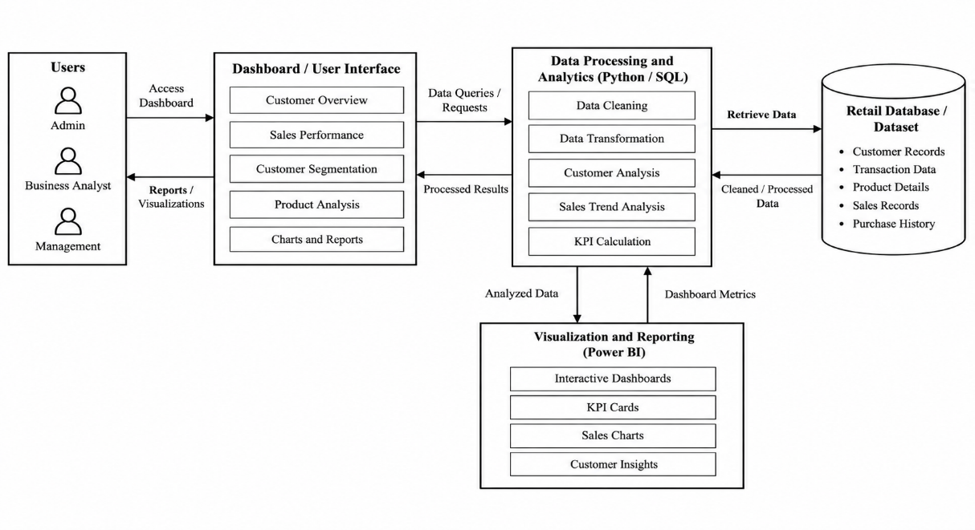
Figure 4.1 System Architecture
Data Collection: Retail customer information and transaction records are collected from the selected dataset.
Data Preprocessing: The collected data is checked for missing values, duplicate records, and inconsistencies before analysis.

Data Analysis: The cleaned dataset is analysed to calculate sales metrics, identify customer purchasing patterns, and understand customer segments.
Dashboard Visualization: The analytical results are presented through charts, tables, KPI cards, and interactive filters to support the interpretation of retail performance.

The main modules of the system are summarized in Table 4.1.
Table 4.1: System Modules

MODULE | DESCRIPTION
Dashboard | Displays customer summaries, sales performance indicators, and charts.
Customer Management | Maintains customer profiles and relevant customer information
Sales Analysis | Analyzes sales transactions, revenue, and sales trends.
Customer Segmentation | Groups customers based on purchasing behaviour and available customer data.
Product Analysis | Identifies popular products, product demand, and sales performance.
Customer Insights | Provides insights into customer preferences, spending patterns, and purchasing frequency.
Performance Analysis | Displays sales, customer activity, and key business performance indicators.
Data Visualization | Presents retail data through charts, graphs, tables, and interactive visualizations.
Reports | Generates summarized reports on customer behaviour, sales trends, and product performance.
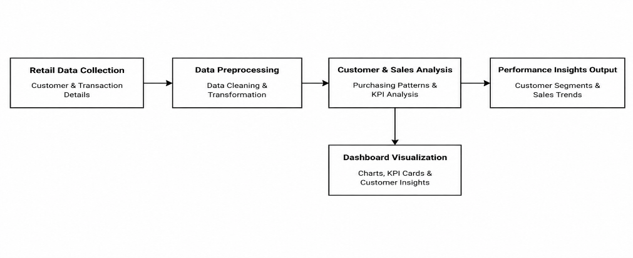
Figure 4.2 shows the process of collecting retail customer and transcation data,preprocessing the data.

Figure 4.2 Retail Customer Analytics and Dashboard Workflow
When retail customer and transaction data is collected, the system processes the available information and prepares it for analysis. The data preprocessing stage handles data cleaning and transformation to improve data consistency and usability. The analysis module examines customer purchasing patterns, sales trends, product performance, and key performance indicators.
The processed results are used to generate dashboard visualizations, including charts, tables, and performance summaries. These visualizations help users understand customer behaviour, identify popular products, and monitor sales performance. The dashboard presents meaningful insights that support effective business analysis and informed decision-making.

DESCRIPTION OF SOFTWARE IMPLEMENTATION AND TESTING PLAN
The The frontend provides the interface through which users interact with the Retail Customer 360 Performance Dashboard. It includes sections for the customer overview, sales analysis, customer segmentation, product performance, data visualization, and reports.The interface presents the analytical results generated from the available retail dataset. The dashboard provides a centralized overview of customer information, sales performance, purchasing patterns, and product trends. It also presents graphical representations of customer activity, sales distribution, and key performance indicators. These visualizations help users interpret retail data and identify meaningful business insights.
Figure 4.3 shows the dashboard interface.
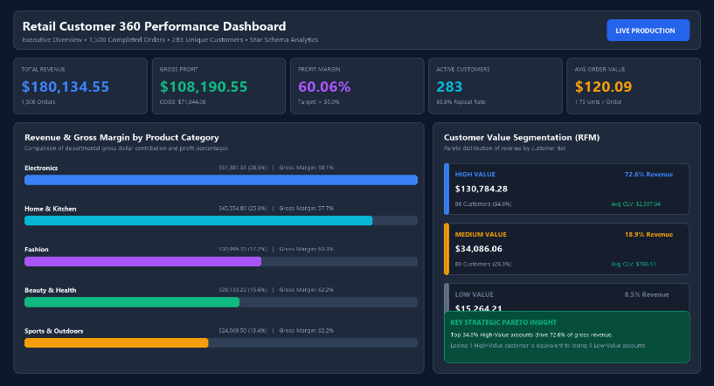
Figure 4.3 Retail Customer Dashboard

The data processing component is responsible for analyzing retail customer information, transaction records, and sales data. It manages data preprocessing, analytical operations, and the calculation of key performance indicators. Python can be used for data processing and analysis, while SQL supports structured data retrieval and management, depending on the implemented technology stack.
The retail dataset contains relevant customer details, transaction information, product details, and sales records. These data elements support customer analysis, sales monitoring, and product performance evaluation.
Relationships between customer records and transaction details help organize the available information for analysis. Historical transaction data can be used to identify purchasing frequency, spending patterns, and customer preferences. Sales information also helps calculate performance indicators and compare results across products, categories, and time periods.
The project focuses on analyzing retail data to identify meaningful customer and business insights.
Data analysis techniques are used to examine customer purchasing behaviour, sales trends, and product performance. The analysis helps identify patterns within the available dataset and supports the calculation of relevant performance indicators.
The resulting insights depend on the quality, completeness, and suitability of the available data. Accurate and consistent data helps improve the reliability of the analytical results.
The dashboard presents the analyzed information through charts, tables, key performance indicators, and interactive visualizations. Users can explore customer activity, compare sales performance, and examine product trends using the available dashboard features. These visualizations help users identify important patterns and support informed business decisions. Figure 4.4 shows the product category sales performance and profitability interface.

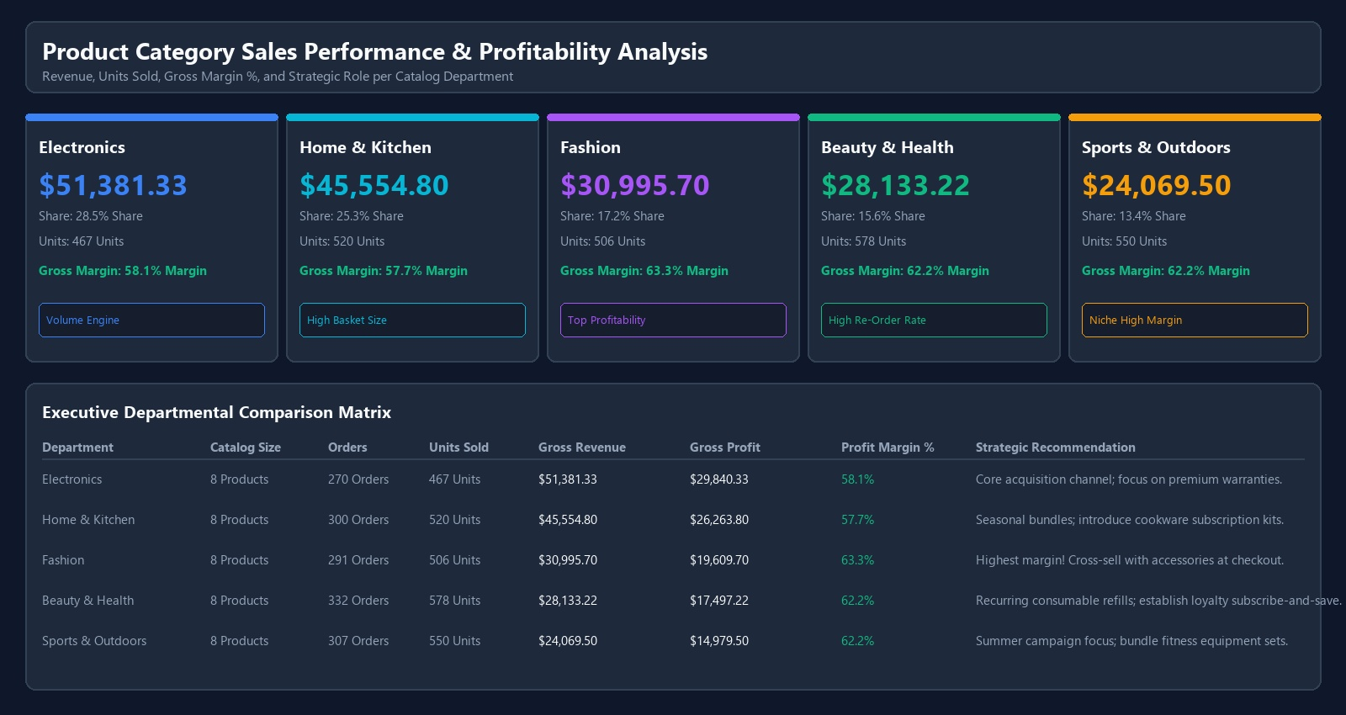
Product Category Performance Analysis

The interface displays comparative sales performance, units sold, and gross profit margins across five major departments: Electronics, Home & Kitchen, Fashion, Beauty & Health, and Sports & Outdoors. Electronics represents the largest revenue driver (,381.33, 28.5% share), while Fashion delivers the highest profitability with a 63.3% gross profit margin.
Departmental profitability is evaluated using unit acquisition cost, transaction volume, and product category margins. Indicators include total revenue, units sold, gross profit, and return on inventory.
Gross Profit Margin % = (Total Gross Profit / Total Gross Revenue) x 100
Average Order Value (AOV) = Total Revenue / Total Completed Orders
Customer Value Segmentation (RFM & CLV)
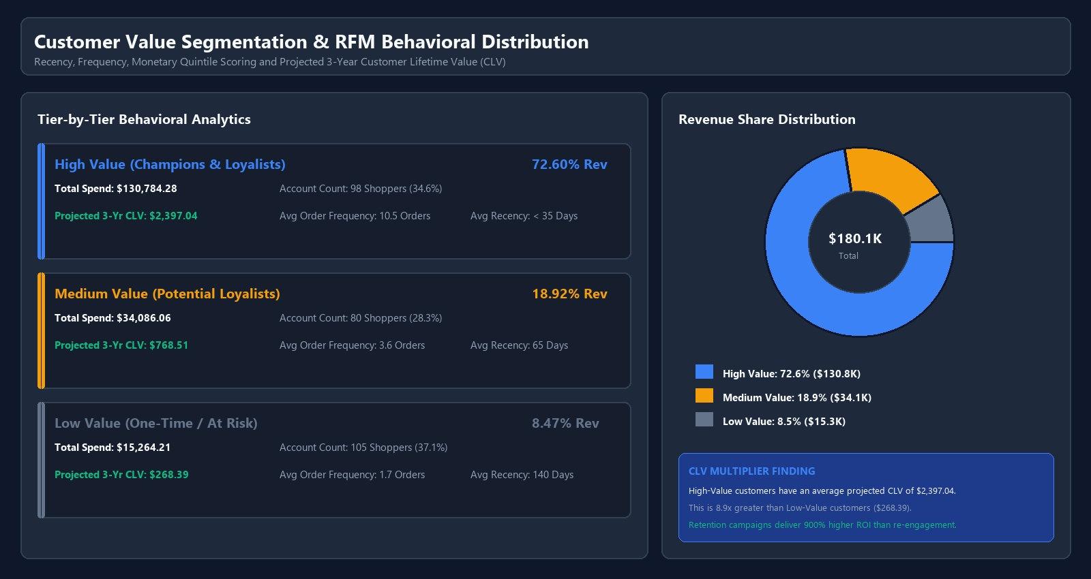
Customer Value Segmentation (RFM & CLV)

The interface reveals that High-Value accounts represent 34.6% of the customer base but generate 72.6% (,784.28) of total gross revenue, with an average projected 3-year CLV of ,397.04.

These metrics and charts support the comparison of vendor performance using available historical records.The alert module provides a centralized location for reviewing relevant delivery and risk notifications.
The time-series analytical interface provides a longitudinal view of monthly sales revenue, order volumes, and gross profit trajectories over a 15-month period. Figure 4.6 shows the monthly sales velocity and profitability trend interface.
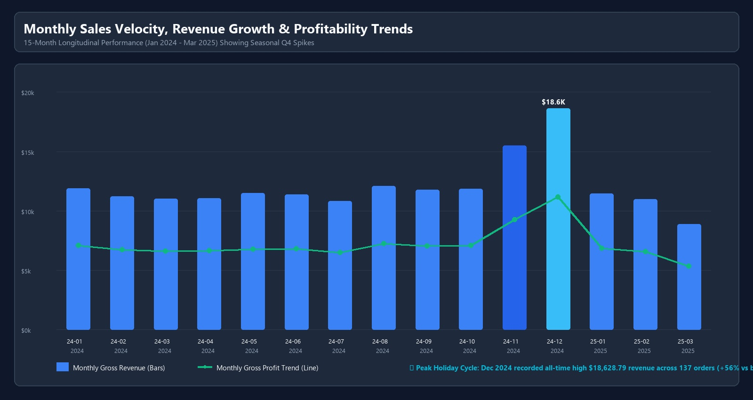
Monthly Sales Velocity & Profit Growth Trends

The figure illustrates monthly sales trends, highlighting the Q4 seasonal holiday surge where December 2024 recorded peak revenue of ,628.79 across 137 completed orders (+56% growth vs baseline).
The feedback module maintains information about vendor-related observations and evaluations. These records can help users understand vendor performance beyond delivery dates and quantities.
The compliance module supports the management of vendor compliance information. Where document expiry dates and monitoring logic are implemented, it can help identify documents that are expired or approaching expiry.
The customer accounts interface provides a ranked breakdown of top-tier accounts by cumulative spend, order frequency, and profit contribution. Figure 4.7 shows the top high-value customer accounts interface.

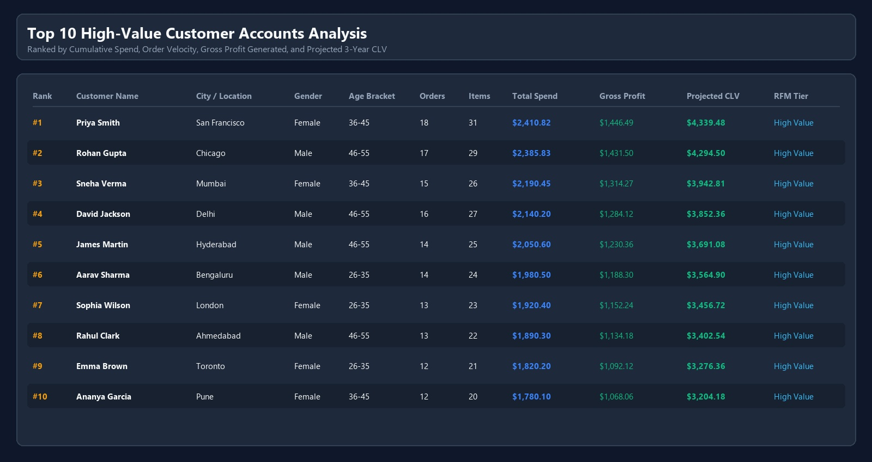
Top 10 High-Value Customer Accounts Analysis

The customer performance interface enables account managers to identify power buyers, monitor purchasing cadence, and deploy targeted VIP loyalty perks. Top accounts such as Priya Smith (,410.82) and Rohan Gupta (,385.83) demonstrate sustained repeat purchasing with over 15 completed transactions.
The Random Forest model should be evaluated using data that was not used during training. Suitable evaluation measures include accuracy, precision, recall, F1-score, and a confusion matrix.
The model’s actual results should be reported only after the evaluation is complete. If the training dataset contains sample or synthetic records, this limitation should also be stated.
Testing is essential to verify that the frontend, backend, database, and machine-learning service function correctly and communicate effectively. Table 4.2 presents the indicative test cases covering major system functionalities, including vendor management, purchase-order processing, delivery-risk prediction, quality evaluation, and performance monitoring. Each test case is designed to validate system responses, ensure accurate data processing, and identify potential errors during execution. Integration testing helps verify the smooth exchange of information between different modules, while functional testing ensures that individual features operate as expected. Systematic testing improves application reliability, accuracy, stability, and overall performance, ensuring that the proposed system meets its intended requirements.

Table 4.2 Indicative Test Cases

Test ID | Test Scenario | Expected Result
TC-01 | Import retail dataset | Dataset loads successfully
TC-02 | Check missing values | Missing values are identified
TC-03 | Remove duplicate records | Duplicate records are handled
TC-04 | Calculate total sales
  Correct sales value is displayed
TC-05 | Analyse customer segments | Customer groups are displayed correctly
TC-06 |  | Product-wise metrics are displayed
  View product performance
TC-07 | Apply dashboard filters | Visualizations update acc to filters
TC-08 |  | KPI values match the underlying data
  Verify KPI calculations
TC-09 |  | Sales trends are displayed for the selected period
  Review sales trends
TC-10 | Validate dashboard
  Charts summaries expected results

PROJECT MANAGEMENT PLAN
The project is divided into well-defined development stages to ensure systematic implementation, efficient resource utilization, and effective testing. Table 4.4 summarizes the major project phases, their activities, and expected deliverables. This phased approach enables the development and evaluation of individual modules before integrating them into the complete application. Regular testing and performance evaluation help identify technical issues, resolve errors, and ensure smooth communication between system components. Proper planning and documentation also support progress tracking and timely completion of development activities. Overall, this structured methodology improves project efficiency, system reliability, maintainability, and the quality of the final application.

Table 4.4: Project Management Plan

Phase | Activities | Expected Deliverable
Phase 1 | Requirement Analysis | Project requirements
Phase 2 | Dataset Collection | Retail dataset
Phase 3 | Data Cleaning and Preprocessing | Cleaned dataset
Phase 4 |  | Analytical results
  Data Analysis and KPI Calculation
Phase 5 | Dashboard Development
  Interactive dashboard
Phase 6 | Documentation | Final project report
The development process involves reviewing individual modules, resolving errors, and checking communication between the system components.

FINANCIAL REPORT ON ESTIMATED COSTING
The project can be developed using available computing resources, public or authorized retail datasets, and suitable data analytics software. Using free development tools and freely available datasets can reduce implementation costs. Additional expenses may arise from paid software licenses, cloud hosting, or other optional services. The total project cost depends on the tools selected and the resources required for implementation.

SOFTWARE TO OPERATIONS PLAN
The operational plan describes the steps required to prepare the dashboard for demonstration and use.

The following activities should be completed:
    - Prepare the retail dataset in the required format.
    - Verify the completeness and consistency of the data.
    - Execute the data preprocessing and analysis steps.
    - Validate the calculated customer and sales metrics.
    - Load the processed data into the dashboard.
    - Verify the charts, KPI cards, and interactive filters.
    - Check that the dashboard displays accurate information.
    - Save the project files and maintain a backup of the dataset.

LIMITATIONS OF THE PROJECT

The Retail Customer 360 Performance Dashboard has certain limitations:

The quality of the analysis depends on the accuracy and completeness of the dataset.

Missing or inconsistent records may affect the calculated metrics.

Customer segmentation depends on the selected variables and analytical methods.

Historical purchasing behaviour may not accurately represent future customer behaviour.

The insights are limited to the information available in the dataset.

Advanced predictions require suitable data and additional model development.

REFERENCES

[1] P. Kotler and K. L. Keller, Marketing Management, 15th ed. Pearson, 2016.
[2] J. Han, M. Kamber, and J. Pei, Data Mining: Concepts and Techniques, 3rd ed. Morgan Kaufmann, 2011.
[3] P. S. Fader, Customer Centricity: Focus on the Right Customers for Strategic Advantage. Wharton Digital Press, 2012.
[4] S. Few, Information Dashboard Design: Displaying Data for At-a-Glance Monitoring, 2nd ed. Analytics Press, 2013.
[5] R. Sharda, D. Delen, and E. Turban, Business Intelligence, Analytics, and Data Science: A Managerial Perspective, 4th ed. Pearson, 2018.
[6] F. Provost and T. Fawcett, Data Science for Business: What You Need to Know About Data Mining and Data-Analytic Thinking. O'Reilly Media, 2013.
[7] W. McKinney, Python for Data Analysis: Data Wrangling with pandas, NumPy, and Jupyter, 3rd ed. O'Reilly Media, 2022.
[8] S. Few, Show Me the Numbers: Designing Tables and Graphs to Enlighten, 2nd ed. Analytics Press, 2012.
[9] C. D. Manning, P. Raghavan, and H. Schütze, Introduction to Information Retrieval. Cambridge University Press, 2008.
[10] J. W. Tukey, Exploratory Data Analysis. Addison-Wesley, 1977.
[11] T. H. Davenport and J. G. Harris, Competing on Analytics: The New Science of Winning. Harvard Business School Press, 2007.
[12] I. H. Witten, E. Frank, M. A. Hall, and C. J. Pal, Data Mining: Practical Machine Learning Tools and Techniques, 4th ed. Morgan Kaufmann, 2016.

