Source PostgreSQL instance on EC2.

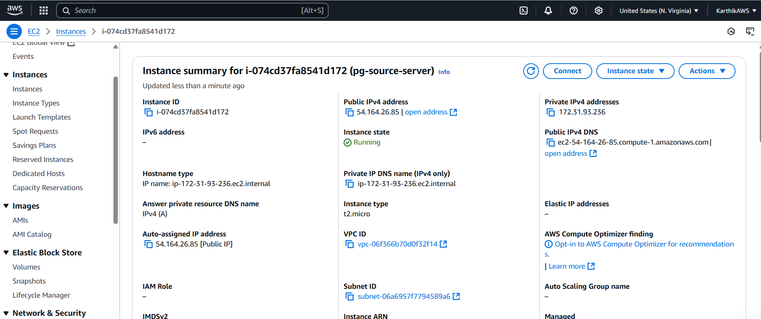

Connected to source PostgresSQL database, sampled, on EC2. List of 3 tables in the database, to be migrated.

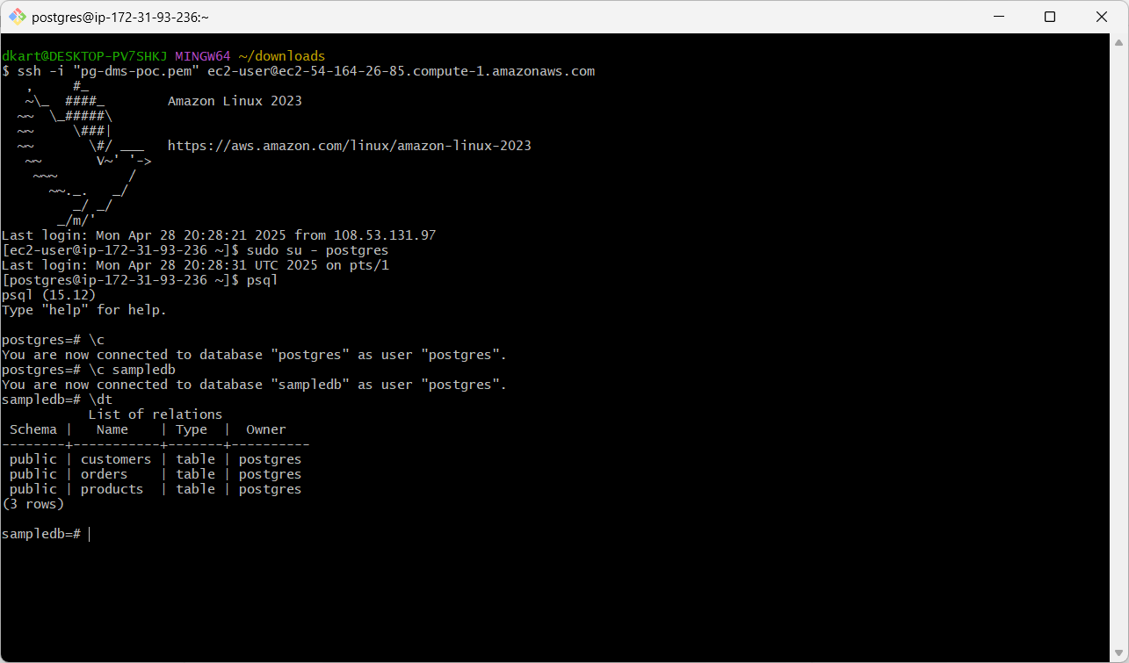

Data in the 3 tables, smapledb.

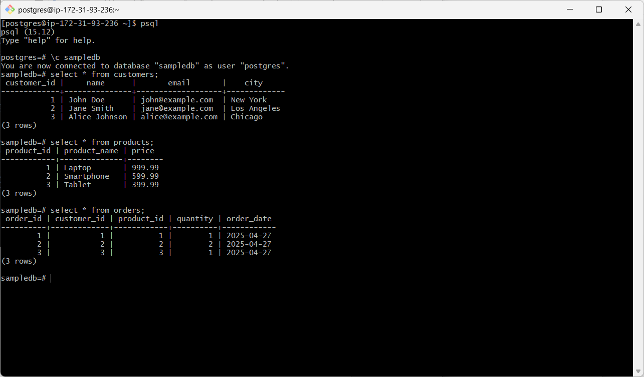

Target RDS PostgreSQL instance.

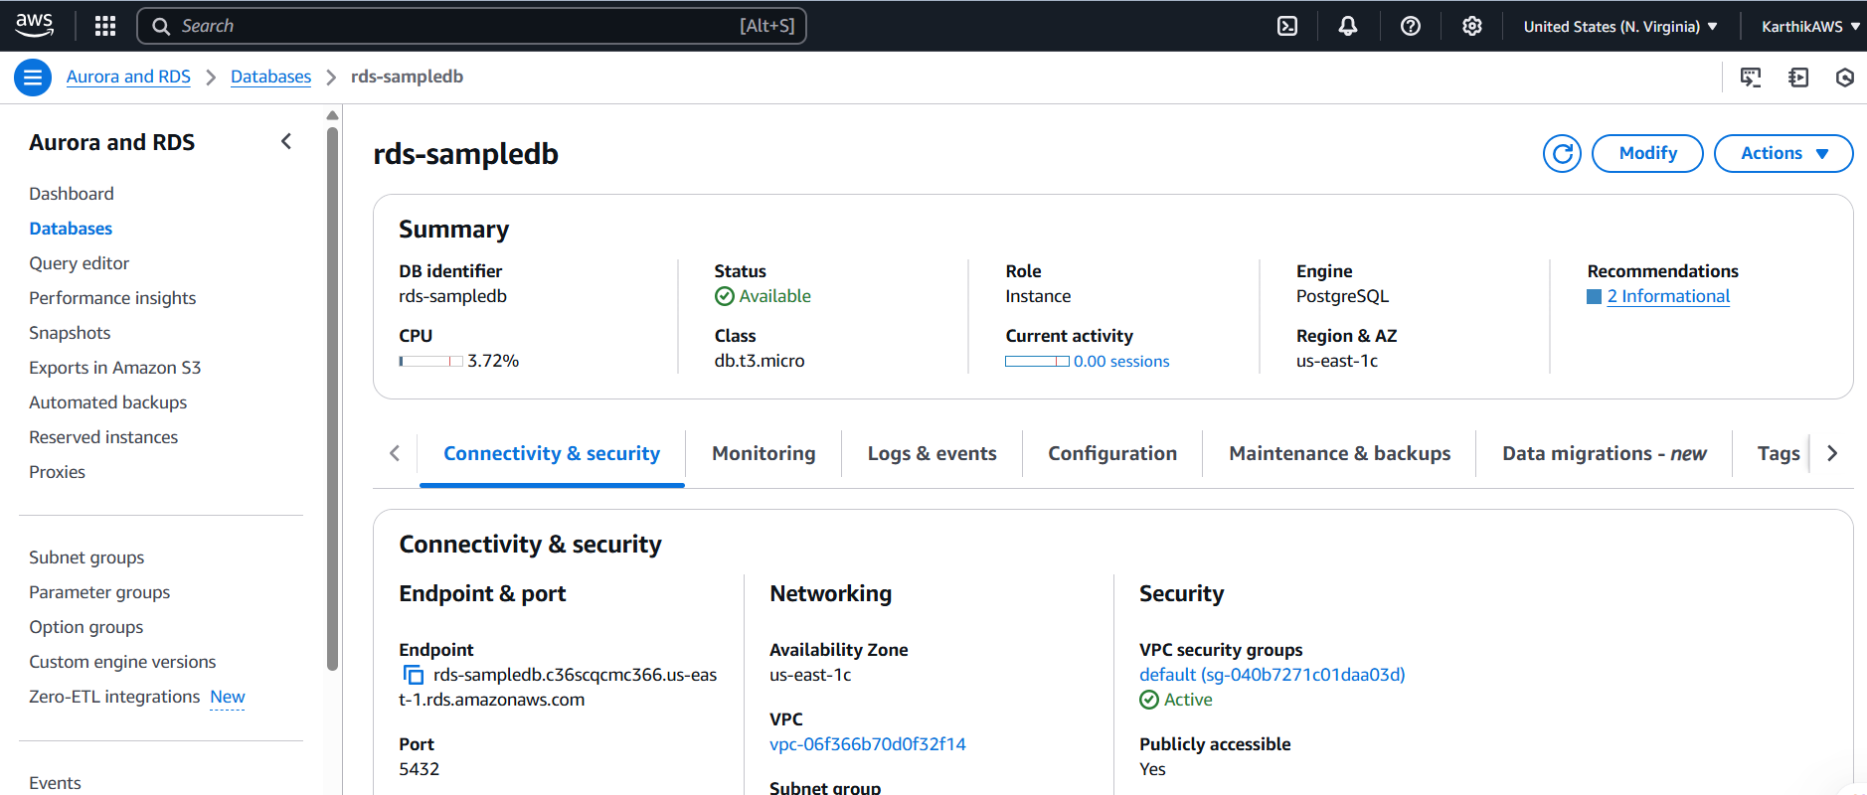

DMS replication instance.

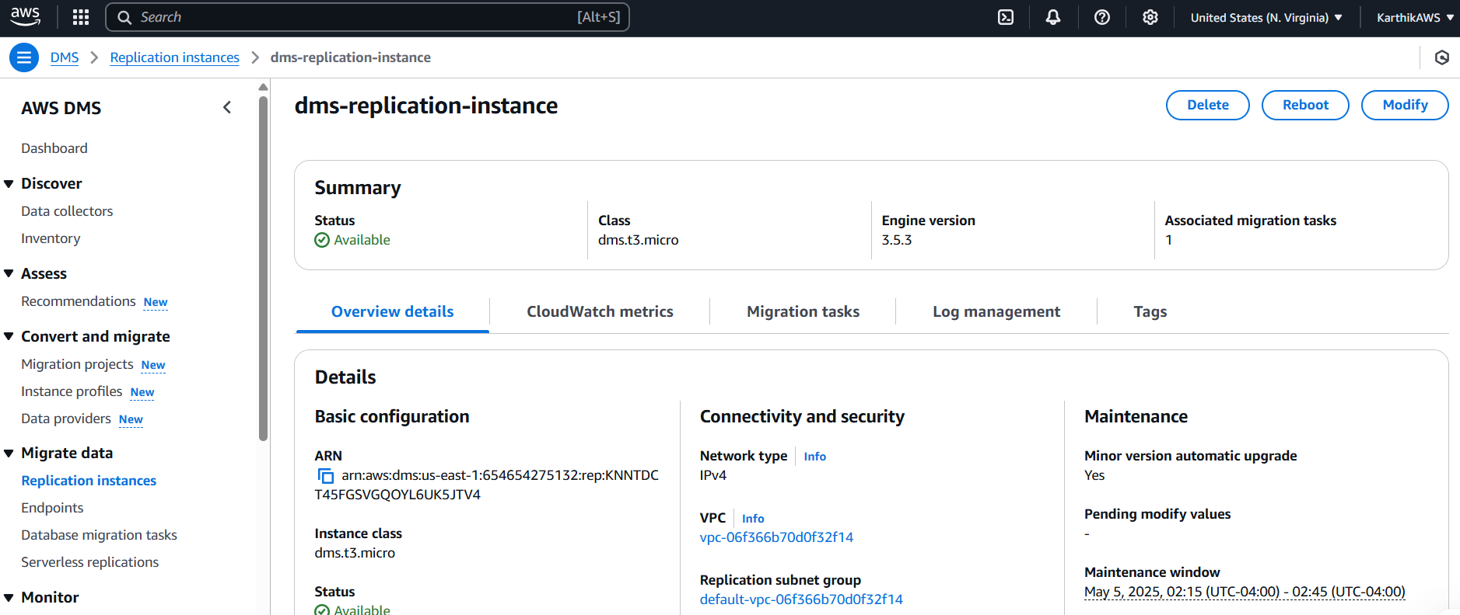

Source endpoint.

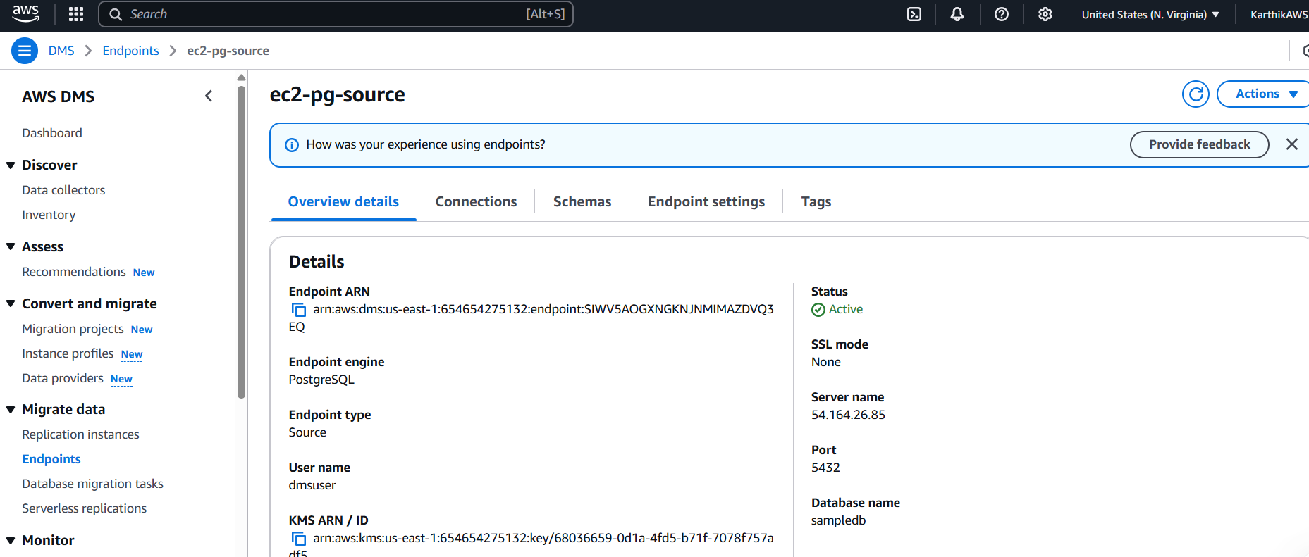

Target endpoint.

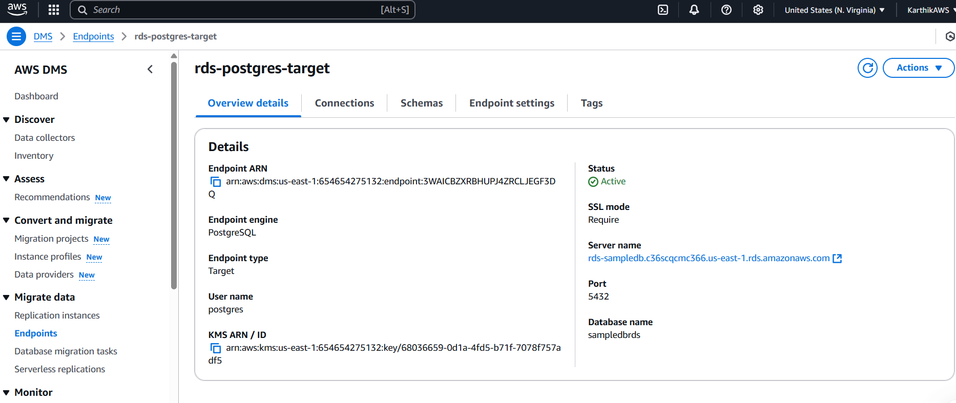

DMS migration task successfully completed.

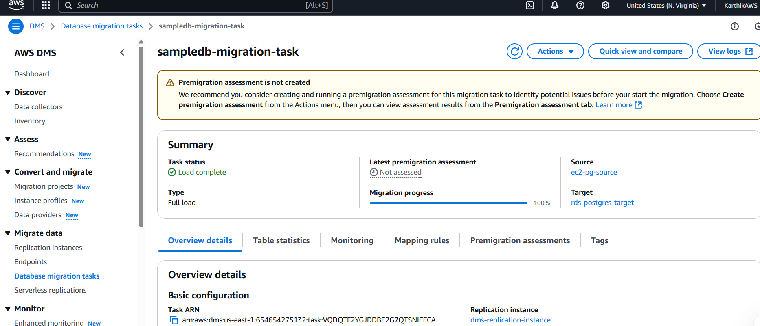

Data in the tables of target RDS PostgreSQL database after the migration.

