Tables on the source sampledb database.

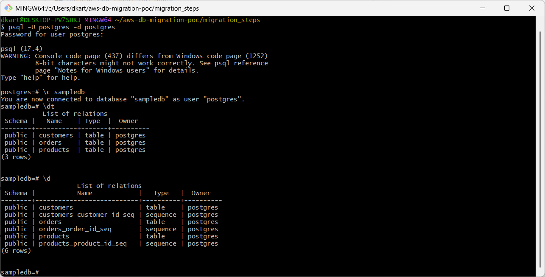

Tables definitions on the source sampledb database.

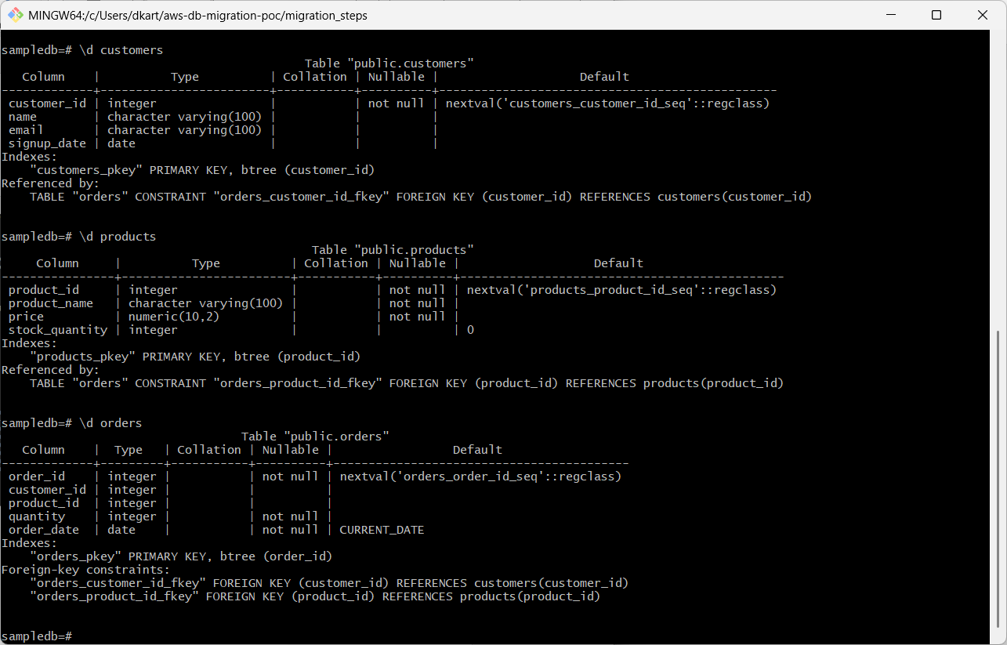

Data in the 3 tables in sampledb database on the source.

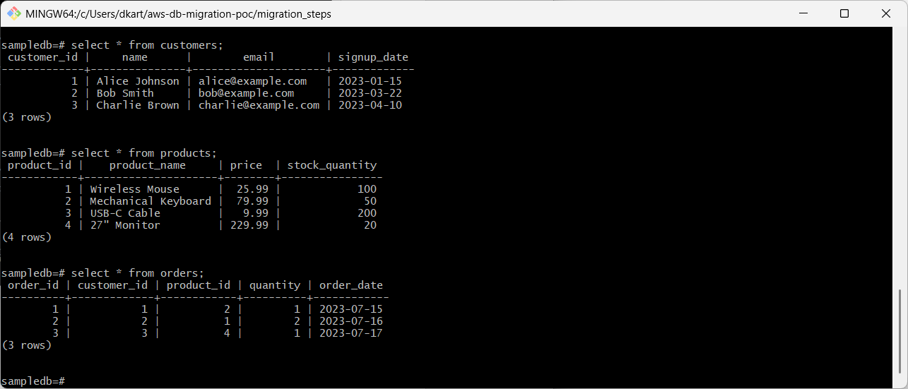

Create an RDS instance in AWS.

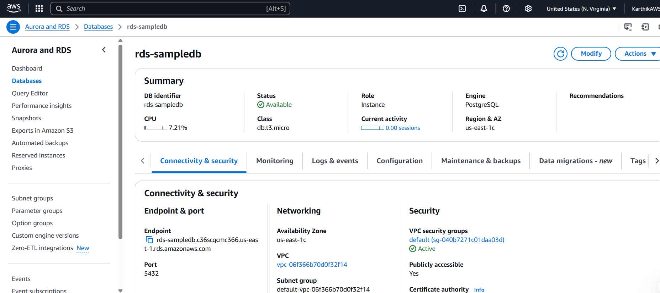

Added local public IP address for Inbound Security Group rules.

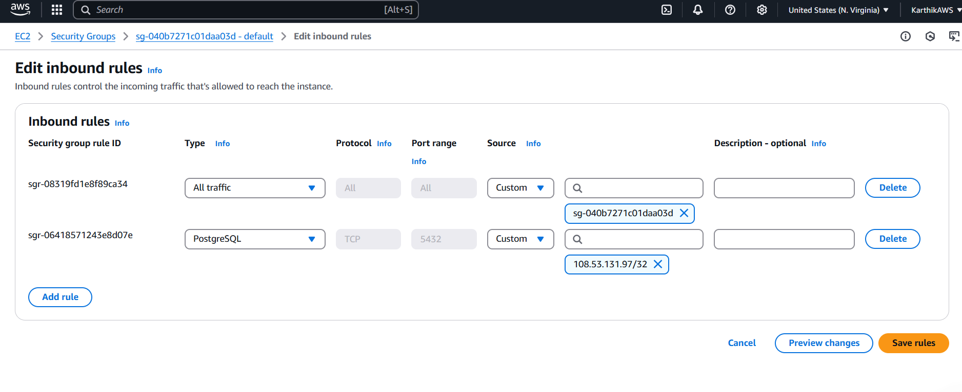

Generated dump of the sampledb database.

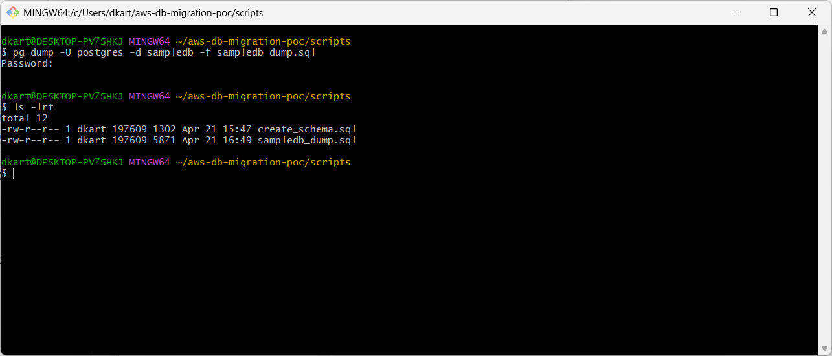

Created the new database sampledbrds on the AWS RDS instance.

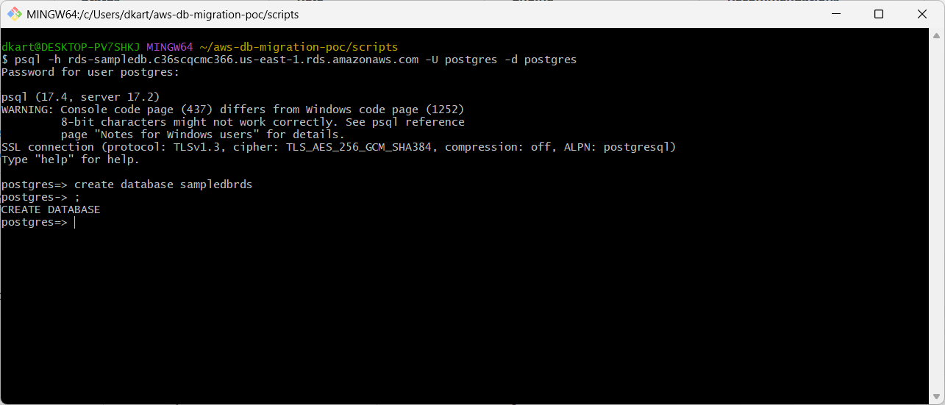

The dump script is deployed on the AWS sampledbrds RDS database.

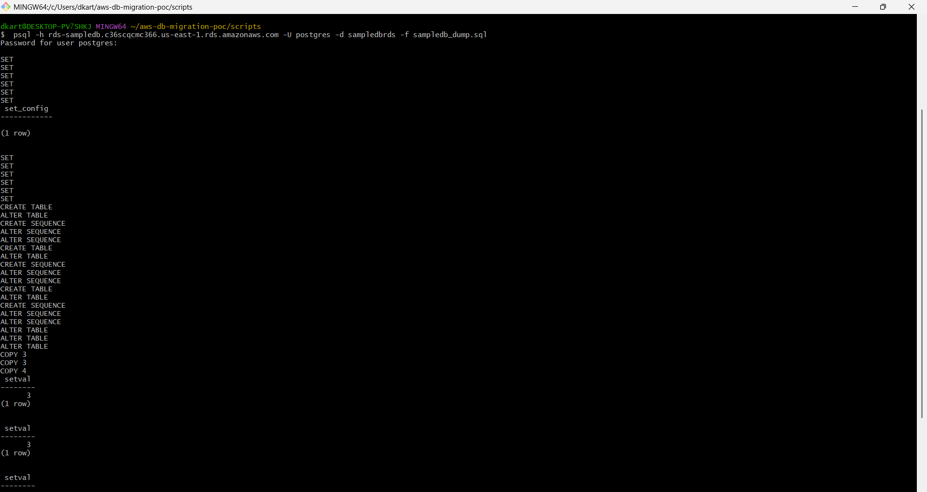

All the 3 tables now exist on sampledbrds RDS database.

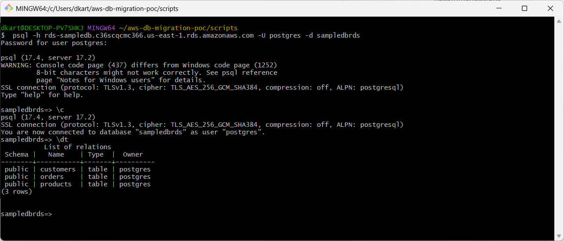

Tables definitions match between source sampledb and target sampledbrds RDS databases.

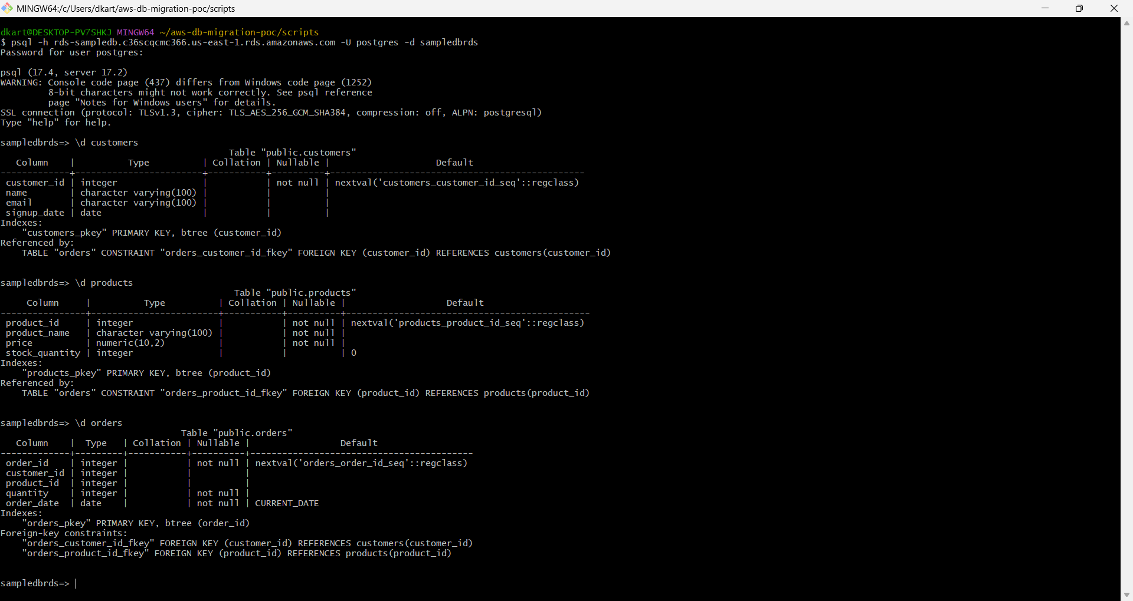

All the rows match between source sampledb and target sampledbrds RDS databases.

