Mine & Follow
Ankit Malhotra (axm125230@utdallas.edu), Santhosh Karthik Sanakkayala(sxs129531@utdallas.edu), Kaushik Sirineni(kxs124530@utdallas.edu), Venkata Mahesh Chinta (vxc121530@utdallas.edu)

Abstract— Using data mining techniques followed by Naïve Bayes classification, we look forward to find out Twitter users who are planning to take some New Year resolutions & suggest them with more ideas on what possible resolutions they can take. Also, we will identify those twitter users who have negative ideas about their resolutions and present them with a set of positive resolutions that they can take up.

Introduction
The project titled ‘Mine & Follow’ will mine into the tweet data of millions of Twitter users & look out for ‘relevant’ Twitter users who should be followed. The idea is to carry a sentimental classification of tweet data filtered against a bag of keywords. These keywords filter out only those tweets containing information about New Year resolutions taken by people. Sentiment classification of these tweets will bifurcate tweets & their corresponding tweeters as positive and negatives. The positivly classified tweeters would be presented with an extensive set of New Year resolution suggestions whereas negatively classified tweeters will be presented with a set of positive resolution suggestions. This task will be carried by a dummy twitter user (henceforth called as a ‘bot’). This idea benefits twitter users to be presented with an extensive set of ideas about their possible New Year resolution plans and also simultaneously extend the reachability of our bot to many Twitter users and gain popularity.
The overview of the project assignment can be summarized as in the Figure.
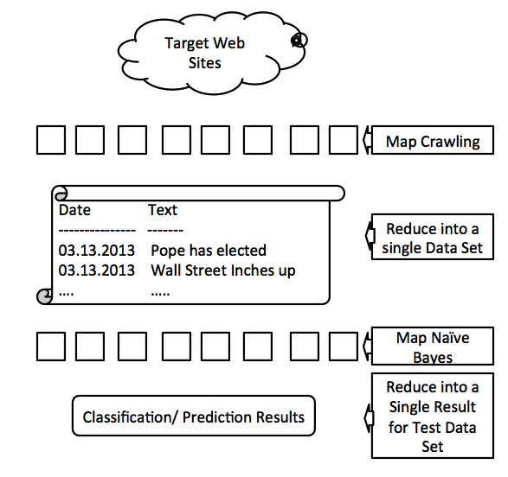

implementation plan

Knowledge Discovery Process

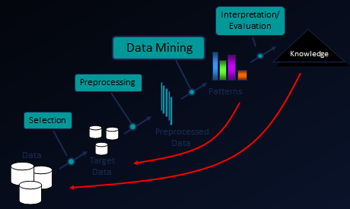

Selection of Data Source

First, selection of data source is done in Twitter dataset. Twitter dataset files are in JSON (JavaScript Object Notation) format. Sample data from Twitter input files. Size of the twitter dataset of Jan-2012 of 22.5 GB. The twitter data files contain tweets on people posting about New Year resolutions and New Year wishes from Dec 31 and throughout January. A Search for keywords like: new year, happy new year, resolution, resolutions, smoking, year, 2012, beginning, avenues, direction, ideas, changes, quit, give up etc. will help us in filtering out the relevant tweets of our interest. This complete twitter dataset is parsed & searched for above keywords. This forms one job task, which will be handled by Hadoop framework in a mapper phase.
The dataset we are using is a web-crawled data from Twitter website. This data has been extracted for the month of January 2012 and is in compressed JSON format. The size of this dataset is approx. 22.5 GB.

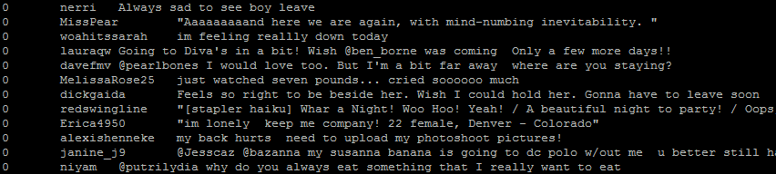

Distributed parsing
Reading and parsing of the JSON files dataset is done from the HDFS input directory, which has JSON files containing Tweet data. The mapper phase will map each keyword with a corresponding tweeter name and emit. The mapper will read JSON file per line and call the parsing routine which parses and returns tweeter name and the tweet along with a randomly assigned clas-label of either 0 or 4. The class-label, tweeter name & tweet are written to the mapper file as key-value pair, where class-label along with tweeter name form the combined key in this case.
The search keywords such as-‐ new year, happy new year, resolution, resolutions, smoking, year, 2012, beginning, avenues, direction, ideas, changes, quit, give up etc. are stored in the Distributed Cache [4] and distributed across each mapper job tasks. We apply the predicting keywords in the mapper phase, along with set of parsed tweets and store it in the ArrayList. These set of keywords help filtering those tweeters, who are talking about their new year resolution plans & would possibly like to receive more information on the same. The mapper will produce only those set of tweeter names & tweets who are talking about their new year resolution plans. We should not require any reducer in this phase, as the information within mapper will suffice our interest. This result set will form the test dataset for our NB classifier.

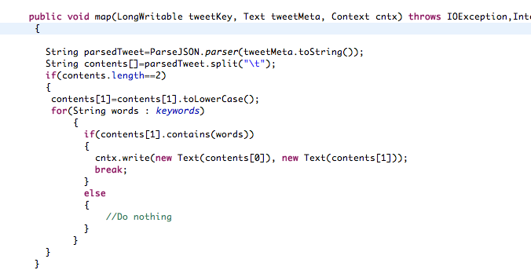

C. Sentimental Analysis using Mahout
Why use Mahout for classification?

Mahout can be used on a wide range of classification projects, but the advantage of Mahout over other approaches becomes striking as the number of training examples gets extremely large. Up to about 100,000 examples, other classification systems can be efficient and accurate. But generally, as
the input exceeds 1 to 10 million training examples, something scalable like Mahout is needed.

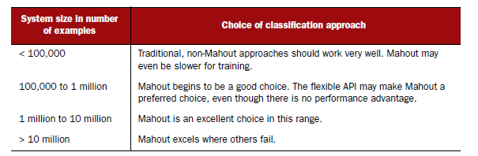

The reason Mahout has an advantage with larger data sets is that as input data increases, the time or memory requirements for training may not increase linearly in a non-scalable system. In general, the classification algorithms in Mahout require resources that increase no faster than the number of training or test examples, and in most cases the computing resources required can be parallelized. This allows you to trade off the number of computers used against the time the problem takes to solve.
How classification works?
Classification algorithms are at the heart of what is called predictive analytics. The goal of predictive analytics is to build automated systems that can make decisions to replicate human judgment. Classification algorithms are a fundamental tool for meeting that goal.
There are two main phases involved in building a classification system: the creation of a model produced by a learning algorithm, and the use of that model to assign new data to categories. The selection of training data, output categories (the targets), the
algorithm through which the system will learn, and the variables used as input are key choices in the first phase of building the classification system.
The basic steps in building a classification system are illustrated in below figure. The figure shows two phases of the classification process: the upper path represents the training of the classification model; the lower path provides new examples to the model, which will assign categories (the target variables) as a way to emulate decisions. Input for the training algorithm consists of example data labeled with known target variables. The target variables are, of course, unknown to the model when using new examples during production. In evaluation, the value of the target variable is known, but it won’t be given to the model.
For testing, which isn’t shown explicitly in below figure, new examples that were withheld from the training data are presented to the model. The results chosen by the model are compared to known answers for the target variables in order to evaluate the model’s performance.
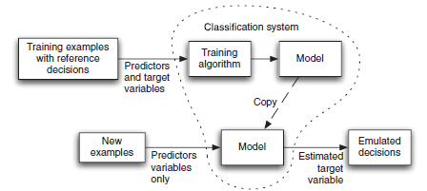

Terminology for the key ideas in classification.
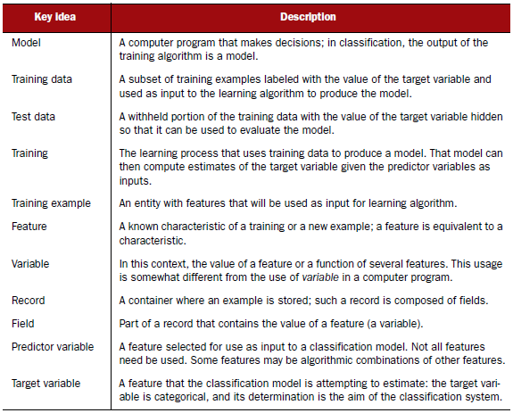

Classification using Naïve Bayes
We are implementing the simplest text classification algorithm “Naïve Bayes”. [2]
The algorithm works by using a training set which is a set of documents already associated to a category. Using this set, the classifier determines for each word, the probability that it makes a document belong to each of the considered categories. To compute the probability that a document belongs to a category, it multiplies together the individual probability of each of its word in this category. The category with the highest probability is the one the document is most likely to belong to.
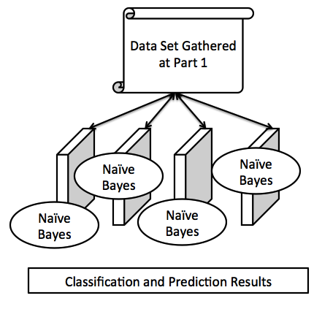
Training a Classifier
Raw data must be collected and preprocessed to turn it into classifiable training data [3]. Once the raw data has been preprocessed into classifiable form i.e in text format predictor and target variables are encoded them as vectors, the input required by Mahout classifier algorithms.

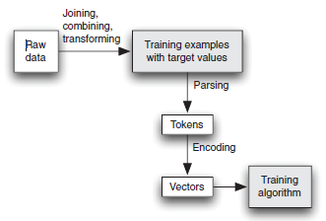

Data Pre-processing
Step1: Text Data is converted into Sequential File Format
. A Sequence File contains a binary encoding of an arbitrary number key-value pairs. Our training/test dataset is converted into .txt format and this is used to create sequence files in Mahout.
Java -cp target/twitter-naive-bayes-example-1.0-jar-with-dependencies.jar com.chimpler.example.bayes.TweetTSVToSeq data/trainingsplittab.txt tweets-seq

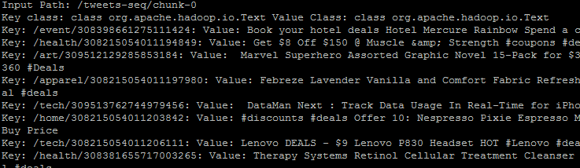

Step2: Creating TF-IDF weighted vectors from Sequential Files
We run mahout to transform the training sets into vectors using TF-IDF(Term frequency * Inverse of Document Frequency)

/usr/local/mahout-0.7/bin/mahout seq2sparse -i /tweets-seq -o tweets-vectors -ow -chunk 100
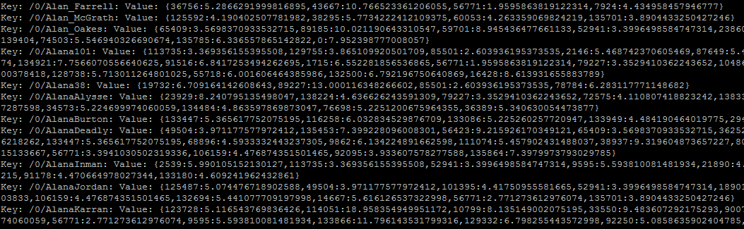

Step3: Splitting to train and Test Set
In order to do the training and check that the classification works fine, Mahout splits the set into two sets: a training set and a testing set. Splitting 60% for Training the model and 40% for testing.

/usr/local/mahout-0.7/bin/mahout split -i tweets-vectors/tfidf-vectors --trainingOutput train-vectors --testOutput test-vectors --randomSelectionPct 40 --overwrite --sequenceFiles -xm sequential

Step4: Training the Naïve Bayes classifier
We train a classifier using Mahout which will classify tweets as positive or negative. We train a naïve bayes classifier using training dataset from Sentiment140. The dataset consists of tweeter name, tweet and a class label (0: negative, 4: positive) in tab separated format.

/usr/local/mahout-0.7/bin/mahout trainnb -i train-vectors –el -li labelindex -o model -ow -c

Step5: Testing classifier is working on training set
To test that the classifier is working properly on the training set.

/usr/local/mahout-0.7/bin/mahout testnb -i train-vectors -m model -l labelindex -ow -o train-testing –c

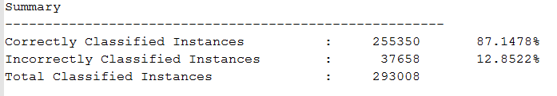

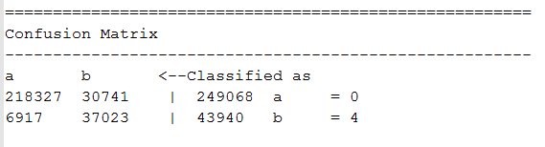
After training is successful, we test the classifier using the output from the mapper phase.

interpretation and evaluation

Mahout will classify a set of tweeter names and tweets as positive or negative. This set of tweeter names will be followed by a dummy twitter bot which will suggest an expanded set of new year resolutions to those twitter users who have been classified as positive by our classifier. It will suggest a set of positive resolutions to those twitter users which are classified as negative by our classifier.

IV FINAL RESULTS

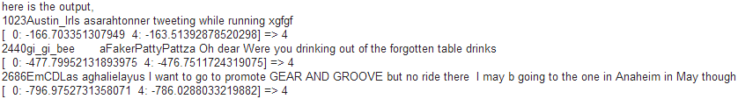

references

[1] Mahout in Action by Sean Owen, Robin Anil, Ted Dunning, and Ellen Friedman. Young.
[2] Using the Mahout Naive Bayes Classifier to automatically classify Twitter messages
http://chimpler.wordpress.com/2013/03/13/using-the-mahout-naive-bayes-classifier-to-automatically-classify-twitter-messages/
[3] Sentiment140
http://help.sentiment140.com/for-students
[4] Data-Intensive Text Processing with MapReduce by Jimmy Lin & Chris Dyer
http://lintool.github.io/MapReduceAlgorithms/MapReduce-book-final.pdf

