Design an OpenVINO-Powered Smart Agriculture Solution for Crop Disease Detection Using Edge Cameras and Evaluate Field Deployment Feasibility

Tomato leaf disease classification (Healthy, Early Blight, Late Blight) with MobileNetV3-Small, OpenVINO CPU inference and a Streamlit application

Submitted by
[Student name(s)] : K Karthik
[Register / roll number(s)] : 12308818
submitted to: Dr. Diwakar

[Institution name] : Lovely Professional University
October 2026

Abstract
Foliar diseases such as early blight and late blight reduce tomato yields, and timely, low-cost recognition of symptoms is valuable to growers. This project develops and evaluates an AI-based tomato leaf disease classifier designed for efficient CPU inference, and assesses how close such a system is to deployment on edge cameras in agriculture.
A MobileNetV3-Small network with pretrained weights was fine-tuned in PyTorch on 3,592 PlantVillage tomato images in three classes (Healthy, Early Blight, Late Blight), using a 15% validation split and five epochs. The best validation accuracy was 98.88%, and the model reached 98.68% accuracy on 908 independent test images. The model was converted to OpenVINO Intermediate Representation and reached 98.46% on the same test images. In a separate CPU benchmark on 102 selected test images, OpenVINO achieved an average latency of 1.61 ms against 4.30 ms for PyTorch, a speed ratio of 2.67× and a latency reduction of about 62.6%. A Streamlit application lets a user upload a leaf image and view the predicted class, the confidence, the inference latency and all class scores, with a warning that the output is not a confirmed diagnosis.

Recorded terminal output: MobileNetV3-Small training across five epochs.
All work was done on a laptop with a public image dataset. No field images, physical camera, edge device, power measurement or end-to-end timing were used, so the results show technical promise but not field readiness. The report discusses the challenges of real farm conditions and proposes a field validation plan.
Keywords: Edge AI; OpenVINO; MobileNetV3-Small; transfer learning; tomato leaf disease; early blight; late blight; CPU inference; Streamlit; smart agriculture

Table of Contents

List of Figures
Figure 1 System architecture of the implemented prototype
Figure 2 Data and experiment pipeline from dataset to future field validation
Figure 3 Directory structure of the smart_agriculture_edge project [placeholder]
Figure 4 Sample PlantVillage tomato leaf images: Healthy, Early Blight and Late Blight [placeholder]
Figure 5 Training and validation accuracy per epoch (plotted from the recorded values)
Figure 6 Training and validation loss per epoch (plotted from the recorded values)
Figure 7 Confusion matrix of the PyTorch model on the 908 test images [placeholder]
Figure 8 Terminal output of the PyTorch to OpenVINO IR conversion [placeholder]
Figure 9 Terminal output of the OpenVINO functional test [placeholder]
Figure 10 Terminal output of a real-image OpenVINO prediction [placeholder]
Figure 11 OpenVINO confusion matrix plotted from the values in the table above
Figure 12 Average and median CPU latency for PyTorch and OpenVINO (102 images)
Figure 13 Terminal output of the CPU benchmark comparing PyTorch and OpenVINO [placeholder]
Figure 14 Home screen of the Streamlit crop disease detection application [placeholder]
Figure 15 Streamlit result screen with the prediction Healthy
Figure 16 Streamlit result screen with the prediction Early Blight
Figure 17 Streamlit result screen with the prediction Late Blight
Figure 18 Sample tomato leaf photographs used for informal testing (file names as supplied)
Figure 19 Proposed future edge camera deployment architecture (conceptual; not implemented)

List of Tables
Table 1 Implemented work versus work that was not performed
Table 2 Known development environment
Table 3 Tools, their purpose and their use in this project
Table 4 Purpose of the listed project files
Table 5 Number of images per class in the training and test sets
Table 6 The three quantitative experiments and their purpose
Table 7 Key training terms as used in this project
Table 8 Training configuration
Table 9 Recorded training and validation results per epoch
Table 10 PyTorch classification report on the test set
Table 11 Approximate sizes of the model files
Table 12 OpenVINO classification report on the test set (908 images)
Table 13 OpenVINO confusion matrix (rows: actual, columns: predicted)
Table 14 PyTorch and OpenVINO results on the 908 test images
Table 15 CPU benchmark results on 102 selected test images
Table 16 Features implemented in the supplied application code
Table 17 Processing steps from upload to displayed result
Table 18 Values displayed in the three captured result screens
Table 19 Common problems and what to check
Table 20 Summary of all recorded results
Table 21 Local (edge) processing compared with cloud processing
Table 22 Possible deployment platforms. None has been tested.
Table 23 Challenges for field deployment and possible responses
Table 24 What exists now compared with what a field system would require
Table 25 Metrics for field validation
Table 26 Feasibility assessment based on the evidence available
Table 27 Limitations, why they matter and how to address them
Table 28 Proposed future work (not implemented)
Table 29 Status of every figure in this report
Table 30 Derived quantities and their calculation

1. Introduction

1.1 Background
Tomato is a widely cultivated vegetable crop, and its leaves are often the first place where disease becomes visible. Two of the most economically important foliar diseases are early blight, caused by the fungus Alternaria solani, and late blight, caused by the oomycete Phytophthora infestans. Early blight typically produces dark lesions with concentric rings, whereas late blight produces water-soaked, dark patches that can spread quickly in cool, humid weather. Because the two diseases call for different management decisions, distinguishing them from a healthy leaf, and from each other, is useful to growers.
Traditional monitoring depends on trained people walking the field and judging symptoms by eye. This is slow, subjective and difficult to scale. Deep learning has become a practical way to automate image-based recognition in agriculture [1], and images can in principle be captured by inexpensive cameras. Running the model close to the camera, known as edge computing [2], can reduce the need to transmit images to a remote server and allows the system to respond locally, even when connectivity is poor.
This project develops a tomato leaf disease classifier based on a lightweight convolutional neural network, converts it to the OpenVINO Intermediate Representation (IR) format, measures how it behaves on a CPU, and wraps it in a Streamlit web application. It then analyses what would be required to move such a system from a laptop prototype to edge cameras in the field.

1.2 Scope: What Was Done and What Was Not
To avoid overstating the work, the scope is stated explicitly. The current implementation was developed and tested on a laptop using an image dataset. No agricultural camera, Raspberry Pi, Intel NPU or physical field deployment was used.
Table 1: Implemented work versus work that was not performed
Implemented and measured | Not performed (future work)
Dataset preparation for three tomato classes | Collection or testing of real field images
MobileNetV3-Small training with PyTorch on an NVIDIA GPU | Integration of a physical edge camera
PyTorch evaluation on 908 test images | Deployment on Raspberry Pi, Intel NPU or other edge hardware
Conversion to OpenVINO IR and evaluation on the same 908 images | Power, energy, memory or thermal measurements
CPU latency benchmark (PyTorch vs OpenVINO) on 102 images | Camera-to-prediction (end-to-end) timing and network latency
Streamlit image-upload application running on the laptop | Live video or camera-stream processing

1.3 Organisation of the Report
Chapters 2 to 4 define the problem, objectives and related work. Chapters 5 to 7 describe the environment, tools and architecture. Chapters 8 to 16 cover the dataset, methodology, model, training, evaluation, conversion, benchmarking and application. Chapter 17 is a step-by-step execution guide. Chapters 18 to 22 present results, field-deployment feasibility, limitations, future scope and conclusions. References and appendices follow.

2. Problem Statement
Farmers and agronomists need a fast, low-cost way to recognise early and late blight in tomato plants before they spread. Manual scouting is subjective and labour intensive, while cloud-based image analysis depends on connectivity that may be unreliable in rural areas. The problem addressed here is to build and evaluate a compact image classifier that can run efficiently on a CPU, and to judge honestly how far a laptop-based prototype is from a deployable edge system.
The project is organised around five questions:
- Can a lightweight MobileNetV3-Small model classify Healthy, Early Blight and Late Blight tomato leaf images accurately on a held-out test set?
- Does conversion to OpenVINO IR preserve classification accuracy?
- How does OpenVINO CPU inference latency compare with PyTorch CPU inference latency?
- Can the model be presented through a simple interface that reports the prediction, confidence and latency, while warning users about its limits?
- What evidence is still needed before the system can be considered for field deployment on edge cameras?

3. Objectives
- Develop a deep-learning-based tomato leaf disease classification system.
- Prepare and organise a dataset containing three tomato leaf classes.
- Train a lightweight MobileNetV3-Small model using PyTorch.
- Evaluate the model using classification metrics.
- Convert the trained model into OpenVINO IR format.
- Evaluate the accuracy of the OpenVINO model.
- Compare PyTorch CPU inference performance with OpenVINO CPU inference performance.
- Build an interactive crop disease detection application using Streamlit.
- Investigate the feasibility of deploying the system on edge computing devices and agricultural cameras.
- Identify limitations and propose improvements for real-world agricultural deployment.

4. Literature Review

4.1 Image-Based Plant Disease Recognition
The PlantVillage project released a large open-access collection of labelled leaf images to support mobile disease diagnostics [3]. Mohanty et al. trained deep convolutional networks on this collection and reported high accuracy on a held-out test set, while also showing that accuracy fell considerably when the model was tested on images taken under conditions different from the training data [4]. This gap between controlled-image accuracy and real-world accuracy is a recurring theme in the literature; Barbedo, for example, examined how dataset size and variety affect plant disease classification [5]. Surveys of deep learning in agriculture likewise identify data variability and limited field validation as open challenges [1]. These findings directly shape the cautious interpretation used throughout this report.

4.2 Efficient Convolutional Networks
Convolutional neural networks learn visual features directly from pixels and have driven recent progress in image recognition [6]. For devices with limited compute, the MobileNet family was designed to reduce computation and parameters. MobileNetV1 introduced depthwise separable convolutions [7]; MobileNetV2 added inverted residuals and linear bottlenecks [8]; and MobileNetV3 combined hardware-aware neural architecture search with squeeze-and-excitation blocks and the hard-swish activation, offering Large and Small variants [9]. MobileNetV3-Small targets the most resource-constrained settings.

4.3 Transfer Learning
Transfer learning reuses knowledge learned on a source task to improve learning on a target task [10]. In computer vision it is common to start from a network pretrained on ImageNet [11] and adapt it to a new, smaller dataset. This reduces the data and training time needed and is the approach used here.

4.4 Edge Computing and Edge AI
Edge computing moves computation closer to where data is generated, with the aim of reducing latency and bandwidth use and supporting operation when connectivity is limited [2]. For agriculture, this suggests running disease recognition on a device near the camera instead of streaming every image to a remote server.

4.5 Inference Optimisation with OpenVINO
OpenVINO is an open-source toolkit for optimising and deploying deep-learning inference. It converts models from frameworks such as PyTorch into an Intermediate Representation and runs them through a runtime that targets devices such as CPUs and integrated GPUs, subject to hardware and driver support [12]. This project evaluates that workflow on CPU.

4.6 Positioning of This Work
This project does not claim a new architecture or a state-of-the-art result. Its contribution is a documented, reproducible pipeline from dataset to a CPU-optimised model and web interface, together with an explicit assessment of what has and has not been demonstrated for field use.

5. System Requirements

5.1 Development Environment
Table 2: Known development environment
Item | Specification | Note
Operating system | Ubuntu Linux | Exact Ubuntu release was not recorded
Computer | Dell G15 5520 laptop | CPU model and RAM were not recorded
GPU | NVIDIA GeForce RTX 3050 Laptop GPU | Used for training only
Language | Python 3.14 | Virtual environment .venv
Deep-learning framework | PyTorch 2.14.1+cu130 | CUDA build used for GPU training
Vision library | torchvision 0.29.1+cu130 | Model definition and transforms
Inference runtime | OpenVINO 2026.4.1 | Available devices: CPU and GPU
Web framework | Streamlit 1.66.1 | Application served at localhost:8501
Other libraries | NumPy, Pillow, scikit-learn | Array handling, image loading, metrics

5.2 Training Device versus Benchmark Device
Important distinction. Model training used the NVIDIA GPU. The CPU benchmark executed both PyTorch and OpenVINO on the CPU. The benchmark is therefore a CPU-to-CPU comparison and must not be described as a GPU comparison. Although OpenVINO reported a GPU device as available, no GPU inference benchmark is reported in this work.

5.3 Information That Should Be Recorded
Latency results depend strongly on the processor, thread count, power mode and background load. For reproducibility, future runs should record the exact CPU model, number of cores and threads, RAM, Ubuntu release, laptop power profile and OpenVINO performance settings. These were not captured for the reference results, so the reported latencies should be treated as specific to this laptop.

6. Tools and Technologies
Table 3: Tools, their purpose and their use in this project
Tool | Purpose | Use in this project
Ubuntu Linux | Operating system | Host environment for development and execution
Dell G15 5520 + RTX 3050 Laptop GPU | Computing hardware | GPU for model training; CPU for inference benchmarking
Python 3.14 and .venv | Programming language and isolated environment | Runs all scripts; keeps dependencies separate from the system
PyTorch [13], [14] | Deep-learning framework | Model training, validation and the PyTorch baseline for evaluation and benchmarking
torchvision [15] | Vision models and transforms | Pretrained MobileNetV3-Small; image resizing and normalisation
OpenVINO [12] | Inference toolkit | IR conversion, CPU compilation, OpenVINO evaluation, benchmarking and the web app
Streamlit [16] | Python web-app framework | Upload interface showing class, confidence and latency
NumPy | Numerical arrays | Processing model outputs (for example scores to class probabilities)
Pillow | Image I/O | Loading uploaded and dataset images; RGB conversion
scikit-learn [17] | Machine-learning utilities | Classification report and confusion matrix (as reported; verify in the evaluation scripts)
Hugging Face dataset repository [18] | Dataset source | Source of the tomato leaf images (geraldmc/plantvillage-full, revision v0.1.0)

7. System Architecture

7.1 Software Architecture
Figure 1 shows how a leaf image flows through the implemented system. The image is preprocessed, classified by a MobileNetV3-Small network that was trained in PyTorch and exported to OpenVINO IR, and the OpenVINO runtime executes it on the CPU. The Streamlit interface presents the result.
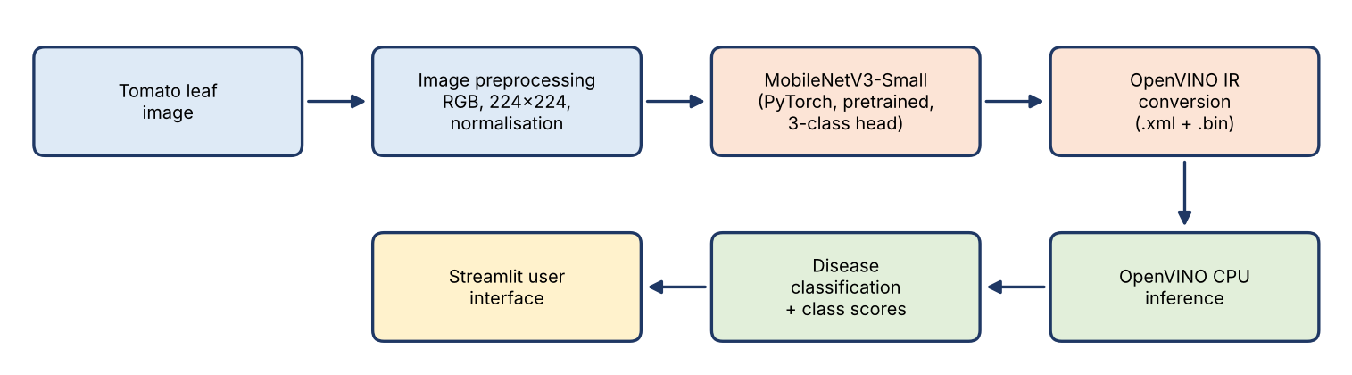
Figure 1: System architecture of the implemented prototype

7.2 Experimental Pipeline
Figure 2 shows the sequence of experiments. The last block, field validation, is drawn dashed because it has not been performed.
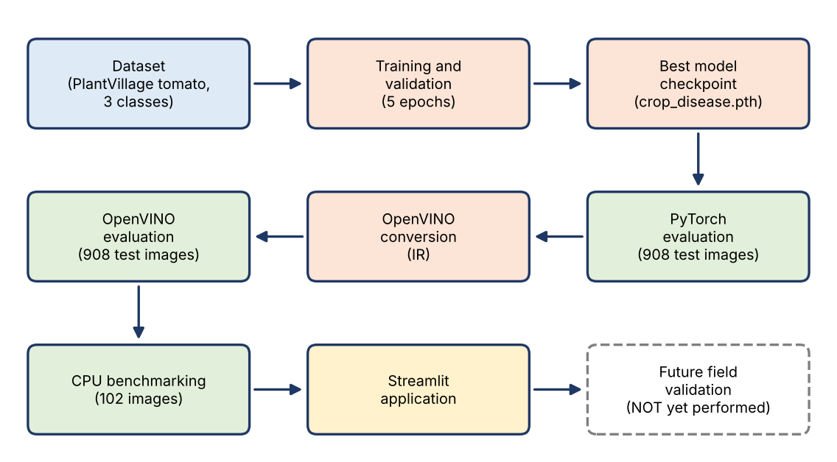
Figure 2: Data and experiment pipeline from dataset to future field validation

7.3 Project Directory Structure
smart_agriculture_edge/
|-- dataset/
| |-- train/ (Healthy/, Early_Blight/, Late_Blight/)
| `-- test/ (Healthy/, Early_Blight/, Late_Blight/)
|-- models/
| |-- pytorch/ (crop_disease.pth, classes.json)
| `-- openvino/ (crop_disease.xml, crop_disease.bin)
|-- src/
| |-- prepare_dataset.py |-- train_model.py
| |-- evaluate_model.py |-- convert_model.py
| |-- test_openvino.py |-- predict_openvino.py
| |-- evaluate_openvino.py |-- benchmark_cpu.py
| `-- app.py
`-- results/
|-- training_history.json |-- test_metrics.json
|-- confusion_matrix.png |-- openvino_test_metrics.json
`-- cpu_benchmark.json

Figure 3: Directory structure of the smart_agriculture_edge project [placeholder]

7.4 Purpose of Each File
The purposes below are stated from the file names and the workflow described in the project brief. The source code of these scripts was not supplied for inspection, so internal implementation details (for example, the optimiser or the exact timing procedure) are deliberately not asserted.
Table 4: Purpose of the listed project files
File | Purpose
prepare_dataset.py | Loads the PlantVillage data, selects the three tomato classes and writes the train and test folders
train_model.py | Trains MobileNetV3-Small (pretrained) with a 15% validation split; saves the checkpoint and training history
evaluate_model.py | Evaluates the PyTorch model on the 908 test images; writes test_metrics.json and confusion_matrix.png
convert_model.py | Converts the PyTorch model to OpenVINO IR (.xml and .bin)
test_openvino.py | Functional test: loads and compiles the IR model for CPU and checks output shape with a dummy input
predict_openvino.py | Predicts the class of a single real image using the OpenVINO model
evaluate_openvino.py | Evaluates the OpenVINO model on all 908 test images; writes openvino_test_metrics.json
benchmark_cpu.py | Compares PyTorch CPU and OpenVINO CPU latency on 102 selected images; writes cpu_benchmark.json
app.py | Streamlit application for uploading a leaf image and viewing the prediction
crop_disease.pth | Trained PyTorch checkpoint (about 6 MB)
classes.json | Class labels used to map output indices to names
crop_disease.xml / .bin | OpenVINO graph description (about 155 KB) and weights (about 5.8 MB)
training_history.json | Per-epoch training and validation loss and accuracy
test_metrics.json, openvino_test_metrics.json, cpu_benchmark.json | Saved numerical results of the three evaluations
confusion_matrix.png | Confusion matrix image for the PyTorch model

Additional generated files may exist in the project folders.

8. Dataset Preparation

8.1 Data Source and Loading
The images were loaded from the Hugging Face dataset repository geraldmc/plantvillage-full, revision v0.1.0 [18]. PlantVillage is an open collection of labelled plant leaf images [3]. All images used here have a size of 256 × 256 pixels. The preparation script loads the data, filters the tomato images belonging to the three target categories, and writes them into class-named folders under dataset/train and dataset/test.

8.2 Class Selection and Folder Creation
Only three tomato categories were retained: Healthy, Early Blight and Late Blight. The folder name of each image is its label, which is the format expected by common PyTorch image-folder loaders and keeps the labels visible and auditable.

8.3 Class Distribution
Table 5: Number of images per class in the training and test sets
Class | Training | Test | Total | Share of total | Training share of class
Healthy | 1,265 | 326 | 1,591 | 35.4% | 79.5%
Early Blight | 800 | 200 | 1,000 | 22.2% | 80.0%
Late Blight | 1,527 | 382 | 1,909 | 42.4% | 80.0%
Total | 3,592 | 908 | 4,500 | 100% | 79.8%

The split is close to 80% training and 20% test within every class. The classes are moderately imbalanced: Late Blight has about 1.9 times as many images as Early Blight. Class distribution matters because a model can reach a high overall accuracy by favouring the larger classes, which is why per-class precision, recall and F1-score are reported in addition to accuracy (Chapter 12).

8.4 Roles of the Training, Validation and Test Sets
Supervised learning requires labelled images, because the loss function compares the model's prediction with a known label. The training set is used to update the model weights. The validation set is a 15% portion held out from the training data by the training script; it is used during training to monitor generalisation and to choose which epoch's weights to keep. The test set of 908 images is kept independent and is used only for the final evaluation. Because the validation set influences model selection, it cannot give an unbiased estimate of final performance; the test set serves that purpose.
A 15% validation split of the 3,592 training images corresponds to roughly 539 validation images and roughly 3,053 images used for weight updates. These counts are derived from the stated percentage; the exact numbers depend on how the script rounds the split.

8.5 Preprocessing and Normalisation
Each image is converted to RGB, resized from 256 × 256 to 224 × 224 pixels, converted to a tensor with values in [0, 1], and normalised channel by channel with the ImageNet statistics, mean = [0.485, 0.456, 0.406] and standard deviation = [0.229, 0.224, 0.225]. For channel c:
x'_c = (x_c − μ_c) / σ_c (1)
Normalisation matters because the pretrained network was trained on inputs with these statistics. Using the same preprocessing at training and inference time is essential; a mismatch silently degrades accuracy.

8.6 Dataset Bias and Limitations
Critical limitation. PlantVillage images are generally collected under controlled conditions, typically a single leaf photographed against a uniform background. High accuracy on this dataset does not demonstrate reliable detection under real outdoor field conditions, where lighting, backgrounds, camera quality and symptom stages vary widely [4], [5].
A second concern is possible near-duplicate images (for example the same leaf photographed several times) falling into both the training and test sets, which can inflate test accuracy. Whether this occurs in the version used here was not verified.

Figure 4: Sample PlantVillage tomato leaf images: Healthy, Early Blight and Late Blight [placeholder]

9. Proposed Methodology
The methodology follows eight stages, each tied to a script and, where relevant, a results file.
- Data preparation: build the labelled train and test folders (prepare_dataset.py).
- Training: fine-tune pretrained MobileNetV3-Small for five epochs on the GPU with a 15% validation split (train_model.py).
- Model selection: keep the weights with the best validation accuracy.
- PyTorch evaluation: measure accuracy, per-class metrics and the confusion matrix on the 908 test images (evaluate_model.py).
- Conversion: export the model to OpenVINO IR (convert_model.py).
- OpenVINO verification: functional tests, a real-image prediction, then evaluation on the same 908 images (test_openvino.py, predict_openvino.py, evaluate_openvino.py).
- CPU benchmarking: compare PyTorch CPU and OpenVINO CPU latency on 102 selected images (benchmark_cpu.py).
- Application: present OpenVINO inference through a Streamlit upload interface (app.py).
It is important to keep the three quantitative experiments separate, because they use different samples and, for latency, different timing procedures.
Table 6: The three quantitative experiments and their purpose
Experiment | Sample | Measures | Results file
PyTorch evaluation | 908 test images | Accuracy, per-class metrics, confusion matrix | test_metrics.json, confusion_matrix.png
OpenVINO evaluation | Same 908 test images | Accuracy, per-class metrics, confusion matrix, latency statistics | openvino_test_metrics.json
CPU benchmark | 102 selected test images | Accuracy and latency of PyTorch CPU versus OpenVINO CPU | cpu_benchmark.json

10. Model Architecture

10.1 Convolutional Neural Networks
A convolutional neural network (CNN) applies small learnable filters across an image. Early layers respond to simple patterns such as edges and colour changes; deeper layers combine them into textures and shapes, such as lesion boundaries. Weight sharing across the image keeps the number of parameters manageable, and the final layers convert the learned features into class scores [6].

10.2 Transfer Learning
Training a CNN from random initial weights needs large datasets. In transfer learning, a network pretrained on ImageNet [11] is reused: the early and middle layers already encode general visual features, and the network is adapted to the new task by training the final layers, and optionally the others, on the smaller target dataset [10]. This project starts from pretrained MobileNetV3-Small weights.

10.3 MobileNetV3-Small
MobileNetV3 [9] builds on depthwise separable convolutions [7], which split a standard convolution into a per-channel spatial filter and a 1 × 1 channel-mixing step, greatly reducing computation. It also uses inverted residual blocks with linear bottlenecks [8], squeeze-and-excitation attention that reweights channels, and the hard-swish activation, which approximates swish at lower cost. The block configuration was found through hardware-aware architecture search. The Small variant is the most compact of the two published versions.

10.4 Why Lightweight Architectures Suit Edge AI
Edge devices have limited processing power, memory, energy and cooling. A smaller network needs fewer operations per image, which generally reduces latency and energy use, and has a smaller file, which simplifies storage and over-the-air updates. In this project the saved model is only about 6 MB (Chapter 13). Whether the model fits the real time, memory and power budget of a specific edge device must still be measured on that device.

10.5 Feature Extraction and the Classifier Layer
The convolutional part of the network acts as a feature extractor: it converts the 224 × 224 × 3 image into a compact feature vector. A classifier at the end maps this vector to class scores. The pretrained network was built for 1,000 ImageNet classes, so its final layer must be adapted to produce three outputs: Early Blight, Healthy and Late Blight. In torchvision this is normally done by replacing the last linear layer [15]; the exact modification in train_model.py was not inspected.
As a plausibility check, the torchvision MobileNetV3-Small has about 2.5 million parameters with a 1,000-class head, and the 1,000-class output layer accounts for roughly one million of them. With a 3-class output layer the model would have about 1.5 million parameters, or about 6 MB at 32-bit precision. This agrees with the observed checkpoint size of about 6 MB. This is an estimate, not a measured parameter count.

10.6 Loss Function and Optimisation
For an image, the network produces three raw scores (logits) z. The softmax function converts them to values that are positive and sum to one:
p_k = exp(z_k) / Σ_j exp(z_j) (2)
Cross-entropy loss compares these values with the true label y, penalising low probability on the correct class:
L = − Σ_k y_k · log(p_k) (3)
Forward propagation passes an image through the network to obtain predictions and the loss. Backpropagation applies the chain rule to compute the gradient of the loss with respect to every weight, and an optimiser then adjusts the weights in the direction that reduces the loss. Cross-entropy is the standard loss for multi-class classification. The optimiser type and learning rate were not supplied in the project brief, so they are not stated here and should be added from train_model.py.

10.7 Training Terminology
Table 7: Key training terms as used in this project
Term | Meaning | Value in this project
Epoch | One full pass through the training data | 5
Batch size | Images processed before each weight update | 32
Iterations per epoch | Training images divided by batch size | About 96 (derived from about 3,053 images)
Training accuracy | Accuracy on the training images during the epoch | See Table 9
Validation accuracy | Accuracy on the held-out validation images after each epoch | See Table 9

11. Training and Validation

11.1 Training Configuration
Table 8: Training configuration
Parameter | Value
Model | MobileNetV3-Small
Pretrained weights | Yes
Number of epochs | 5
Batch size | 32
Input image size | 224 × 224
Training device | NVIDIA GPU (RTX 3050 Laptop GPU)
Validation split | 15% of the training images
DataLoader workers | 0
Optimiser, learning rate, augmentation | Not supplied in the brief; to be confirmed from train_model.py

11.2 Training Results
Table 9: Recorded training and validation results per epoch
Epoch | Training loss | Training accuracy | Validation loss | Validation accuracy
1 | 0.1701 | 92.67% | 0.3014 | 92.94%
2 | 0.0481 | 98.36% | 0.1108 | 97.03%
3 | 0.0472 | 98.46% | 0.0379 | 98.88%
4 | 0.0376 | 98.95% | 0.0471 | 98.33%
5 | 0.0288 | 99.21% | 0.0991 | 96.84%

The best validation accuracy was 98.88%, reached at epoch 3 (bold row). The curves are plotted in Figure 5 and Figure 6 from the values in Table 9; they can be regenerated from results/training_history.json.
Recorded training terminal summary
Training device: cuda
GPU: NVIDIA GeForce RTX 3050 Laptop GPU
Classes: ['Early_Blight', 'Healthy', 'Late_Blight']
Training images: 3054
Validation images: 538
Epoch 1: train loss 0.1701, train accuracy 92.67%, validation loss 0.3014, validation accuracy 92.94%
Epoch 2: train loss 0.0481, train accuracy 98.36%, validation loss 0.1108, validation accuracy 97.03%
Epoch 3: train loss 0.0472, train accuracy 98.46%, validation loss 0.0379, validation accuracy 98.88%
Epoch 4: train loss 0.0376, train accuracy 98.95%, validation loss 0.0471, validation accuracy 98.33%
Epoch 5: train loss 0.0288, train accuracy 99.21%, validation loss 0.0991, validation accuracy 96.84%
Best validation accuracy: 98.88% at epoch 3
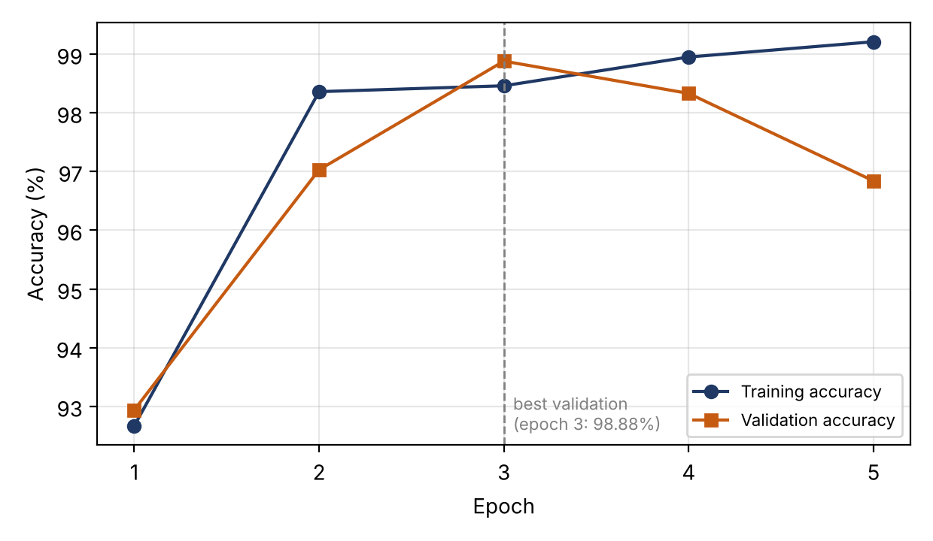
Figure 5: Training and validation accuracy per epoch (plotted from the recorded values)
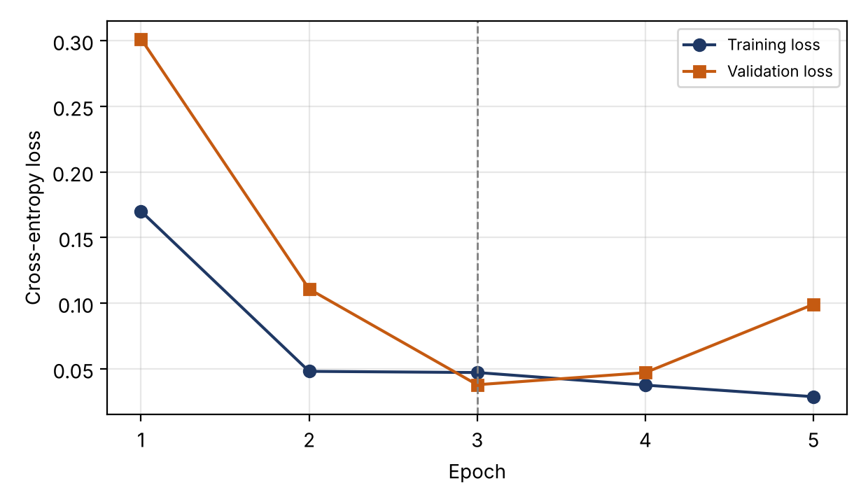
Figure 6: Training and validation loss per epoch (plotted from the recorded values)

11.3 Selecting the Best Validation Model
The last epoch is not automatically the best one. Training loss keeps falling as the network fits the training images, but performance on unseen images can peak earlier and then decline. Choosing the checkpoint with the best validation accuracy (or lowest validation loss) is a simple form of early stopping that guards against keeping a model that has begun to fit noise. Here, epoch 3 has both the highest validation accuracy (98.88%) and the lowest validation loss (0.0379).
To verify. The brief identifies epoch 3 as the best epoch and names crop_disease.pth as the saved model. Whether the saved file holds the epoch-3 weights or the epoch-5 weights depends on the save logic in train_model.py, which was not supplied. This should be confirmed before the report is submitted.

11.4 Interpreting the Behaviour After Epoch 3
After epoch 3, training loss continued to decrease (0.0472 to 0.0288) and training accuracy continued to increase (98.46% to 99.21%), while validation loss rose (0.0379 to 0.0991) and validation accuracy fell (98.88% to 96.84%). This pattern is consistent with the onset of overfitting, in which the model fits the training data more closely but generalises less well.
It does not, however, prove overfitting. The validation set contains roughly 539 images, so a single image is worth about 0.19 percentage points and a swing of two percentage points corresponds to about ten images. Epoch-to-epoch variation can also arise from the random order of batches, from changes in the learning dynamics, and from the fact that training accuracy is accumulated while the weights are still changing and layers such as dropout are active. A conclusive statement would require repeated runs with different random seeds, or a larger validation set. The cautious reading is that generalisation performance varied between epochs and that selecting the best validation epoch is justified.

12. PyTorch Evaluation

12.1 Evaluation Metrics
Let TP, FP, TN and FN denote true positives, false positives, true negatives and false negatives for one class, treating that class as positive and all others as negative.
Accuracy = (correct predictions) / (all predictions) (4)
Precision = TP / (TP + FP) (5)
Recall = TP / (TP + FN) (6)
F1 = 2 · Precision · Recall / (Precision + Recall) (7)
- Accuracy is the fraction of all test images classified correctly.
- Precision answers: of the images predicted as a class, how many truly belong to it? Low precision for a disease class means false alarms.
- Recall answers: of the images that truly belong to a class, how many were found? Low recall for a disease class means missed disease.
- F1-score is the harmonic mean of precision and recall and is high only when both are high.
- Support is the number of true test images of a class.
- Macro average is the unweighted mean of the per-class values, so every class counts equally, including the smallest.
- Weighted average weights each class by its support, so larger classes count more.
- Confusion matrix is a table in which rows are actual classes and columns are predicted classes; diagonal cells are correct predictions and off-diagonal cells show which classes are confused.

12.2 Results on the 908 Test Images
The PyTorch model achieved an overall test accuracy of 98.68% on the 908 test images.
Recorded PyTorch evaluation result
Test images: 908
Test accuracy: 98.68%
Macro average — Precision: 0.9855, Recall: 0.9865, F1-score: 0.9860
Weighted average — Precision: 0.9868, Recall: 0.9868, F1-score: 0.9868
Output file: results/test_metrics.json
Confusion matrix: results/confusion_matrix.png
Table 10: PyTorch classification report on the test set
Class | Precision | Recall | F1-score | Support
Early Blight | 0.9752 | 0.9850 | 0.9801 | 200
Healthy | 0.9969 | 0.9877 | 0.9923 | 326
Late Blight | 0.9843 | 0.9869 | 0.9856 | 382
Macro average | 0.9855 | 0.9865 | 0.9860 | 908
Weighted average | 0.9868 | 0.9868 | 0.9868 | 908

As simple arithmetic on the reported figures, 98.68% of 908 images corresponds to 896 correct predictions and 12 errors. Multiplying each class recall by its support gives 197 correct Early Blight, 322 correct Healthy and 377 correct Late Blight images, which also sum to 896. These counts are derived, not read from the saved file.

12.3 Confusion Matrix
The confusion matrix was saved to results/confusion_matrix.png. Its individual cell values were not supplied with the brief and are therefore not reproduced or estimated here. The figure should be inserted from the results folder.
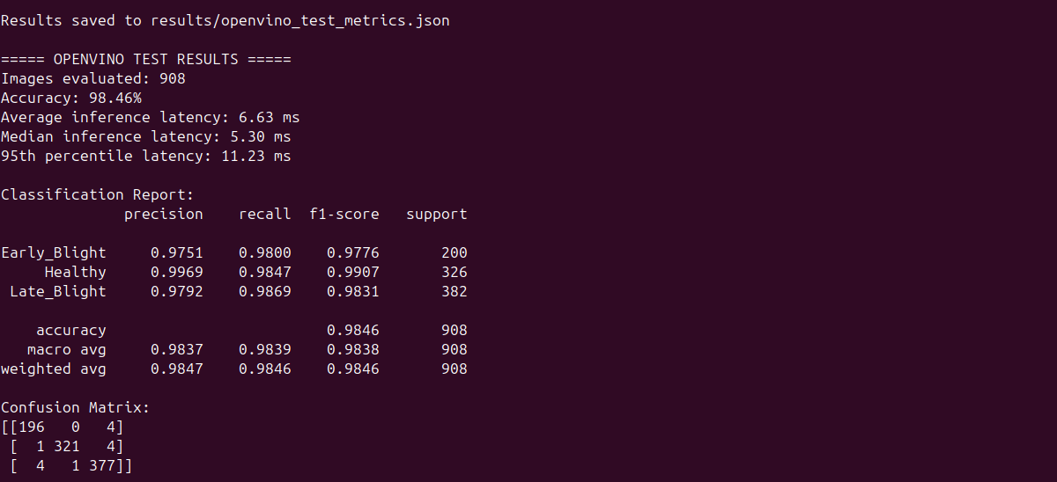
Figure 7: Confusion matrix of the PyTorch model on the 908 test images [placeholder]

12.4 Why Accuracy Alone Is Insufficient
A single accuracy figure hides how errors are distributed. For disease detection the two kinds of error have different consequences: a diseased plant called Healthy (a false negative) may go untreated, whereas a healthy plant called diseased (a false positive) may trigger unnecessary treatment or scouting. Early Blight and Late Blight also call for different responses, so confusing them is itself costly. Accuracy also depends on class balance, and it says nothing about whether the model's confidence scores are trustworthy. Per-class precision and recall, the confusion matrix, and eventually calibration and field data are needed for a fair assessment.

13. OpenVINO Conversion

13.1 Concepts
OpenVINO is an open-source toolkit for optimising and deploying AI inference [12]. Edge inference means running a trained model on a device near the data source, such as a camera, instead of sending data to a remote server. OpenVINO represents a converted model in its Intermediate Representation (IR), which consists of two files:
- an XML file (crop_disease.xml) describing the network graph: layers, operations and connections;
- a BIN file (crop_disease.bin) holding the weights and other binary constants.
Conversion is useful because it decouples the model from the training framework: the OpenVINO runtime can read the IR, apply graph optimisations, and compile it for a selected device such as the CPU. Compilation prepares device-specific, optimised execution of the graph. A converted model should always be tested against the original, because conversion changes the execution path and numerical differences or unsupported operations can alter results. Conversion also does not make a model ready for every edge device: the target hardware, drivers, operating system, runtime version and model precision all need to be compatible and tested.

13.2 Conversion Result
src/convert_model.py converted the trained PyTorch model and produced the two IR files.
Table 11: Approximate sizes of the model files
File | Role | Approximate size
models/pytorch/crop_disease.pth | PyTorch checkpoint | 6 MB
models/openvino/crop_disease.xml | IR graph description | 155 KB
models/openvino/crop_disease.bin | IR weights | 5.8 MB

The weights file is about the same size as the checkpoint, which suggests the weights were stored at similar precision, but the precision setting was not verified.

13.3 Compatibility Warning
The conversion succeeded, but a warning appeared about torch.jit.trace support under Python 3.14 and later. The successful conversion, the functional tests (Chapter 14) and the evaluation on 908 images are evidence that the generated model worked in this environment. The warning nevertheless indicates that tracing-based export may change or be limited in newer Python versions, so it should be monitored and the conversion re-tested whenever Python, PyTorch or OpenVINO versions change.
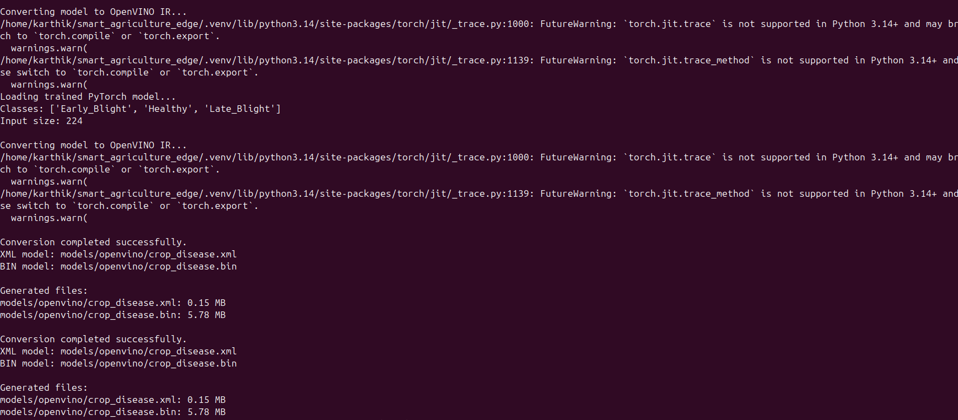
Figure 8: Terminal output of the PyTorch to OpenVINO IR conversion [placeholder]

14. OpenVINO Evaluation

14.1 Functional Test
src/test_openvino.py loaded the IR model and compiled it for CPU execution. The model input is shaped batch × 3 × height × width, with dynamic dimensions reported by the model. For a single image the output shape was (1, 3), that is, three values corresponding to the three classes. A dummy-input test completed successfully.
Caution. The dummy input consisted of zeros and the model predicted Late Blight. This result has no meaning for disease detection; the test only shows that the model loads, compiles and returns three outputs.

Figure 9: Terminal output of the OpenVINO functional test
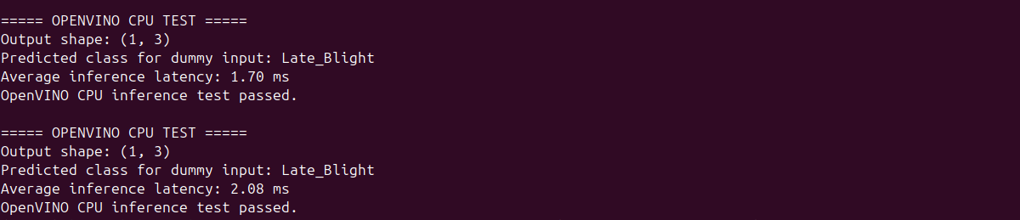

Figure 9: Terminal output of the OpenVINO functional test

14.2 Real-Image Prediction
A real-image test used dataset/test/Early_Blight/tomato_038275.jpg. The model predicted Early Blight, matching the actual class, with a reported confidence of 99.93% and a latency of about 2.19 to 2.88 ms across repeated runs. This single result demonstrates that the prediction path works. It says nothing about general accuracy, which is measured on the full test set. Softmax confidence is also not a guarantee of correctness: neural networks can be confidently wrong, and their confidence is not necessarily well calibrated [19].
Recorded real-image prediction output
Image: dataset/test/Early_Blight/tomato_038275.jpg
Actual class: Early_Blight
Predicted class: Early_Blight
Confidence: 99.93%
Inference latency: approximately 2.19–2.88 ms across recorded runs
Note: confidence is a model score and is not a guarantee of correctness.
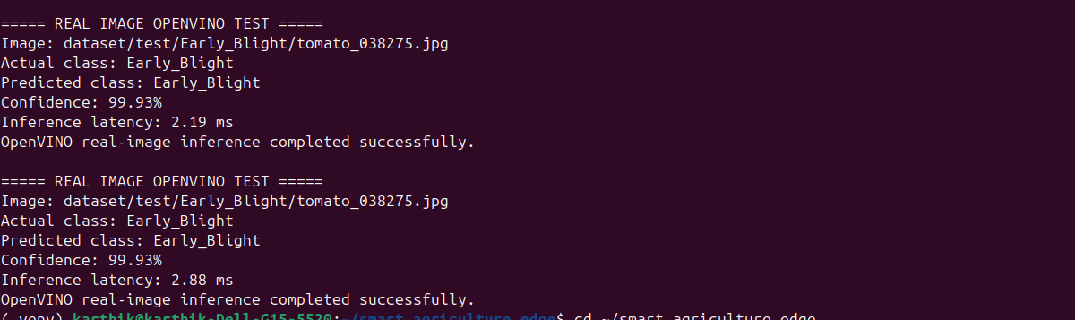
Figure 10: Terminal output of a real-image OpenVINO prediction

14.3 Evaluation on the Full Test Set
src/evaluate_openvino.py evaluated the OpenVINO model on all 908 test images. Overall accuracy was 98.46%. Latency statistics were: average about 6.6 ms, median about 5.31 ms, and 95th percentile about 11.24 ms. Results are stored in results/openvino_test_metrics.json.
Recorded OpenVINO evaluation terminal summary
Images evaluated: 908
Accuracy: 98.46%
Average inference latency: approximately 6.6 ms
Median inference latency: approximately 5.31 ms
95th-percentile latency: approximately 11.24 ms
Confusion matrix (actual rows; predicted columns; class order Early_Blight, Healthy, Late_Blight):
[[196, 0, 4],
[1, 321, 4],
[4, 1, 377]]
Saved: results/openvino_test_metrics.json
Table 12: OpenVINO classification report on the test set (908 images)
Class | Precision | Recall | F1-score | Support
Early Blight | 0.9751 | 0.9800 | 0.9776 | 200
Healthy | 0.9969 | 0.9847 | 0.9907 | 326
Late Blight | 0.9792 | 0.9869 | 0.9831 | 382
Macro average (derived) | 0.9837 | 0.9839 | 0.9838 | 908

The macro-average row is calculated from the three class values above; it was not part of the supplied results.

14.4 Confusion Matrix and Error Analysis
Rows are actual classes and columns are predicted classes, in the order Early Blight, Healthy, Late Blight.
Table 13: OpenVINO confusion matrix (rows: actual, columns: predicted)
Actual \ Predicted | Early Blight | Healthy | Late Blight
Early Blight | 196 | 0 | 4
Healthy | 1 | 321 | 4
Late Blight | 4 | 1 | 377

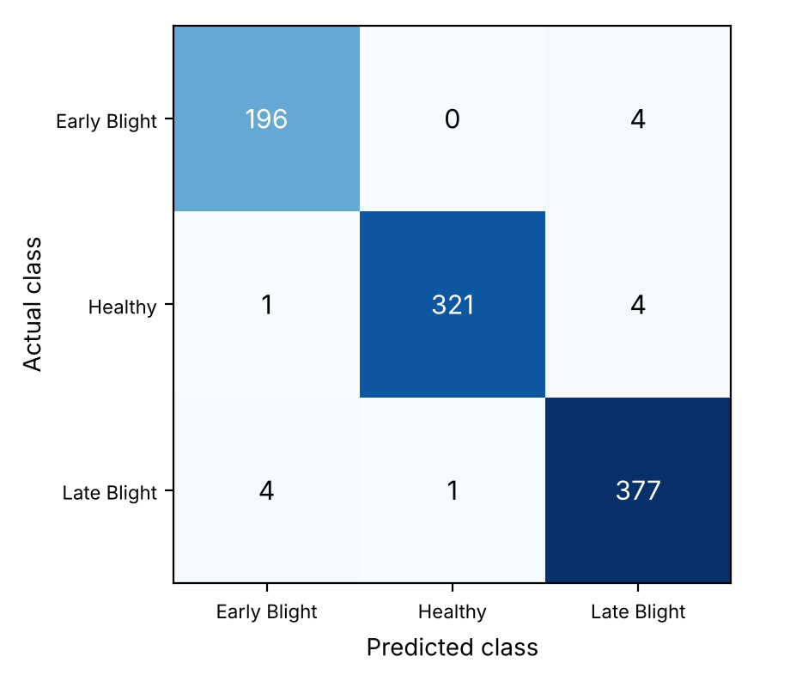
Figure 11: OpenVINO confusion matrix plotted from the values in the table above
The diagonal sums to 894 correct predictions out of 908 (98.46%), leaving 14 misclassifications:
- Early versus Late Blight: 8 errors (4 in each direction). The two diseases can look similar on a leaf, particularly in early stages or when lesions are not typical.
- Healthy leaves flagged as diseased: 5 of 326 healthy images (about 1.5%): 4 as Late Blight and 1 as Early Blight. These are false alarms.
- Diseased leaves called Healthy: only 1 of 582 diseased images (about 0.2%), a Late Blight image. No Early Blight image was predicted Healthy.
In an agricultural setting missed disease is usually costlier than a false alarm, so the very low rate of diseased leaves labelled Healthy is encouraging. It is still a count of one on a controlled-image test set, and field data are needed before drawing any conclusion about missed-disease rates in practice.

14.5 PyTorch versus OpenVINO on the Same Test Set
Table 14: PyTorch and OpenVINO results on the 908 test images
Measure | PyTorch | OpenVINO
Accuracy | 98.68% | 98.46%
Correct predictions (derived) | 896 | 894
Early Blight recall | 0.9850 | 0.9800
Healthy recall | 0.9877 | 0.9847
Late Blight recall | 0.9869 | 0.9869

The accuracy difference is 0.22 percentage points, which equals two images. Comparing the per-class recalls, the OpenVINO model has one fewer correct Early Blight image and one fewer correct Healthy image than the PyTorch model, while Late Blight is unchanged.
Interpretation limit. The cause of this small difference has not been established. Possible contributors include numerical differences between the two runtimes, differences in preprocessing between the evaluation scripts (for example image resizing implementation), or the conversion itself. Attributing it to conversion would require a per-image comparison of the two models' predictions and output scores on identical preprocessed inputs, which was not performed.

The latency figures in this chapter (average about 6.6 ms) come from the full 908-image evaluation and must not be compared directly with the 102-image benchmark in the next chapter, as explained there.

15. CPU Benchmarking

15.1 Benchmark Design
src/benchmark_cpu.py compared PyTorch and OpenVINO inference on the CPU using 102 selected test images. Both frameworks ran on the CPU; the GPU was not used. The brief does not record details such as batch size, warm-up runs, thread settings, or whether image preprocessing was included in the timed region, so these should be checked in the script and stated when the results are quoted.

15.2 Results
Table 15: CPU benchmark results on 102 selected test images
Metric | PyTorch CPU | OpenVINO CPU
Images evaluated | 102 | 102
Accuracy on selected subset | 100.00% | 100.00%
Average inference latency | 4.30 ms | 1.61 ms
Median inference latency | 4.18 ms | 1.44 ms

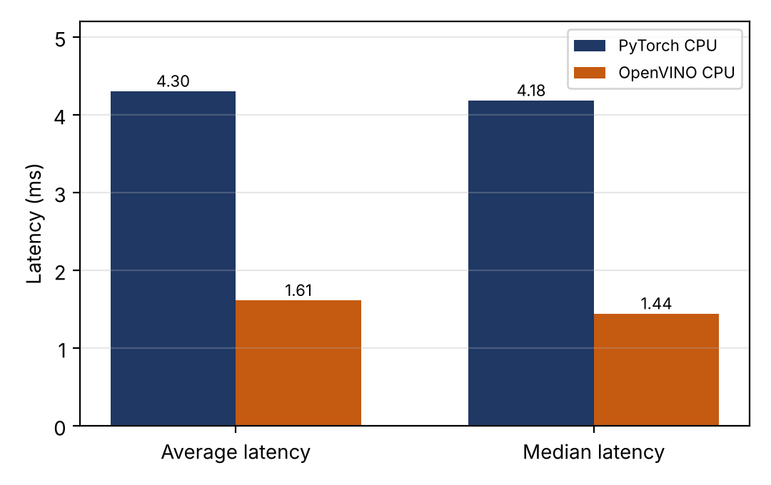
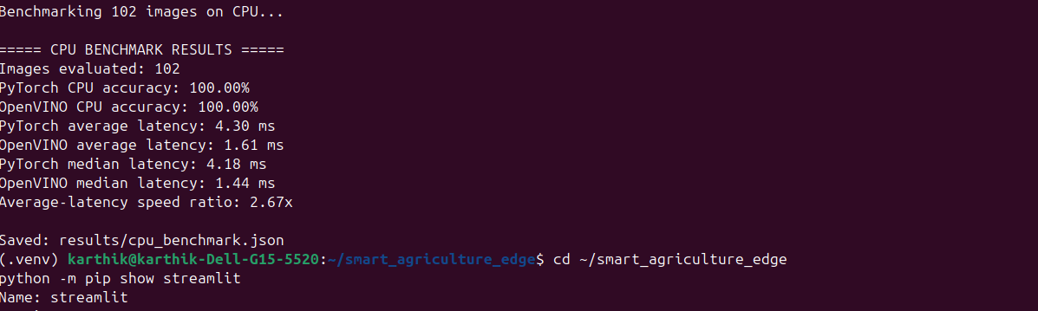
Figure 12: Average and median CPU latency for PyTorch and OpenVINO (102 images)

15.3 Calculations
The average-latency speed ratio is the PyTorch latency divided by the OpenVINO latency:
Recorded CPU benchmark terminal output
Checkpoint fields: ['model_state_dict', 'class_names', 'image_size']
Benchmarking 102 images on CPU...
Images evaluated: 102
PyTorch CPU accuracy: 100.00%
OpenVINO CPU accuracy: 100.00%
PyTorch average latency: 4.30 ms
OpenVINO average latency: 1.61 ms
PyTorch median latency: 4.18 ms
OpenVINO median latency: 1.44 ms
Average-latency speed ratio: 2.67x
Saved: results/cpu_benchmark.json
Speed ratio = 4.30 ms / 1.61 ms = 2.67× (8)
The percentage reduction in average latency is:
Reduction = (4.30 − 1.61) / 4.30 × 100 = 62.6% (9)
The absolute saving is 2.69 ms per image. Using the medians, the ratio is 4.18 / 1.44 = 2.90× and the reduction is about 65.6%; these median-based figures are derived and give a consistent picture. The results are saved in results/cpu_benchmark.json.

15.4 Discussion
OpenVINO ran about 2.67 times faster than PyTorch on the same CPU in this test, with the same accuracy on the selected subset. This is encouraging for edge AI, because many edge devices have only a CPU and a lower inference time leaves more of the time and energy budget for capture, preprocessing and communication. It also shows that a toolchain optimisation can bring a meaningful gain without changing the model architecture.
Critical comparison requirement. The benchmark used 102 selected images, whereas the OpenVINO evaluation in Chapter 14 used 908 images. The sample sizes and timing procedures differ, so the 1.61 ms benchmark latency and the 6.6 ms average from the full evaluation must not be compared as if they came from the same experiment.
Accuracy of 100% on a 102-image subset does not mean the model is universally accurate or field-ready. The subset is small and was selected, and the images come from the same controlled dataset.

15.5 What Was Not Measured
The benchmark measures model inference time on one laptop CPU. It does not measure total camera-to-prediction time (capture, transfer, decoding and preprocessing on a device), network latency, memory use, power consumption or energy efficiency. No claim about these is made.
[INSERT FIGURE 13: CPU benchmark terminal output]
Capture from: Terminal output after running python src/benchmark_cpu.py.
Should demonstrate: PyTorch CPU and OpenVINO CPU average and median latency and accuracy on the 102 images.
Placeholder only: no image has been fabricated for this figure.
Figure 13: Terminal output of the CPU benchmark comparing PyTorch and OpenVINO

16. Streamlit Application

16.1 Overview and Features
The application in src/app.py provides a browser interface for the OpenVINO model. It uses Streamlit [16] for the interface, OpenVINO for CPU inference, Pillow for image loading, torchvision transforms for preprocessing and NumPy for processing model outputs.
Table 16: Features implemented in the supplied application code
# | Feature
1 | Upload a JPG, JPEG or PNG image
2 | Display the uploaded image
3 | Run OpenVINO inference when the Detect Crop Disease button is clicked
4 | Display the predicted class
5 | Display the model confidence score
6 | Display inference latency
7 | Display scores for all three classes
8 | Show a warning that the output is an AI prediction and not a confirmed diagnosis
9 | Cache the compiled model and class labels

The application also states that it was evaluated using PlantVillage images and has not been validated for real-world field conditions. It processes uploaded images only; it does not use a live camera stream.

16.2 Image Processing Pipeline
Table 17: Processing steps from upload to displayed result
Step | Operation | Library
1 | Leaf image upload | Streamlit
2 | Image loading | Pillow
3 | RGB conversion | Pillow
4 | Resize to 224 × 224 | torchvision transforms
5 | Tensor conversion | torchvision transforms
6 | Normalisation (ImageNet mean and standard deviation) | torchvision transforms
7 | OpenVINO inference on CPU | OpenVINO
8 | Class score calculation (softmax) | NumPy
9 | Predicted class and confidence (highest score) | NumPy
10 | Display of results | Streamlit

16.3 Observed Application Output
User-captured Streamlit result: Early Blight prediction
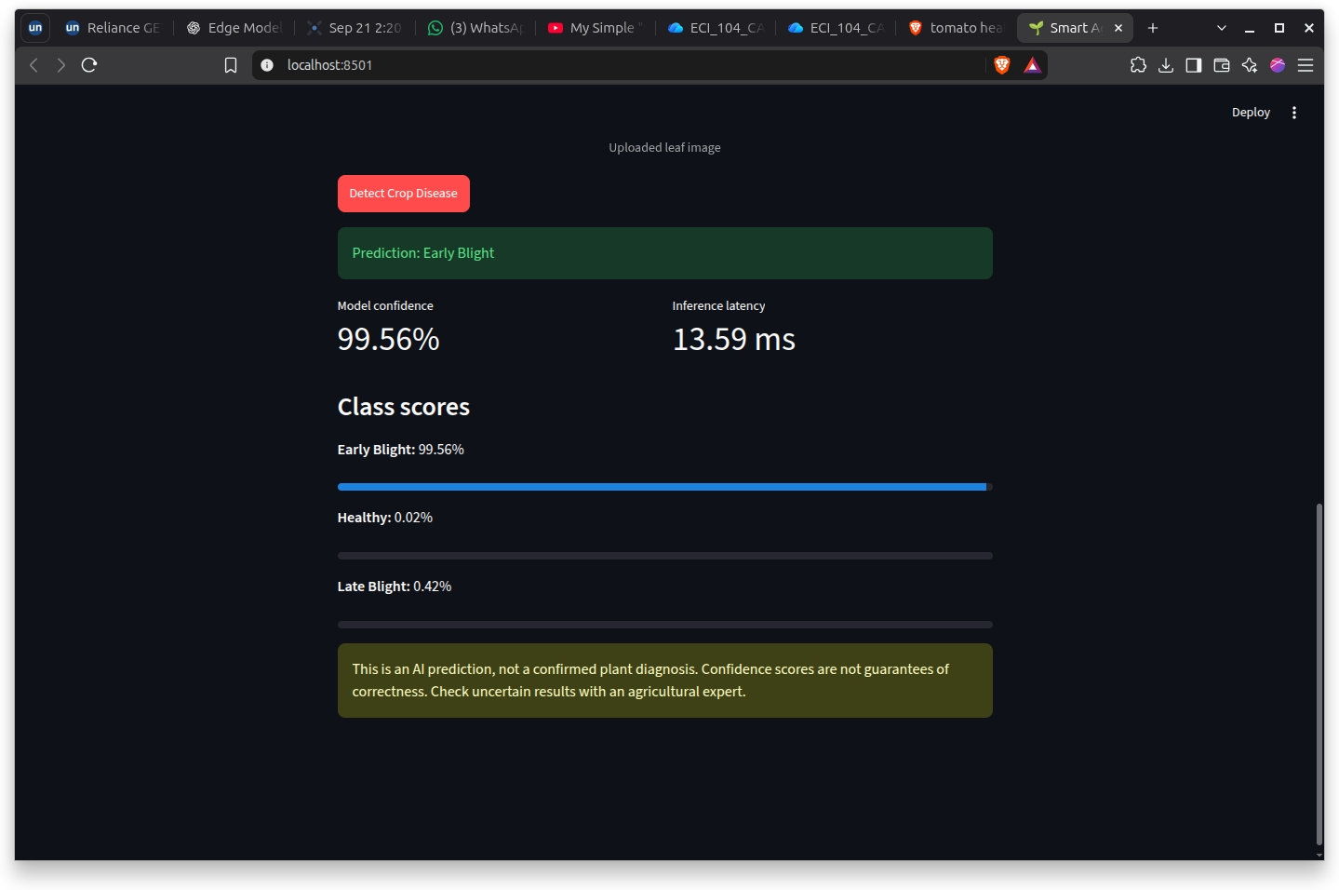
Figure: Streamlit application output showing Early Blight, confidence 99.56%, and displayed inference latency 13.59 ms. This is one application run; its latency is not directly comparable to the separate CPU benchmark.
The application was run locally (localhost:8501) and three result screens were captured. They are shown below, cropped to the application area. They show what the interface displays: the predicted class, the model confidence, the inference latency and the three class scores, followed by the disclaimer.
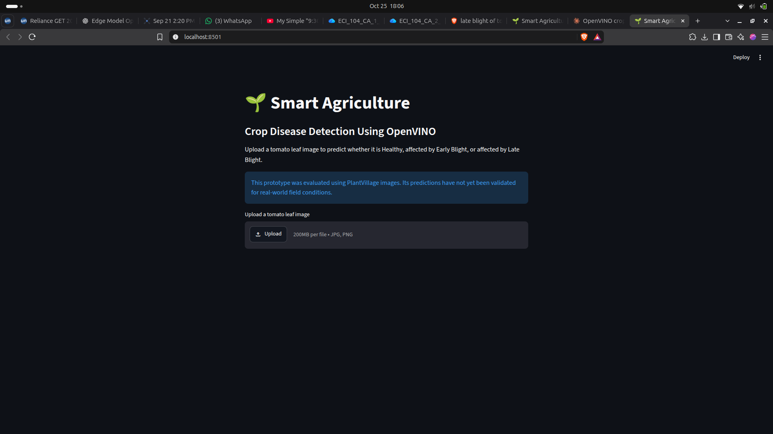
Figure 14: Home screen of the Streamlit crop disease detection application [placeholder]
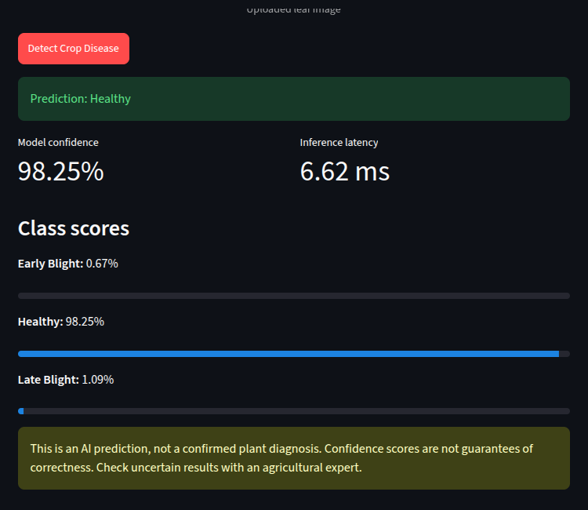
Figure 15: Streamlit result screen with the prediction Healthy
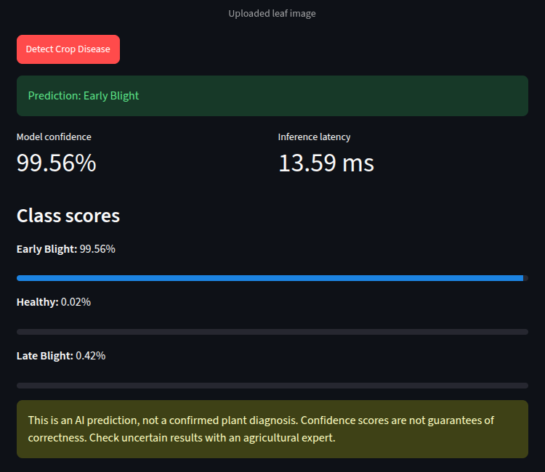
Figure 16: Streamlit result screen with the prediction Early Blight
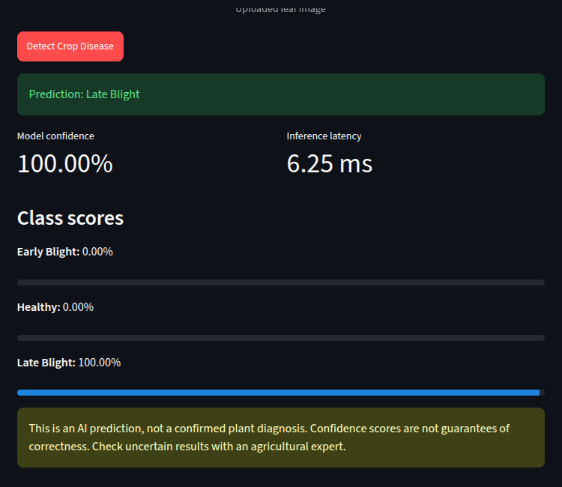
Figure 17: Streamlit result screen with the prediction Late Blight
Table 18: Values displayed in the three captured result screens
Prediction | Confidence | Latency | Early Blight | Healthy | Late Blight
Healthy | 98.25% | 6.62 ms | 0.67% | 98.25% | 1.09%
Early Blight | 99.56% | 13.59 ms | 99.56% | 0.02% | 0.42%
Late Blight | 100.00% | 6.25 ms | 0.00% | 0.00% | 100.00%

These screens show that the application runs and produces output for all three classes. They are qualitative demonstrations only. The uploaded image is not visible in the captured region, the true label of each uploaded image was not independently confirmed by an expert, and three images cannot measure accuracy. The latencies were reported by the application for single uploads; the timed region was not inspected, and single-run values naturally vary (the Early Blight screen shows 13.59 ms against about 6 ms for the others). They should not be compared with the benchmark in Chapter 15.
The Late Blight screen displays a confidence of 100.00%. This is the displayed value rounded to two decimals; it indicates that the softmax output was very close to one, not that the prediction is certain or correct. The application's own disclaimer makes the same point.

16.4 Additional Sample Photographs
Figure 18 shows three tomato leaf photographs supplied during testing. They are ordinary photographs with natural backgrounds, unlike the controlled PlantVillage images. They are included only to illustrate the kind of input the application receives. The report does not state which photograph produced which screen above, and their provenance and licence must be confirmed before publication.
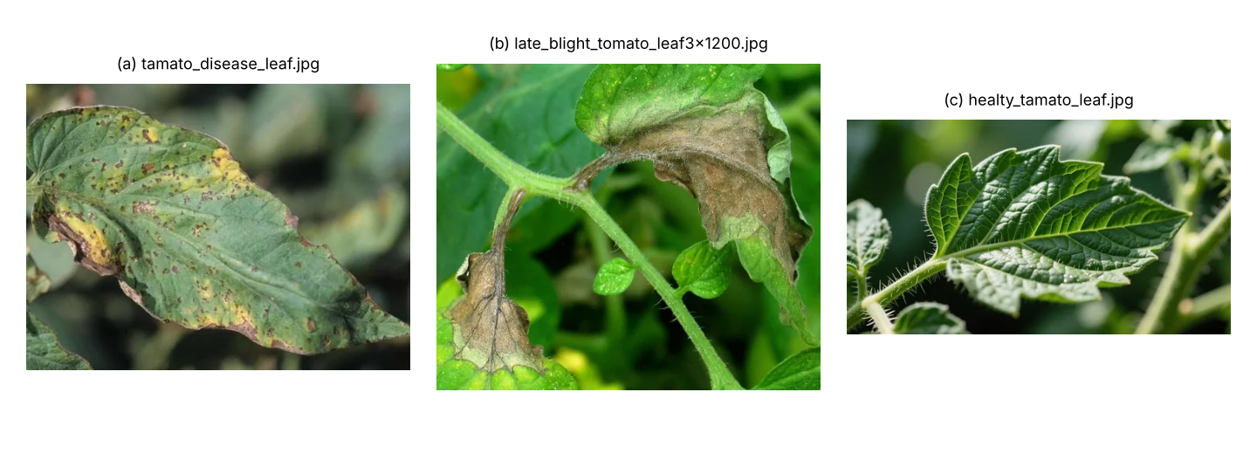
Figure 18: Sample tomato leaf photographs used for informal testing (file names as supplied)

17. Complete Execution Guide
This guide explains how to run the project on Ubuntu Linux. The commands and paths are those of the known workflow. Because the source code of the scripts was not supplied, anything that depends on their internal details is flagged as needing verification.

Step 1: Open the terminal and enter the project folder
cd ~/smart_agriculture_edge

Open a terminal (Ctrl+Alt+T) and move into the project directory. All later commands assume you are in this folder.

Step 2: Activate the virtual environment
source .venv/bin/activate

A virtual environment keeps this project's Python packages separate from the system. When activation succeeds, the terminal prompt begins with the environment name, for example (.venv). If it does not, the later commands will probably fail with missing-package errors.

Step 3: Inspect the project structure
find . -maxdepth 3 -type f | sort

This lists the files up to three levels deep so you can confirm that the scripts, models and results exist. Because .venv also contains many files, the output may be long; adding -not -path "./.venv/*" hides them.

Step 4: Prepare the dataset
python src/prepare_dataset.py

This script loads the selected PlantVillage dataset, filters the tomato classes and prepares the training and test folders. It may need internet access to download the data, and it normally depends on a dataset-loading package such as Hugging Face datasets, which was not in the supplied library list (verify). If dataset/ already exists, inspect the script before running it again so that existing folders are not overwritten or duplicated.

Step 5: Train the model
python src/train_model.py

Training takes time and uses the GPU if one is available. It should create the PyTorch checkpoint and the training history. The known trained checkpoint is models/pytorch/crop_disease.pth, with the history in results/training_history.json.

Step 6: Evaluate the PyTorch model
python src/evaluate_model.py

Expected reference result: test accuracy of 98.68%, metrics saved to results/test_metrics.json and the confusion matrix saved to results/confusion_matrix.png. If the model is retrained or the dataset changes, exact values may differ.

Step 7: Convert the model to OpenVINO
python src/convert_model.py

Expected output files: models/openvino/crop_disease.xml and models/openvino/crop_disease.bin. A warning about torch.jit.trace support under Python 3.14 and later may appear; conversion succeeded despite it in the reference run.

Step 8: Test the OpenVINO model
python src/test_openvino.py

This checks that the converted model can be loaded and compiled for CPU and that it produces three outputs. A dummy input is used, so the predicted class is not meaningful.

Step 9: Test a real leaf image
python src/predict_openvino.py

The script uses the image path configured inside its source file. To test a different image, open the script and update that path.

Step 10: Evaluate OpenVINO on the test set
python src/evaluate_openvino.py

Expected reference results: 908 test images, 98.46% accuracy and an average latency of about 6.6 ms. Results are written to results/openvino_test_metrics.json.

Step 11: Benchmark CPU inference
python src/benchmark_cpu.py

Expected reference results: PyTorch CPU average latency 4.30 ms, OpenVINO CPU average latency 1.61 ms, a ratio of 2.67×, and 100% accuracy for both on the 102-image subset. Latency depends on the machine and its load, so reruns will differ.

Step 12: Launch the Streamlit application
Observed application result supplied by the user
Prediction: Early Blight
Model confidence: 99.56%
Displayed inference latency: 13.59 ms
Class scores: Early Blight 99.56%; Healthy 0.02%; Late Blight 0.42%
Application address: localhost:8501 (local-only development address, not a public website)
streamlit run src/app.py

Streamlit prints a local address, commonly http://localhost:8501. Open it in a browser, upload a tomato leaf image (JPG, JPEG or PNG) and click Detect Crop Disease. The result screens in Chapter 16 were captured from this application.

Step 13: Stop the application
Press Ctrl+C in the terminal that is running Streamlit to stop the server.

Step 14: Inspect the generated results
ls -lh results/

The folder should contain the training history, the PyTorch and OpenVINO metric files, the confusion matrix image and the CPU benchmark file described in Chapter 7.

17.1 Troubleshooting
Table 19: Common problems and what to check
Problem | Likely cause | What to check
ModuleNotFoundError or import error | A required package is missing | Confirm the environment is active, then run pip list. Additional setup may be required, for example installing the missing package with pip (versions as in Chapter 5; verify)
Command not found, wrong Python or packages | Virtual environment not activated | Run source .venv/bin/activate; check which python points inside .venv
Dataset folders missing or empty | Preparation not run, download failed or no internet | Re-run Step 4 after inspecting the script; check ls dataset/train
Model file not found | Training or conversion not completed, or wrong working directory | Check ls models/pytorch models/openvino; run commands from the project root
Streamlit port already in use | Another process, often a previous Streamlit run, uses port 8501 | Stop the old process, or run streamlit run src/app.py --server.port 8502
OpenVINO conversion or compatibility warnings | Newer Python or library versions than the export path was designed for | Read the warning text, confirm the output files were created, run Step 8; consider a Python version supported by all packages
Installation fails on Python 3.14 | Some packages may lack builds for very recent Python versions | Check each package's supported versions; use a supported Python version if necessary
Results differ from the reference values | Retraining, different dataset, random seed, hardware or system load | Compare with Appendix C; latency varies by machine and accuracy varies slightly with retraining

18. Results and Discussion

18.1 Summary of Results
Table 20: Summary of all recorded results
Stage | Sample | Result
Dataset | 4,500 tomato images, 256 × 256 | 3,592 training and 908 test images in three classes
Training | 15% validation split, 5 epochs | Best validation accuracy 98.88% (epoch 3)
PyTorch test evaluation | 908 test images | Accuracy 98.68%; macro F1 0.9860
OpenVINO test evaluation | Same 908 test images | Accuracy 98.46%; average latency about 6.6 ms; median about 5.31 ms; 95th percentile about 11.24 ms
CPU benchmark | 102 selected test images | PyTorch 4.30 ms versus OpenVINO 1.61 ms average; ratio 2.67×; reduction about 62.6%; both 100% accurate on the subset
Streamlit application | Three captured result screens | Application runs and shows class, confidence, latency, class scores and a disclaimer

18.2 PyTorch versus OpenVINO Accuracy
On the full 908-image test set the PyTorch model scored 98.68% and the OpenVINO model 98.46%, a difference of 0.22 percentage points (two images). Both models show the same overall behaviour: Healthy is classified with the highest precision, and most errors involve one of the two blight classes. Without a per-image comparison, the reason for the small difference is not asserted.

18.3 CPU Latency
In the separate 102-image benchmark, OpenVINO's average CPU latency was 1.61 ms against 4.30 ms for PyTorch, a ratio of 2.67× and a latency reduction of about 62.6%. These are two separate experiments with different sample sizes and timing procedures, so the benchmark is read as a relative comparison between two frameworks on the same machine, not as an absolute latency expected in the field.

18.4 Discussion
The results show that a compact model can classify controlled tomato leaf images with accuracy close to 99% and can be executed on a CPU in a few milliseconds, with OpenVINO providing a clear speed advantage over PyTorch on the same hardware. The model is small (about 6 MB), which favours edge storage and updating. The Streamlit application makes the model usable by a non-programmer and communicates its uncertainty and limits.
These findings are evidence for technical feasibility of the model and the toolchain. They are not evidence of field performance: all accuracy figures come from a single dataset collected under controlled conditions, evaluated with a single train-test split.

18.5 Threats to Validity
- Dataset similarity: training and test images share the same source and style; possible near-duplicates were not checked.
- Single split and run: one train-test split and one training run were reported, so variability from random seeds is unknown.
- Small validation set: roughly 539 images, so epoch-to-epoch fluctuations of about one or two points are within plausible noise.
- Single machine: latency was measured on one laptop whose CPU model and power state were not recorded.
- Timing details: warm-up, batch size, thread count and the timed region are not documented in the brief.
- Three classes only: the model cannot say "none of these" for other diseases, pests, deficiencies or non-tomato inputs.

19. Field Deployment Feasibility

19.1 Concepts
Smart agriculture applies sensing, data and automation to farming decisions. Crop disease detection is one use: recognising disease from images so that scouting and treatment can be targeted. Edge computing performs computation near the data source [2], and edge AI inference runs a trained model on such a device, here a camera-side computer, instead of on a remote server.

19.2 Camera-to-Model Data Flow
Figure 19 shows a proposed architecture for a future field system. It is a design concept only; none of the hardware shown has been built or tested in this work.
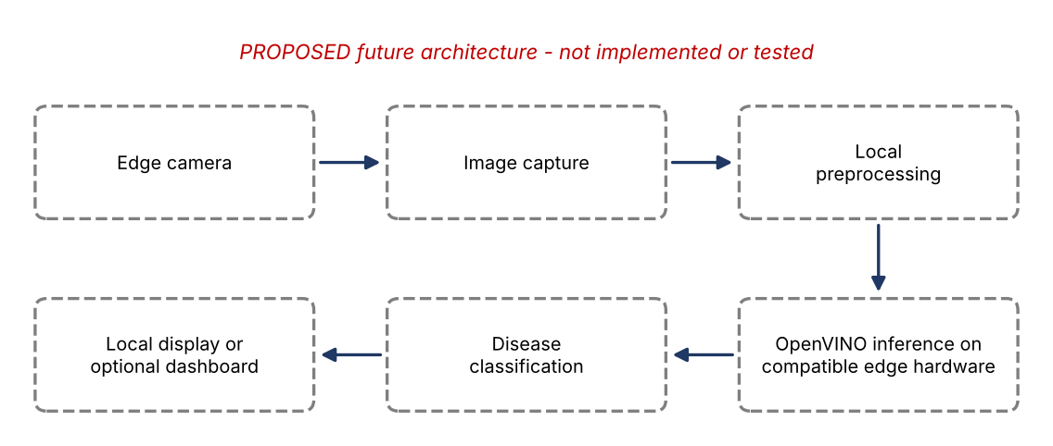
Figure 19: Proposed future edge camera deployment architecture (conceptual; not implemented)

19.3 Local versus Cloud Processing
Table 21: Local (edge) processing compared with cloud processing
Aspect | Local (edge) | Cloud
Latency | No network round trip; limited by device compute | Depends on connection quality; adds transfer time
Bandwidth | Send only results or flagged images | Every image must be uploaded
Offline operation | Possible | Not possible without connectivity
Privacy | Images can stay on the farm | Images leave the farm and need secure handling
Compute resources | Limited by device power, memory and heat | Large, scalable resources
Maintenance and updates | Models must be distributed and monitored across devices | Central updates are easy

As a simple illustration of bandwidth, one 224 × 224 RGB image occupies 224 × 224 × 3 = 150,528 bytes (about 147 KB) uncompressed, and real camera frames are usually much larger, whereas a predicted class and score need only a few bytes. The saving depends entirely on the camera, compression and reporting policy, and has not been measured here.

19.4 Candidate Hardware Platforms (Future, Untested)
Table 22: Possible deployment platforms. None has been tested.
Platform | Status | Considerations
Intel CPU-based edge computers | Future candidate | Most direct path for OpenVINO; the benchmark used a laptop CPU, which is not representative of low-power edge processors
Intel integrated graphics or supported accelerators | Future candidate | Subject to hardware compatibility, drivers and runtime support; no GPU or NPU inference was benchmarked
Raspberry Pi or similar ARM devices | Future candidate | Subject to runtime and deployment compatibility; performance unknown and likely lower than the development laptop
Industrial edge computers with connected cameras | Future candidate | Weather protection, power supply, thermal design and connectivity requirements must be assessed

OpenVINO device availability depends on the supported hardware and installed drivers and runtime. The fact that CPU and GPU devices were available on the development laptop does not prove that any other accelerator, such as an NPU or an ARM device, is supported or will perform adequately.

19.5 Real-World Challenges
Table 23: Challenges for field deployment and possible responses
# | Challenge | Why it matters | Possible response
1 | Changing lighting | Colour and contrast change through the day and weather | Collect data across times and conditions; use augmentation; consider controlled illumination
2 | Leaf shadows | Shadows resemble dark lesions | Include shadowed examples; test robustness
3 | Overlapping leaves | Hidden or mixed symptoms | Detection or segmentation of single leaves
4 | Background soil and vegetation | Model trained on plain backgrounds may be misled | Train with realistic backgrounds; crop to leaves
5 | Different tomato varieties | Leaf shape and colour vary | Include multiple varieties
6 | Disease severity variation | Appearance changes with severity | Label severity; balance across stages
7 | Early-stage symptoms | Subtle signs are hard to see yet most valuable to catch | Expert-labelled early-stage data; evaluate recall for early stages separately
8 | Motion blur | Wind and moving cameras blur images | Fast shutter; blur-aware quality checks
9 | Camera resolution | Small lesions vanish at low resolution or after resizing | Choose adequate sensor and distance; test resolution sensitivity
10 | Dust, moisture and weather | Lens contamination and enclosure fogging | Protective enclosures; maintenance schedule
11 | Device power and heat | Sustained inference raises temperature and power draw | Measure power and thermals; duty cycling
12 | Connectivity | Rural networks are intermittent | Local storage and delayed upload
13 | Model drift and seasonal variation | Crops, pathogens and conditions change over time | Monitor performance; periodic retraining
14 | False positives and false negatives | Wrong treatment or missed disease | Report uncertainty; human review of uncertain cases

19.6 Classification versus Detection
The current model is an image classifier: it assigns one label to an entire image. A field camera usually sees many leaves, soil and other objects, and several diseases may be present at once. A deployed system would likely need object detection or segmentation to find leaves first, plus an option for "unknown" or "other" inputs. The present three-class classifier will always choose one of the three classes, even for inputs that belong to none of them.

19.7 Current Prototype versus a Validated Field System
Table 24: What exists now compared with what a field system would require
Aspect | Current prototype | Validated field system (future)
Images | PlantVillage test images and a few uploaded photographs | Farm images across conditions, devices and seasons
Input | Uploaded image files | Camera capture, possibly continuous
Hardware | Laptop (CPU benchmark) | Specific edge device with measured performance
Labels | Dataset labels | Expert agronomist annotation
Metrics | Accuracy, per-class metrics, model latency | Plus end-to-end latency, memory, power, field accuracy
Status | Proof of concept on a public dataset | Evidence-backed deployment

19.8 Proposed Field Validation Plan
- Collect images on real tomato farms in several locations and seasons, with multiple lighting conditions, camera devices and distances.
- Annotate with agricultural experts; use at least two annotators on a sample, resolve disagreements, and report agreement.
- Split by field, plant or date, not by random image, so that near-identical images do not appear in both training and test sets.
- Evaluate the current model first without retraining to measure the domain gap, then fine-tune and re-evaluate on held-out field data.
- Deploy on candidate hardware and measure latency, memory, power and temperature over extended runs.
- Define acceptance criteria with domain experts before testing, rather than after seeing results.
Table 25: Metrics for field validation
Metric | What it shows
Accuracy | Overall fraction of correct classifications on field data
Per-class precision and recall | False alarms and missed disease for each class
F1-score | Balance between precision and recall
Confusion matrix | Which classes are confused, such as Early versus Late Blight
Latency | Model inference time and, separately, full camera-to-result time
Memory use | Fit within the device's available memory
Power consumption | Feasibility for battery or solar operation
Performance by condition | Accuracy across lighting, weather, distance and device

No values are given for field latency, memory use, power or energy efficiency because none were measured.

19.9 Feasibility Assessment
Table 26: Feasibility assessment based on the evidence available
Dimension | Evidence in this project | Assessment
Model size | About 6 MB checkpoint; IR about 6 MB | Favourable
Inference speed on CPU | 1.61 ms average on a laptop CPU (102 images) | Promising; not shown on edge hardware
Accuracy on controlled data | 98.46% (OpenVINO) on 908 images | Favourable for the dataset only
Accuracy in field conditions | None | Unproven
Camera integration | None (image upload only) | Not assessed
Power and thermal limits | None | Not assessed
Connectivity and updates | None | Not assessed

In summary, the model and toolchain appear technically promising as the basis for an edge solution, but the project establishes feasibility only at the proof-of-concept level. Field deployment feasibility is conditional on the validation steps above.

20. Limitations
Table 27: Limitations, why they matter and how to address them
Limitation | Why it matters | How to address
Trained and evaluated on PlantVillage imagery | Controlled images may not reflect farm conditions | Collect and test on field images
Real-world field images not evaluated | True field performance is unknown | Independent field test set
Only three tomato classes | Other diseases and non-tomato inputs are forced into three classes | Add classes and an unknown class
Only five training epochs | Training was short; behaviour after epoch 3 varied | Longer runs with early stopping, repeated seeds
CPU benchmark used 102 selected images | Small selected sample; 100% accuracy on it is not general | Larger, randomly chosen benchmark with documented procedure
No actual field camera integrated | Capture quality and pipeline effects untested | Connect and test a real camera
No physical edge device used | Performance on target hardware unknown | Benchmark on candidate devices
Power and energy not measured | Determines battery and solar feasibility | Measure with a power meter
Network latency not measured | Matters for hybrid or cloud workflows | Measure end-to-end timings
Field robustness not established | Lighting, background and weather can change results | Condition-wise field validation
Confidence is not a guarantee of correctness | Users may trust a wrong, confident prediction | Calibration studies, uncertainty estimates, expert review
High test accuracy can fail under distribution shift | Deployment data differ from training data | Monitor performance and retrain

21. Future Scope
Note. Everything in this chapter is proposed future work. None of it has been implemented or tested.

Table 28: Proposed future work (not implemented)
Area | Proposed work
Data | Collect a diverse dataset from real tomato farms; test under different lighting and weather; evaluate on independent field data
Model optimisation | Investigate FP16 or INT8 model optimisation and its effect on accuracy and speed
Hardware | Measure memory use and power consumption; deploy on compatible edge hardware; connect a real camera
Application | Add real-time video processing; add timestamped disease records; add an optional dashboard for disease history
Advice and safety | Add expert-reviewed recommendations; design a safe human-in-the-loop workflow for uncertain cases
Trustworthiness | Explore explainability methods such as Grad-CAM [20]; evaluate model calibration and uncertainty [19]

22. Conclusion
A MobileNetV3-Small model was trained to classify three categories of tomato leaf images: Healthy, Early Blight and Late Blight. On 908 independent test images the PyTorch model reached 98.68% accuracy and the converted OpenVINO model reached 98.46% on the same set, with 14 misclassifications out of 908 for OpenVINO and very few diseased leaves labelled as healthy.
In a separate benchmark on 102 selected test images, OpenVINO achieved an average CPU inference latency of 1.61 ms compared with 4.30 ms for PyTorch, an average-latency speed ratio of 2.67× and a reduction of about 62.6%. A Streamlit application was developed that lets a user upload a leaf image and view the predicted class, the confidence, the latency and all class scores, together with a warning that the output is not a confirmed diagnosis.
These results demonstrate promising potential for edge AI in crop disease detection. They are, however, based on a controlled public dataset, a single laptop and an image-upload interface. Real field images, actual edge hardware, a physical camera, and measurements of end-to-end latency, memory and power have not been tested. Further testing and expert-labelled field validation are necessary before any production deployment.

23. References
[1] A. Kamilaris and F. X. Prenafeta-Boldú, "Deep learning in agriculture: A survey," Comput. Electron. Agric., vol. 147, pp. 70–90, 2018.
[2] W. Shi, J. Cao, Q. Zhang, Y. Li, and L. Xu, "Edge computing: Vision and challenges," IEEE Internet Things J., vol. 3, no. 5, pp. 637–646, Oct. 2016.
[3] D. P. Hughes and M. Salathé, "An open access repository of images on plant health to enable the development of mobile disease diagnostics," arXiv:1511.08060, 2015.
[4] S. P. Mohanty, D. P. Hughes, and M. Salathé, "Using deep learning for image-based plant disease detection," Front. Plant Sci., vol. 7, Art. no. 1419, 2016, doi: 10.3389/fpls.2016.01419.
[5] J. G. A. Barbedo, "Impact of dataset size and variety on the effectiveness of deep learning and transfer learning for plant disease classification," Comput. Electron. Agric., vol. 153, pp. 46–53, 2018. [Verify volume, pages and DOI before submission.]
[6] Y. LeCun, Y. Bengio, and G. Hinton, "Deep learning," Nature, vol. 521, no. 7553, pp. 436–444, 2015.
[7] A. G. Howard et al., "MobileNets: Efficient convolutional neural networks for mobile vision applications," arXiv:1704.04861, 2017.
[8] M. Sandler, A. Howard, M. Zhu, A. Zhmoginov, and L.-C. Chen, "MobileNetV2: Inverted residuals and linear bottlenecks," in Proc. IEEE/CVF Conf. Comput. Vis. Pattern Recognit. (CVPR), 2018, pp. 4510–4520.
[9] A. Howard et al., "Searching for MobileNetV3," in Proc. IEEE/CVF Int. Conf. Comput. Vis. (ICCV), 2019, pp. 1314–1324.
[10] S. J. Pan and Q. Yang, "A survey on transfer learning," IEEE Trans. Knowl. Data Eng., vol. 22, no. 10, pp. 1345–1359, Oct. 2010.
[11] J. Deng, W. Dong, R. Socher, L.-J. Li, K. Li, and L. Fei-Fei, "ImageNet: A large-scale hierarchical image database," in Proc. IEEE Conf. Comput. Vis. Pattern Recognit. (CVPR), 2009, pp. 248–255.
[12] OpenVINO Documentation, Intel Corporation. [Online]. Available: https://docs.openvino.ai/ (accessed: [insert access date]).
[13] A. Paszke et al., "PyTorch: An imperative style, high-performance deep learning library," in Advances in Neural Information Processing Systems 32 (NeurIPS), 2019, pp. 8024–8035.
[14] PyTorch Documentation. [Online]. Available: https://pytorch.org/docs/stable/ (accessed: [insert access date]).
[15] "MobileNet V3," torchvision models documentation. [Online]. Available: https://pytorch.org/vision/stable/models/mobilenetv3.html (accessed: [insert access date]).
[16] Streamlit Documentation. [Online]. Available: https://docs.streamlit.io/ (accessed: [insert access date]).
[17] F. Pedregosa et al., "Scikit-learn: Machine learning in Python," J. Mach. Learn. Res., vol. 12, pp. 2825–2830, 2011.
[18] "geraldmc/plantvillage-full," Hugging Face dataset repository, revision v0.1.0. [Online]. Available: https://huggingface.co/datasets/geraldmc/plantvillage-full [Verify availability, licence and revision details.]
[19] C. Guo, G. Pleiss, Y. Sun, and K. Q. Weinberger, "On calibration of modern neural networks," in Proc. 34th Int. Conf. Mach. Learn. (ICML), PMLR 70, 2017, pp. 1321–1330.
[20] R. R. Selvaraju et al., "Grad-CAM: Visual explanations from deep networks via gradient-based localization," in Proc. IEEE Int. Conf. Comput. Vis. (ICCV), 2017, pp. 618–626.
Note: items marked [Verify] and all access dates for web documentation should be confirmed against the original sources before submission.

Appendix A: Important Commands and File Structure
cd ~/smart_agriculture_edge
source .venv/bin/activate
find . -maxdepth 3 -type f | sort
python src/prepare_dataset.py
python src/train_model.py
python src/evaluate_model.py
python src/convert_model.py
python src/test_openvino.py
python src/predict_openvino.py
python src/evaluate_openvino.py
python src/benchmark_cpu.py
streamlit run src/app.py # then open http://localhost:8501
ls -lh results/

The directory structure and the purpose of each file are given in Section 7.3 and Table 4.

Appendix B: Figure Checklist
Figures marked "To capture" are placeholders that must be replaced with real screenshots or files from the project. Figures marked "Included" already contain real data or screenshots.
Table 29: Status of every figure in this report
Figure | Title | Status
Figure 1 | System architecture of the implemented prototype | Included
Figure 2 | Data and experiment pipeline from dataset to future field validation | Included
Figure 3 | Directory structure of the smart_agriculture_edge project | To capture / insert
Figure 4 | Sample PlantVillage tomato leaf images: Healthy, Early Blight and Late Blight | To capture / insert
Figure 5 | Training and validation accuracy per epoch (plotted from the recorded values) | Included
Figure 6 | Training and validation loss per epoch (plotted from the recorded values) | Included
Figure 7 | Confusion matrix of the PyTorch model on the 908 test images | To capture / insert
Figure 8 | Terminal output of the PyTorch to OpenVINO IR conversion | To capture / insert
Figure 9 | Terminal output of the OpenVINO functional test | To capture / insert
Figure 10 | Terminal output of a real-image OpenVINO prediction | To capture / insert
Figure 11 | OpenVINO confusion matrix plotted from the values in the table above | Included
Figure 12 | Average and median CPU latency for PyTorch and OpenVINO (102 images) | Included
Figure 13 | Terminal output of the CPU benchmark comparing PyTorch and OpenVINO | To capture / insert
Figure 14 | Home screen of the Streamlit crop disease detection application | To capture / insert
Figure 15 | Streamlit result screen with the prediction Healthy | Included
Figure 16 | Streamlit result screen with the prediction Early Blight | Included
Figure 17 | Streamlit result screen with the prediction Late Blight | Included
Figure 18 | Sample tomato leaf photographs used for informal testing (file names as supplied) | Included
Figure 19 | Proposed future edge camera deployment architecture (conceptual; not implemented) | Included

Appendix C: Derived Calculations
Development troubleshooting note
During development, an initial training attempt raised a Python 3.14 multiprocessing/DataLoader error. The project was adjusted to use DataLoader num_workers=0 and the model subsequently trained successfully.
An initial CPU benchmark attempt also loaded the full checkpoint dictionary as if it were the state dictionary, causing missing/unexpected-key errors. The corrected benchmark loaded checkpoint['model_state_dict'] and completed successfully.
These errors are documented as troubleshooting history; they are not the final benchmark results.
The values below were calculated from the supplied results and are not separate measurements.
Table 30: Derived quantities and their calculation
Quantity | Calculation | Result
Average latency reduction | (4.30 − 1.61) / 4.30 × 100 | 62.56%, reported as about 62.6%
Average speed ratio | 4.30 / 1.61 | 2.67×
Median speed ratio | 4.18 / 1.44 | 2.90×
Median latency reduction | (4.18 − 1.44) / 4.18 × 100 | About 65.6%
Absolute average saving | 4.30 − 1.61 | 2.69 ms
Accuracy difference, PyTorch − OpenVINO | 98.68 − 98.46 | 0.22 percentage points (2 images)
OpenVINO correct predictions | 196 + 321 + 377 | 894 of 908 (98.46%)
OpenVINO errors | 908 − 894 | 14
Diseased images predicted Healthy | 0 + 1 of 200 + 382 | 1 of 582 (about 0.17%)
Healthy images predicted diseased | 1 + 4 of 326 | 5 of 326 (about 1.53%)
PyTorch correct predictions | 0.9868 × 908 | 896 (12 errors)
Validation images | 0.15 × 3,592 | About 539 (training about 3,053)
Iterations per epoch | 3,053 / 32, rounded up | About 96
Raw size of one 224 × 224 RGB image | 224 × 224 × 3 | 150,528 bytes
Estimated model parameters | About 2.5 M (1,000-class head) minus about 1.0 M plus 3-class head | About 1.5 M (estimate)

