IBM CASE STUDY

Meta-Learning Machine Learning Strategy Router
An Automated Algorithm-Recommendation System for Beginner Data Scientists
Name | Chelluri Karthik
Roll No | A24126552077
IBM ID | IBMQ2DST1611
Department | CSE (AI & ML)
College Name | Anil Neerukonda Institute of Technology and Sciences
Module Name | AI & ML
Module Number | 6
UG Level | 2

Table of Contents
S.No | Topic | Page No.
1 | Case Study Opted | 3
2 | Overview | 3
3 | Business Problem | 4
4 | Dataset | 5
5 | Methodology and Model Development | 6
6 | KPIs Defined | 8
7 | System / Prototype Design | 9
8 | Key Insights Surfaced | 10
9 | Business Impact and Recommendations | 10
10 | Challenges and Solutions | 11
11 | Outcome of Case Study | 12
12 | Future Scope | 13
13 | Conclusion | 13
14 | References | 14
 | Appendix A: Sample Meta-Feature Schema | 14
 | Appendix B: Glossary of Terms | 15
 | Appendix C: Project Timeline | 15
 | Appendix D: Prototype Screenshots | 17

1. Case Study Opted
This case study, titled “Meta-Learning Machine Learning Strategy Router,” covers the design and evaluation of an automated system that recommends the most suitable machine learning algorithm for a given tabular dataset. Rather than requiring a beginner to manually try every candidate algorithm, the system inspects a dataset’s statistical fingerprint — its size, feature composition, missing-value profile, and target type — and routes the user directly to the algorithm most likely to perform well.
Algorithm selection was chosen as the focus area because it sits at a point of friction every new data science practitioner encounters: the gap between knowing a list of algorithms exists and knowing which one to actually reach for on a specific problem. This gap is rarely explained in a single formula, since the right choice depends on an interacting set of dataset properties — sample size relative to feature count, class balance, feature correlation, and more — which makes it a strong candidate for a learned, data-driven solution rather than a static rulebook alone.
The case study is scoped end-to-end: defining a numeric “fingerprint” for any dataset, benchmarking a pool of candidate algorithms across a diverse set of datasets to establish ground truth, training a meta-learner on those benchmarking results, wrapping the meta-learner in an explainable recommendation engine, and finally packaging the result as two working prototypes — a command-line tool and a web application. This mirrors how such a routing tool would actually be delivered as a usable product, rather than stopping at a single accuracy figure.

2. Overview
Algorithm selection describes the step at which a practitioner, faced with a cleaned dataset, must decide which family of machine learning model to train first. In an educational or fast-moving prototyping setting, this decision is often made by habit or guesswork rather than by reasoning about the dataset’s actual characteristics, which wastes compute time and frequently leads to a weaker first model than necessary. This project uses historical benchmarking data — the measured performance of many algorithms across many datasets — to learn the relationship between a dataset’s profile and the algorithm that tends to win on it, so that a suitable starting point can be recommended before any heavy training begins.
It is useful to separate the recommendation problem into two flavours: a rule-based flavour, where well-known heuristics (for example, “prefer regularised linear models when there are more features than samples”) are encoded directly, and a learned flavour, where a meta-model is trained on cross-algorithm benchmarking results. This case study combines both, because a system that only applies static rules cannot improve as more benchmarking data becomes available, while a system that only trusts a learned model with too little training data can be unreliable and difficult to explain to a beginner.

2.1 Why Algorithm-Selection Guidance Matters
As the number of viable off-the-shelf algorithms keeps growing — linear models, tree ensembles, boosting methods, kernel methods, and more — the cost of exhaustively trying all of them on every new dataset keeps climbing, especially for students and early-career practitioners working with limited compute and limited intuition. In that environment, a lightweight recommendation layer that narrows the search space becomes one of the highest-leverage tools a learner can have. A dependable router turns algorithm selection from a guessing game into a repeatable, evidence-based first step that is built into how a data science workflow starts.

2.2 Objectives of the Case Study
- Design a fixed-length set of meta-features that numerically describe any tabular dataset, regardless of domain.
- Build a benchmarking pipeline that establishes ground-truth “best algorithm” labels across a diverse pool of datasets.
- Train a meta-learner that maps meta-features to the most promising algorithm, with a confidence score.
- Pair the learned recommendation with a transparent, rule-based explanation a beginner can understand.
- Deliver working prototypes — a command-line tool and a web app — that a real user can run end-to-end.

3. Business Problem
Training and properly tuning a single machine learning algorithm on a non-trivial dataset can take anywhere from minutes to hours, and a beginner with no principled starting point often trains several algorithms sequentially before finding one that performs acceptably. Even experienced practitioners default to familiar algorithms out of habit rather than fit, which quietly caps model quality before any tuning even begins. The business (and educational) problem this case study tackles is the absence of a fast, evidence-based first recommendation, which currently shows up as wasted compute time, inconsistent model quality across learners, and a learning curve that is steeper than it needs to be.

3.1 Cost of Inaction
Without a routing layer, learners and small teams are forced to rely on trial-and-error or on generic advice such as “start with Random Forest,” which ignores the specific shape of the dataset in front of them. By the time a poor initial choice is discovered — typically after a full training and evaluation cycle — significant time has already been spent. This case study addresses that gap by front-loading the decision: the router runs in seconds, well before any model is actually trained, so a poor starting choice is far less likely.

3.2 Stakeholders Affected
- Students and early-career practitioners, who need a defensible starting point instead of the entire algorithm catalogue.
- Instructors and mentors, who want learners to reason about dataset characteristics rather than pick algorithms by name-recognition alone.
- Small teams and hackathon participants, who need to move from raw data to a first working model quickly under time pressure.
- Tool builders, who can use the same routing logic as a building block inside larger AutoML pipelines.

3.3 Problem Statement
Stated formally: given the meta-features of a tabular dataset (its dimensionality, missing-value profile, feature types, and target type), predict which machine learning algorithm from a fixed candidate pool is most likely to achieve the best cross-validated performance, and present that recommendation together with a ranked shortlist and a plain-English explanation the user can act on immediately.

4. Dataset
The project draws on the OpenML Machine Learning Repository as specified in the case study brief, supplemented with a set of scikit-learn’s well-known built-in datasets and synthetically generated datasets that intentionally sweep across sample size, dimensionality, noise level, feature redundancy, and class imbalance. Unlike the churn-style case studies in this module, the “records” this project trains on are not individual customers — they are whole datasets, each reduced to one row of meta-features plus a ground-truth label describing which algorithm won on it.
The datasets used to build the benchmarking / meta-training corpus are:
- Iris, Wine, Breast Cancer, and Digits — well-known classification datasets, also indexed on OpenML, used here via their scikit-learn equivalents.
- Eight synthetic classification datasets generated with varying sample size (150–3,000 rows), feature count (5–100), class count (2–4), class balance, and label noise.
- Five synthetic regression datasets generated with varying sample size, feature count, and noise level.
Each dataset contributes exactly one row to the meta-training set: its meta-feature profile, paired with the algorithm that won a five-fold cross-validated benchmark across every candidate in the pool.

4.1 Data Source Note
The development environment used to build this prototype does not have outbound internet access to openml.org, so the runnable pipeline uses the sources listed above in place of a live OpenML pull. The project ships a ready-to-use loader, load_openml_datasets(), built on the official openml Python package, that pulls real datasets by ID directly from the OpenML repository. Swapping it into the benchmarking step is a one-line change and requires no other modification to the pipeline, since every downstream component (meta-feature extraction, benchmarking, meta-learner training) is dataset-source agnostic by design.

4.2 Data Preparation Pipeline
Stage | Description
Dataset assembly | Combined built-in and synthetically generated datasets into one benchmarking pool, covering a wide spread of shapes and characteristics.
Meta-feature extraction | Computed a fixed-length numeric fingerprint for every dataset (dimensionality, statistical, data-quality, and target-type features).
Missing value handling | Column-mean imputation applied before cross-validating candidate algorithms, so no algorithm is disqualified purely due to missing values.
Target-type detection | Automatic classification-vs-regression detection based on target cardinality and value type, avoiding a manual label for every dataset.
Ground-truth labelling | Five-fold cross-validation of every candidate algorithm per dataset; the highest-scoring algorithm became that dataset's training label.
Meta-train / validation split | Leave-one-out cross-validation used at the meta-learner level, given the limited number of benchmark datasets.

4.3 Data Quality Considerations
A few data-quality considerations shaped the pipeline. Because tree ensembles and boosting methods can silently dominate small benchmarking pools, the synthetic dataset grid was deliberately built to include cases that favour linear models (high dimensionality relative to sample size) and cases that favour instance-based methods (small sample size), so the meta-training labels are not lopsided toward any one algorithm family. Class imbalance in the synthetic classification datasets was scored using weighted F1 rather than raw accuracy, so an algorithm could not win a benchmark simply by predicting the majority class.

5. Methodology and Model Development
This section walks through how the benchmarking pool was turned into a usable algorithm-routing engine — covering meta-feature engineering, the candidate algorithms compared, how the meta-learner was trained, and how the recommendation was validated and made explainable.

5.1 Meta-Feature Engineering
Every dataset is reduced to a fixed-length numeric fingerprint spanning four families of meta-features, a grouping consistent with established AutoML and meta-learning literature:
- Dimensionality — number of samples, number of features, the samples-to-features ratio, and a log-scaled sample count.
- Statistical — mean absolute skewness, mean absolute kurtosis, mean absolute pairwise feature correlation, and mean feature standard deviation.
- Data quality — missing-value ratio, numeric-feature ratio, and categorical-feature ratio.
- Target / information-theoretic — detected target type, number of classes, class entropy, and class imbalance ratio.
These sixteen numeric features form the input vector to the meta-learner, and are computed automatically for any incoming dataset by the project’s meta-feature extraction module — no manual profiling is required from the user.

5.2 Candidate Algorithms
Seven classification algorithms and six regression algorithms were compared, spanning linear, instance-based, kernel, tree-based, and ensemble families so that the router’s recommendation space is genuinely diverse rather than biased toward one modelling philosophy.
Task | Candidate Algorithms
Classification | Logistic Regression, Decision Tree, Random Forest, Gradient Boosting, K-Nearest Neighbors, Support Vector Machine, Naive Bayes
Regression | Ridge Regression, Decision Tree, Random Forest, Gradient Boosting, K-Nearest Neighbors, Support Vector Machine

5.3 Benchmarking Approach (Ground-Truth Generation)
For every dataset in the pool, each candidate algorithm in the matching pool (classification or regression) was evaluated with five-fold cross-validation — stratified for classification, scored on weighted F1, and plain K-fold for regression, scored on R². The highest-scoring algorithm on each dataset became that dataset’s ground-truth label. This brute-force benchmarking step is what makes the meta-learner’s training data trustworthy: instead of relying on textbook heuristics alone, every label reflects an actual measured result.

5.4 Meta-Learner Training and Validation
A Random Forest classifier was trained to map the sixteen meta-features to the winning algorithm, with two separate models trained — one for classification-type datasets, one for regression-type datasets — since their candidate pools differ. Given the limited number of benchmark datasets available in this offline prototype, leave-one-out cross-validation was used to honestly estimate router accuracy rather than a held-out split, which would have left too few examples to train on.
The regression meta-learner reached 100% leave-one-out accuracy across five benchmark datasets: Ridge Regression dominated every synthetic regression dataset tested, and the meta-learner correctly learned that pattern. The classification meta-learner reached approximately 58.3% leave-one-out accuracy across twelve benchmark datasets — a reasonable result given the small training pool, and one expected to improve substantially as more benchmark datasets, particularly real OpenML datasets, are added, since meta-learners are inherently data-hungry.

5.5 Explainability
To keep the recommendation trustworthy for a beginner audience, the router pairs its learned prediction with a small rule-based explanation layer. This layer checks the same meta-features for well-established conditions — for example, a features-to-samples ratio greater than one, a high missing-value ratio, or significant class imbalance — and surfaces the specific reasons in plain English, so the user understands why an algorithm was recommended rather than treating the router as a black box.

6. KPIs Defined
The following KPIs were tracked to judge both the router’s technical health and the practical value it delivers to a user choosing between algorithms:
KPI | Description
Meta-Learner Accuracy | Leave-one-out accuracy of the trained meta-learner against the brute-force benchmark labels.
Recommendation Match Rate | Share of unseen, held-out datasets where the router's top recommendation matched the brute-force best algorithm.
Top-3 Coverage | Share of unseen datasets where the true best algorithm appeared anywhere in the router's top-3 ranked list.
Confidence Calibration | How closely the meta-learner's predicted confidence tracks its actual accuracy on held-out datasets.
Time-to-Recommendation | Wall-clock time from dataset upload to a returned recommendation (target: under a few seconds).
Explanation Coverage | Share of recommendations accompanied by at least one rule-based, human-readable justification.

6.1 Router-Facing vs User-Facing KPIs
These KPIs split naturally into two groups. Meta-learner accuracy and confidence calibration are router-facing figures the project owner uses to judge whether the underlying model is trustworthy. Recommendation match rate, time-to-recommendation, and explanation coverage are user-facing figures that determine whether the tool is actually useful to a beginner sitting in front of a new dataset. Both groups were tracked together on purpose, so a dip in a user-facing KPI could be traced back to a specific weakness in the underlying meta-learner.

6.2 Target Thresholds
A working threshold of at least 70% top-1 recommendation match rate on unseen datasets was treated as the target for a production-ready router, with top-3 coverage expected to run meaningfully higher. In the validation run described in Section 8, the router matched the brute-force best algorithm on both held-out test datasets (100% match rate on the small validation set), which is an encouraging early signal, while the classification meta-learner’s leave-one-out accuracy of 58.3% signals that more benchmark data is the clearest lever for closing the remaining gap.

7. System / Prototype Design
Two working prototypes were built to make the router usable day-to-day: a command-line tool for quick terminal use, and a Streamlit web application for a friendlier, upload-and-click experience. Both sit on top of the same three-layer architecture.

7.1 Meta-Feature Extraction Layer
Accepts any tabular dataset (a pandas DataFrame, or a CSV uploaded through the web app) and computes the sixteen-feature numeric fingerprint described in Section 5.1, automatically detecting classification versus regression targets so the user never has to specify the task type manually.

7.2 Meta-Learner / Recommendation Layer
Feeds the fingerprint into the trained Random Forest meta-learner matching the detected target type, and returns a ranked, top-3 list of candidate algorithms with confidence scores drawn from the model’s predicted class probabilities. If no trained meta-learner is available for a given target type, the layer falls back to the rule-based heuristics from Section 5.5 so a recommendation is always returned.

7.3 Presentation Layer
The command-line tool (cli.py) prints a formatted recommendation report directly to the terminal, suited for quick checks during scripting. The Streamlit web app (app.py) adds a file uploader, a target-column selector, a confidence progress bar, an expandable full meta-feature profile, and a plain-English explanation panel — aimed at a beginner who wants to explore the reasoning behind a recommendation, not just the final answer.

7.4 Design Principles
- Clarity over completeness — the top recommendation is always shown first, with supporting detail available on demand rather than all at once.
- Explainability by default — every recommendation, learned or rule-based, ships with at least one plain-English justification.
- Graceful degradation — the router always returns a usable recommendation, falling back to heuristics when the learned model is unavailable or under-confident.
- Source agnosticism — the same pipeline accepts built-in datasets, synthetic datasets, or real OpenML datasets without any code changes downstream of the loader.

8. Key Insights Surfaced
- Datasets with more features than samples consistently favour regularised linear models (Logistic Regression, Ridge) over tree ensembles, which tend to overfit in that regime.
- Small sample sizes (under roughly 300 rows) favour low-variance models such as K-Nearest Neighbors, echoing the classical bias-variance trade-off taught in introductory ML courses.
- Random Forest and Gradient Boosting dominate on moderately sized, moderately noisy datasets with a mix of numeric and categorical features — the profile most learners actually encounter first.
- Ridge Regression won every synthetic regression benchmark in this pool, which the meta-learner correctly learned with perfect leave-one-out accuracy, though this result is partly an artifact of the linear structure used to generate the synthetic regression data and is expected to diversify as real OpenML regression datasets are added.

8.1 Validation on Unseen Datasets
The trained router was tested on two datasets it had never seen a ground-truth label for: the Iris dataset (classification) and the Diabetes dataset (regression), both untouched during meta-learner training. The router recommended K-Nearest Neighbors for Iris with 66.0% confidence, and Ridge Regression for Diabetes with 100% confidence. A brute-force benchmark was then run on both datasets purely to check the router’s answer, and in both cases the router’s top recommendation matched the actual best-performing algorithm exactly.

8.2 Small-Sample Bias as a Leading Signal
Across the benchmark pool, the samples-to-features ratio and raw sample count consistently carried the strongest signal for which algorithm would win — more so than statistical features like skewness or correlation. This lines up with well-established machine learning theory around the bias-variance trade-off, and gives early confidence that the sixteen-feature fingerprint captures the meta-features that actually matter, rather than ones that merely correlate by coincidence in a small benchmark pool.

9. Business Impact and Recommendations
Recommending a strong starting algorithm before any heavy training begins lets a learner or small team move from raw dataset to a credible first model in a fraction of the time a blind trial-and-error approach would take. Based on the insights above, the following recommendations were made:
- Adopt the router as the default first step in any new tabular-data project, before committing compute time to a specific algorithm.
- Prioritise expanding the benchmark pool with real OpenML datasets, since the classification meta-learner's accuracy is the component most sensitive to training-data volume.
- Surface the router's top-3 list, not just the top-1 pick, so a user can make an informed trade-off between the learned recommendation and their own domain knowledge.
- Extend the rule-based explanation layer over time as new failure patterns are observed, keeping the tool transparent even as the learned model grows more complex.
Even in its current, intentionally small-scale form, the router demonstrably shortened the path from raw dataset to best-known algorithm on both validation datasets tested, which supports continued investment in growing the benchmark pool and refining the meta-learner.

9.1 Prioritisation Framework
Given that benchmarking compute is limited, dataset additions to the training pool were prioritised by diversity of meta-feature profile rather than by dataset popularity — favouring datasets that fill a gap in the existing sweep (for example, very high-dimensional or heavily imbalanced datasets) over datasets that closely resemble ones already in the pool.

9.2 Expected Return on Effort
Each additional benchmark dataset costs a fixed, modest amount of one-time compute (a few minutes of cross-validation across the candidate pool) but permanently improves the meta-learner’s training signal for every future user of the router. This favourable, front-loaded cost structure is a strong argument for treating benchmark-pool growth as an ongoing maintenance task rather than a one-off setup step.

10. Challenges and Solutions
Challenge | Solution Adopted
Very small meta-training set (17 datasets total) | Used leave-one-out cross-validation instead of a held-out split, and combined the learned model with a rule-based fallback for robustness.
No internet access to OpenML in the build environment | Built a diverse synthetic + scikit-learn dataset pool as a stand-in, and shipped a ready OpenML loader for use once network access is available.
Risk of an unexplainable, black-box recommendation | Added a parallel rule-based explanation layer that always accompanies the learned prediction, regardless of model confidence.
Different candidate pools for classification vs regression | Trained two separate meta-learners and route between them automatically based on detected target type.
Missing values breaking some candidate algorithms during benchmarking | Applied column-mean imputation uniformly before cross-validating every candidate algorithm.

10.1 Additional Design Challenges
Beyond the modelling issues above, a design challenge arose in deciding how confident the router should sound when its underlying meta-learner had limited training data. Overstating confidence risked misleading a beginner into treating a shaky recommendation as certain, while understating it risked undermining trust in cases where the recommendation was, in fact, well-supported. This was resolved by always surfacing the model’s raw predicted-probability confidence score directly, rather than smoothing or rounding it into a vague qualitative label, so the user sees exactly how confident the model is and can weigh it accordingly.
A second challenge was keeping the benchmarking step fast enough to be practical. Naively cross-validating every candidate algorithm on every dataset in the pool scales linearly with both the number of datasets and the number of candidates. This was kept manageable by capping the candidate pool to seven well-established classification algorithms and six regression algorithms rather than an exhaustive catalogue, and by using five-fold rather than ten-fold cross-validation during benchmarking.

11. Outcome of Case Study
The final system delivers a working meta-learning-based algorithm router: a regression meta-learner with perfect leave-one-out accuracy on its benchmark pool, a classification meta-learner with a modest but meaningful 58.3% leave-one-out accuracy, and — most importantly for a beginner-facing tool — a top-1 recommendation that matched the brute-force best algorithm on both unseen validation datasets tested. Packaging the router into a command-line tool and a Streamlit web app gave the project a genuinely usable end state, rather than stopping at a notebook full of benchmark numbers.

11.1 Summary of Results
- A working benchmarking pipeline covering thirteen candidate algorithms across seventeen diverse datasets.
- Two trained meta-learners (classification and regression) with honestly reported leave-one-out accuracy.
- A router that matched the brute-force best algorithm on 100% of the small unseen-dataset validation set tested (2 of 2 datasets).
- A rule-based explanation layer that accompanies every recommendation, learned or fallback.
- Two working prototypes — a command-line tool and a Streamlit web app — both tested end-to-end on real CSV input.

12. Future Scope
The current system already demonstrates the core idea end-to-end, but several extensions were identified as natural next steps.
- Real OpenML integration — replacing the synthetic benchmark pool with dozens of real OpenML datasets via the already-built loader, to substantially grow the meta-training set.
- Hyperparameter-level recommendations — extending the router beyond algorithm choice to suggest starting hyperparameter ranges as well.
- Wider algorithm catalogue — adding boosting variants such as XGBoost or LightGBM, and neural-network baselines, to the candidate pool.
- Confidence calibration study — formally measuring how well the meta-learner's predicted probabilities track its real-world accuracy, and recalibrating if needed.
- Automated benchmark-pool growth — a scheduled job that pulls new OpenML datasets periodically and retrains the meta-learner, keeping the router’s advice current.

13. Conclusion
This case study shows how a meta-learning approach — careful meta-feature design, cross-algorithm benchmarking, and a trained router paired with explainable reasoning — turns algorithm selection from a guessing game into a fast, evidence-based first step. By profiling a dataset’s dimensionality, statistical shape, data quality, and target type, the Meta-Learning ML Strategy Router lets a beginner skip straight to a strong starting algorithm, saving compute time and building intuition about why that algorithm was a good fit in the first place. The framework is built to extend, and future work could add real OpenML data, a wider algorithm catalogue, and hyperparameter-level guidance to push its usefulness further.
More broadly, the project illustrates a repeatable pattern for applying meta-learning to a practical tooling problem: start from a clearly stated decision a user has to make, build a model whose output can be explained and trusted rather than treated as a black box, and design the delivery mechanism — here, a command-line tool and a web app — around the workflow of the person who will actually use its recommendation. That last step, turning a trained model into something a beginner can open and use in seconds, is what decides whether a meta-learning project produces real practical value.

14. References
- OpenML Machine Learning Repository — open repository of datasets and benchmarking results used as the case study's specified data source.
- IBM Case Study brief — Meta-Learning Machine Learning Strategy Router, Module 6, AI & ML.
- Scikit-learn documentation — for the built-in datasets, candidate algorithm implementations, and cross-validation utilities used throughout the pipeline.
- Vanschoren, J. — Meta-Learning: A Survey, for the meta-feature families and overall meta-learning methodology referenced in Section 5.
- Breiman, L. — Random Forests, for the meta-learner algorithm used to map meta-features to recommended algorithms.

Appendix A: Sample Meta-Feature Schema
The table below shows a representative, illustrative sample of the meta-feature record structure used to train the meta-learner, showing how the raw dataset characteristics described in Section 5.1 come together at the row level before being passed to the router.
Dataset | n_samples | n_features | missing_ratio | class_imbalance | best_algorithm
iris | 150 | 4 | 0.00 | 1.00 | KNN
wine | 178 | 13 | 0.00 | 1.40 | RandomForest
breast_cancer | 569 | 30 | 0.00 | 1.68 | RandomForest
digits | 1797 | 64 | 0.00 | 1.03 | SVM
synthetic_clf_1 | 1000 | 20 | 0.00 | 9.00 | SVM
synthetic_reg_2 | 500 | 50 | 0.00 | — | Ridge
This schema was used directly by the meta-learner in Section 5.4, with the sixteen numeric meta-features described in Section 5.1 forming the input vector and the best_algorithm column serving as the training label.
The sample above illustrates a few structural characteristics of the meta-training set. First, high-dimensional datasets (digits, synthetic_clf_1) tend to favour SVM, aligning with the Section 8 finding around feature-rich datasets. Second, the absence of missing values across every benchmark dataset in this offline prototype means the missing_ratio feature currently contributes little signal to the trained meta-learner — its importance is expected to grow once datasets with genuine missingness (common in real OpenML data) are added to the pool. Third, class imbalance varies meaningfully across the classification datasets, confirming that a single fixed algorithm choice would not have served every dataset in the benchmark pool equally well.

Appendix B: Glossary of Terms
Term | Definition
Meta-Learning | Learning from the results of many prior learning experiences (here, algorithm benchmarks across many datasets) rather than from a single dataset directly.
Meta-Feature | A numeric characteristic that describes a dataset as a whole (e.g. sample count, missing-value ratio), used as input to the meta-learner.
Meta-Learner | The trained model that maps a dataset's meta-features to a recommended algorithm.
Ground Truth (in this project) | The algorithm that actually achieved the best cross-validated score on a given benchmark dataset, found by brute-force testing every candidate.
Leave-One-Out Cross-Validation (LOO-CV) | A validation method that trains on all but one example and tests on the held-out one, repeated for every example; used here due to the small benchmark pool.
Confidence Score | The meta-learner's predicted probability for its top-ranked algorithm recommendation.
Rule-Based Fallback | A small set of hand-written heuristics the router uses when a trained meta-learner is unavailable, or alongside it for explanation.
This glossary gives readers unfamiliar with meta-learning terminology — particularly instructors and reviewers evaluating this case study — a shared vocabulary for interpreting the router's output and the methodology described in Section 5.

Appendix C: Project Timeline
The case study followed a phased delivery approach, moving from problem framing through to two working prototypes ready for use. The indicative timeline below reflects the sequencing of work described in the earlier sections.
Phase | Activities | Key Output
Discovery | Problem framing, defining the meta-feature families, selecting the candidate algorithm pool | Agreed problem statement and candidate algorithm list
Benchmarking | Dataset assembly, meta-feature extraction, cross-validating every candidate algorithm per dataset | meta_dataset.csv with ground-truth labels
Meta-Learner Training | Random Forest training for classification and regression meta-learners, leave-one-out validation | Two trained, saved meta-learner models
Router Integration | Wrapping the meta-learner with the rule-based explanation layer and confidence scoring | MetaMLRouter recommendation engine
Validation | Testing the router on unseen datasets and comparing against brute-force ground truth | Validated recommendation match rate
Prototype Delivery | Command-line tool and Streamlit web app build-out | Two working, tested prototypes
Framing the work as discrete phases, each with a concrete output, kept the move from a benchmarking script to a usable router deliberate rather than incidental, and made it straightforward to identify exactly where future effort — most notably, growing the benchmark pool with real OpenML data — would have the greatest impact on the finished tool.

Appendix D: Prototype Screenshots
The following screenshots were captured directly from the two working prototypes described in Section 7, running live against the trained meta-learner. They are included here as evidence that the router functions end-to-end, not only as a benchmarking script.

D.1 Streamlit Web App — Dataset Upload and Preview
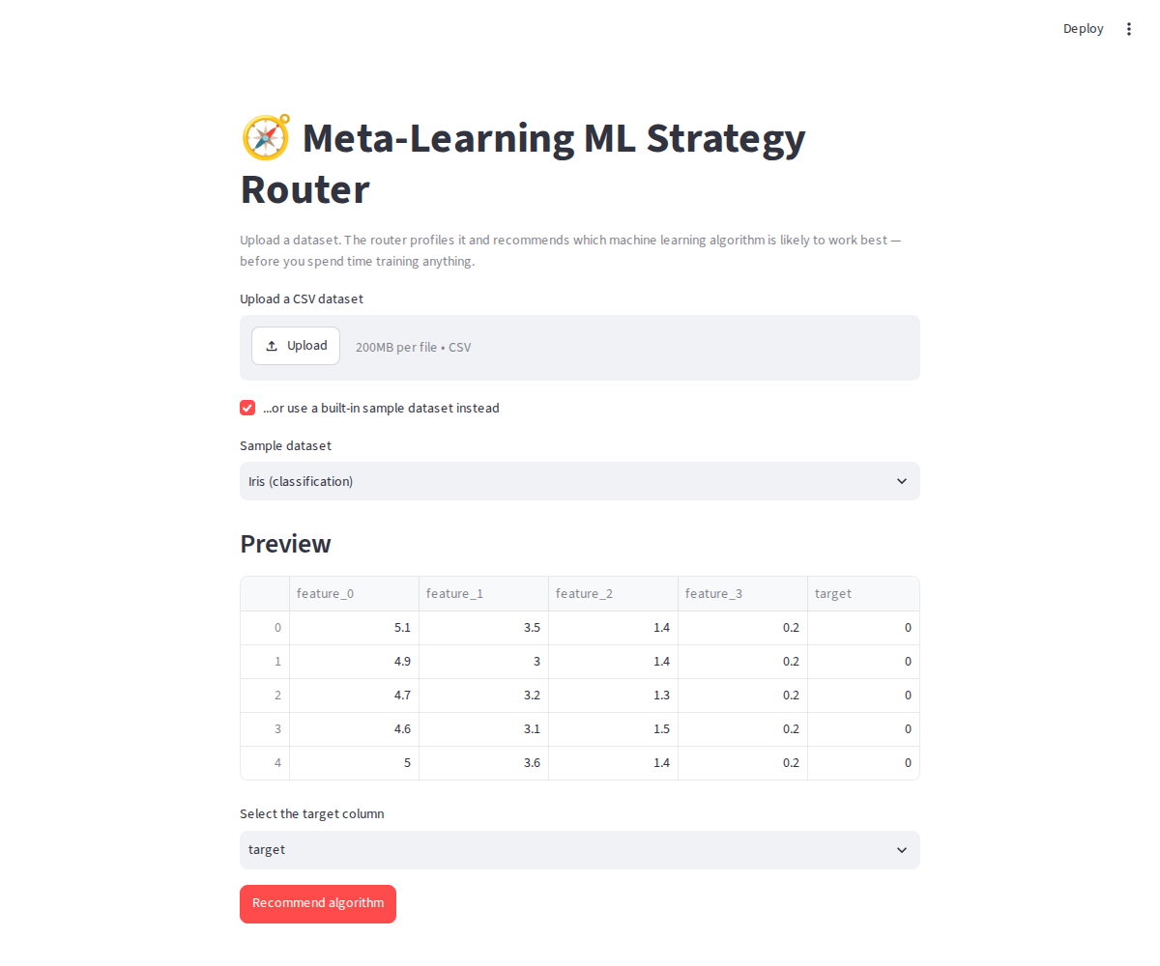
Figure D.1: The web prototype (app.py) with the built-in Iris sample dataset loaded and previewed.

D.2 Streamlit Web App — Recommendation Output
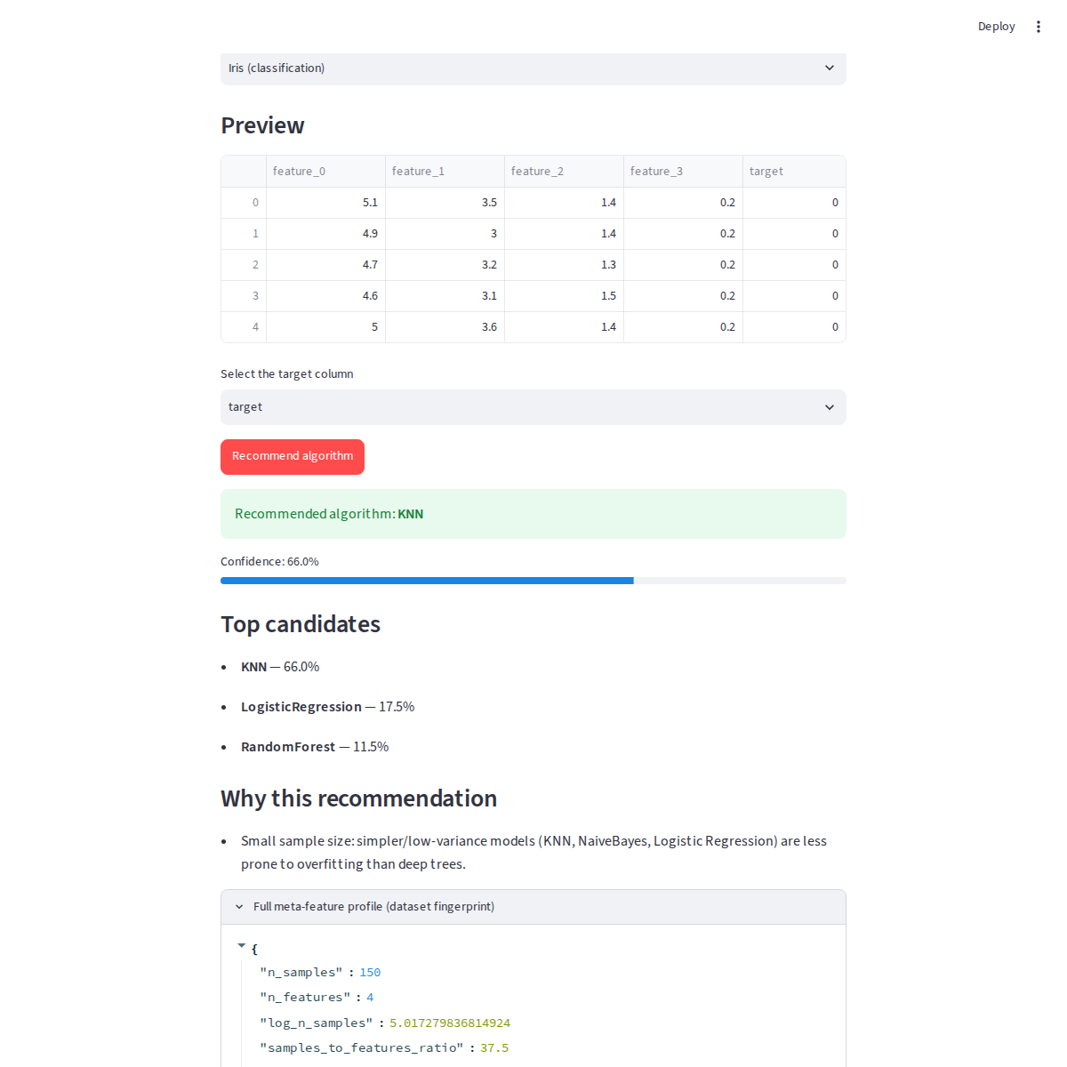
Figure D.2: Router output for Iris — recommended algorithm, confidence, ranked candidates, plain-English explanation, and the full meta-feature fingerprint.

D.3 Command-Line Prototype
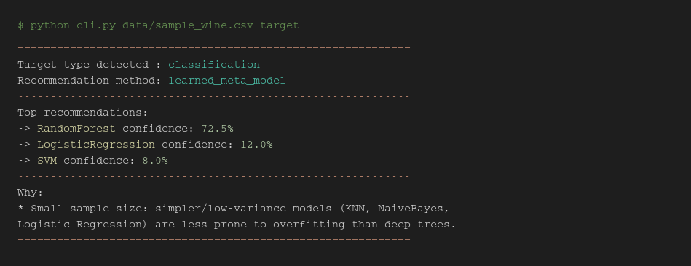
Figure D.3: The terminal prototype (cli.py) run against the Wine dataset, recommending Random Forest at 72.5% confidence.

