**AI ASSISTED CODING-4**

**TASK-1:**

● Zero-shot: Prompt AI to write a function that checks whether a given year is a leap  
year

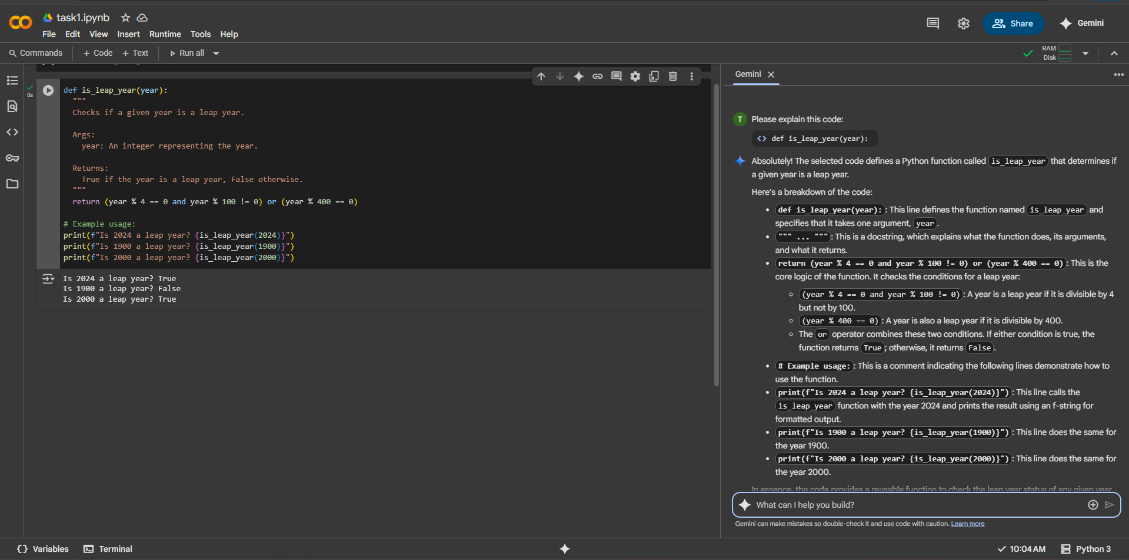

**TASK-2:**

● One-shot: Give one input-output example to guide AI in writing a function that  
converts centimeters to inches

def cm_to_inches(cm):

  """Converts centimeters to inches.

  Args:

    cm: The value in centimeters.

  Returns:

    The value in inches.

  """

  return cm * 0.393701

# Example usage:

centimeters = 10

inches = cm_to_inches(centimeters)

print(f"{centimeters} centimeters is equal to {inches} inches.")

output:

10 centimeters is equal to 3.9370100000000003 inches

Explanation

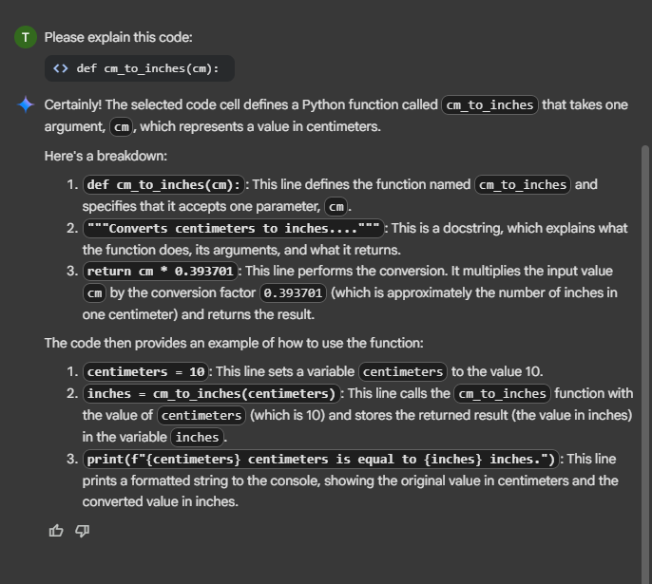

**TASK-3:**

Few-shot: Provide 2–3 examples to generate a function that formats full names as  
“Last, First”

def format_name(full_name):

  """

  Formats a full name string as "Last, First".

  Args:

    full_name: A string containing the full name (e.g., "John Doe").

  Returns:

    A string with the name formatted as "Last, First" (e.g., "Doe, John").

    Returns the original string if it cannot be split into at least two parts.

  """

  names = full_name.split()

  if len(names) >= 2:

    first_name = names[0]

    last_name = names[-1]

    return f"{last_name}, {first_name}"

  else:

    return full_name # Return original if not enough parts

# Example usage:

print(format_name("John Doe"))

print(format_name("Jane Smith"))

print(format_name("Peter"))

**output:**

Doe, John

Smith, Jane

Peter

**Explanation:**

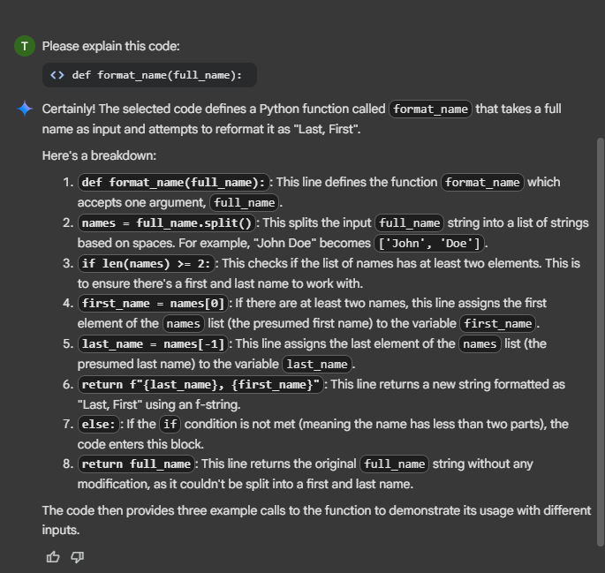

**TASK-4:**

● Compare zero-shot and few-shot prompts for writing a function that counts the  
number of vowels in a string

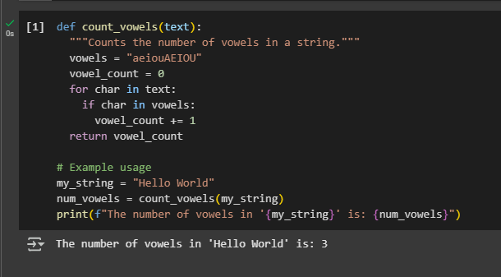

**Explanation:**

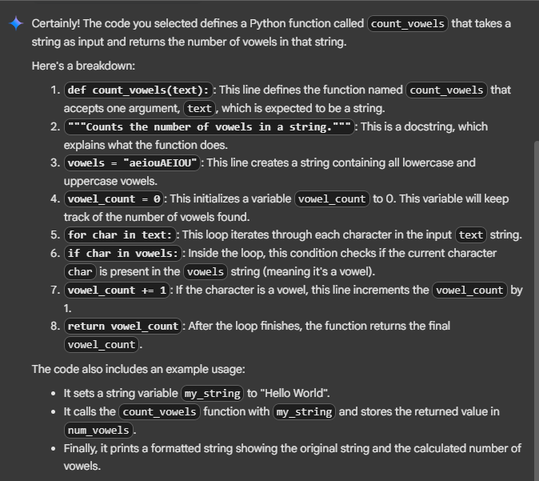

**TASK-5:**

● Use few-shot prompting to generate a function that reads a .txt file and returns the  
number of lines

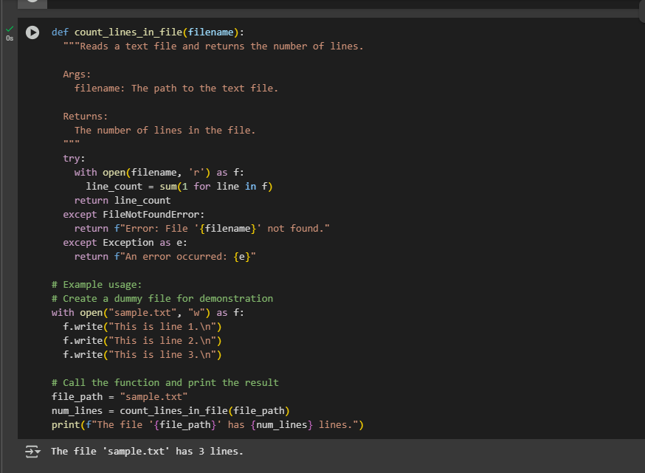

**Explanation:**

