**Flight Search Engine App:**

**What are we looking for:**

**=======================**

1.Please use basic JS(ES5/ES6) to build this Application.

2.You can use libraries like jQuery, moment js, datepicker, underscore etc.

3.You can use DOM selector for jQuery.

4.Do not use CSS frameworks like Bootstrap, Foundation, Materialize CSS etc.

5.Please do not use frameworks like React / Vue / Angular etc.

6.Create sample JSON to make search happen.

**Brownie Points:**

**=============**

1.Responsive design.

2.Creativity in terms of look and feel of the page.

3.Code structure and organization.

4.compatible with modern browsers(Chrome,FF)

**Update From Developer[Vijay P] - Technical specification used to develop Flight Search application:**

***Note : All JS and CSS are Not minified for code evaluation purpose also this app is very light weighted not used any NPM module or any task runner(Grunt,Gulp,webpack)***

**Design Pattern:** Prototype Design Pattern

**CSS Preprocessor:** LESS along with responsive design and Flexbox CSS3 animation.

**Third Party Library –** Jquery,underscore js(template engine),moment(data,time conversion),datepicker.

**Unit Tests :** Jasmine 3.3.0

**CrossBowser compatibility(Modern Browser): Chrome, FF**

**Project Setup related Information:**

Copy paste the flight-search repo and open index.html file in your modern browser.

**Landing page url path:**

**.../flight-search/index.html**

**To Run Unit Test Case in browser:**

**../flight-search/jasmine/flightSearchRunner.html**

**To Search flight information Input Data:**

Origin-> MAA

Destination-> DEL

DepartureDate -> Dec 6th 2019

ReturnDate - > Dec 7th 2019

Sorting –> based on Price low or high

**Find below a few screenshots for responsive design and application looks and feel.**

**1. Jasmine Unit Test case execution result:**

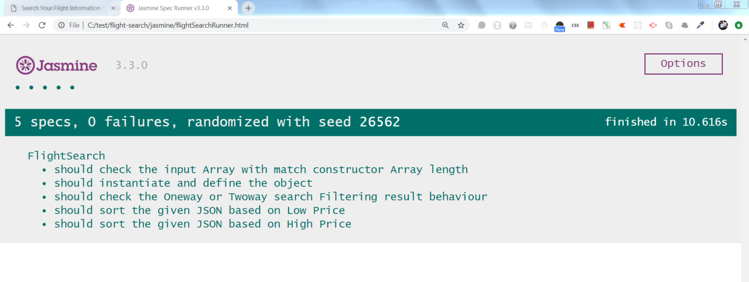

**2.Mobile display Portrait Mode:**

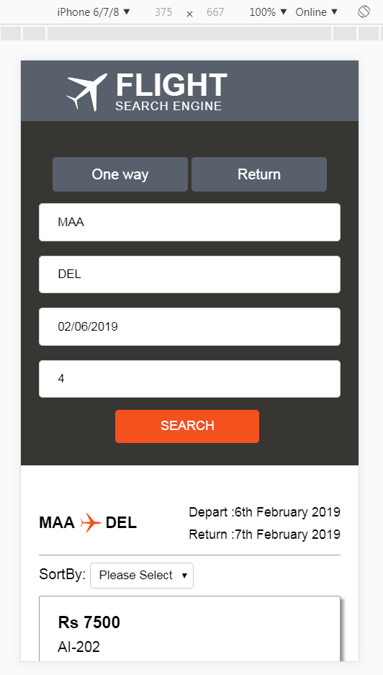

**3.Tab/ipad display:**

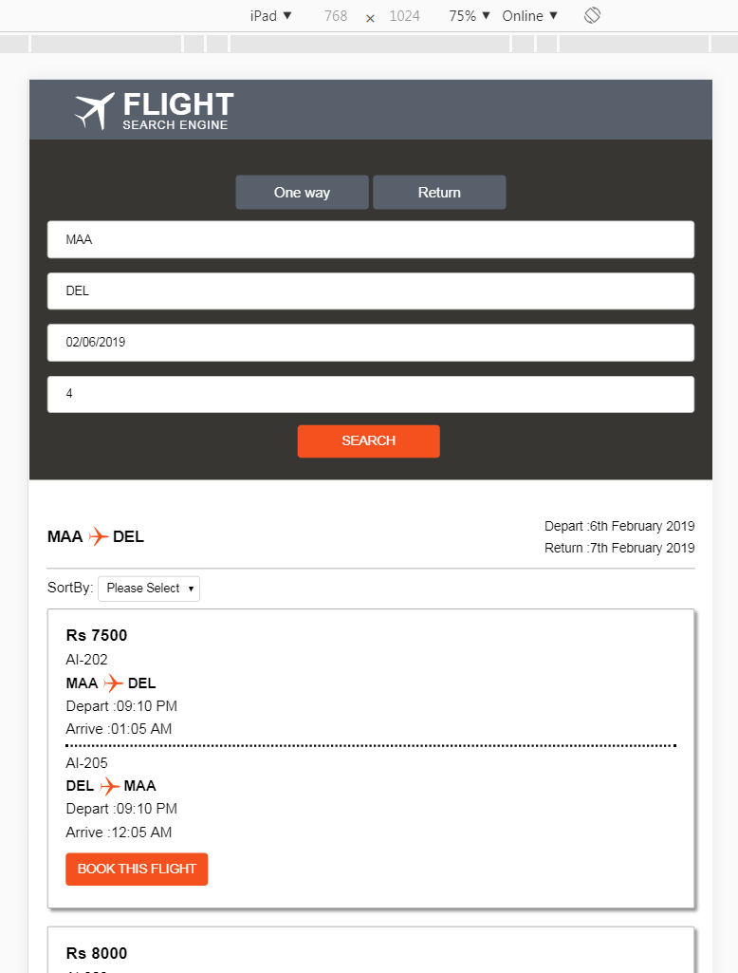

**4.Desktop Display:**

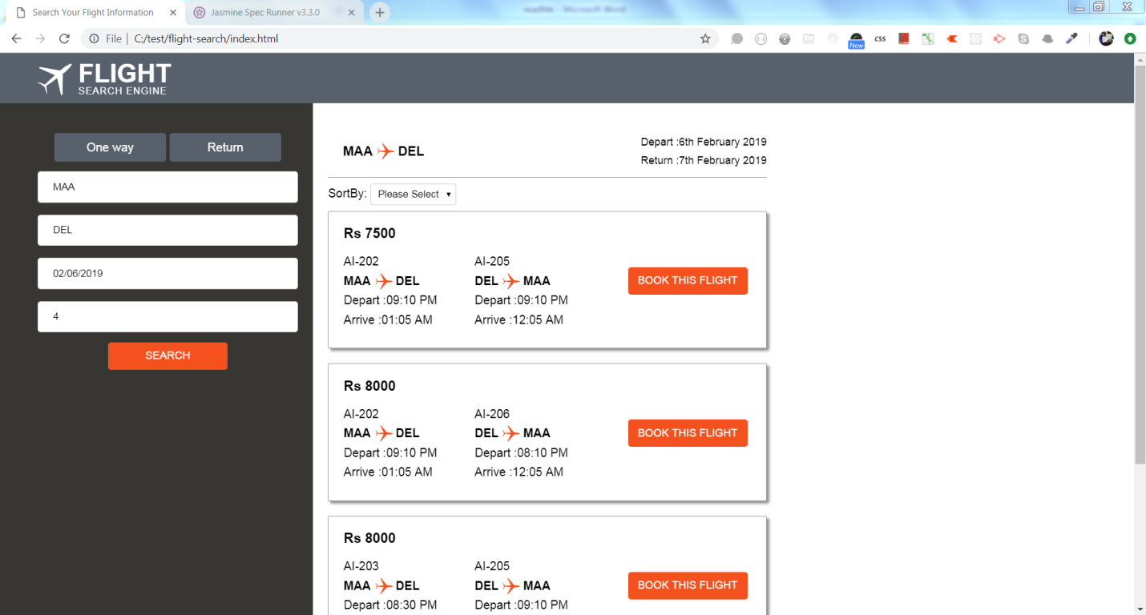

**5.cross-browser FF display:**

