Name Of the Student : Damarla Karthik
Regd. Number : 24BCE8378
School/Dept : SCOPE
Date Of Conduction : 11-06-2026
Course Name : FACE Prep - MongoDB Database Administrator

SHARDING

The Config Server (Port 27019 - The Map) :
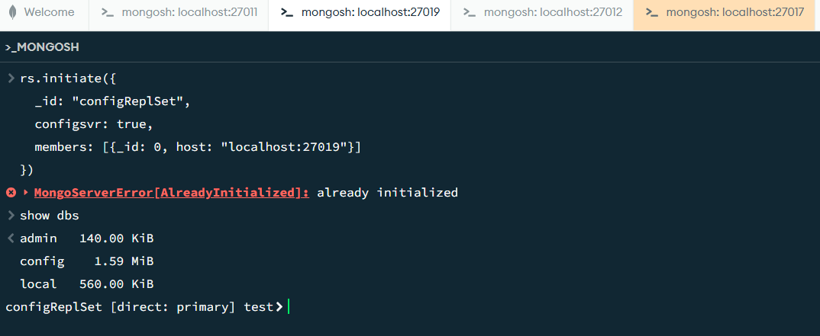

The Query Router / mongos (Port 27017 - The Traffic Cop) :
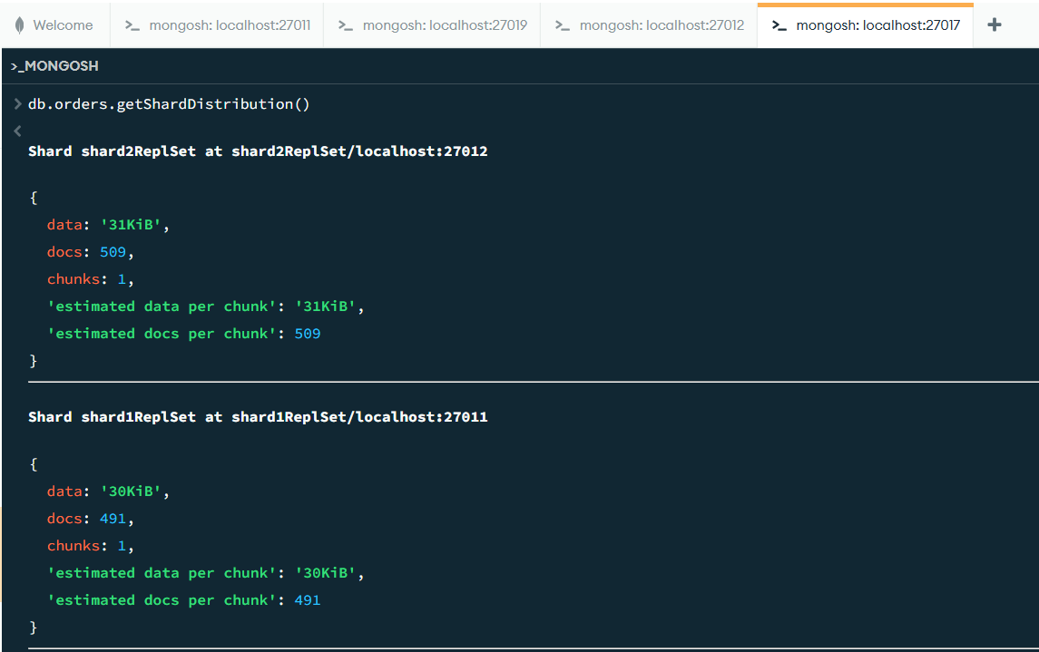

The Shards (Ports 27011 & 27012 - The Storage Boxes) :

Port : 27011 :
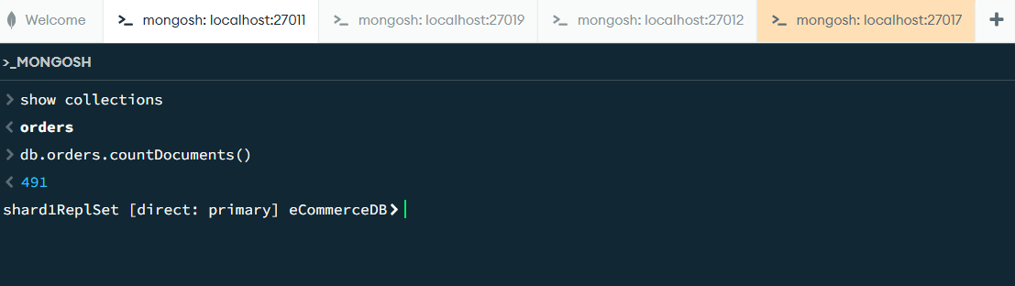

Port 27012 :
