Name Of the Student : Damarla Karthik
Regd. Number : 24BCE8378
Email : karthik.24bce8378@vitaptudent.ac.in
School/Dept : SCOPE
Date Of Conduction : 05-06-2026
Course Name : FACE Prep - MongoDB Database Administrator

ECLIPSE - mongo\src\MongoDBConnection.java :

package mongo;

import com.mongodb.client.MongoClient;
import com.mongodb.client.MongoClients;
import com.mongodb.client.MongoDatabase;

public class MongoDBConnection {
public static void main(String[] args) {
String connectionString = "mongodb://localhost:27017";

try (MongoClient mongoClient = MongoClients.create(connectionString)) {
MongoDatabase database = mongoClient.getDatabase("testdb");
System.out.println("Connected successfully to MongoDB!");
}
}
}

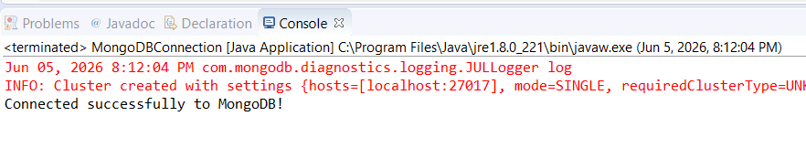

ECLIPSE - mongo\src\aggregate.java (for $sum) :

package mongo;

import org.bson.Document;
import com.mongodb.client.*;
import java.util.*;

public class aggregate {

public static void main(String[] args){

// Connect to MongoDB
MongoClient mongoClient = MongoClients.create("mongodb://localhost:27017");

// Access database
MongoDatabase database = mongoClient.getDatabase("vit");

// Access collection
MongoCollection<Document> collection = database.getCollection("sales");

// ==========================
// CREATE (insert)
// ==========================
Document s1 = new Document("_id", 1).append("item", "Americanos").append("price", 5).append("size", "Short").append("quantity", 22)
.append("date", new Date(122, 0, 15));

Document s2 = new Document("_id", 2).append("item", "Cappuccino").append("price", 6).append("size", "Short").append("quantity", 12)
.append("date", new Date(122, 0, 16));

Document s3 = new Document("_id", 3).append("item", "Lattes").append("price", 15).append("size", "Grande").append("quantity", 25)
.append("date", new Date(122, 0, 16));

Document s4 = new Document("_id", 4).append("item", "Mochas").append("price", 25).append("size", "Tall").append("quantity", 11)
.append("date", new Date(122, 1, 17));

Document s5 = new Document("_id", 5).append("item", "Americanos").append("price", 10).append("size", "Grande").append("quantity", 12)
.append("date", new Date(122, 1, 18));

Document s6 = new Document("_id", 6).append("item", "Cappuccino").append("price", 7).append("size", "Tall").append("quantity", 20)
.append("date", new Date(122, 1, 20));

Document s7 = new Document("_id", 7).append("item", "Lattes").append("price", 25).append("size", "Tall").append("quantity", 30)
.append("date", new Date(122, 1, 21));

Document s8 = new Document("_id", 8).append("item", "Americanos").append("price", 10).append("size", "Grande").append("quantity", 21)
.append("date", new Date(122, 1, 22));

Document s9 = new Document("_id", 9).append("item", "Cappuccino").append("price", 10).append("size", "Grande").append("quantity", 17)
.append("date", new Date(122, 1, 23));

Document s10 = new Document("_id", 10).append("item", "Americanos").append("price", 8).append("size", "Tall").append("quantity", 15)
.append("date", new Date(122, 1, 25));

collection.insertMany(Arrays.asList(s1, s2, s3, s4, s5, s6, s7, s8, s9, s10));
System.out.println("Sales Documents Inserted Successfully");

// ==========================
// READ — All documents
// ==========================
System.out.println("\nAll Sales Records:");
FindIterable<Document> allDocs = collection.find();
for (Document doc : allDocs) {
System.out.println(doc.toJson());
}

// ==========================
// AGGREGATE
// ==========================
List<Document> newDoc = Arrays.asList(
// Stage 1 — $group: group by item, sum quantity
new Document("$group", new Document("_id", "$item")
.append("totalQty", new Document("$sum", "$quantity"))),

// Stage 2 — $sort: sort by totalQty descending (-1)
new Document("$sort", new Document("totalQty", -1))
);

// ==========================
// READ — Aggregation result
// ==========================
System.out.println("\nTotal Quantity per Item (Descending):");
AggregateIterable<Document> result = collection.aggregate(newDoc);
for (Document doc : result) {
System.out.println(doc.toJson());
}

// Close connection
mongoClient.close();

}
}

ECLIPSE CONSOLE OUTPUT :
