Name Of the Student : Damarla Karthik
Regd. Number : 24BCE8378
Email : karthik.24bce8378@vitaptudent.ac.in
School/Dept : SCOPE
Date Of Conduction : 10-06-2026
Course Name : FACE Prep - MongoDB Database Administrator

Replication Set :
1. mongosh: localhost:27017 (PRIMARY)

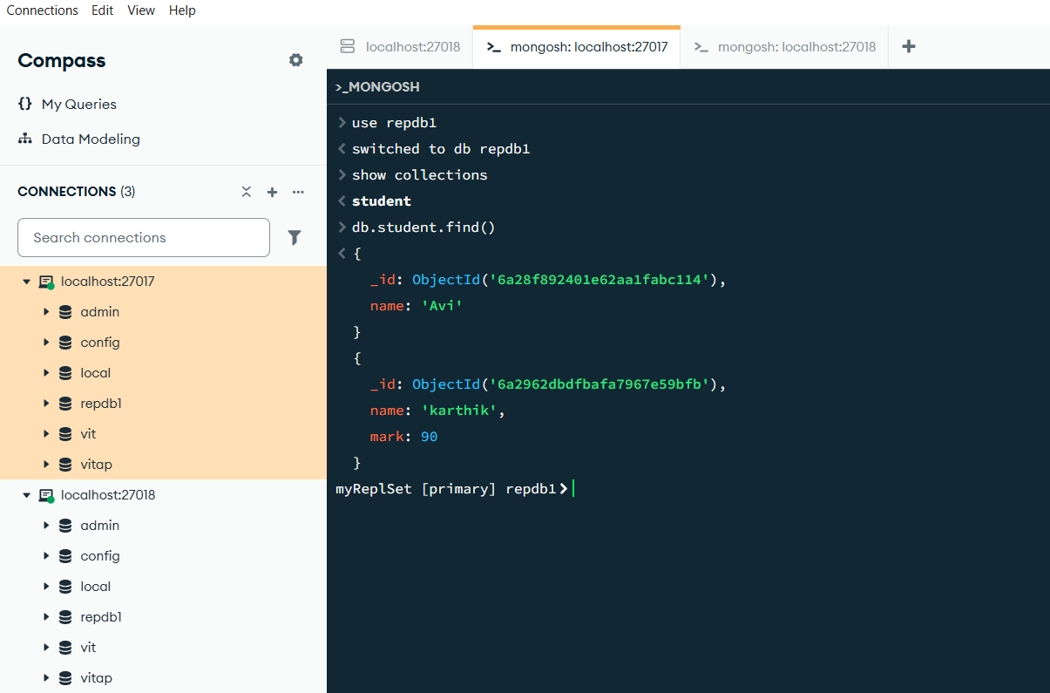

- mongosh: localhost:27018 (SECONDARY)

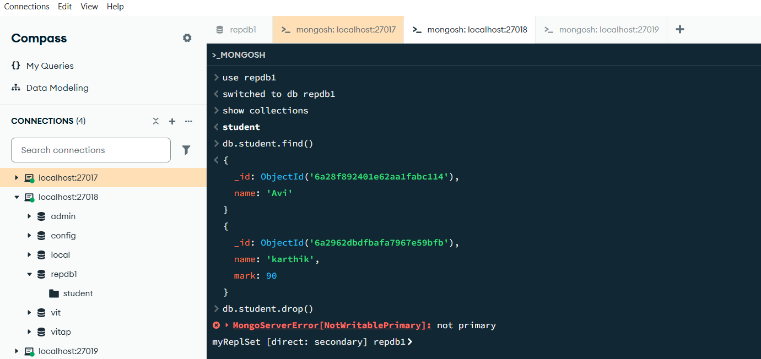

- mongosh: localhost:27019 (SECONDARY)

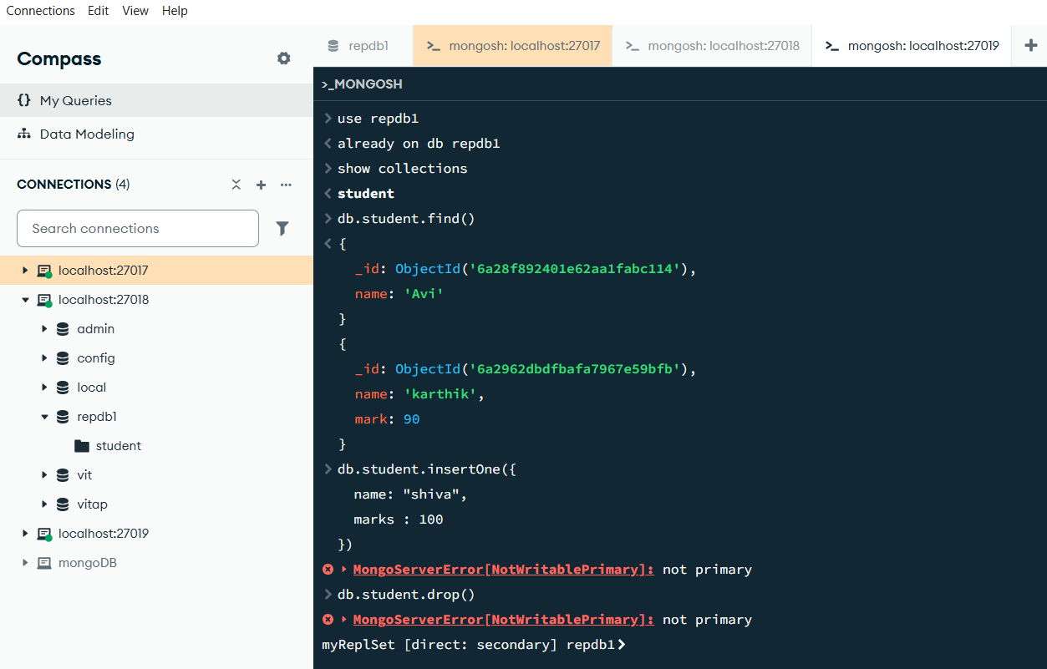

Sharding :
Port : 27019
mkdir -p ~/data/config
mkdir : An item with the specified name C:\Users\karth\data\config already exists.
At line:1 char:1
+ mkdir -p ~/data/config
+ ~~~~~~~~~~~~~~~~~~~~~~
+ CategoryInfo : ResourceExists: (C:\Users\karth\data\config:String) [New-Item], IOException
+ FullyQualifiedErrorId : DirectoryExist,Microsoft.PowerShell.Commands.NewItemCommand

mongod --configsvr --replSet configReplSet --dbpath ~/data/config --port 27019
mongod : The term 'mongod' is not recognized as the name of a cmdlet, function, script file, or operable program. Check the
spelling of the name, or if a path was included, verify that the path is correct and try again.
At line:1 char:1
+ mongod --configsvr --replSet configReplSet --dbpath ~/data/config --p ...
+ ~~~~~~
+ CategoryInfo : ObjectNotFound: (mongod:String) [], CommandNotFoundException
+ FullyQualifiedErrorId : CommandNotFoundException

& "C:\Program Files\MongoDB\Server\8.3\bin\mongod.exe" --configsvr --replSet configReplSet --dbpath "C:\Users\karth\data\config" --port 27019
{"t":{"$date":"2026-06-10T20:23:02.705+05:30"},"s":"I", "c":"-", "id":8991200, "ctx":"thread1","msg":"Shuffling initializers","attr":{"seed":3649314618}}
{"t":{"$date":"2026-06-10T20:23:02.750+05:30"},"s":"I", "c":"CONTROL", "id":97374, "ctx":"thread1","msg":"Automatically disabling TLS 1.0 and TLS 1.1, to force-enable TLS 1.1 specify --sslDisabledProtocols 'TLS1_0'; to force-enable TLS 1.0 specify --sslDisabledProtocols 'none'"}
{"t":{"$date":"2026-06-10T20:23:02.755+05:30"},"s":"I", "c":"EXECUTOR", "id":11280000,"svc":"-", "ctx":"thread1","msg":"Starting thread pool","attr":{"poolName":"AuthorizationRouter","numThreads":0,"minThreads":0,"maxThreads":1000000000}}
{"t":{"$date":"2026-06-10T20:23:02.757+05:30"},"s":"I", "c":"NETWORK", "id":4915701, "svc":"-", "ctx":"thread1","msg":"Initialized wire specification","attr":{"spec":{"incomingExternalClient":{"minWireVersion":0,"maxWireVersion":28},"incomingInternalClient":{"minWireVersion":0,"maxWireVersion":28},"outgoing":{"minWireVersion":6,"maxWireVersion":28},"isInternalClient":true}}}
{"t":{"$date":"2026-06-10T20:23:02.757+05:30"},"s":"I", "c":"EXECUTOR", "id":11280000,"svc":"-", "ctx":"thread1","msg":"Starting thread pool","attr":{"poolName":"ThreadPool1","numThreads":0,"minThreads":0,"maxThreads":1}}
{"t":{"$date":"2026-06-10T20:23:02.757+05:30"},"s":"I", "c":"REPL", "id":5123008, "svc":"-", "ctx":"thread1","msg":"Successfully registered PrimaryOnlyService","attr":{"service":"ReshardingCoordinatorService","namespace":"config.reshardingOperations"}}
{"t":{"$date":"2026-06-10T20:23:02.757+05:30"},"s":"I", "c":"REPL", "id":5123008, "svc":"-", "ctx":"thread1","msg":"Successfully registered PrimaryOnlyService","attr":{"service":"ConfigsvrCoordinatorService","namespace":"config.sharding_configsvr_coordinators"}}
{"t":{"$date":"2026-06-10T20:23:02.757+05:30"},"s":"I", "c":"REPL", "id":5123008, "svc":"-", "ctx":"thread1","msg":"Successfully registered PrimaryOnlyService","attr":{"service":"ShardingDDLCoordinator","namespace":"config.system.sharding_ddl_coordinators"}} ……running
rs.initiate({
>> _id: "configReplSet",
>> configsvr: true,
>> members: [{_id: 0, host: "localhost:27019"}]
>> })
rs.initiate : The term 'rs.initiate' is not recognized as the name of a cmdlet, function, script file, or operable program.
Check the spelling of the name, or if a path was included, verify that the path is correct and try again.
At line:1 char:1
+ rs.initiate({
+ ~~~~~~~~~~~
+ CategoryInfo : ObjectNotFound: (rs.initiate:String) [], CommandNotFoundException
+ FullyQualifiedErrorId : CommandNotFoundException

mongosh --port 27019
Current Mongosh Log ID: 6a297a938766155be4abc113
Connecting to: mongodb://127.0.0.1:27019/?directConnection=true&serverSelectionTimeoutMS=2000&appName=mongosh+2.8.3
Using MongoDB: 8.3.2
Using Mongosh: 2.8.3

For mongosh info see: https://www.mongodb.com/docs/mongodb-shell/

------
The server generated these startup warnings when booting
2026-06-10T20:23:03.106+05:30: Access control is not enabled for the database. Read and write access to data and configuration is unrestricted
2026-06-10T20:23:03.106+05:30: This server is bound to localhost. Remote systems will be unable to connect to this server. Start the server with --bind_ip <address> to specify which IP addresses it should serve responses from, or with --bind_ip_all to bind to all interfaces. If this behavior is desired, start the server with --bind_ip 127.0.0.1 to disable this warning
------

test> rs.initiate({
| _id: "configReplSet",
| configsvr: true,
| members: [{_id: 0, host: "localhost:27019"}]
| })
{
ok: 1,
'$clusterTime': {
clusterTime: Timestamp({ t: 1781103255, i: 1 }),
signature: {
hash: Binary.createFromBase64('AAAAAAAAAAAAAAAAAAAAAAAAAAA=', 0),
keyId: Long('0')
}
},
operationTime: Timestamp({ t: 1781103255, i: 1 })
}
configReplSet [direct: secondary] test>

mkdir -p ~/data/shard1 ~/data/shard2
mkdir : A positional parameter cannot be found that accepts argument '~/data/shard2'.
At line:1 char:1
+ mkdir -p ~/data/shard1 ~/data/shard2
+ ~~~~~~~~~~~~~~~~~~~~~~~~~~~~~~~~~~~~
+ CategoryInfo : InvalidArgument: (:) [mkdir], ParameterBindingException
+ FullyQualifiedErrorId : PositionalParameterNotFound,mkdir

mkdir -p C:\Users\karth\data\shard1 C:\Users\karth\data\shard2
mkdir : A positional parameter cannot be found that accepts argument 'C:\Users\karth\data\shard2'.
At line:1 char:1
+ mkdir -p C:\Users\karth\data\shard1 C:\Users\karth\data\shard2
+ ~~~~~~~~~~~~~~~~~~~~~~~~~~~~~~~~~~~~~~~~~~~~~~~~~~~~~~~~~~~~~~
+ CategoryInfo : InvalidArgument: (:) [mkdir], ParameterBindingException
+ FullyQualifiedErrorId : PositionalParameterNotFound,mkdir

mkdir C:\Users\karth\data\shard1

Directory: C:\Users\karth\data

Mode LastWriteTime Length Name
---- ------------- ------ ----
d----- 6/10/2026 8:26 PM shard1

mkdir C:\Users\karth\data\shard2

Directory: C:\Users\karth\data

Mode LastWriteTime Length Name
---- ------------- ------ ----
d----- 6/10/2026 8:27 PM shard2

Port : 27011

& "C:\Program Files\MongoDB\Server\8.3\bin\mongod.exe" --shardsvr --replSet shard1ReplSet --dbpath "C:\Users\karth\data\shard1" --port 27011
{"t":{"$date":"2026-06-10T20:27:16.306+05:30"},"s":"I", "c":"-", "id":8991200, "ctx":"thread1","msg":"Shuffling initializers","attr":{"seed":512970681}}
{"t":{"$date":"2026-06-10T20:27:16.313+05:30"},"s":"I", "c":"CONTROL", "id":97374, "ctx":"thread1","msg":"Automatically disabling TLS 1.0 and TLS 1.1, to force-enable TLS 1.1 specify --sslDisabledProtocols 'TLS1_0'; to force-enable TLS 1.0 specify --sslDisabledProtocols 'none'"}
{"t":{"$date":"2026-06-10T20:27:16.350+05:30"},"s":"I", "c":"EXECUTOR", "id":11280000,"svc":"-", "ctx":"thread1","msg":"Starting thread pool","attr":{"poolName":"AuthorizationRouter","numThreads":0,"minThreads":0,"maxThreads":1000000000}}
{"t":{"$date":"2026-06-10T20:27:16.351+05:30"},"s":"I", "c":"NETWORK", "id":4915701, "svc":"-", "ctx":"thread1","msg":"Initialized wire specification","attr":{"spec":{"incomingExternalClient":{"minWireVersion":0,"maxWireVersion":28},"incomingInternalClient":{"minWireVersion":0,"maxWireVersion":28},"outgoing":{"minWireVersion":6,"maxWireVersion":28},"isInternalClient":true}}}
{"t":{"$date":"2026-06-10T20:27:16.352+05:30"},"s":"I", "c":"EXECUTOR", "id":11280000,"svc":"-", "ctx":"thread1","msg":"Starting thread pool","attr":{"poolName":"ThreadPool1","numThreads":0,"minThreads":0,"maxThreads":1}}
{"t":{"$date":"2026-06-10T20:27:16.353+05:30"},"s":"I", "c":"REPL", "id":5123008, "svc":"-", "ctx":"thread1","msg":"Successfully registered PrimaryOnlyService","attr":{"service":"ShardingDDLCoordinator","namespace":"config.system.sharding_ddl_coordinators"}} …..running

Port : 27012

& "C:\Program Files\MongoDB\Server\8.3\bin\mongod.exe" --shardsvr --replSet shard2ReplSet --dbpath "C:\Users\karth\data\shard2" --port 27012
{"t":{"$date":"2026-06-10T20:27:25.009+05:30"},"s":"I", "c":"-", "id":8991200, "ctx":"thread1","msg":"Shuffling initializers","attr":{"seed":2999111809}}
{"t":{"$date":"2026-06-10T20:27:25.053+05:30"},"s":"I", "c":"CONTROL", "id":97374, "ctx":"thread1","msg":"Automatically disabling TLS 1.0 and TLS 1.1, to force-enable TLS 1.1 specify --sslDisabledProtocols 'TLS1_0'; to force-enable TLS 1.0 specify --sslDisabledProtocols 'none'"}
{"t":{"$date":"2026-06-10T20:27:25.057+05:30"},"s":"I", "c":"EXECUTOR", "id":11280000,"svc":"-", "ctx":"thread1","msg":"Starting thread pool","attr":{"poolName":"AuthorizationRouter","numThreads":0,"minThreads":0,"maxThreads":1000000000}}
{"t":{"$date":"2026-06-10T20:27:25.058+05:30"},"s":"I", "c":"NETWORK", "id":4915701, "svc":"-", "ctx":"thread1","msg":"Initialized wire specification","attr":{"spec":{"incomingExternalClient":{"minWireVersion":0,"maxWireVersion":28},"incomingInternalClient":{"minWireVersion":0,"maxWireVersion":28},"outgoing":{"minWireVersion":6,"maxWireVersion":28},"isInternalClient":true}}}
{"t":{"$date":"2026-06-10T20:27:25.059+05:30"},"s":"I", "c":"EXECUTOR", "id":11280000,"svc":"-", "ctx":"thread1","msg":"Starting thread pool","attr":{"poolName":"ThreadPool1","numThreads":0,"minThreads":0,"maxThreads":1}}
{"t":{"$date":"2026-06-10T20:27:25.059+05:30"},"s":"I", "c":"REPL", "id":5123008, "svc":"-", "ctx":"thread1","msg":"Successfully registered PrimaryOnlyService","attr":{"service":"ShardingDDLCoordinator","namespace":"config.system.sharding_ddl_coordinators"}}
{"t":{"$date":"2026-06-10T20:27:25.059+05:30"},"s":"I", "c":"REPL", "id":5123008, "svc":"-", "ctx":"thread1","msg":"Successfully registered PrimaryOnlyService","attr":{"service":"RenameCollectionParticipantService","namespace":"config.localRenameParticipants"}}…..running

