Name Of the Student : Damarla Karthik
Regd. Number : 24BCE8378
School/Dept : SCOPE
Date Of Conduction : 16-06-2026
Course Name : FACE Prep - MongoDB Database Administrator
Swagger UI Screenshots for project completed so far :
- User registration and Authorization using JWT token
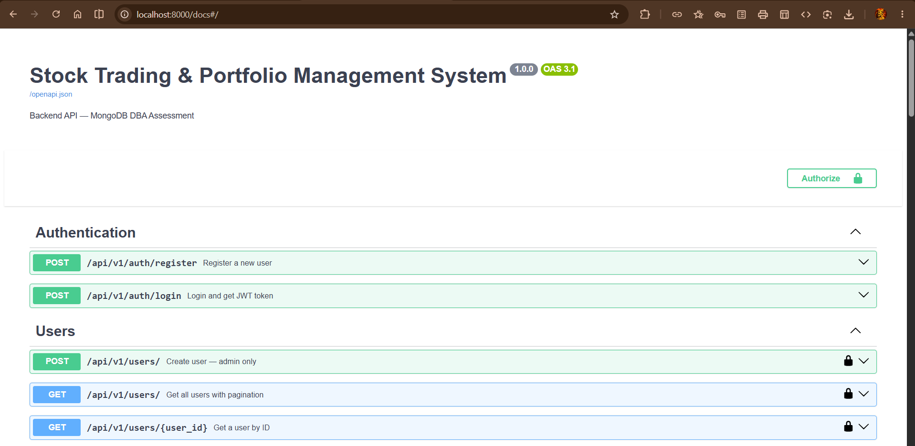

Register a new User | Login and get JWT token
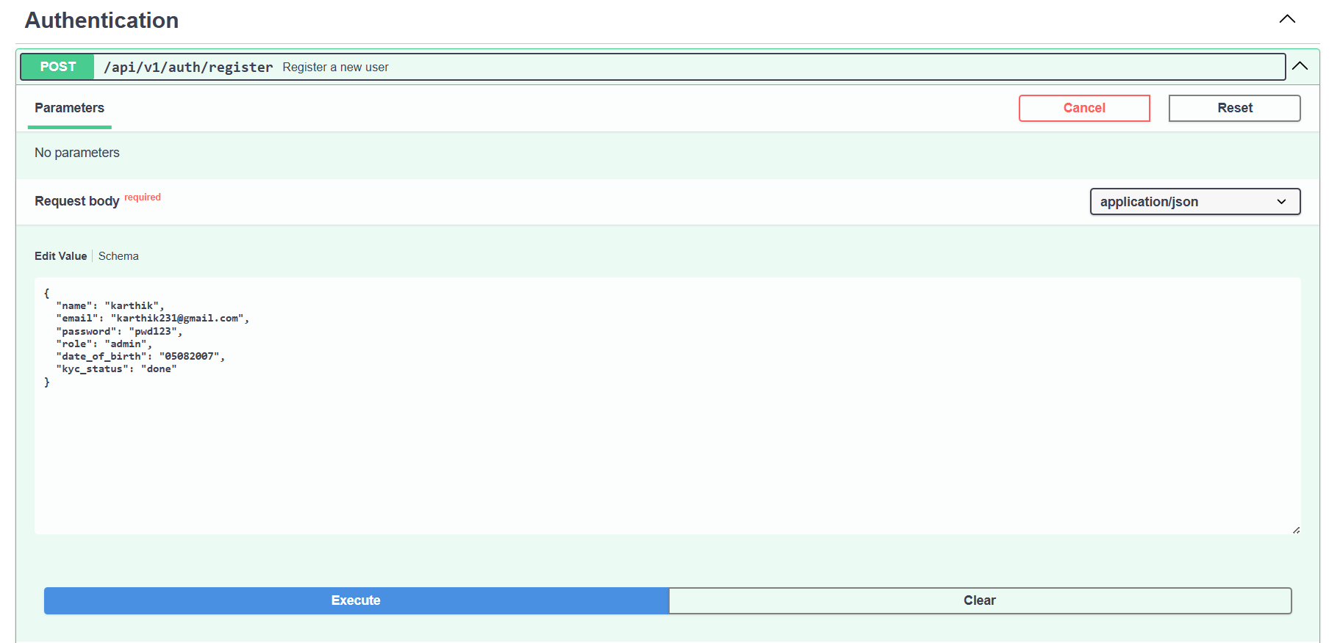 | 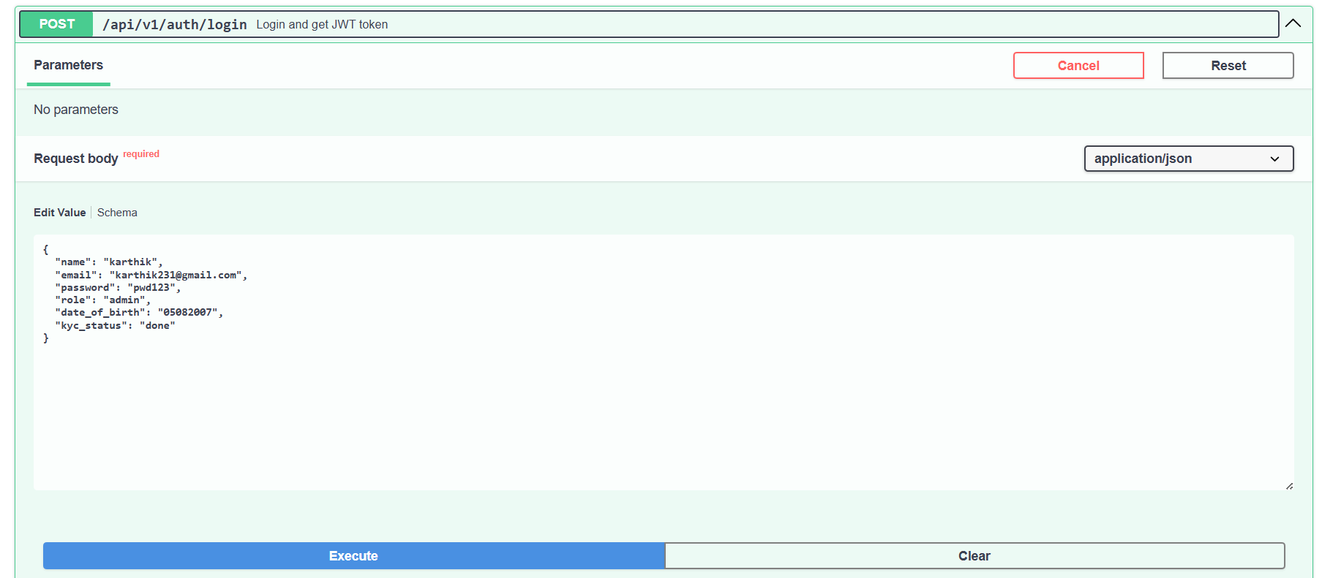
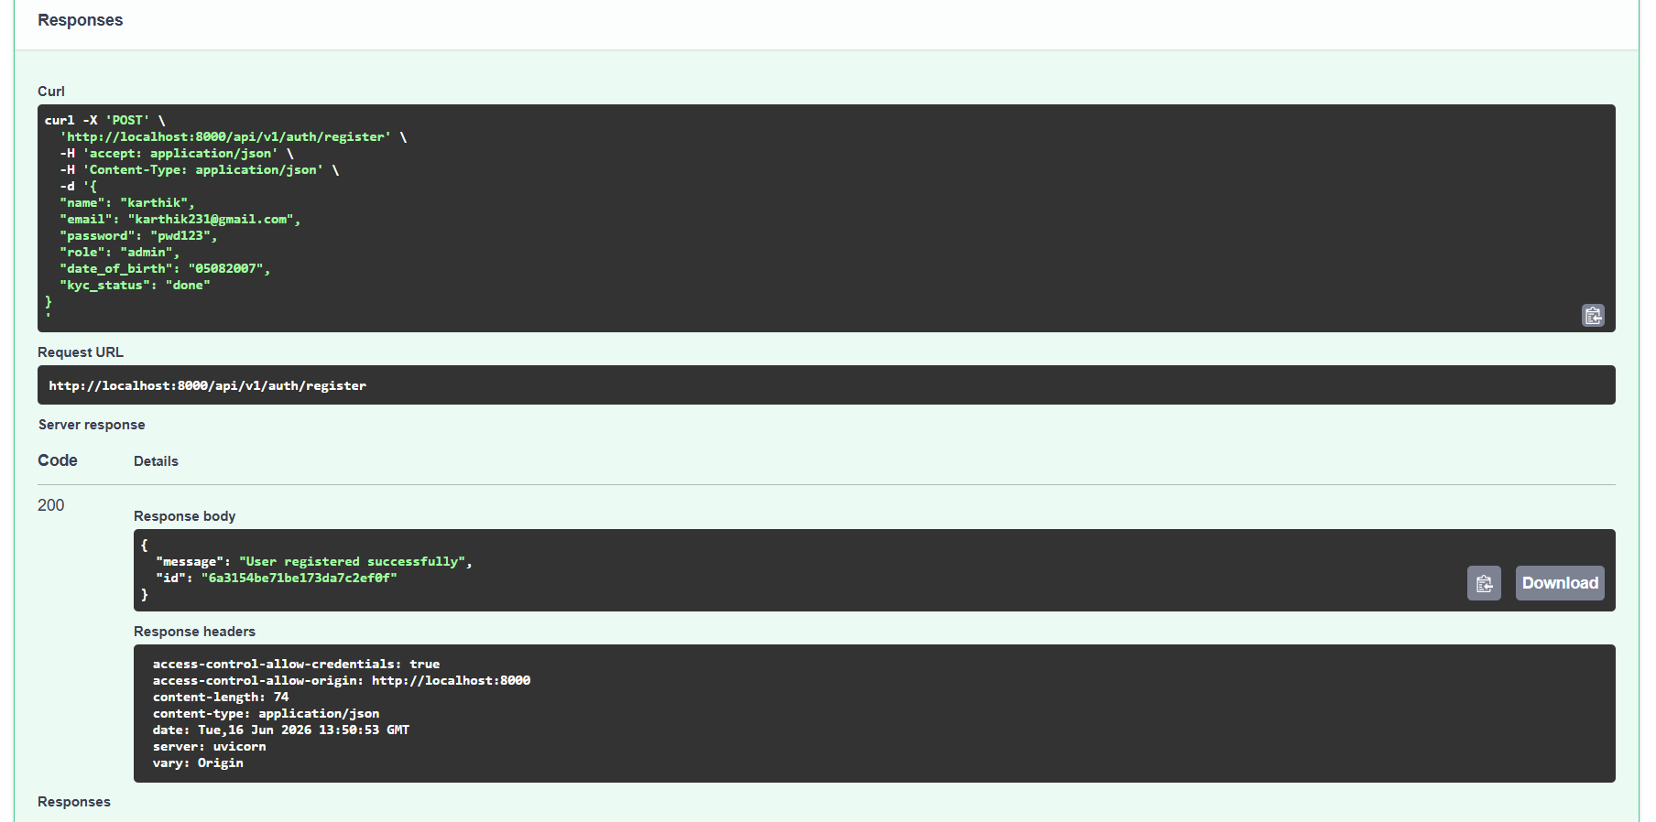 | 

- User
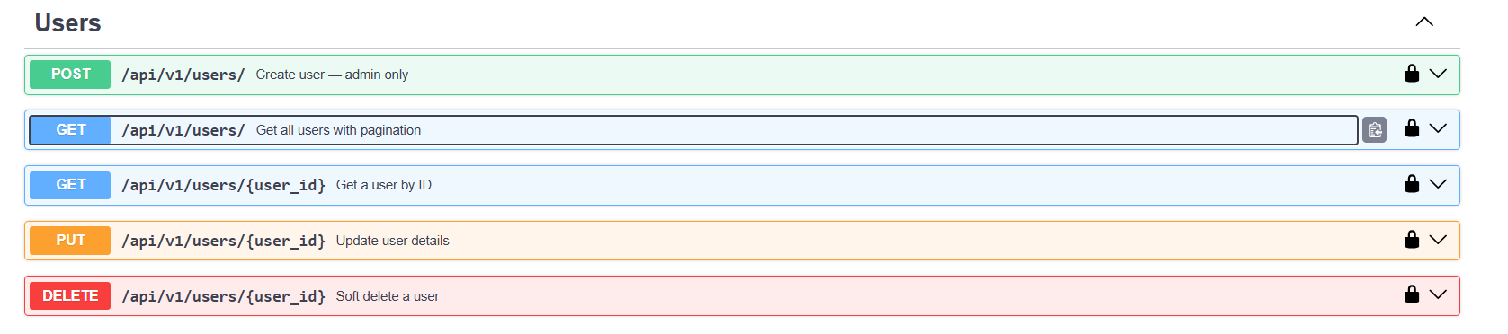

GET /api/v1/users/ Get all users with pagination :
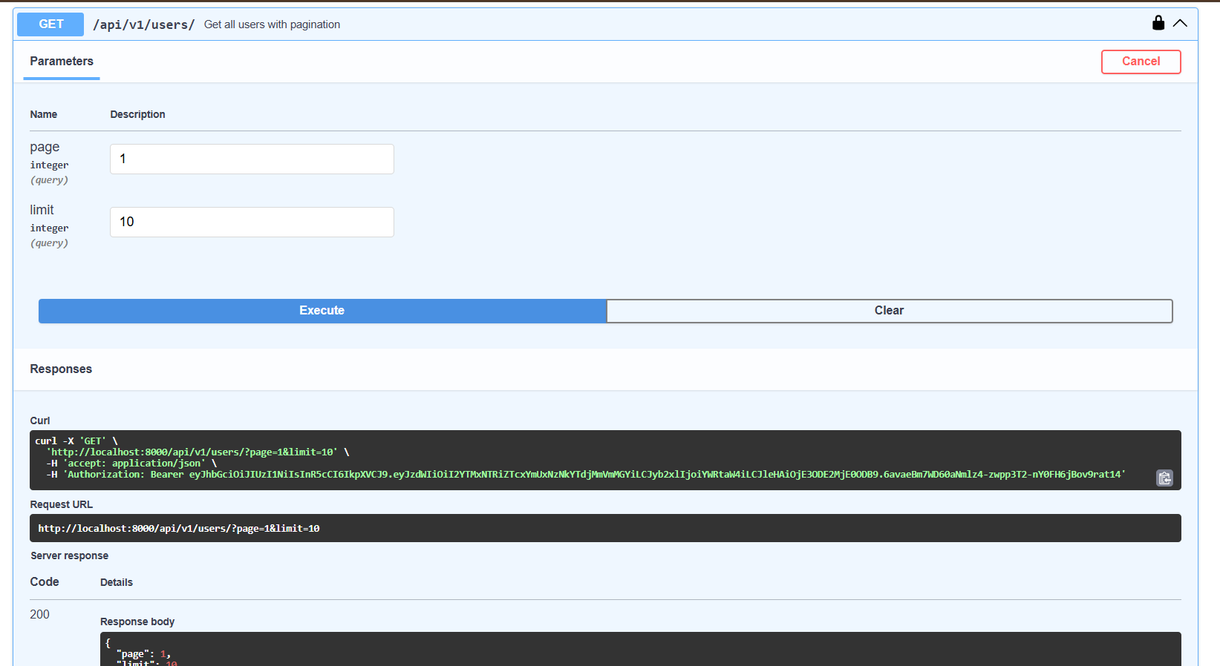
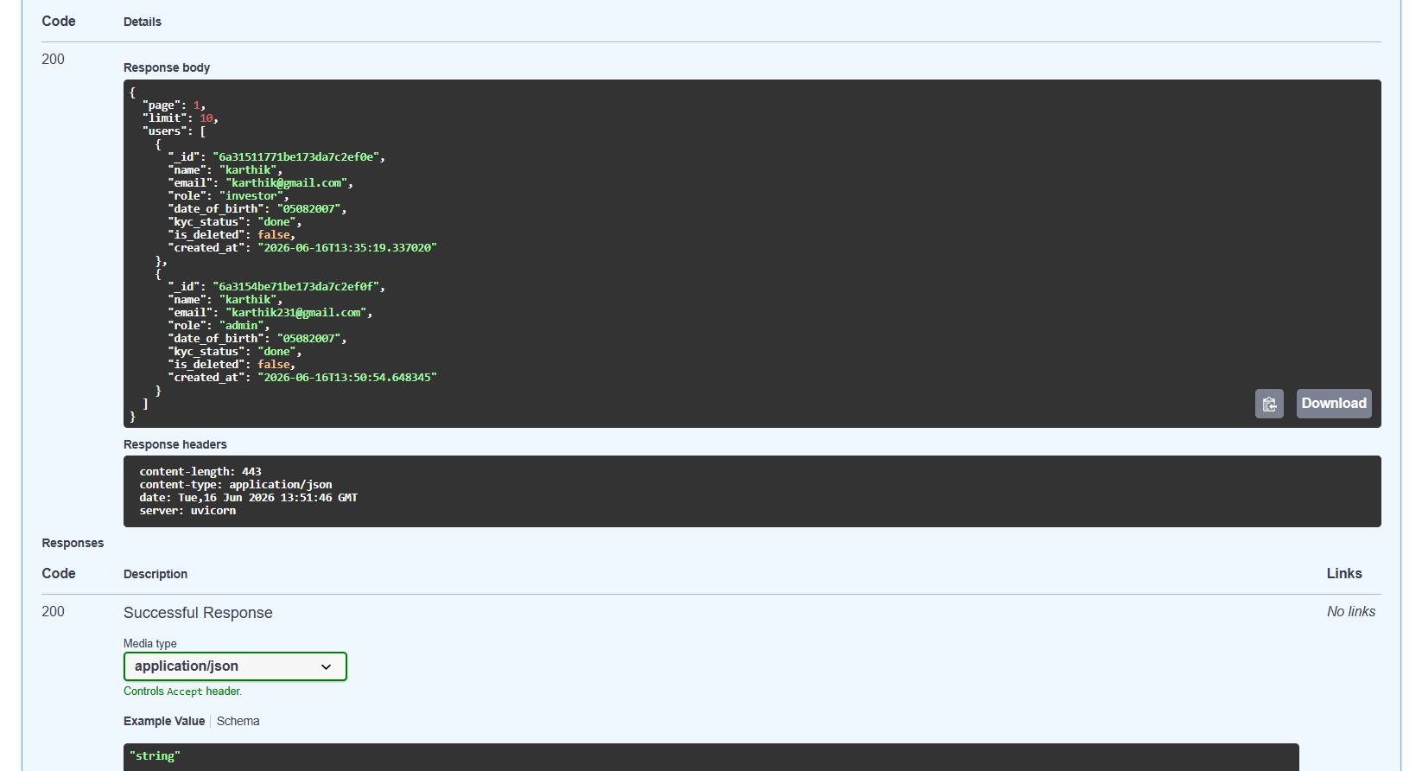

GET /api//v1/users/{user_id} : Get User by ID
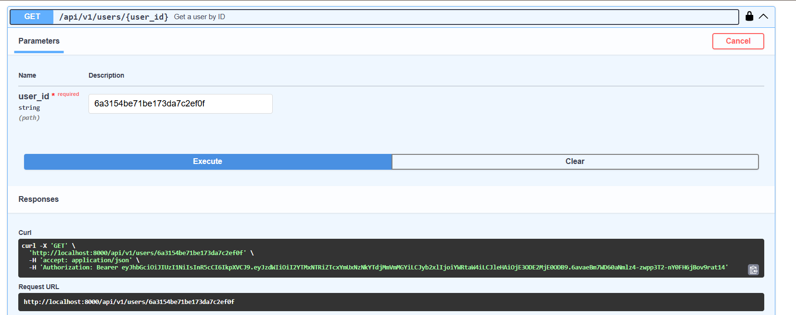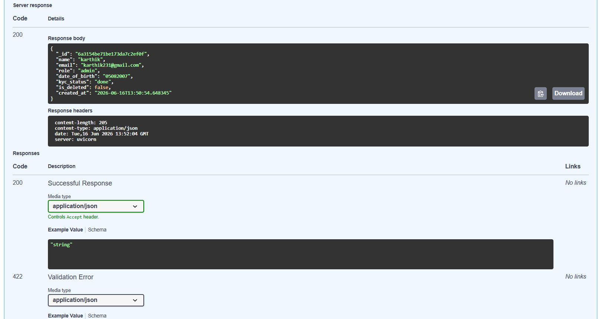

PUT /api/v1/users/{user_id} Update user details :
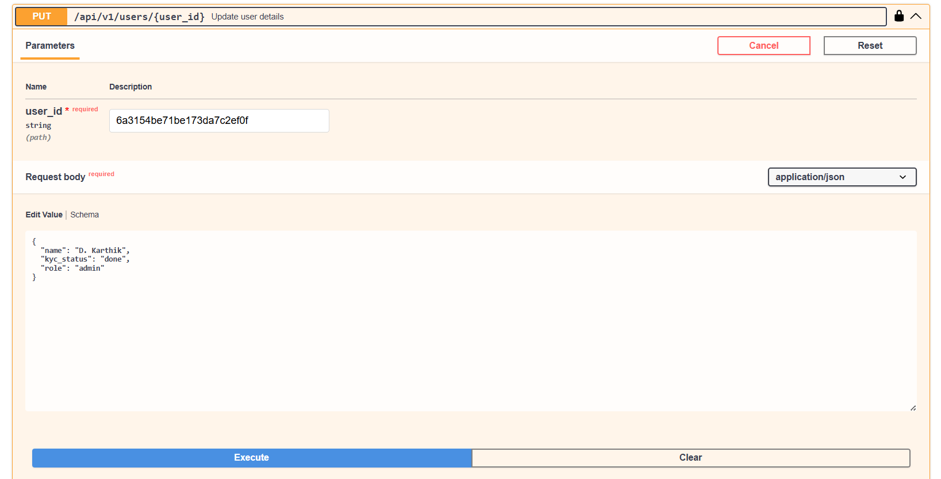
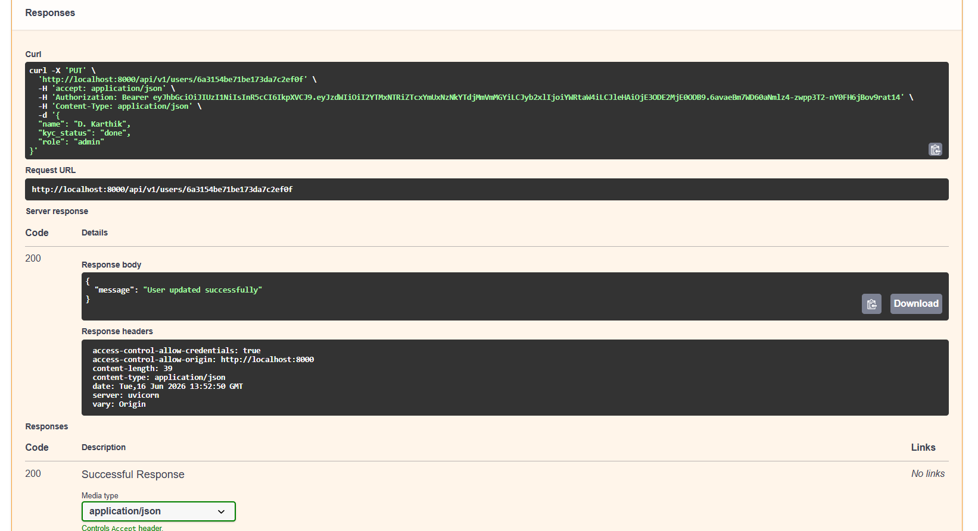

DELETE /api/v1/users/{user_id} Soft Delete a user :
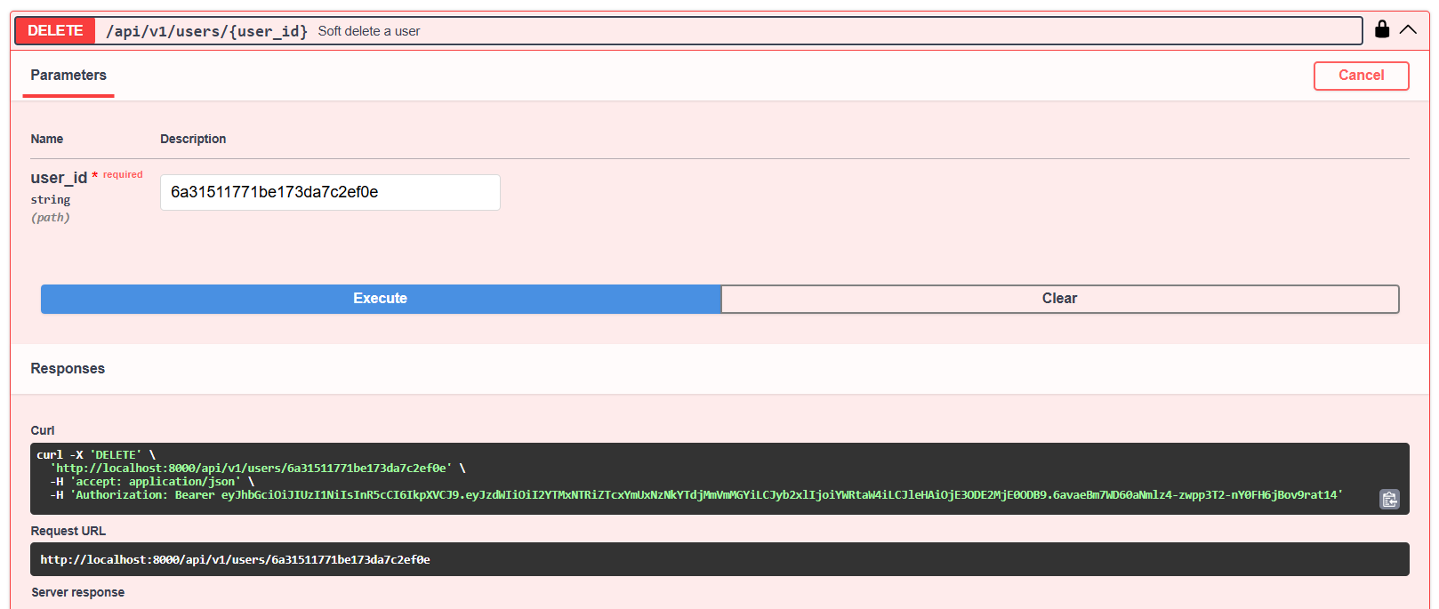
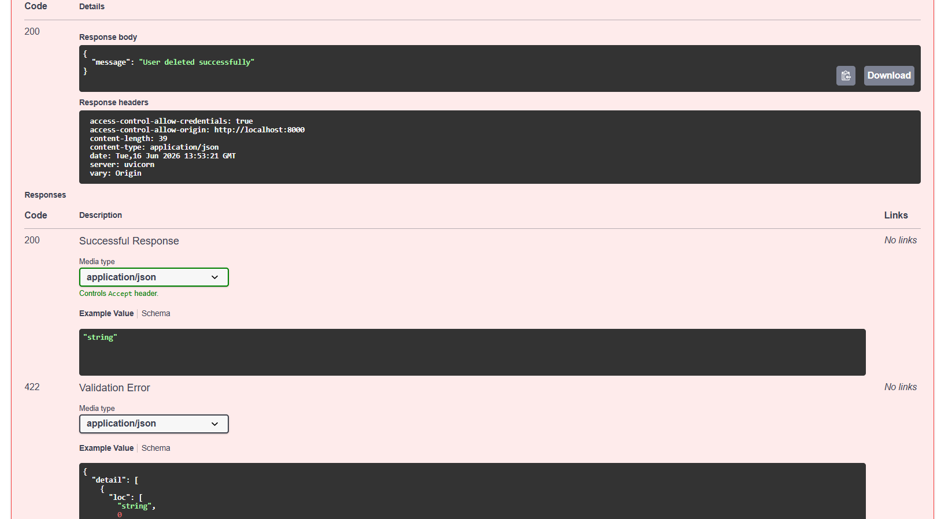

(AFTER UPDATE, DELETE) GET /api/v1/users/ Get all users with pagination :

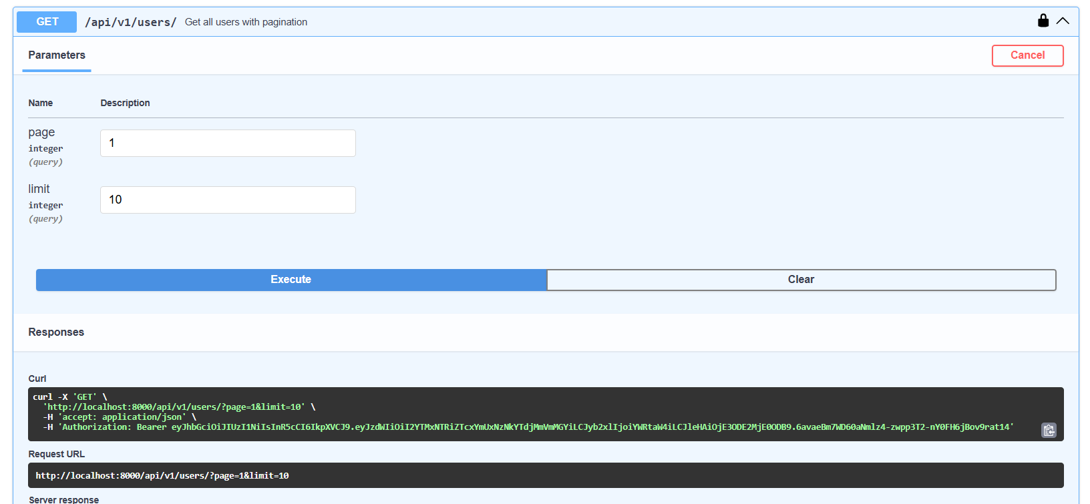
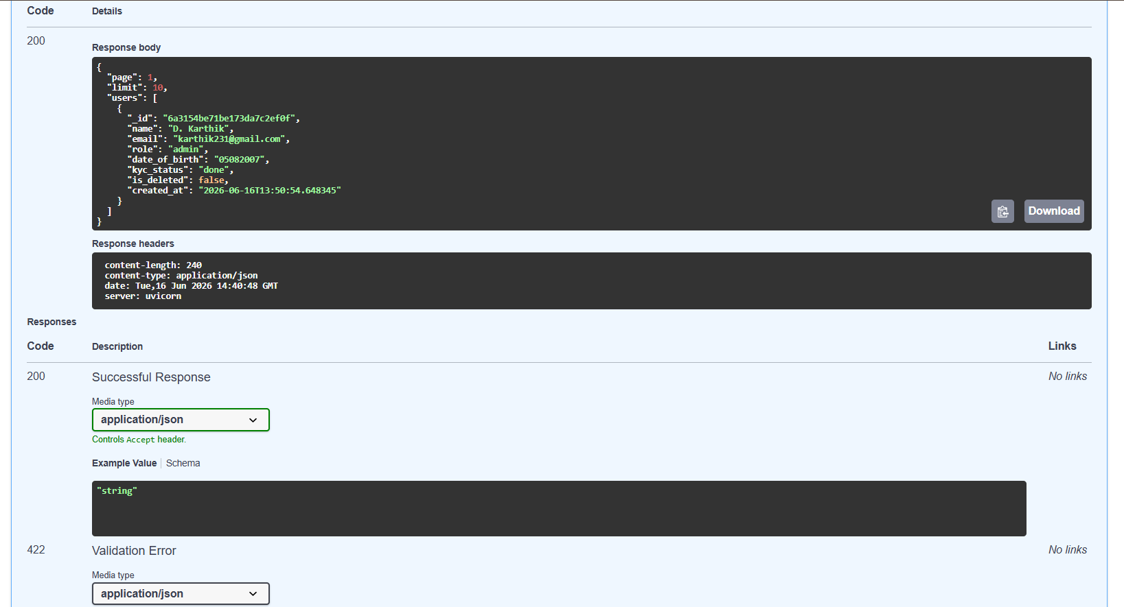

- Stocks
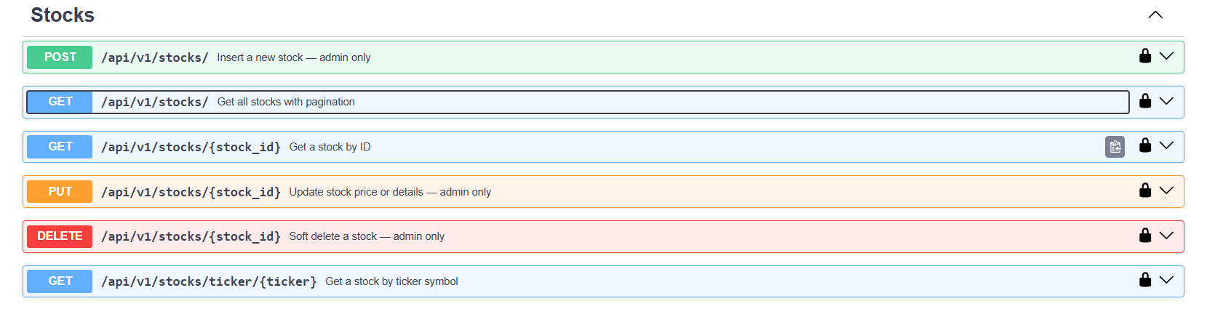

POST /api/v1/stocks/ Insert a new Stock - admin only :
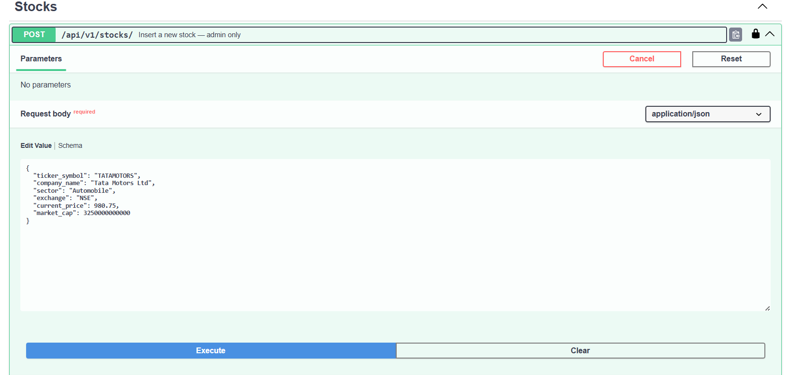
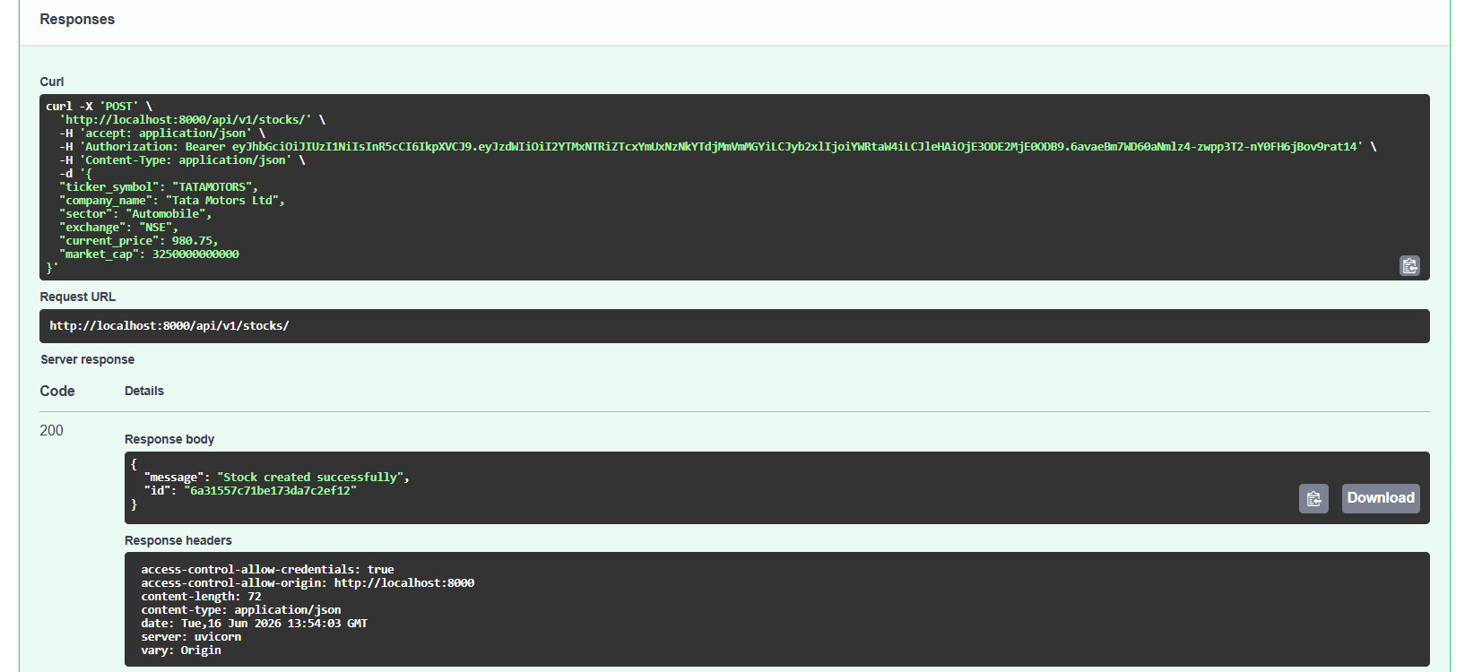
{  "ticker_symbol": "RELIANCE",  "company_name": "Reliance Industries Ltd",  "sector": "Energy & Retail",  "exchange": "NSE",  "current_price": 2950.50,  "market_cap": 19500000000000  } | {  "ticker_symbol": "TATAMOTORS",  "company_name": "Tata Motors Ltd",  "sector": "Automobile",  "exchange": "NSE",  "current_price": 980.75,  "market_cap": 3250000000000  }

GET /api/v1/stocks/ Get all stocks with pagination :

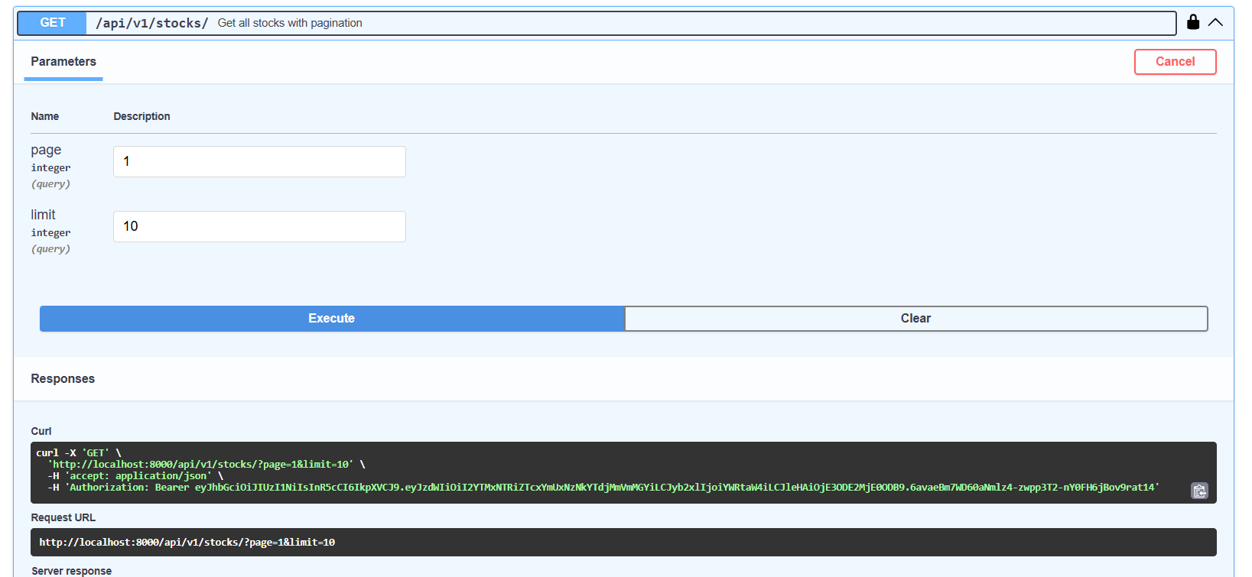
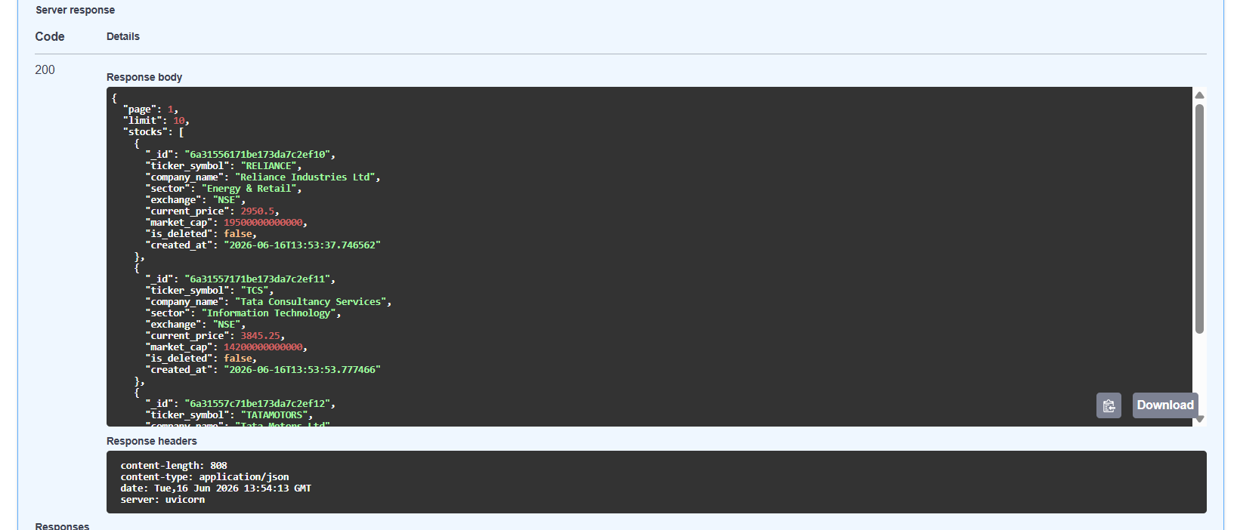

GET /api/v1/stocks/{stock_id} Get stock by id :
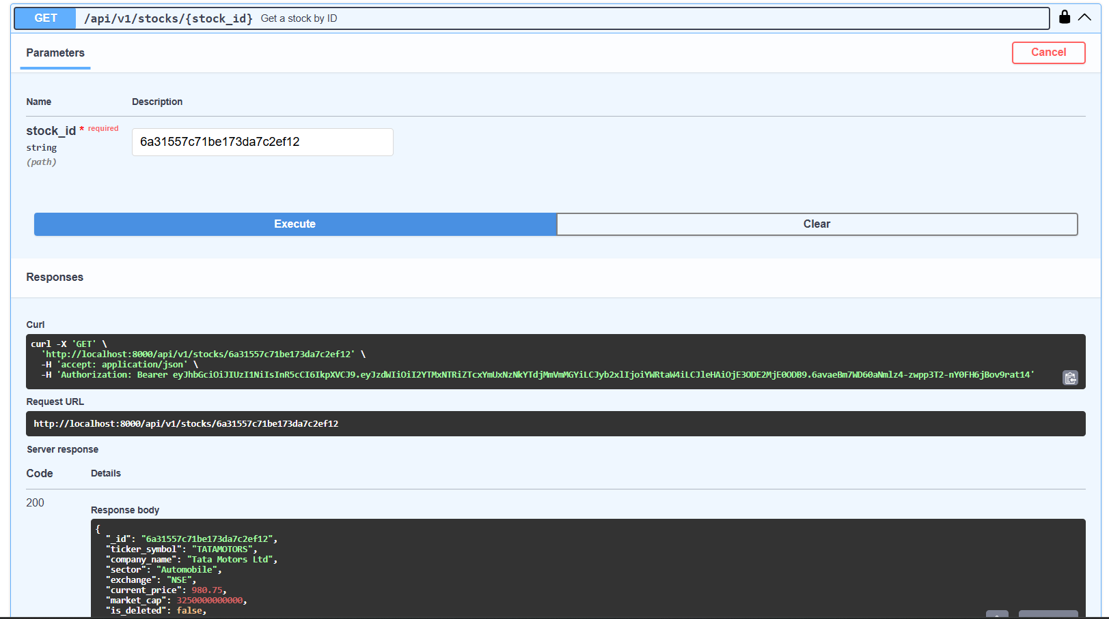

PUT /api/v1/stocks/{stock_id} Update stock price or detals - admin only :
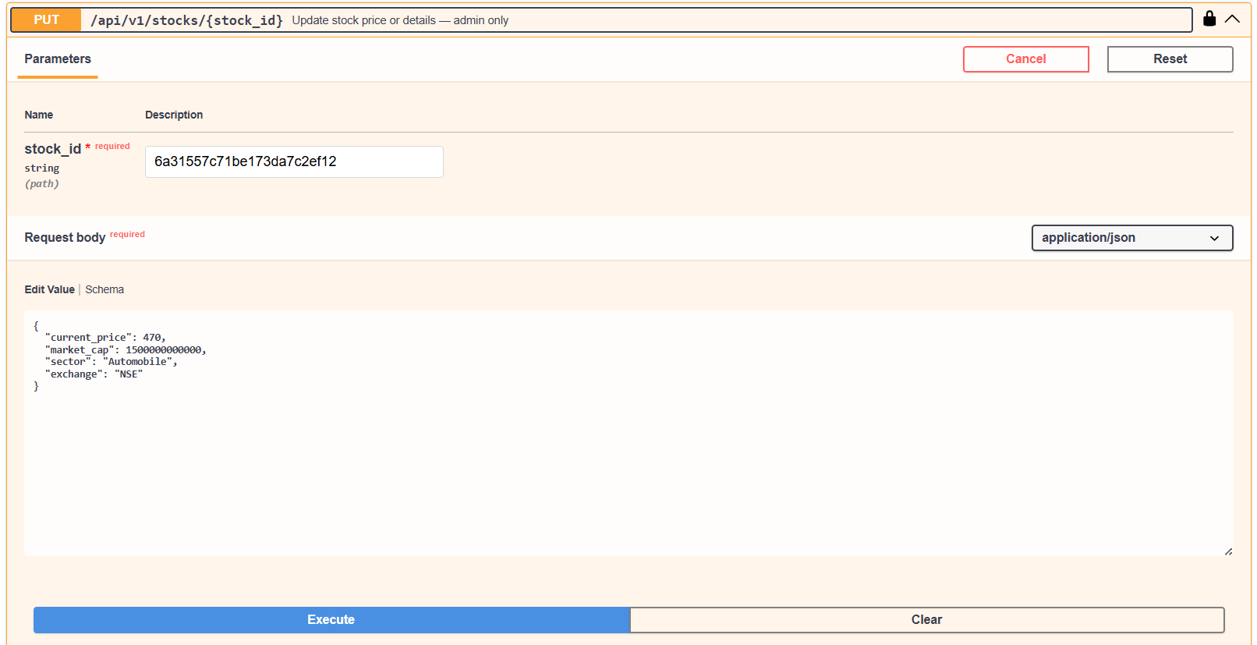
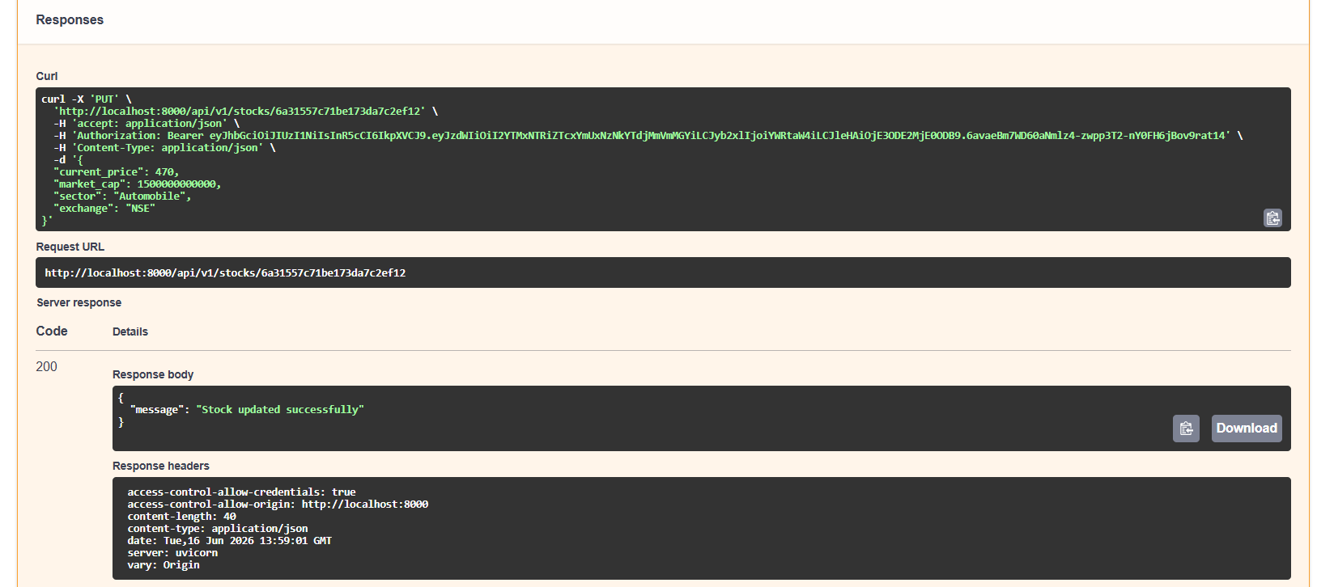

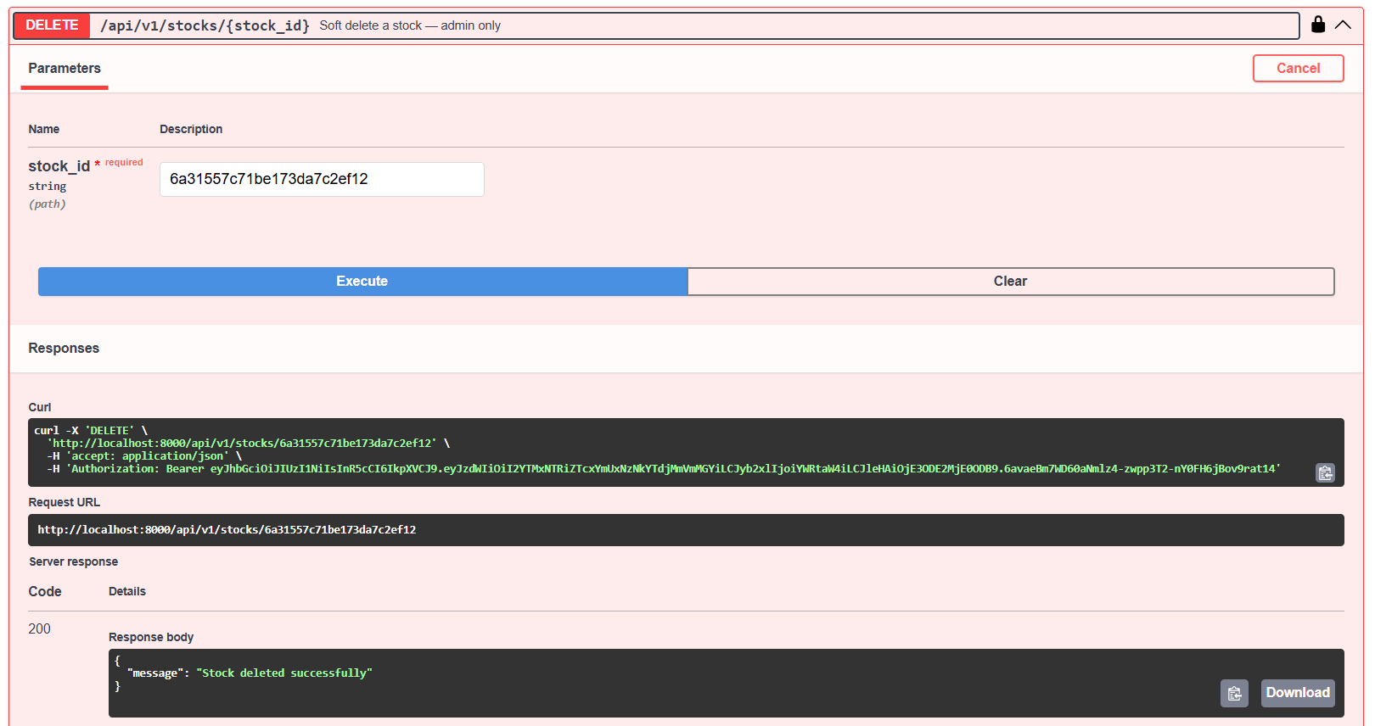

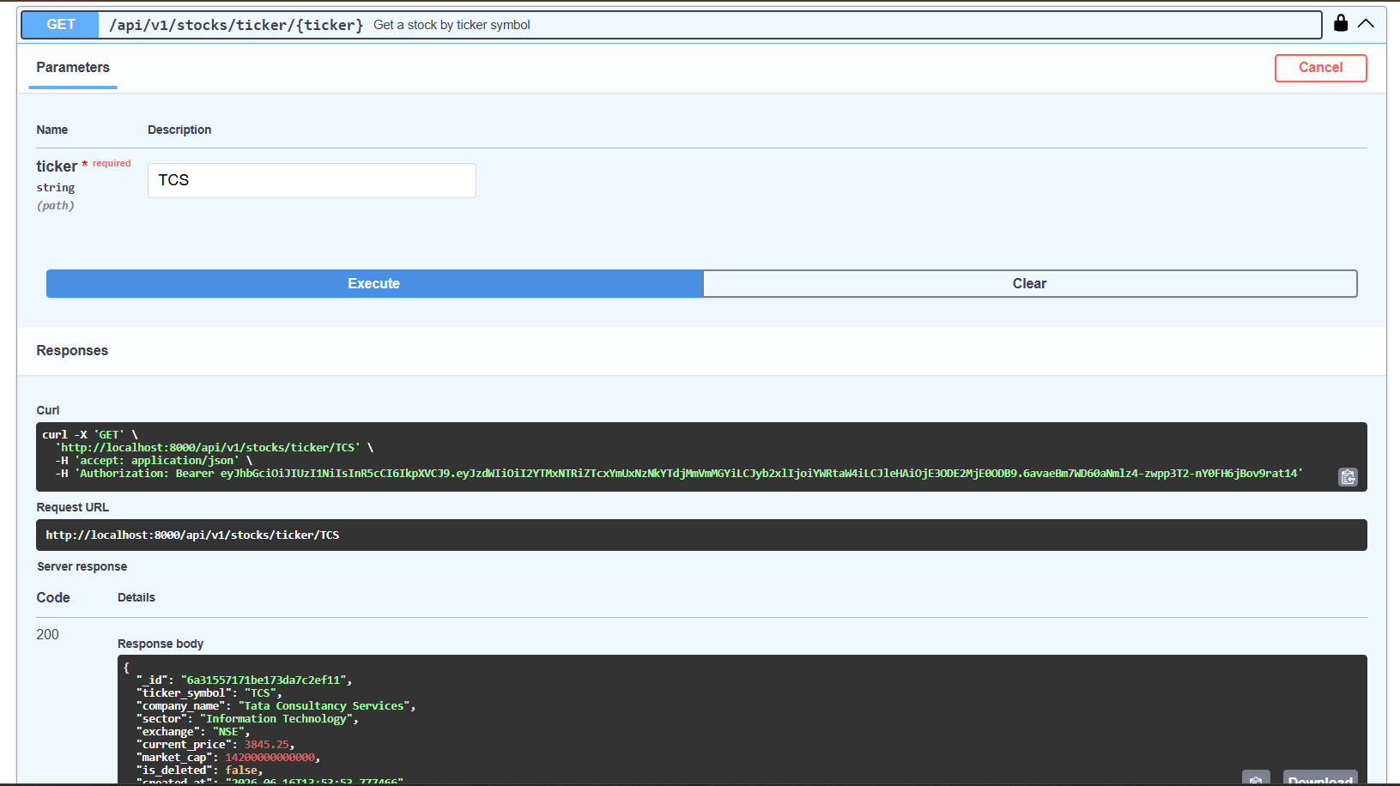

- Orders collection
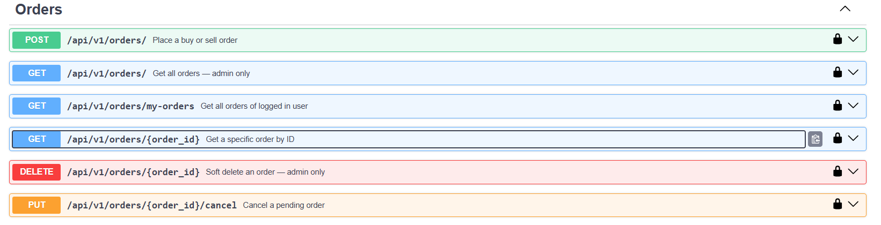

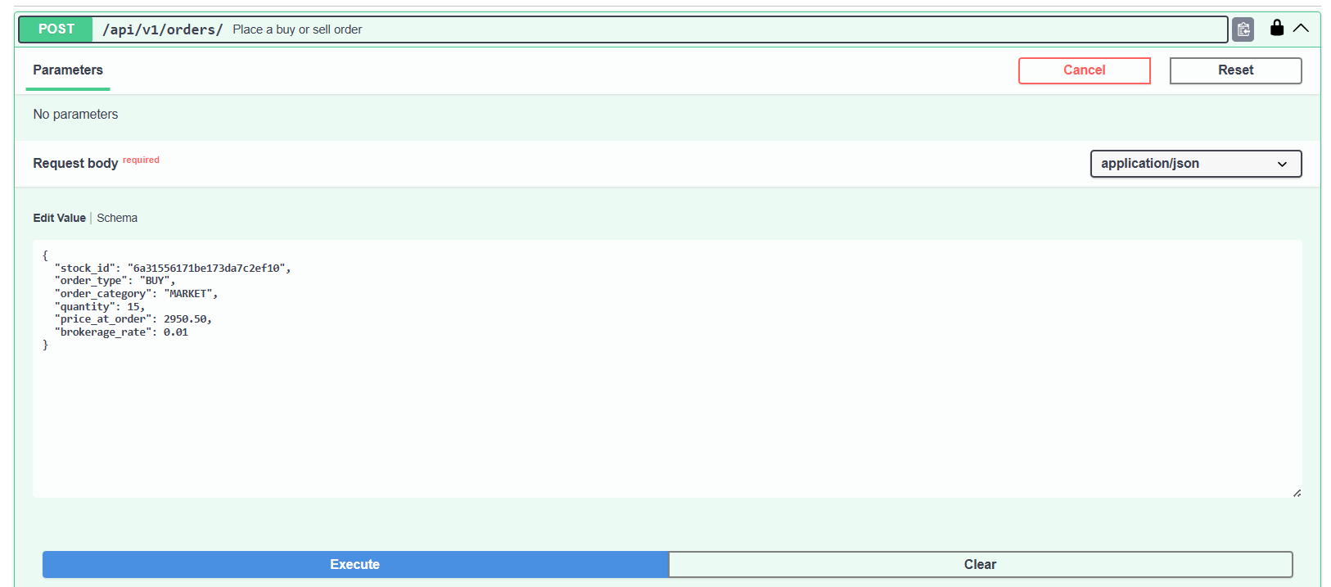
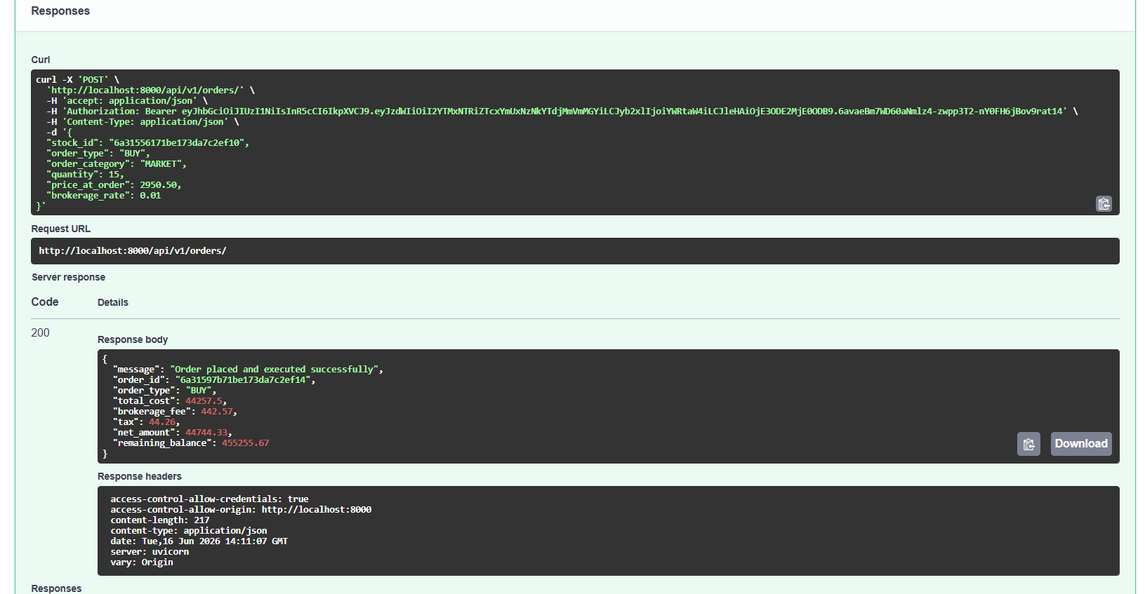

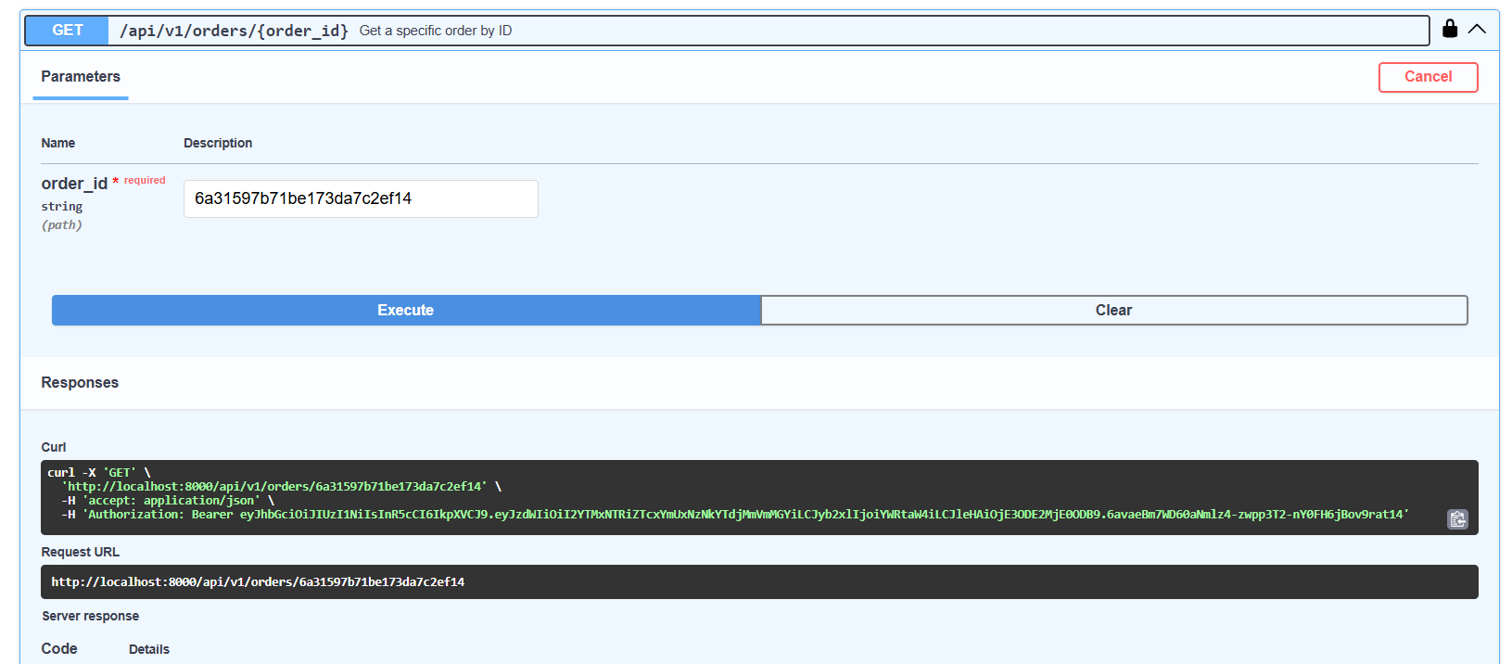
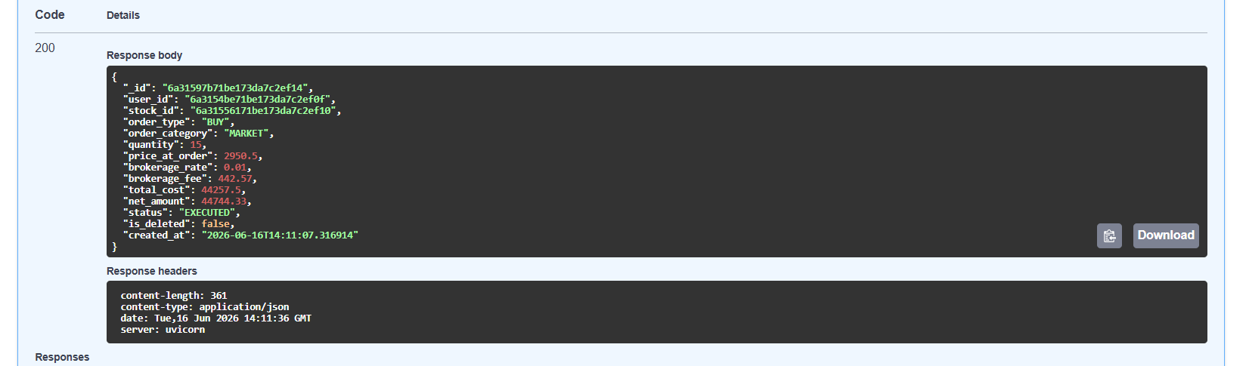

- Portfolio & Holdings and Watchlist :
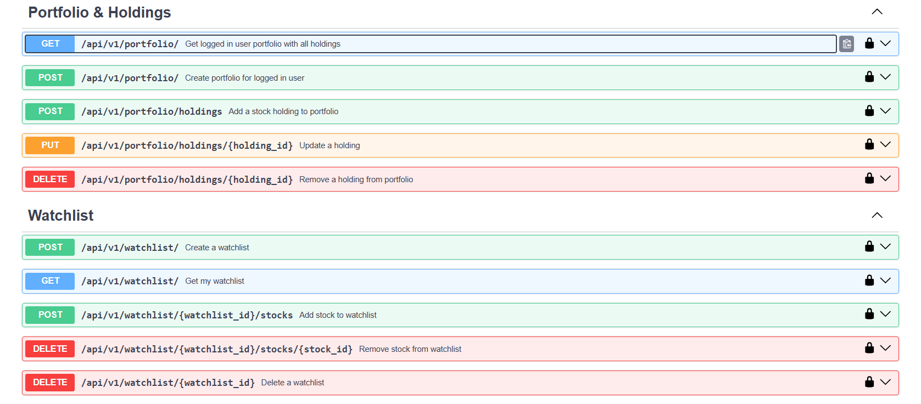
- Price History
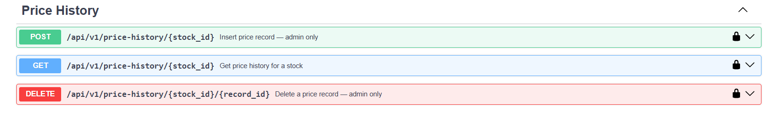

- Accounts
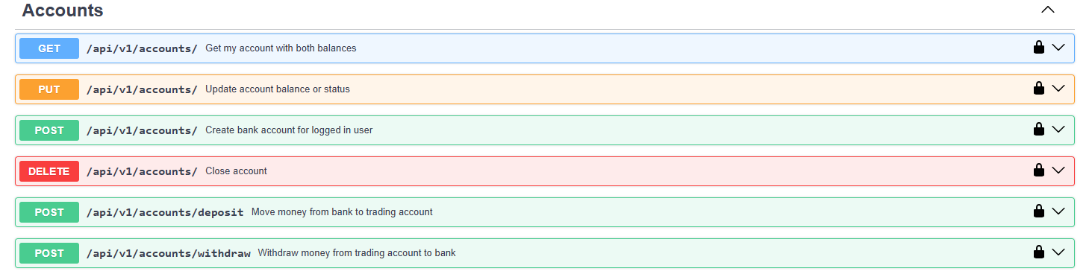

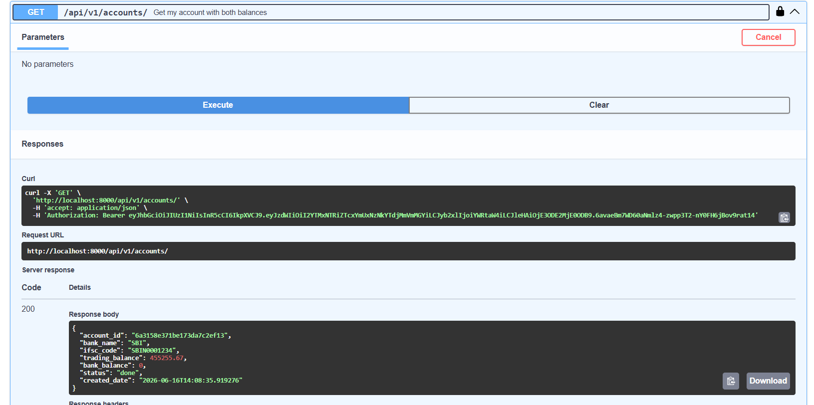
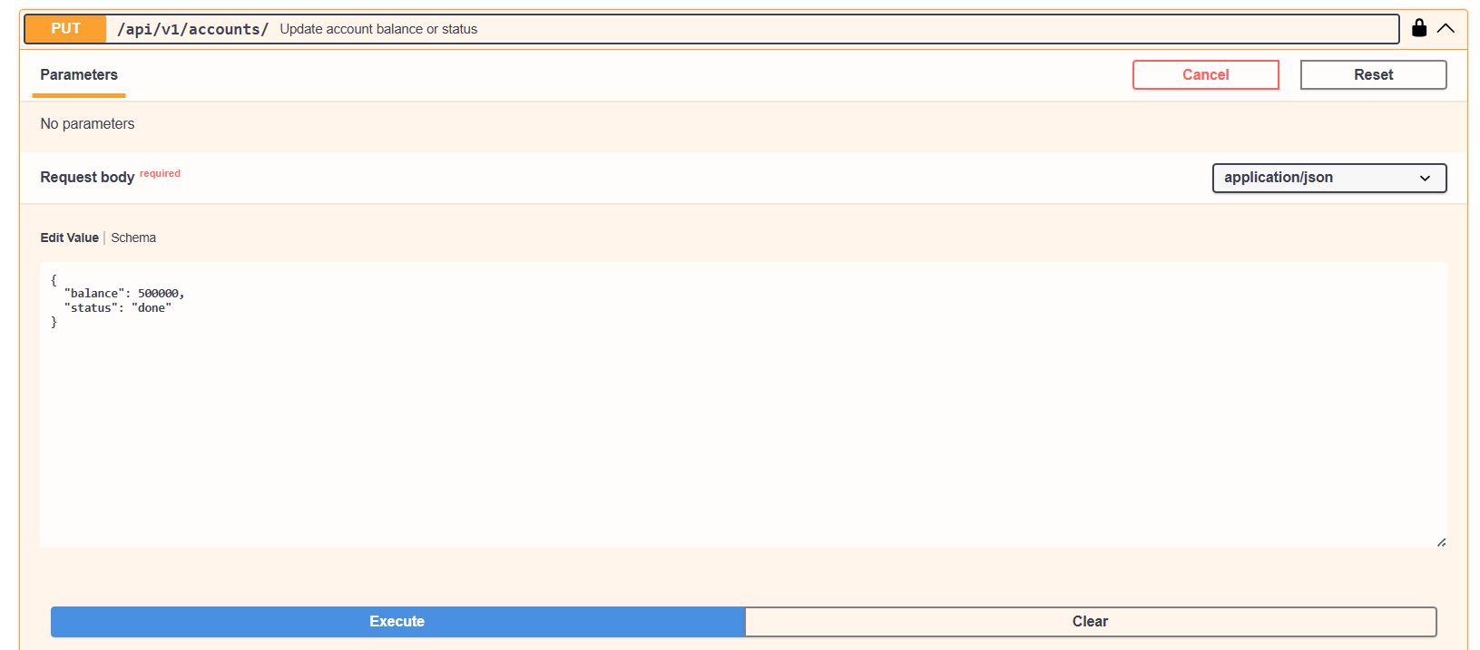
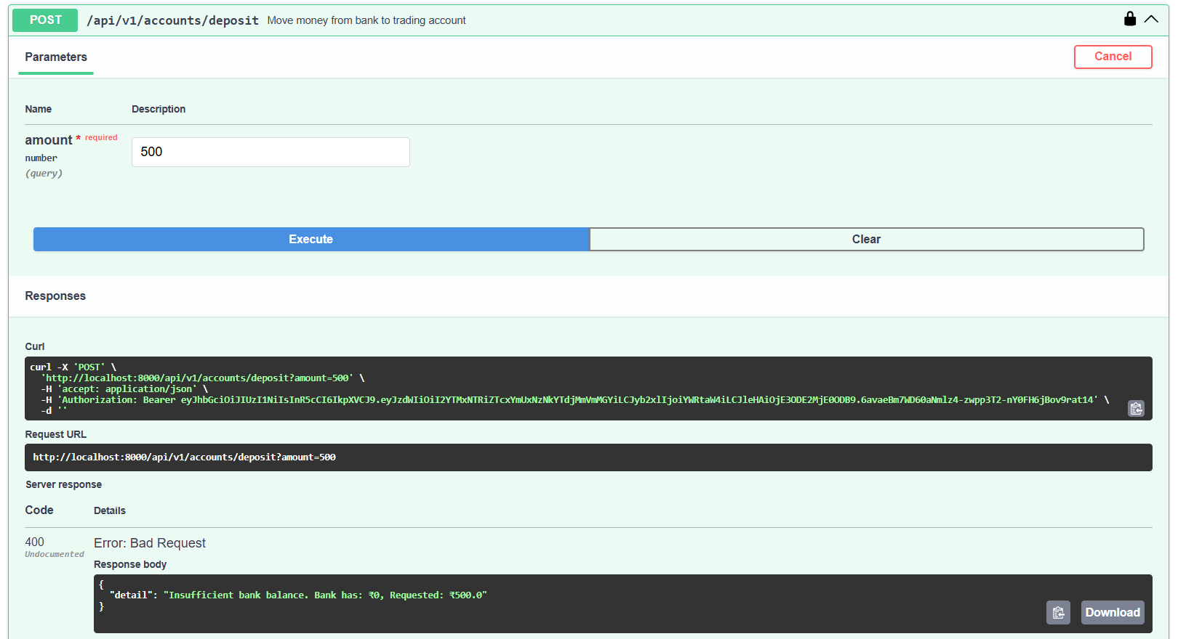
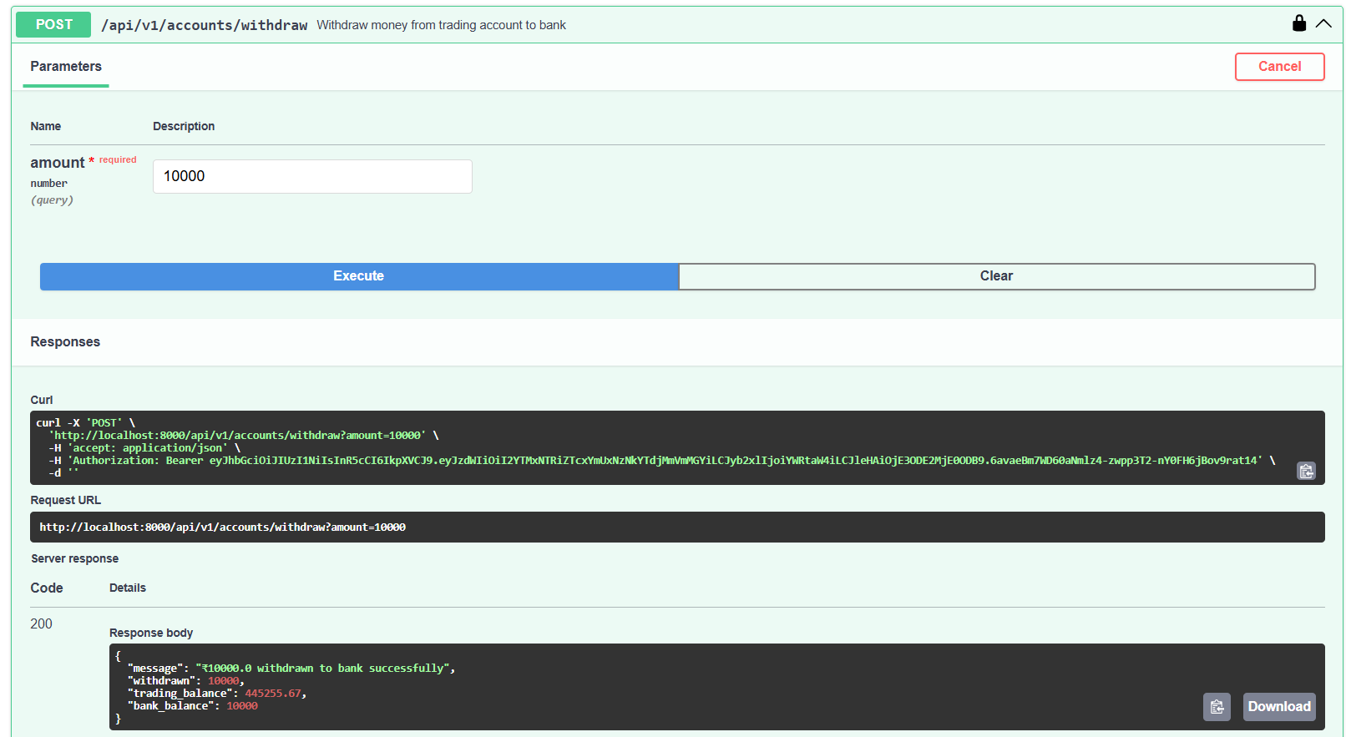

- System Health (Replication) :
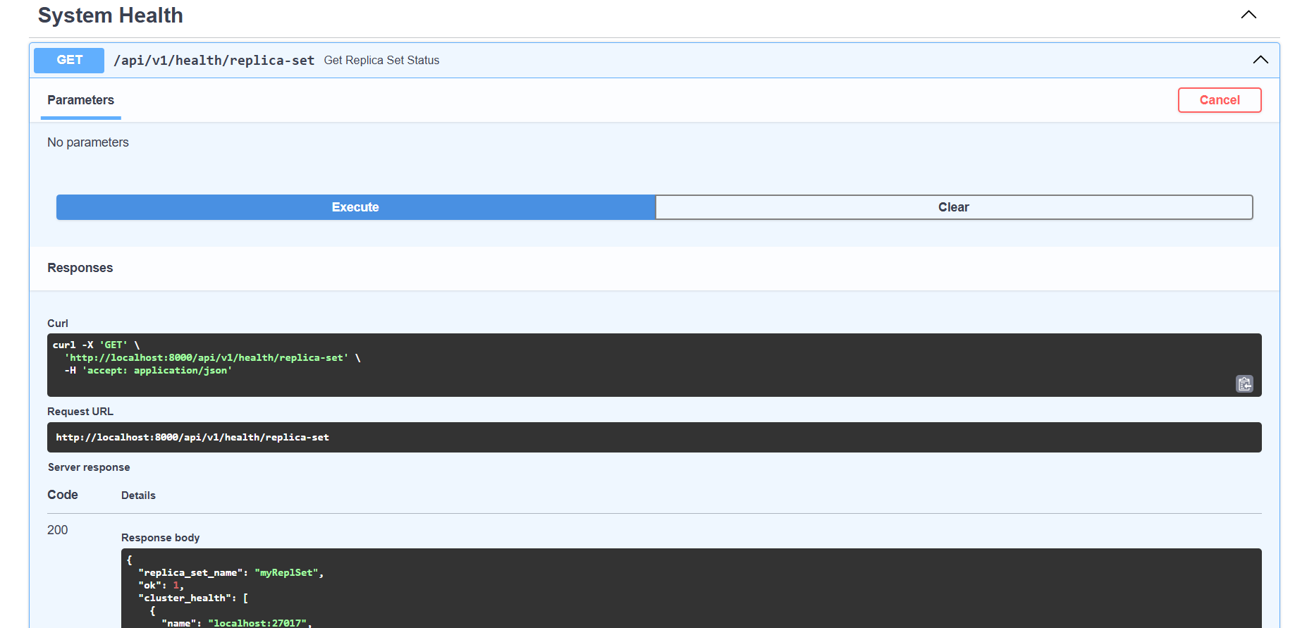
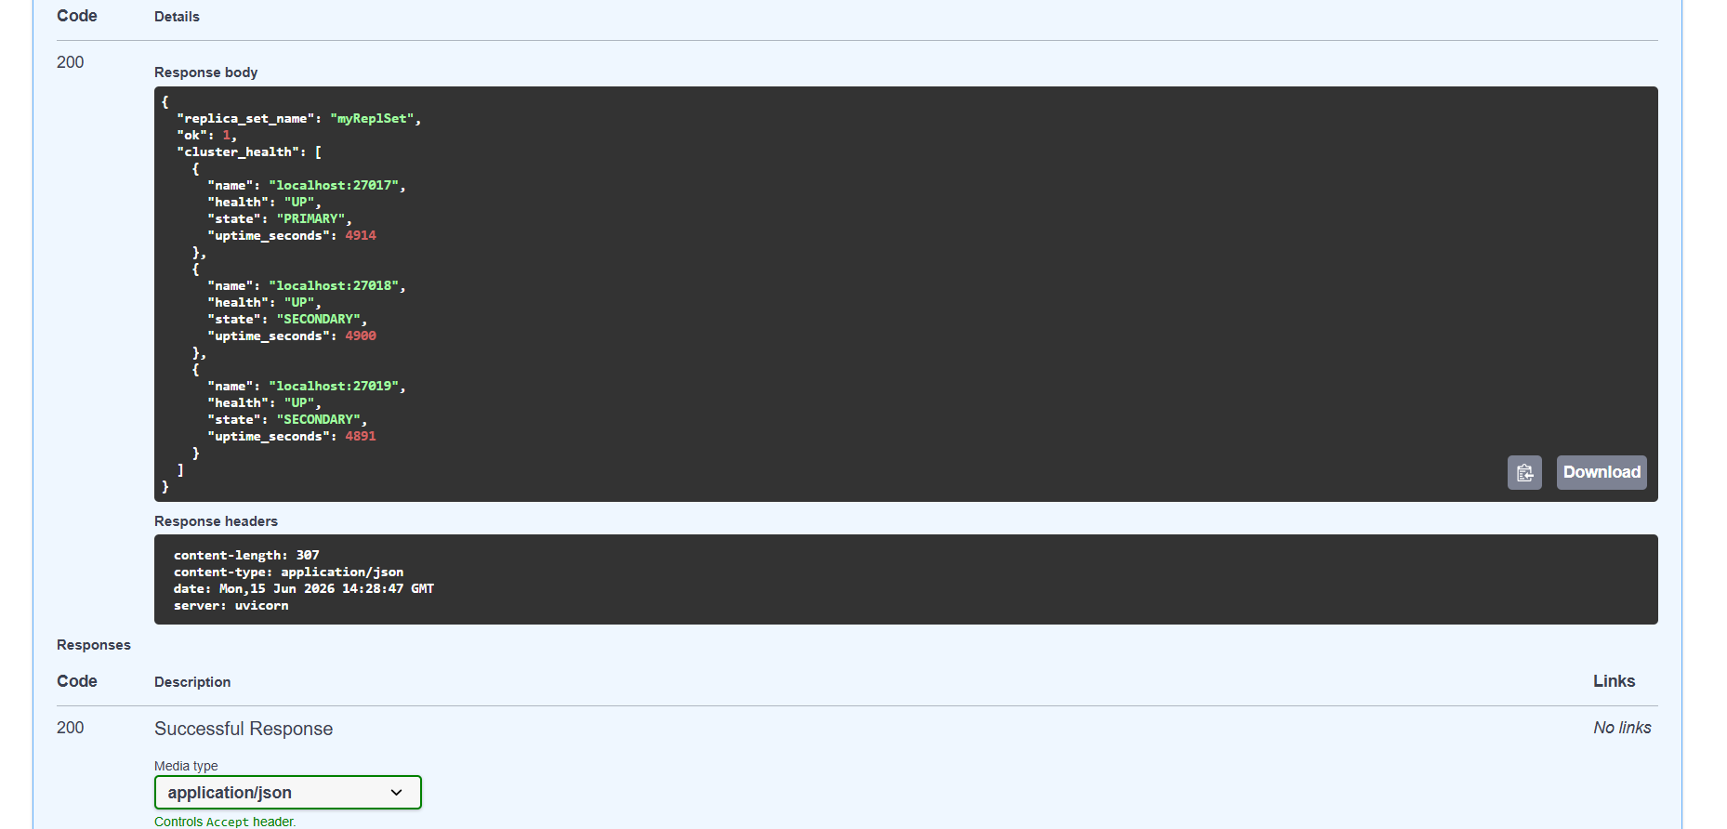

- Root :
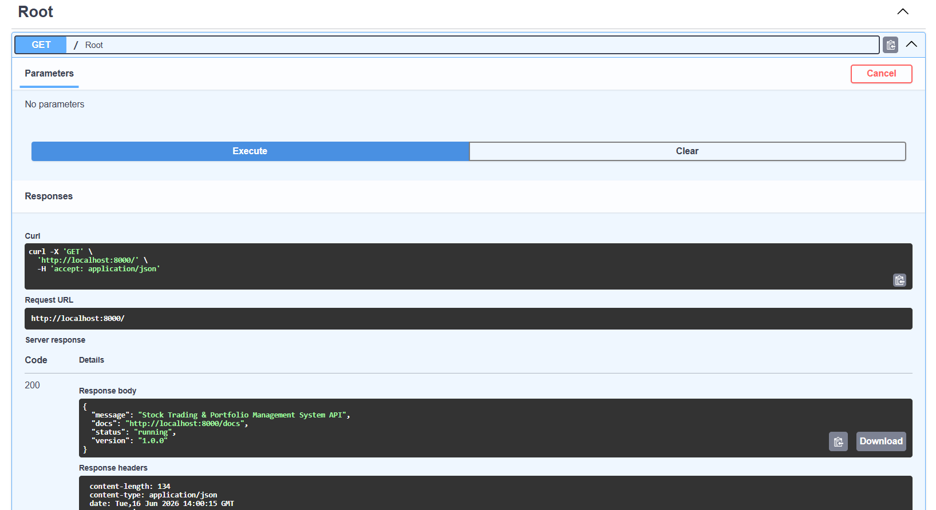
- Schemas
