Name Of the Student : Damarla Karthik
Regd. Number : 24BCE8378
School/Dept : SCOPE
Date Of Conduction : 03-06-2026
Course Name : FACE Prep - MongoDB Database Administrator

CRUD “One” Operations

MongoDB CODE :

db.createCollection("Students");
{ ok: 1 }

ECLIPSE - mongo\src\mongoCRUDExample.java :

package mongo;

import com.mongodb.client.*;
import com.mongodb.client.model.Filters;
import com.mongodb.client.model.Updates;
import org.bson.Document;

public class MongoCRUDExample {

public static void main(String[] args) {

// Connect to MongoDB
MongoClient mongoClient = MongoClients.create("mongodb://localhost:27017");

// Access database
MongoDatabase database = mongoClient.getDatabase("vitap");

// Access collection
MongoCollection<Document> collection =
database.getCollection("Students");

// ==========================
// CREATE (Insert)
// ==========================
Document student = new Document("id", 101)
.append("name", "John")
.append("department", "CSE")
.append("cgpa", 8.7);

collection.insertOne(student);
System.out.println("Document Inserted Successfully");

// ==========================
// READ (Find)
// ==========================
System.out.println("\nStudent Records:");

FindIterable<Document> students = collection.find();

for (Document doc : students) {
System.out.println(doc.toJson());
}

// ==========================
// UPDATE
// ==========================
collection.updateOne(
Filters.eq("id", 101),
Updates.set("cgpa", 9.2)
);

System.out.println("\nDocument Updated Successfully");

// ==========================
// READ Updated Record
// ==========================
Document updatedStudent =
collection.find(Filters.eq("id", 101)).first();

System.out.println("\nUpdated Record:");
System.out.println(updatedStudent.toJson());

// ==========================
// DELETE
// ==========================
collection.deleteOne(Filters.eq("id", 101));

System.out.println("\nDocument Deleted Successfully");

// Close connection
mongoClient.close();
}
}

CONSOLE Output :

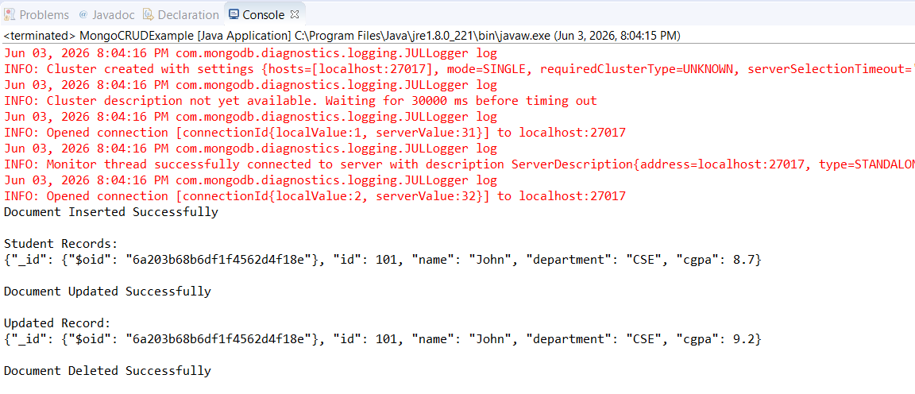

CRUD “Many” Operations :

MongoDB CODE :

use vit;
switched to db vit
show collections;
books
Employee
products
db.createCollection("Students");
{ ok: 1 }

ECLIPSE - mongo\src\CRUDmany.java :

package mongo;

import com.mongodb.client.*;
import com.mongodb.client.model.Filters;
import com.mongodb.client.model.Updates;
import org.bson.Document;
import java.util.*;

public class CRUDmany {

public static void main(String[] args) {

// Connect to MongoDB
MongoClient mongoClient = MongoClients.create("mongodb://localhost:27017");

// Access database
MongoDatabase database = mongoClient.getDatabase("vit");

// Access collection
MongoCollection<Document> collection =
database.getCollection("Students");

// ==========================
// CREATE (Insert)
// ==========================
Document s1 = new Document("id", 101)
.append("name", "John")
.append("department", "ECE")
.append("cgpa", 8.7);

Document s2 = new Document("id", 102).append("name", "Ken").append("department", "CSE").append("cgpa", 9.7);
Document s3 = new Document("id", 103).append("name", "Karthik").append("department", "CSE").append("cgpa", 8.9);

List<Document> studentList = new ArrayList<>();
studentList.add(s1);
studentList.add(s2);
studentList.add(s3);

collection.insertMany(studentList);
System.out.println("Documents Inserted Successfully");

// ==========================
// READ (Find)
// ==========================
System.out.println("\nStudent Records:");

FindIterable<Document> students = collection.find();

for (Document doc : students) {
System.out.println(doc.toJson());
}

// ==========================
// UPDATE MANY
// ==========================
collection.updateMany(
Filters.eq("department", "CSE"),
Updates.set("cgpa", 9.5)
);
System.out.println("\nupdateMany — All CSE students cgpa set to 9.5");

// READ after updateMany
System.out.println("\nRecords After updateMany:");
for (Document doc : collection.find()) {
System.out.println(doc.toJson());
}

// ==========================
// DELETE MANY
// ==========================
collection.deleteMany(
Filters.gt("cgpa", 9.5)
);
System.out.println("\ndeleteMany — All students with cgpa >= 9.5 deleted");

// Close connection
mongoClient.close();
}
}

CONSOLE Output :

