Name Of the Student : Damarla Karthik
Regd. Number : 24BCE8378
School/Dept : SCOPE
Date Of Conduction : 01-06-2026
Course Name : FACE Prep - MongoDB Database Administrator

MySQL WORKBENCH CODE :

SHOW DATABASES;

USE vitcampus;

CREATE TABLE students(
id INT PRIMARY KEY,
Fname VARCHAR(10) NOT NULL,
marks INT );

INSERT INTO students VALUES (101, 'karthik', 93);
INSERT INTO students VALUES (102, 'aarthi', 87);
INSERT INTO students VALUES (105, 'shiva', 99);

SELECT * FROM students;

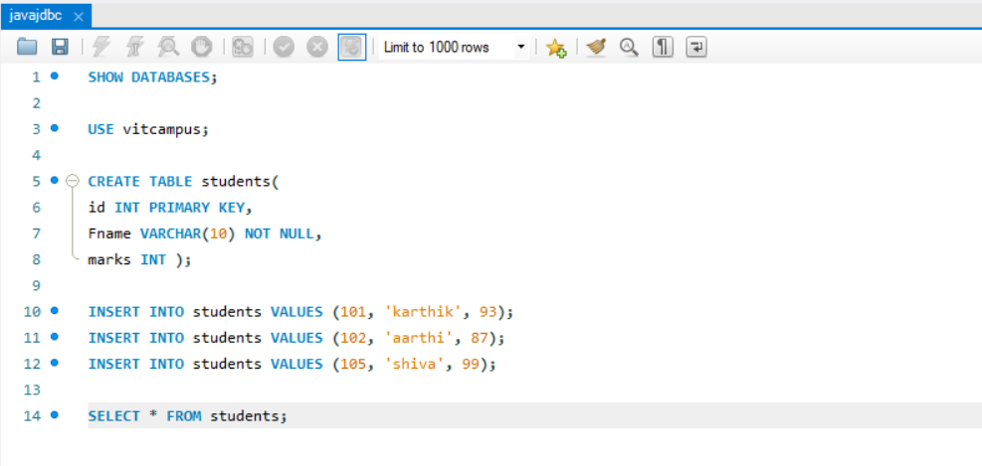

ECLIPSE - mongoDB\src\HelloWorld.java :

package mongoDB;

import java.sql.*;
public class HelloWorld {

public static void main(String[] args) {

try {
// 1. Register the Driver
Class.forName("com.mysql.cj.jdbc.Driver");

// 2. Connect to the DB (Changed 'test' to 'vit campus')
// Ensure your MySQL user name and password are "root" and "root"
Connection con = DriverManager.getConnection("jdbc:mysql://localhost:3306/vitcampus", "root", "root");

// 3. Create Statement
Statement stmt = con.createStatement();

// 4. Execute Query (Changed 'student' to 'students')
ResultSet rs = stmt.executeQuery("select * from students");

// 5. Print Results
while(rs.next()) {
System.out.println(rs.getInt(1) + " " + rs.getString(2) + " " + rs.getInt(3));
}

con.close();

} catch(Exception e) {
// It is highly recommended to print the actual error message while testing
// so you know exactly what failed (e.g., wrong password, missing jar)
System.out.println("Connection failed!");
e.printStackTrace();
}
}
}

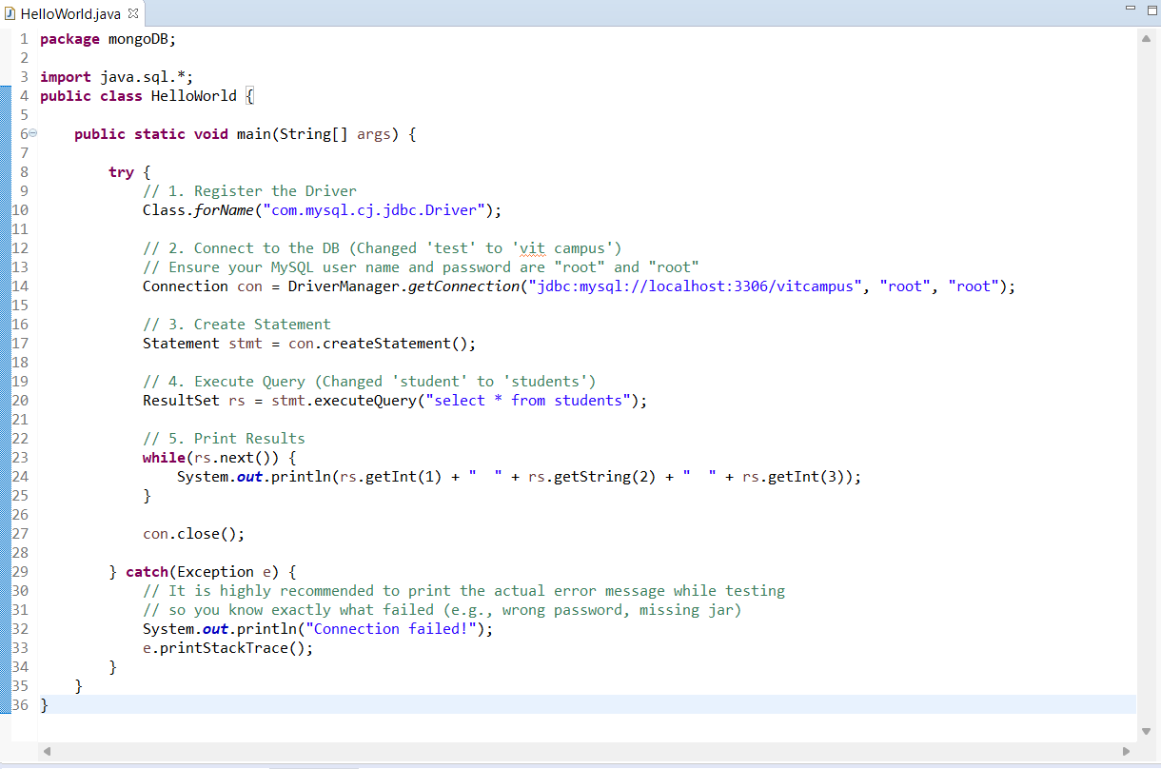

ECLIPSE CONSOLE OUTPUT :

101 karthik 93
102 aarthi 87
105 shiva 99

