Name Of the Student : Damarla Karthik
Regd. Number : 24BCE8378
School/Dept : SCOPE
Date Of Conduction : 15-06-2026
Course Name : FACE Prep - MongoDB Database Administrator
Swagger UI Screenshots for project completed so far :
- User registration and Authorization using JWT token
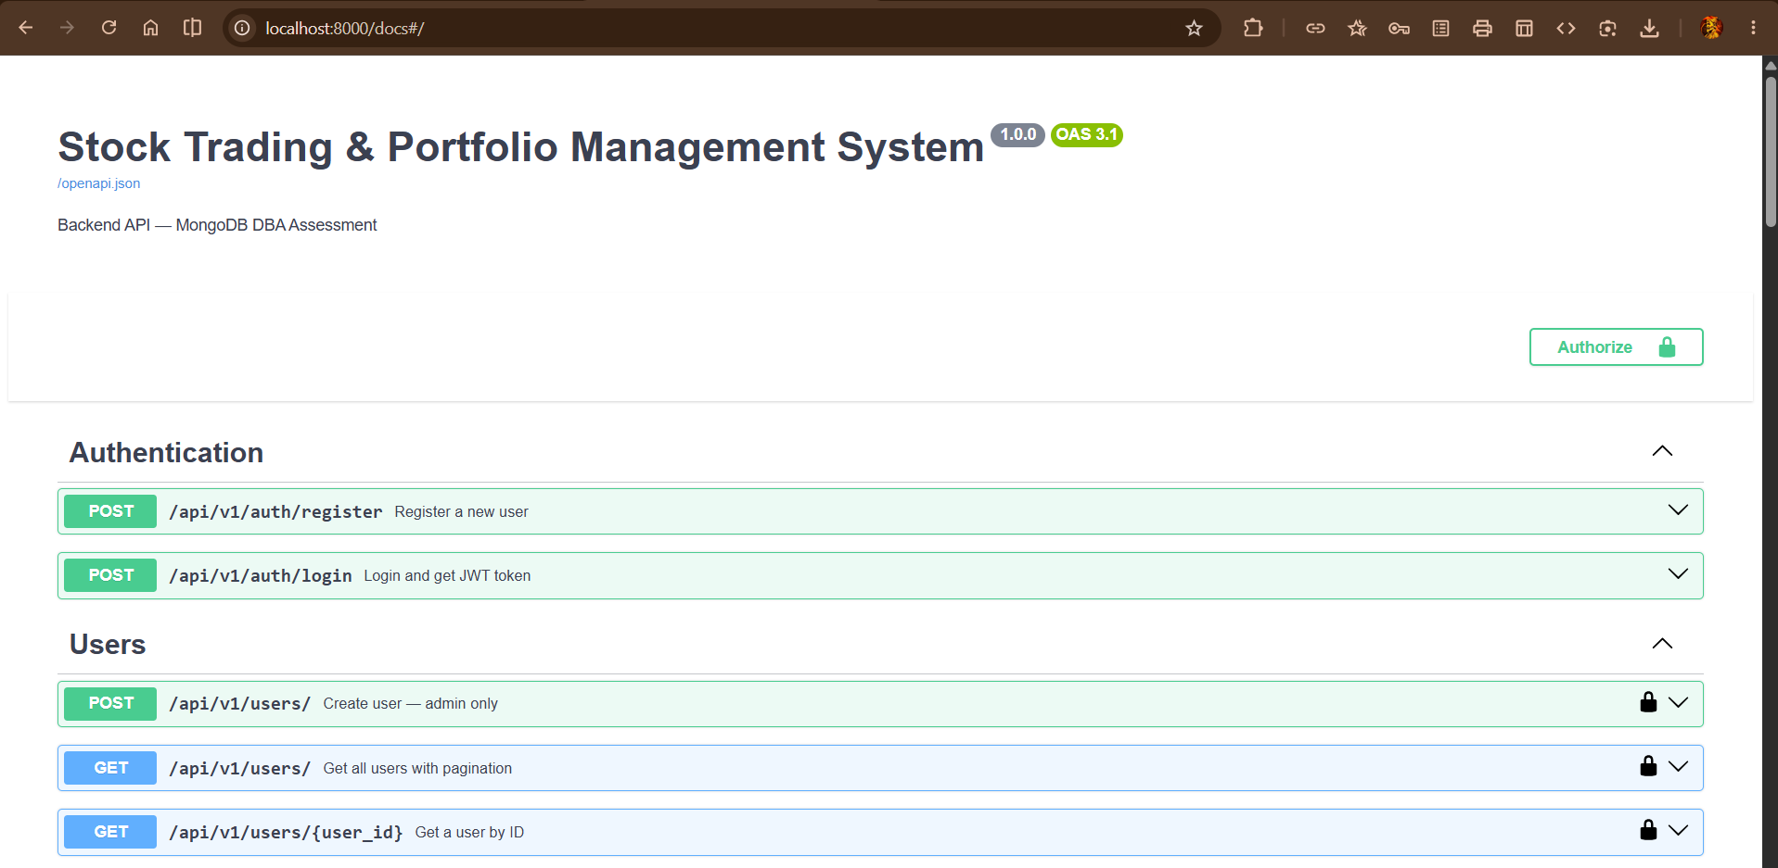

- User

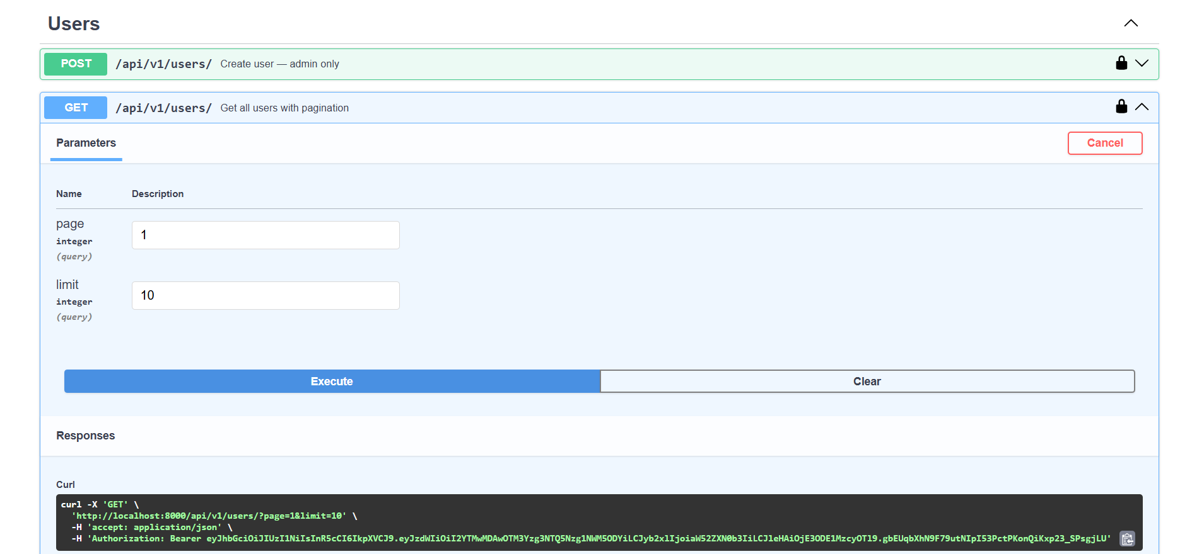
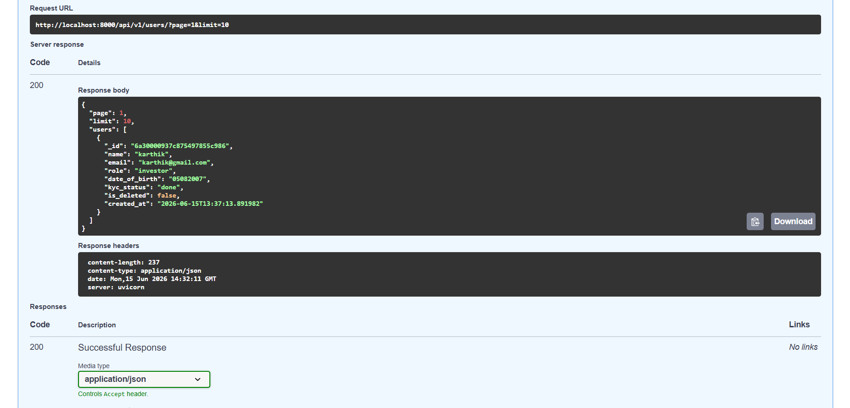
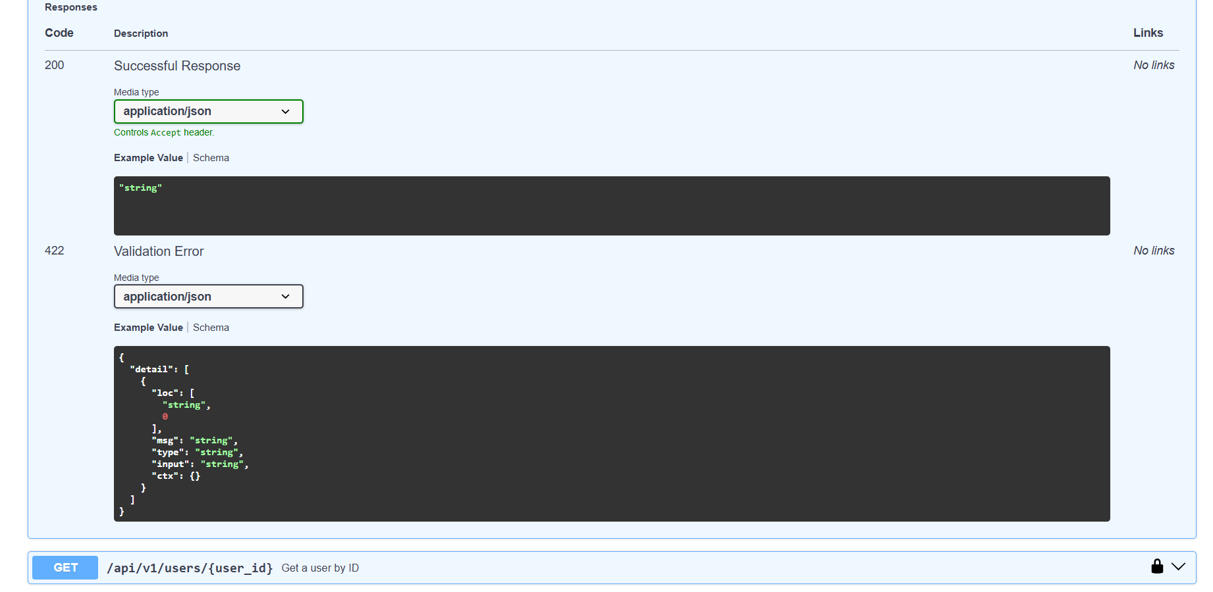

- Stocks
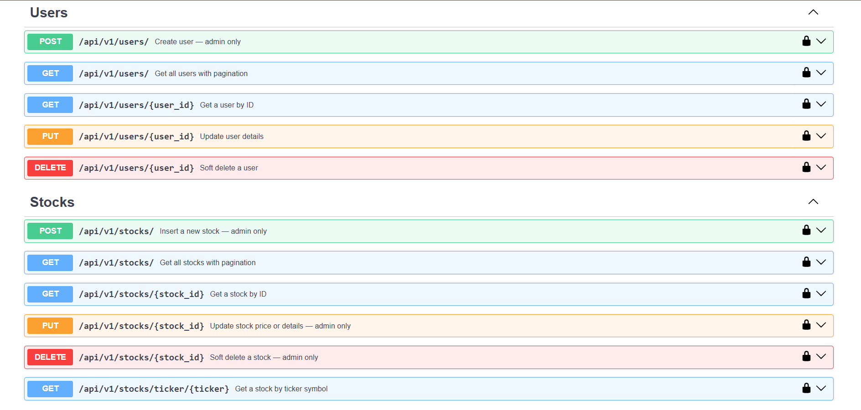

- Orders collection and Portfolio & Holdings
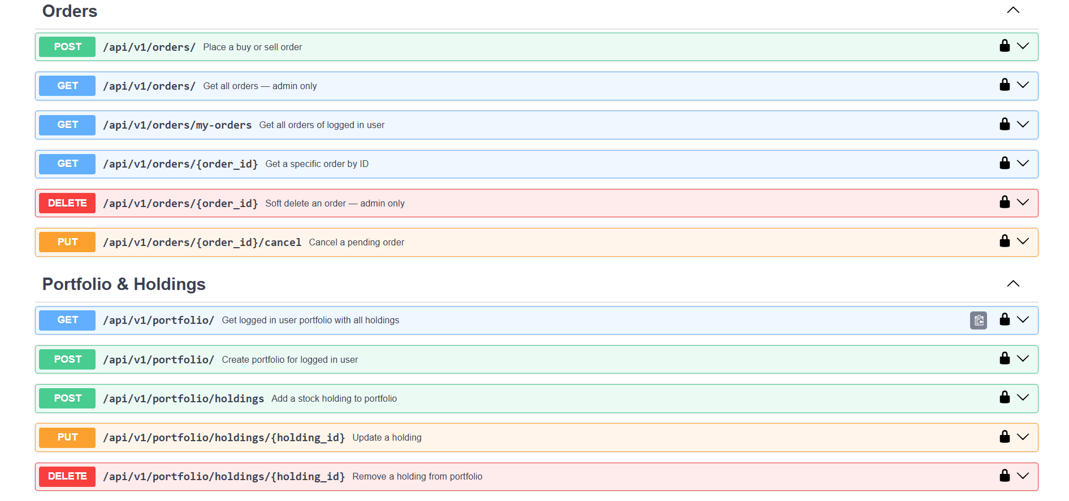

- Watchlist, Price History & Accounts
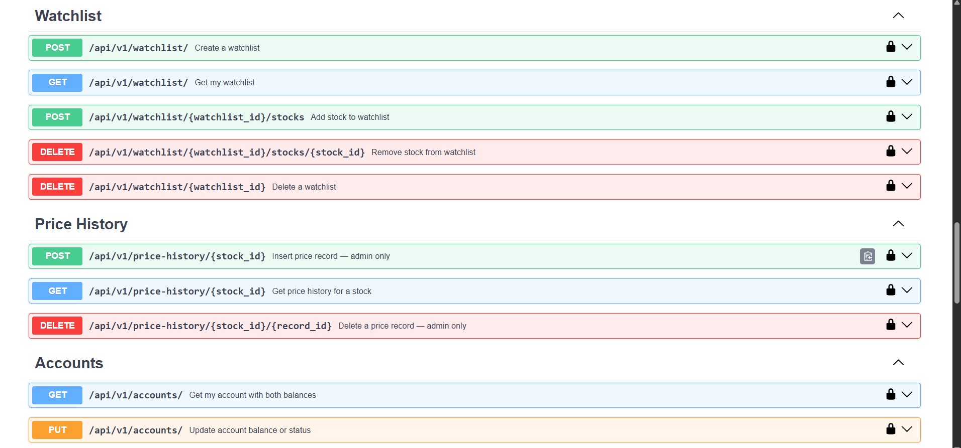
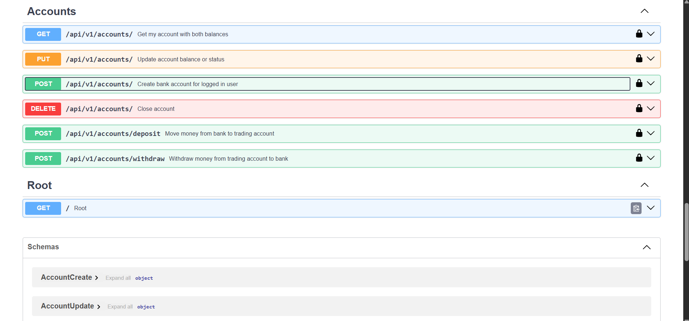
- System Health (Replication) :
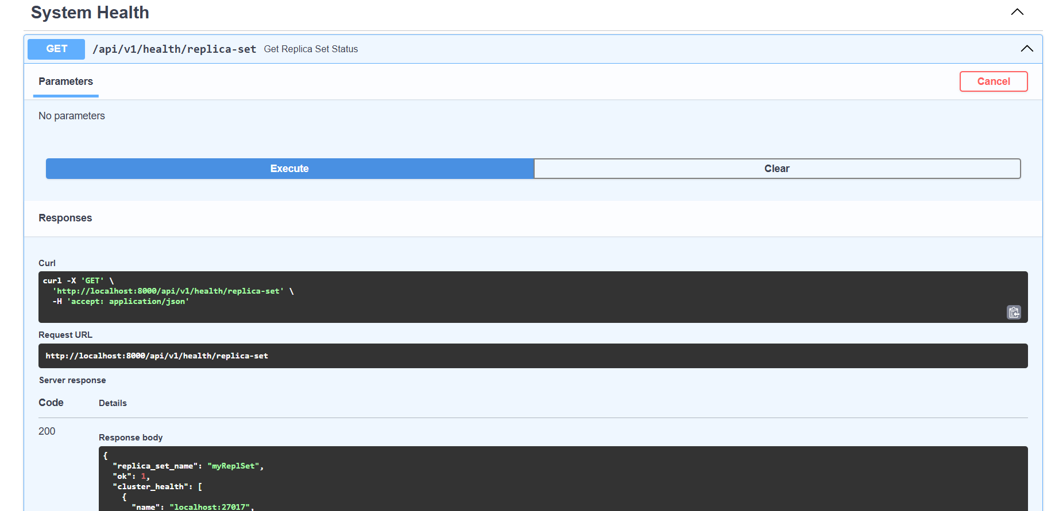
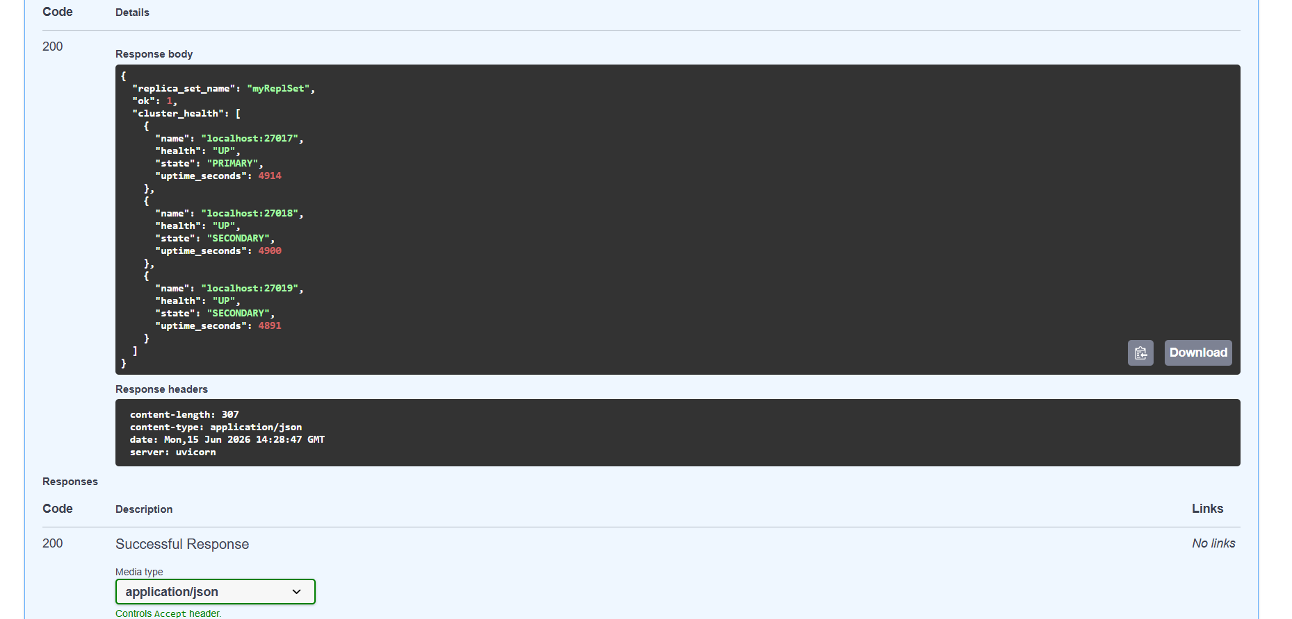
- Schemas

