Name Of the Student : Damarla Karthik
Regd. Number : 24BCE8378
School/Dept : SCOPE
Date Of Conduction : 02-06-2026
Course Name : FACE Prep - MongoDB Database Administrator

MySQL WORKBENCH CODE :

USE vitcampus;
DROP TABLE user;
CREATE TABLE user (
sl_no INT PRIMARY KEY,
name VARCHAR(100),
email VARCHAR(100)
);

Output :
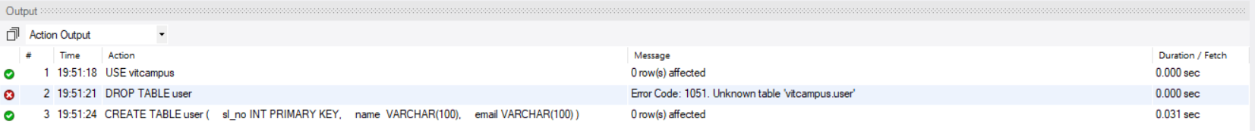

ECLIPSE - CRUD\src\DB_Connection.java :

package crud_operations;

import java.sql.Connection;
import java.sql.DriverManager;
public class DB_Connection {
public static void main(String[] args) {
DB_Connection obj_DB_Connection=new DB_Connection();
System.out.println(obj_DB_Connection.get_connection());
}
public Connection get_connection(){
Connection connection=null;
try {
Class.forName("com.mysql.cj.jdbc.Driver");
connection = DriverManager.getConnection("jdbc:mysql://localhost:3306/vitcampus","root",
"idk.Mysql.1729");

} catch (Exception e) {
System.out.println(e);
}
return connection;
}
}

CONSOLE Output :
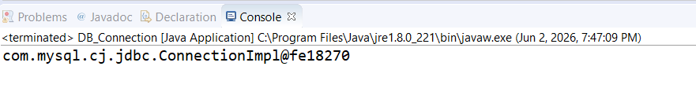

ECLIPSE - CRUD\src\CRUD_Test.java :

package crud_operations;

import java.sql.Connection;
import java.sql.PreparedStatement;
import java.sql.ResultSet;

public class CRUD_Test {
public static void main(String[] args) {
CRUD_Test objTest=new CRUD_Test();
// insert data
objTest.create_data("1", "jinu", "jinu@gmail.com");
objTest.create_data("2", "jawad", "jawad@gmail.com");
objTest.read_data("1");

// ALTER
objTest.alter_table("ALTER TABLE user ADD phone VARCHAR(15)");

objTest.create_data("3", "alex", "alex@gmail.com");

// read
objTest.read_data("3");

objTest.alter_table("ALTER TABLE user RENAME COLUMN phone TO mobile");

objTest.alter_table("ALTER TABLE user MODIFY COLUMN mobile VARCHAR(20)");

objTest.alter_table("ALTER TABLE user DROP COLUMN mobile");

// TRUNCATE
objTest.truncate_table();

objTest.read_data("1");
}

public void create_data(String sl_no,String name,String email){
DB_Connection obj_DB_Connection=new DB_Connection();
Connection connection=obj_DB_Connection.get_connection();
PreparedStatement ps=null;
try {
String query="insert into user(sl_no,name,email) values (?,?,?)";
ps=connection.prepareStatement(query);
ps.setString(1, sl_no);
ps.setString(2, name);
ps.setString(3, email);
System.out.println(ps);
ps.executeUpdate();
} catch (Exception e) {
System.out.println(e);
}
}

public void read_data(String sl_no){
DB_Connection obj_DB_Connection=new DB_Connection();
Connection connection=obj_DB_Connection.get_connection();
PreparedStatement ps=null;
ResultSet rs=null;
try {
String query="select * from user where sl_no=?";
ps=connection.prepareStatement(query);
ps.setString(1, sl_no);
System.out.println(ps);
rs=ps.executeQuery();
while(rs.next()){
System.out.println("Sl no -"+rs.getString("sl_no"));
System.out.println("name -"+rs.getString("name"));
System.out.println("email -"+rs.getString("email"));
System.out.println("---------------");
}
} catch (Exception e) {
System.out.println(e);
}
}

public void update_data(String sl_no,String new_sl_no,String name,String email){
DB_Connection obj_DB_Connection=new DB_Connection();
Connection connection=obj_DB_Connection.get_connection();
PreparedStatement ps=null;
try {
String query="update user set sl_no=?,name=?,email=? where sl_no=?";
ps=connection.prepareStatement(query);
ps.setString(1, new_sl_no);
ps.setString(2, name);
ps.setString(3, email);
ps.setString(4, sl_no);
System.out.println(ps);
ps.executeUpdate();
} catch (Exception e) {
System.out.println(e);
}
}

public void delete_data(String sl_no){
DB_Connection obj_DB_Connection=new DB_Connection();
Connection connection=obj_DB_Connection.get_connection();
PreparedStatement ps=null;
try {
String query="delete from user where sl_no=?";
ps=connection.prepareStatement(query);
ps.setString(1, sl_no);
System.out.println(ps);
ps.executeUpdate();
} catch (Exception e) {
System.out.println(e);
}

}

public void truncate_table() {
DB_Connection obj_DB_Connection = new DB_Connection();
Connection connection = obj_DB_Connection.get_connection();
try {
PreparedStatement ps = connection.prepareStatement("TRUNCATE TABLE user");
ps.executeUpdate();
System.out.println("Table truncated successfully.");
} catch (Exception e) {
System.out.println(e);
}
}

public void alter_table(String operation) {
DB_Connection obj_DB_Connection = new DB_Connection();
Connection connection = obj_DB_Connection.get_connection();
try {
PreparedStatement ps = connection.prepareStatement(operation);
ps.executeUpdate();
System.out.println("Alter operation executed successfully.");
} catch (Exception e) {
System.out.println(e);
}
}
}

CONSOLE OUTPUT :
