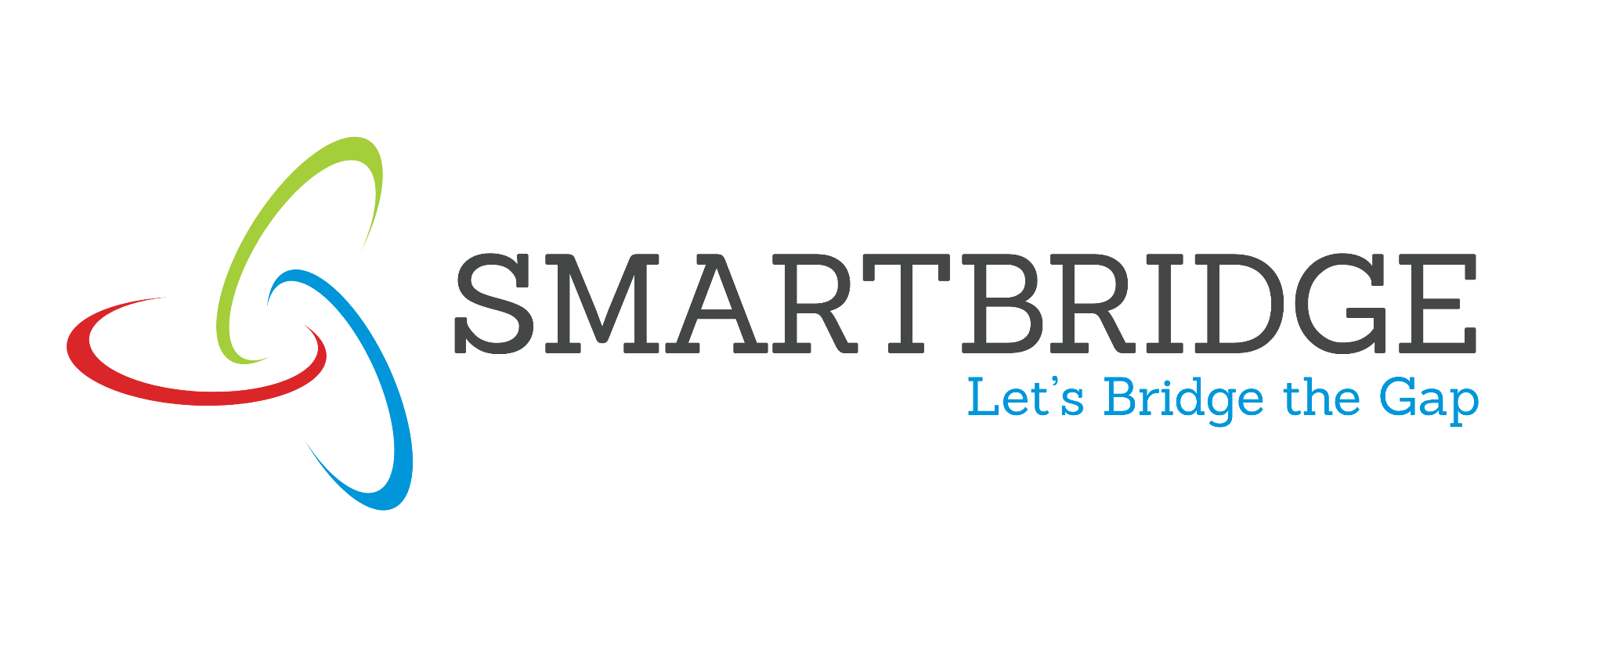 | 

Empathy Map
Date | 15 March 2024
Team ID | SB-FL-2026-01
Project Name | Rising Waters – Flood Prediction System
Maximum Marks | 4 Marks

SAYS  - I need accurate rainfall data before I can issue any warning.  - We can't afford a false alarm, but we also can't afford to be late.  - Cross-checking multiple weather reports manually takes too much time. | THINKS  - There must be a faster, more reliable way to assess flood risk.  - If I miss the early signs, lives could be at risk.  - Historical rainfall patterns should help predict this more accurately.
METEOROLOGIST
(Disaster Management Official)
DOES  - Monitors rainfall, cloud cover and river levels daily.  - Cross-references multiple weather sources before issuing alerts.  - Coordinates with disaster relief teams during high-risk periods. | FEELS  - Anxious about making the wrong call.  - Overwhelmed by the volume of data during monsoon season.  - Relieved when predictions are accurate and warnings reach people in time.

