ALAGAPPA UNIVERSITY
(Reaccredited with ‘A’ Grade by NAAC)
KARAIKUDI
ALAGAPPA UNIVERSITY STUDY CIRCLE

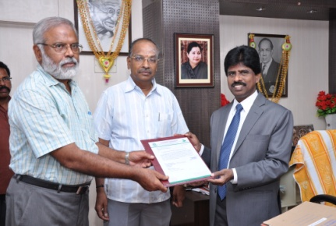
Dr. P. Suresh Kumar
Director,
Alagappa University Study Circle,
Alagappa University,
Karaikudi

Culmination of education should result in empowerment. With a view to empower students of Alagappa University, our Vice-Chancellor has created Alagappa University Study Circle. It is functioning at L.CT.L. Palaniappa Chettiar Memorial Auditorium for the benefit of students who wish to convert education into employment. Dr. P. Suresh Kumar has been designated as Director of Alagappa University Study Circle.
The service rendered by Alagappa University Study Circle:

1. Career information dissemination
2. Offering guidance and counseling
3. Conducting coaching classes for various bank examinations
4. Conducting coaching for TRB examinations
5. Guiding aspirants for civil services conducted by UPSC
6. Guiding aspirants for TNPSC examinations
7. Guiding aspirants for posts notified by Uniformed Services Recruitment
Board
8. Guiding aspirants for RRB/SSC
9. Conducting mock test/mock interview (need based)

Weekend classes are also organized periodically for various competitive examinations. Students of Alagappa University and Job seekers at large can avail the facilities rendered by Alagappa University Study Circle.

E-mail id: careergurusuresh@gmail.com Mobile: 9443574653

