ALAGAPPA UNIVERSITY
FACULTY DETAILS

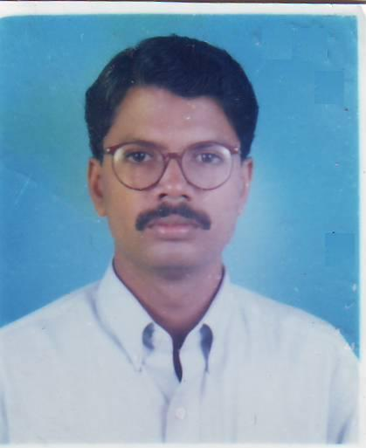 | P.Prabhu
Date of Birth | 02-06-1970
Gender | Male
Department | Information Technology/Computer Science
Qualification | M.C.A.,MPhil.,PGDBA.,
Designation | Lecturer in Information Technology
Address | Directorate of Distance Education  Alagappa University, Karaikudi
Pin code | 630 003
Phone | +919841898894
Email | pra_bhu70@yahoo.com
Website | http://www.alagappauniversity.ac.in
Fax

University Studied UG and PG :

S.No | Degree | University | Year of Study
1 | M.C.A., | Bharathiar university,Coimbatore | 1990-1993
2 | B.Sc.,(Computer Science) | Madurai Kamaraj University, Madurai | 1987-1990

University Where Research done : MPhil

Name of the University | Year of Study | Area of Specialization
Bharathidasan University | 2005 | MPhil(Computer Science)

PG Specialization (subjects) :

1.Java Programming | 2.Object Oriented Analysis and Design
3.Web Technology | 4. Computer Networks

Total Teaching Experience : 10 Years

S.No | Institution | Position | Period
S.No | Institution | Position | From | To
1 | V.H.N.S.N.College,Virudhunagar | Lecturer | 1993 –1994
2 | S.R.M.Arts & Science College,  Kattankulathur, Chennai. | Lecturer | 1998 – 2000
3 | Mohamed Sathak College of Arts  And Science, Sholinganallur. Chennai. | Lecturer | 2001 – 2009
4 | Alagappa University,DDE,Karaikudi | Lecturer | Since 19/02//2009

Total Research Experience (No. of Years): 4 in Mphil.

Current Research Field :

1.Web Technology | 2.Data Mining
3.Computer Networks | 4. Distributed Database

No. of MPhil & PhDs Guided :

M.Phil | 17 | Ph.D | -

Seminar/Workshops Attended :
National

S.No | Title | Institution and Event Name | Period
1 | Enterprise Resource Planning | MASCON,Chennai | 2003
2 | Security and Networking | MIT,Chrompet,Chennai | 2004
3 | Lesson Writers | DDE,Alagappa University,Karaikudi | 2009

Papers Presented :
National

S.No | Title | Institution and Event Name | Period
1 | Role of ICT on delivery of Public Services for solving e-Governance Issues and Challenges | Gobi Arts & Science College, Gobi chettipalayam | August 2009

Membership in Professional Bodies

S.No | Name of the institution and place | Capacity / Status
1 | The Science Congress Association | Life Member

Awards/Rewards/Fellowship/any other Recognition

S.No | Name of the Award/ Fellowship | Institution awarding the Honor | Year
1 | National Eligibility Test (NET) | ICAR (ASRB), New Delhi, recognized by UGC/CSIR | 2004

Service Seniority order Number (As per Attendance Register) :14

