ALAGAPPA UNIVERSITY
FACULTY DETAILS

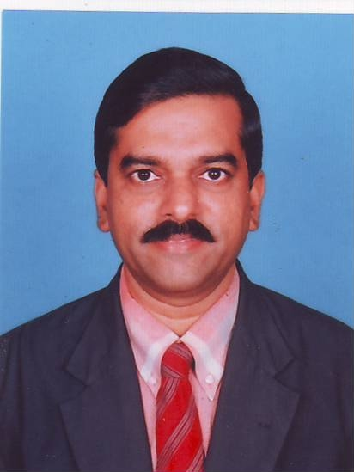 | DR. P. SIVAKUMAR
Date of Birth | 25.06.1965
Gender | Male
Department | Directorate of Distance Education
Qualification | M. Sc., M.Ed., M.A., M. Phil., Ph.D.,D.Cr
Designation | Professor of Education
Address | DDE, Alagappa University, Karaikudi- TN
Pin code | 630 003
Phone | 09442151171
Email | psksiva2002@yhaoo.co.in
Website | http://www.alagappauniversity.ac.in
Fax | 04565-225216

University Studied UG and PG :

S.No | Degree | University | Year
1 | M. Sc., | Annamalai Universtiy | 1987
2 | M.Ed., | Annamalai University | 1989
3 | M. Phil., | Alagappa University | 1992
4 | M.A., | Annamalai University | 1994

University Where Research done :

Degree | Name of the University | Year | Area of Specialization
M. Phil, | Alagappa University | 1992 | Educational Technology
Ph. D. | Alagappa University | 2003 | Educational Technology

PG Specialization (subjects) :

1.Eductional Technology | 2. Environmental Education
3. Curriculum Development | 4.

Total Teaching Experience : 15 Years

S.No | Institution | Position | Period
S.No | Institution | Position | From | To
1 | SMSV Higher Sec. School, Karaikudi | P.G. Assistant in Biology | 8.12.1988 - 1.02.1995
2 | Alagappa University  College of Education | Lecturer in Education  Senior Lecturer in Education  Reader in Education | 2.2.1995 - 1.2.2000  2.2.2000- 1.2.2005  2.2.2005 – 15.2.2009  (2.3.2006 – 1.3.2007  On lien)
 | Alagappa University  DDE | Professor of Education | 16.2.2009 onwards
3 | Bharathidhasan University,  CDE | Professor and Head, Dept. of Education | 2.3.2006 – 1.3.2007

Total Research Experience (No. of Years): 20

Current Research Field :
1.Eduction Technology | 2. Curriculum Development
3.Environmental Education | 4.Biology Education

No. of MPhil & PhDs Guided :

M.Phil | 30 | Ph.D | 5

Projects done Minor/Major:

S.No | Title | Funding Agency | Year | Status (Ongoing/ Completed)
1 | Evolving Multimedia based learning courseware to Promote environmental values at secondary teacher education level | UGC | 2006 | On going
2 | Developing guided Inquiry Strategy in Learning Biology at Higher Secondary Level | UGC | 2005 | Completed

Seminar/Workshops Organized : 3

Seminar/Workshops Attended : 24
(a) National: 22

(b) International: 2

Papers Presented : 23

(a) National : 21
(b) International : 2

Papers Published: 20
(a) National : 17

(a) International : 3

Books Published / Course material written

S.No | Title | Publisher | Year
1 | :Information Processing Models of Teaching – Theory and Research | Neelkamal, Hyderabad,  New Delhi, India | 1995
2 | Environmental Education | Ram , Chennai, India | 1996
3 | Applications of ICT in Education | Neelkamal, Hyderabad,  New Delhi, India | 2009
4 | Teaching and learning  Physics through Multimedia | Puducherry  Co-operative  Book Society,  Pondicherry | 2009

Exposures as Resources persons/ Chairpersons, etc: 7

Membership in Professional Bodies:

S.No |  | Name of the institution and place | Capacity / Status
1 |  | Society for Educational Technology Research and Development, Bharathidasan University, Tiruchrappalli | Life Member
2 |  | International Association of Educators for World Peace ( IAWEP) | Life Member
3 | The Indian Science Congress Association |  | Life Member

Awards/Rewards/Fellowship/any other Recognition

S.No | Name of the Award/ Fellowship | Institution awarding the Honor | Year
1 | M. Phil., Education, University First Rank Holder. | Alagappa University,Karaikudi | 2002
2 | NCERT Award for Innovation | NCERT, New Delhi | 2004
3 | Appreciation Award | IJC, Karaikudi | 2005

Additional Administrative Positions Held
S.No | Position | Period
S.No | Position | From | To
1 | Director I/C, Centre for Distance Education, Bharathidasan Unviersity, Tiruchirappalli | 23.05.2006 – 11  09.2006
2 | Deputy Director, Centre for Adult, Continuing Education and Extension, Alagappa University | 21.03.2007 onwards

Service Seniority order Number (As per Attendance Register): First Position

