ALAGAPPA UNIVERSITY
FACULTY DETAILS

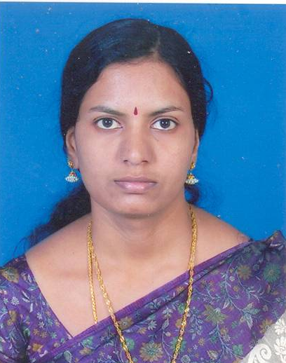 | Mrs. C. Sumathi
Date of Birth | 21.07.1977
Gender | Female
Department | Bioelectronics and Biosensors
Qualification | B.E
Designation | Master Technician
Address | No.5, Subramaniapuram 8th Street south, Karaikudi.
Pin code | 630 003
Phone | 9486014119
Email | cnsumathi@yahoo.com
Website | http://www.alagappauniversity.ac.in
Fax | 04565-225202

University Studied UG and PG :

S.No | Degree | University | Year of Study
1. | B.E., Electrical and Electronics Engineering | M.K.University | 2003

Total Teaching Experience :

S.No | Institution | Position | Period
S.No | Institution | Position | From | To
1. | Alagappa University | Master Technician | 18.08.08 to till date

Total Research Experience (No. of Years):

Seminar/Workshops Attended :
National
S.No | Title | Institution and Event Name | Period
1 | Attended | Alagappa University, Karaikudi and National seminar on Importance of Nano Science and Technology | March 14-15, 2009
2 | Attended | Alagappa University, Karaikudi and National seminar on Recent trends in molecular modeling and Drug design | March 18-19, 2009
3 | Attended | Alagappa University, Karaikudi and National Seminar on Advancements in Bioelectronics and Biosensors | March 19-20, 2009
4 | Attended | Alagappa University, Karaikudi and National Seminar on Application of Genomics and Bioinformatics in Animal Health | March 24-25, 2009

(b) International

S.No | Title | Institution and Event Name | Period
1 | Attended | Alagappa University, Karaikudi and  International Colloquium on Emerging Biotechnologies in Agriculture, Animal Health and Productivity | Feb. 22-26, 2009

Papers Presented :
National
S.No | Title | Institution and Event Name | Period
1. | A New stable Ferrocyanide immobilized Poly (Butyl-Viologen) modified electrode for Dopamine determination. | Alagappa University, Karaikudi  National Seminar on Advancements in Bioelectronics and Biosensors | March 19-20, 2009

