ALAGAPPA UNIVERSITY
FACULTY DETAILS

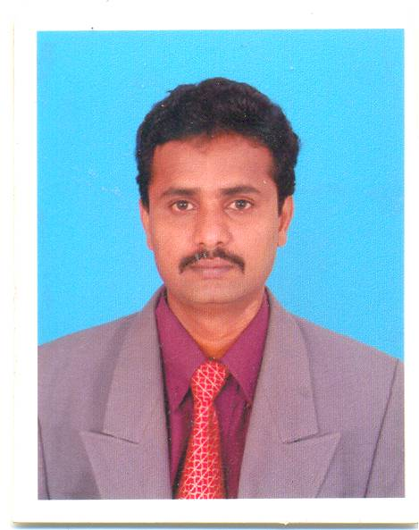 | Dr. J. Wilson
Date of Birth | 28.05.1971
Gender | Male
Department | Bioelectronics and Biosensors
Qualification | M.Sc., B.Ed., Ph.D.,
Designation | Lecturer
Address | 592, Emmanuel Dafney mansion,  Malligai Street, Soodamanipuram,  Karaikudi.
Pin code | 630 003
Phone | 9488260016
Email | Wilson.j2008@yahoo.com
Website | http://www.alagappauniversity.ac.in
Fax | 04565-225202

University Studied UG and PG :

S.No | Degree | University | Year of Study
1.  2.  3. | B.Sc., Physics  B.Ed  M.Sc., Physics | M.K.University  Alagappa University  Bharathidasan University | 1988-91  1995-96  1992-94

University Where Research done :

Name of the University | Year of Study | Area of Specialization
Alagappa University | 2002-2006 | Polymer Lithium Batteries

PG Specialization (subjects) :

1.Electronics | 2.
3. | 4.

Total Teaching Experience :

S.No | Institution | Position | Period
S.No | Institution | Position | From | To
1. | Alagappa University | Lecturer | 12.08.08 to till date

Total Research Experience (No. of Years): 7 years

Current Research Field :

1.Conducting Polymers | 2.
3. | 4.

No. of MPhil & PhDs Guided :

M.Phil |  | Ph.D | 1

Projects done Minor/Major:

S.No | Title | Funding Agency | Year | Status (Ongoing/ Completed)
1. | Application of RuO₂ Nanoparticle Doped Conducting Copolymer (Polypyrrole-Polyaniline) Composite for DNA Sensors | UGC | 2009 | Ongoing

Seminar/Workshops Attended :
National

S.No | Title | Institution and Event Name | Period
1 | Attended | Alagappa University, Karaikudi and National seminar on Importance of Nano Science and Technology | March 14-15, 2009
2 | Attended | Alagappa University, Karaikudi and National seminar on Recent trends in molecular modeling and Drug design | March 18-19, 2009
3 | Attended | Alagappa University, Karaikudi and National Seminar on Advancements in Bioelectronics and Biosensors | March 19-20, 2009
4 | Attended | Alagappa University, Karaikudi and National Seminar on Application of Genomics and Bioinformatics in Animal Health | March 24-25, 2009

(b) International

S.No | Title | Institution and Event Name | Period
1 | Attended | Alagappa University, Karaikudi and  International Colloquium on Emerging Biotechnologies in Agriculture, Animal Health and Productivity | Feb. 22-26, 2009

Papers Published
International

S.No | Paper Title | Name of Journal, Volume No and Page | Year Publication
1.  2.  3.  4. | J.Wilson, G. Ravi and M. Anbukulandainathan. Electrochemical Studies on Inertfiller Incorporated Poly (Vinylidene Fluoride-Hexafluoropropylene)(PvDF-HFP) Composite Electrolytes  Manuel Stephen, Kee Suk Nahm, M.Anbukulandainathan, G.Ravi, J.Wilson. Nanofiller Incorporated (PvDF-HFP) Composite Electrolytes for Lithium Batteries.  Manuel Stephen, Kee Suk Nahm,T.Prem kumar, M.Anbukulandainathan, G.Ravi, J.Wilson. Poly(Vinylidene Fluoride-Hexafluoropropylene)(PvDF-HFP) Based Composite Electrolytes for Lithium Batteries  A. Manuel Stephen, Kee Suk Nahm, M.Anbukulandainathan, G.Ravi, J.Wilson. Electrochemical Studies on Nanofiller Incorporated Poly (Vinylidene Fluoride- Hexafluoropropylene) (PvDF-HFP) Composite Electrolytes for Lithium Batteries | Polymeros.16, 88-93  European Polymer Journal. 42, 1728-1734.  Journal Power Sources. 159, 1316-1321.  Journal of Applied Electrochemistry. 36: 1091-1097 | 2006  2006  2006  2006

Membership in Professional Bodies

S.No | Name of the institution and place | Capacity / Status
1. | The Indian Science Congress Association  14, DR. Biresh Guha Street,  Kolkata-700 017,  India.

Service Seniority order Number (As per Attendance Register): 2

