
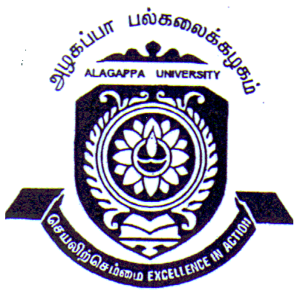 ALAGAPPA UNIVERSITY
A State University Accredited with A+ Grade by NAAC (CGPA: 3.64)
KARAIKUDI – 630 003
Pre-Registration Qualifying Entrance Examination for Ph.D. Program, February 2018

(NET/SET/GATE– qualified candidates are exempted from clearing the Entrance Exam
- Both Written Examination & Interview. They need not apply for the examination)

APPLICATION FORM

Subject / Discipline for Ph.D. registration (Choose the right discipline
relevant to your PG program. Choice once exercised cannot be altered later.
For details refer ‘research / regulations’ in the University web-site)

Name of the Candidate as  in PG Degree Certificate |  |  |  |  |  |  |  |  |  |  |  |  |  | Affix your  recent passport  size photo  (To be attested by Self)
Date of Birth
Nationality |  |  |  |  |  | Religion
Community and Gender (put √ mark in appropriate box) | OC |  | BC |  | MBC/DNC |  | SC/ST |  | Gender
 |  |  |  |  |  |  |  |  | M |  |  | F
Special Category  (put √ mark) | OBC (Non Creamy Layer) |  |  |  |  |  | Physically Challenged
 | Yes |  |  | No |  |  | Yes |  |  |  | No
Parent /Husband / Guardian Name &Details (score off inappropriate)
Contact Address with PIN code and Phone Numbers (Land Line & Mobile) and e-mail |  |  |  |  |  |  |  |  |  |  |  | E-mail:
 |  |  |  |  |  |  |  |  |  |  |  | Mobile No:
 |  |  |  |  |  |  |  |  |  |  |  | Land Line No:
P.G. Degree with subject |  |  |  |  |  |  |  | % of marks in PG Degree (if grade system, equivalent to %  of marks should be mentioned)
Institution from which
P.G degree obtained
Undertaking: The details given above are true and correct.  I abide by the University’s decision in case of untrue / incorrect or insufficient information given by me |  |  |  |  |  |  |  |  |  | Signature
 |  |  |  |  |  |  |  |  |  | Date
 |  |  |  |  |  |  |  |  |  | Place

Application should be enclosed with –
- Attested Photo copy of Cumulative Mark Statement of P.G. Degree & Community Certificate
- Hall ticket (Duly filled in except office use space) with recent passport size photo.
- DD for Rs.500/- Favouring “The Registrar, Alagappa University” payable at Karaikudi

DD Number /Date :
DD Amount : Rs. 500/- (for all applicants)
Name & Place of the Bank :

Filled in Applications should be sent to
The Registrar, Alagappa University, Karaikudi – 630 003 on or before 05-02-2018

  ALAGAPPA UNIVERSITY  A State University Accredited with A+ Grade by NAAC 3.64)  KARAIKUDI– 630 003    Ph.D. Pre-Registration  Qualifying Entrance Examination, February 2018 |  |  |  | Affix your recent passport size photo  (To be attested by Self)
HALL TICKET
Name of the Candidate |  | Reg. No | Office use
Subject/Discipline |  | Venue | Office use
Date & Time | 25.02.2018, 10.00 a.m.

REGISTRAR

