
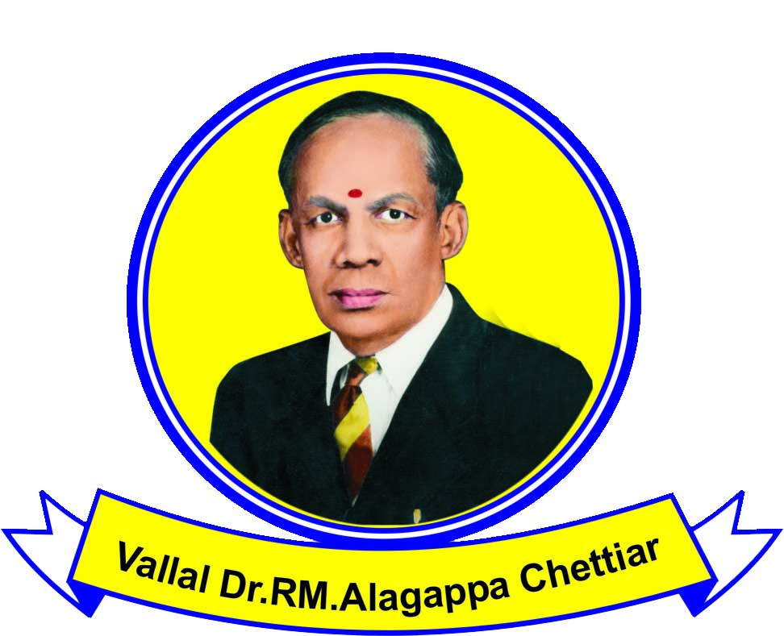
ALAGAPPA UNIVERSITY
KARAIKUDI – 630 003
CENTRAL INSTRUMENTATION FACILITY

CONFOCAL LASER SCANNING MICROSCOPY (CLSM)
(Analysis request form for outside users)
Name and official address:  Phone:  Email: | In case of student, name and official address of the Guide/Head of the Department:  Phone:  Email:
No. of Samples :
Nature of Samples :
Brief history of Samples :
Purpose of use : UG/PG/M.Phil., project work/Ph.D. work/Research
Requested Date : | Date allotted :
Total amount Rs. :
DD No & Date :
Issuing bank :
(please write your name, address and purpose on the back of DD)
Does the sample present any danger to the personnel
or equipment? If yes, handling instructions :
Special request if any :
Charges for CLSM per sample
Category 1: Educational institutes - Rs.300/-
Category 2: National Labs - Rs.600/-
Category 3: Industries/Private Labs - Rs.1000/- (Services extra)
Charges for providing soft copy in CD - Rs.50/- extra

Filled in request form can be sent through Email to vaseeharanb@gmail.com or submitted in person to ‘The Head, Department of Animal Health & Management, Science Block, Alagappa University, Karaikudi -630 004’, who will assign and inform you the analysis date based on the availability of the instrument.

Demand Draft
The applicant should remit analysis charges only through DD drawn in favour of “The Registrar, Alagappa University” payable at Karaikudi. DD should be produced to the concerned at the time of analysis.

Please note that the samples will be discarded after the analysis.
For more information, please visit: http://www.alagappauniversity.ac.in.

Date:
Place:
Signature of the Applicant Signature of Guide Signature of the Head of the
Department/Institution

Instructions
- The filled in request form should be submitted well in advance (at least a week before the requested date of analysis).
- The applicant will be permitted to use CLSM only during the time and date allotted for him/her.
- The applicant has to bring the samples in person along with the DD for the specified amount (Sample analysis cost + Rs. 50/- for CD).
- Samples will not be processed, if sent through post/courier or without DD.
- Applicants should handle the samples very carefully and care should be taken to avoid spillage on the instrument/lab floor.

