ALAGAPPA UNIVERSITY
FACULTY DETAILS

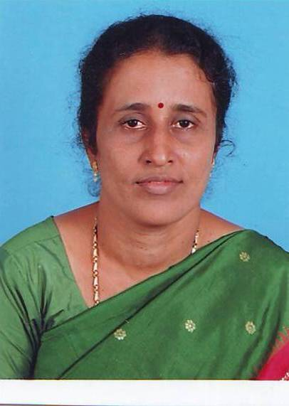 | Dr. V.THIRUVENI
Date of Birth | 30/05/1967
Gender | Female
Department | Directorate of Distance Education
Qualification | M.A., M.Phil., Ph.D
Designation | Lecturer in Tamil
Address | Alagappa University, DDE, Karaikudi.
Pin code | 630 003
Phone | +919486276465
Email
Website
Fax | 04565 - 225202

University Studied UG and PG :

S.No | Degree | University | Year of Study
1 | B.Litt | Annamalai University,Chidambaram | 1993-1996
2 | M.A | Annamalai University,Chidambaram | 1996-1998
3 | M.Phil | Alagappa University,karaikudi | 2004
4 | Ph.D | Alagappa University,karaikudi | 2008

University Where Research done :

Name of the University | Year of Study | Area of Specialization
Alagappa University,karaikudi | 2002-2008 | Kalaignarin Pulapaattu thiran , Novel

Total Teaching Experience : 10 Years

S.No | Institution | Position | Period
S.No | Institution | Position | From | To
1 | Alagappa model higher Secondary School, Karaikudi | Tamil Pandit | 1992-2009

Total Research Experience (No. of Years): 6 years

Current Research Field :

1. Novel | 2. Illakkanam

Seminar/Workshops Attended :
(a) National

S.No | Title | Institution and Event Name | Period
1 | Reflection and. Assessment: Supporting in Service and Pre-Service Teachers in B.Ed. Programme" | Organized by United States – India Education Foundation and Alagappa School of Education, Alagappa University, Karaikudi, | Nov 2008.
2 | “Workshop for Lesson Writers of Distance Education” | Directorate of Distance Education, Alagappa University, Karaikudi, | June 2009
3 | Tholkapiya poongavil Thalaiputhiran’- Tamil Teachers Association | Alagappa university, Karaikudi | 2005
4 | ‘Thalthapatta makkalin nanbar kalaignar’- Kalaignar padaiillakiya parvai | Thanjavur | 2008

(b) International

S.No | Title | Institution and Event Name | Period
1 | - Vikramanin Rajathithan Sabathathil kathai pinnal”-Indian Universities Tamil Teachers Association- | Tiruchirappalli | -2005
2 | Kalaignarin Ilakiyangalil thanithrankal”- Indian Universities Tamil Teachers Association, | Madurai | 2008
3 | Tamizhodu Kalaignar’- Kalignar Padaipulagam | Chennai | 2008
4 | “Kannadhasan Nengil niraintha kaviyangal’(Thaipavayil Agavazhvu Sinthanaigal – | Karaikudi Kannathasan manimandapam | 2007

Books Published / Course material written

S.No | Title | Publisher | Year
1 | Kalaignarin Pulappaatuthiran | Seethai Pathipagam Chennai” ISBN-978-81-907239-7-8 | 2008
2 | Vikramanin Rajathithan Sabatham | Ramaiah Pathipagam, Chennai ISBN-978-81-907651-9-0 | 2008

Awards/Rewards/Fellowship/any other Recognition

S.No | Name of the Award/ Fellowship | Institution awarding the Honor | Year
1 | State Eligibility Test (SET) | Bharathiar University | 2008

Service Seniority order Number (As per Attendance Register) | 18

