ALAGAPPA UNIVERSITY
FACULTY DETAILS

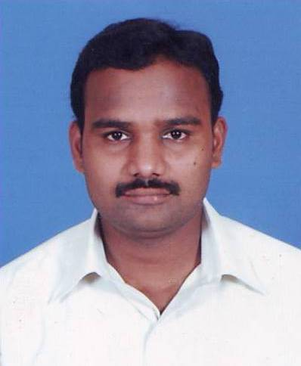 | Mr.G.P.Raja
Date of Birth | 01.06.1979
Gender | Male
Department | Education , DDE
Qualification | M.Com., M.Phil., M.Ed.,
Designation | Lecturer
Address | Directorate of Distance Education  Alagappa University, Karaikudi
Pin code | 630 003
Phone | 9442993245
Email | geepeer2002@yahoo.co.in
Website | http://www.alagappauniversity.ac.in
Fax | 04565-225216

University Studied UG and PG :

S.No | Degree | University | Year of Study
1 | B.Com. | Madurai Kamaraj University | 1996 - 1999
2 | DECM | Manonmaniam Sundaranar Univeristy | 1999 - 2000
3 | M.Com. | Madurai Kamaraj University | 2001 - 2003
4 | M.Phil | Alagappa University | 2003 - 2004
5 | M. Ed. | Madurai Kamaraj University | 2005 - 2007
6 | M.Phil(doing) | Bharathidasan University

PG Specialization (subjects) :

1. System Analysis | 2.Curriculam
3. | 4.

Total Teaching Experience : 2 Years

S.No | Institution | Position | Period
S.No | Institution | Position | From | To
1 | Jairam College of Education | Lecturer | June 2007 – Feb 2009

Total Research Experience (No. of Years): 2 Years

Current Research Field :

1. Education | 2 Vocational Education
3. Teacher Education | 4.Curriculam

Seminar/Workshops Attended :
(a) National

S.No | Title | Institution and Event Name | Period
1 | Workshop on “census data Dissemination” | Madurai Kamaraj University | 12/07/2006
2 | Role of Teachers in developing the personality of the children at elementary level | DIET,Mayanur,Karur  Distrtict | 24/04/08 to 25/04/08
3 | Impact of Programmed learning in upper primary school students | DIET,Mayanur,Karur  Distrtict | November 2008
4 | Refresher Course in Educational Technology | Bharathidasan university | 23 /12/2008 to 12/01/2009
5 | Workshop on “Lesson  Writers “ | Alagappa University, Karaikudi | June 2009

(b) International

S.No | Title | Institution and Event Name | Period
1 | Quality Enhancement in Educational Communication | Bharathidasan University | 29-03-2008 to 30-03-2008

Papers Presented :
(a) National

S.No | Title | Institution and Event Name | Period
1 | Role of Teachers in developing the personality of the children at elementary level | DIET,Mayanur,Karur  Distrtict | 24/04/08 to 25/04/08
2 | Impact of Programmed learning in upper primary school students | DIET,Mayanur,Karur  Distrtict | 2008

Membership in Professional Bodies

S.No | Name of the institution and place | Capacity / Status
1 | The Indian Science Congress Association | Life member

Awards/Rewards/Fellowship/any other Recognition

S.No | Name of the Award/ Fellowship | Institution awarding the Honor | Year
1 | National Level Eligibility Test (NET) | University Grants Commission | 2006

Service Seniority order Number (As per Attendance Register) : 12

