DE–4462
11
DISTANCE EDUCATION
M.Sc. DEGREE EXAMINATION, DECEMBER 2008.
Mathematics
ALGEBRA
Time : Three hours Maximum : 100 marks
Answer any FIVE questions.
All questions carry equal marks.
- (a) Let 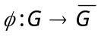 be a homomorphism of G into 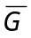 with kernel K. Prove that K is a normal subgroup of G and 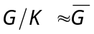.
(b) Prove that if a prime number p divides the order of an abelian group G, then G has an element of order p.
- (a) Prove that if A and B are finite subgroups of a group G, then 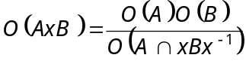.
(b) State and prove the third part of Sylow’s thorem.
- (a) Prove that a finite integral domain is a field. Deduce that the ring 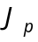 of integers mod p is a field if and only if p is a prime.
(b) Prove that an ideal M in a commutative ring R with unit is a maximal ideal if and only if R/M is a field.
- Prove that every integral domain can be imbedded in a field.
- (a) Let W be a subspace of a finite-dimensional vector space V. Prove that W is finite dimensional and
.
(b) If V is finite dimensional, prove that a linear transformation 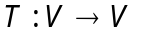 is one-to-one if and only if T is onto.
- (a) Define a nilpotent linear transformation. Give an example.
(b) Show that two nilpotent linear transformations are similar if and only if they have the same invariants.
- (a) Let L be a finite extension of K and K a finite extension of F. Prove that L is a finite extension of F and 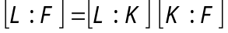.
(b) Let K be an extension of F. Prove that an element 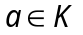 is algebraic over F if and only if F (a) is a finite extension of F.
- (a) Let F be a finite field with q elements, and K a finite field containing F as a sub field. Prove that K has 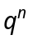 elements for some positive integer n.
(b) Prove that for every prime p and every positive integer n there exists a field having 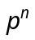 elements.
————————
DE–4463
12
DISTANCE EDUCATION
M.Sc. (Mathematics) DEGREE EXAMINATION,
DECEMBER 2008.
REAL ANALYSIS
Time : Three hours Maximum : 100 marks
Answer any FIVE questions.
All questions carry equal marks.
1. (a) Prove that every non empty open set S in 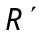 is the union of a countable collection of disjoint component intervals of S.
(b) Let F be an open covering of a closed and bounded set A in 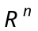. Show that a finite subcollection of F also covers A.
2. (a) Show that every Cauchy sequence is convergent in 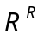.
(b) Prove that the continuous image of a compact set is compact.
3. (a) State and prove the chain rule.
(b) State and prove the generalized mean value theorem.
4. State and prove the implicit function theorem.
5. (a) If 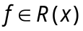 on 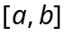, show that 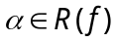 on and 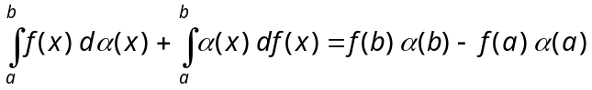.
(b) Assume that increases on . If on , then show that 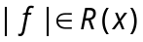 and 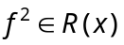.
6. (a) Let be of bounded variation on and assume that on . Prove that on every subinterval 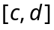 of .
(b) State and prove the second fundamental theorem of integral calculus.
7. Show that the collection m of measurable sets is a
-algebra.
8. State and prove the Littlewood's three principles.

————————
13
DE-4464
DISTANCE EDUCATION
M.Sc. DEGREE EXAMINATION, DECEMBER 2008.
Mathematics
DIFFERENTIAL EQUATIONS AND NUMERICAL METHODS
Time : Three hours Maximum : 100 marks
Answer any FIVE questions.
All questions carry equal marks.
1. (a) Find the orthogonal trajectories of the family
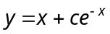.
(b) Find the general solutions of 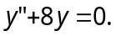
(c) Explain the method of variation of parameters.
2. Apply Picard's method to solve
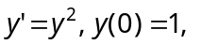with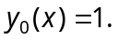
3. Find the general curves of the equations
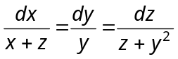.
4. (a) Find the integral surface of the linear partial differential equation
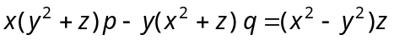
which contains the straight line
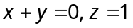.
(b) Reduce the equation
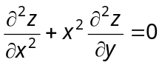
to canonical form.
5. (a) Use the Newton method to approximate positive solution of the system of equations.
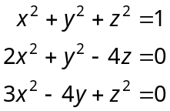
Starting with the initial approximation.
(b) State and prove Chebyshev theorem.
6. (a) Derive the sequence of Legendre polynomials.
(b) State the properties of orthogonal polynomials.
7. Explain the Gauss-Hermite integration methods with examples.
8. Use the Numerov method to solve the initial value problem :
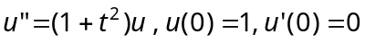 with h = 0.2 in the interval [0, 1].
————————
DE–4465
14
DISTANCE EDUCATION
M.Sc. (Mathematics) DEGREE EXAMINATION,
DECEMBER 2008.
OPERATIONS RESEARCH
Time : Three hours Maximum : 100 marks
Answer any FIVE questions.
1. Solve the following LPP by the revised simplex method
Maximize 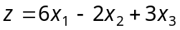
Subject to
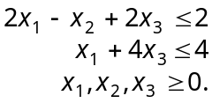
2. Solve the following LPP
Maximize 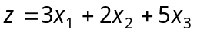
Subject to
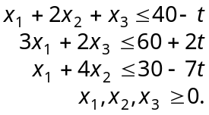
3. (a) A 4-ton vessel is loaded with one or more of three items. The following table gives the unit weight, 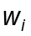, in tons and the unit revenue in thousands of rupees , for item i. How should the vessel be loaded to maximize the total return?
Item i
1 | 2 | 31
2 | 3 | 47
3 | 1 | 14
(b) In a community college data shows that 75% of new students who took calculus in high school do well, compared with 50% of those who did not take calculus. Admissions for the current academic year show that only 30% of the new students have completed a course in calculus. What is the probability that a new student well do well in college?
4. (a) The cost matrix of decision problem is given below
 | s₁ | s₂ | s₃ | s₄
a₁ | 5 | 10 | 18 | 25
a₂ | 8 | 7 | 12 | 23
a₃ | 21 | 18 | 12 | 21
a₄ | 30 | 22 | 19 | 15
Recommend a course of action based on each of the four criteria of decisions under uncertainty.
(b) The following games give A’s pay off. Determine the values of p and q that will make the entry (2, 2) of each game a saddle point
(i)
 | B₁ | B₂ | B₃
A₁ | 1 | q | 6
A₂ | p | 5 | 10
A₃ | 6 | 2 | 3
(ii)
 | B₁ | B₂ | B₃
A₁ | 2 | 4 | 5
A₂ | 10 | 7 | q
A₃ | 4 | p | 6
5. Construct the project network comprised of activities A to G with the following precedence relationships and determine the critical path for the project
Activities : | A | B | C | D | E | F | G
Predecessors : | – | A | A | C | D | B, E | E, F
Duration (in days) : | 10 | 7 | 5 | 3 | 2 | 1 | 14
6. (a) Describe the method of determining the optimum solution for inventory problem with price breaks.
(b) An item is consumed at the rate of 30 items per day. The holiday cost per day is Rs. 5 and the set up cost is
Rs. 10,000. Suppose that no shortage is allowed and that the purchasing cost per unit is Rs. 1,000 for any quantity not exceeding 500 units and Rs. 800 otherwise. Determine the optimal inventory policy, given a 21-day lead time.
7. (a) For a 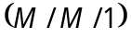 : 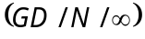 queuing model determine the steady state probabilities and derive the expressions for L_{s}, W_{s}, W_{q} and L_{q} (with usual notations)
(b) Show that for the 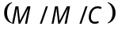 : 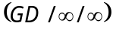 model 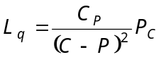.
8. A company operates with three checkout counters. The following schedule is used to determine the number of counters in operation depending on the number of customers in the store.
No. of customers in the store | No. of counters in operation
1 to 3 | 1
4 to 6 | 2
More than 6 | 3
Customers arrive in the counter area according to a Poisson distribution with a mean rate of 10 customers per hour. The average checkout time per customer is exponential with mean 12 minutes. Determine the steady-state probabilities 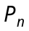 and the probabilities distribution of the number of open counters.

———————
DE–4466
15
DISTANCE EDUCATION
M.Sc. (Mathematics) DEGREE EXAMINATION,
DECEMBER 2008.
MATHEMATICAL STATISTICS
Time : Three hours Maximum : 100 marks
Answer any FIVE questions.
1. (a) The joint density function of a bivariate distribution is given by 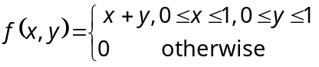.
Find the conditional probability density functions and the correlation coefficient between X and Y.
(b) (i) State and prove Cauchy Schwarz inequality
(ii) Prove that the correlation coefficient between X and Y lies between -1 and 1.
2. (a) Prove that the Poisson distribution is the limiting form of a binomial distribution.
(b) Find the characteristic function of a normal distribution.
(c) Define gamma distribution and find its mean and variance.
3. (a) State and prove the central limit theorem.
(b) If a random variable X is 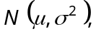 then prove that 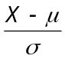 is 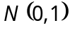 and 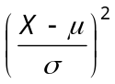 is 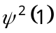.
4. (a) Let 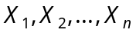 be a random sample from a distribution having the density function 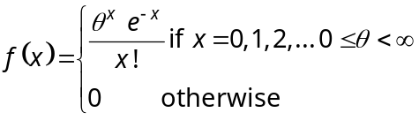. Find the maximum likelihood estimator of .
(b) Define consistent estimator. Show that the sample variance 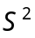 is a consistent estimator of the population variance.
5. (a) Find the confidence interval for the unknown parameter p of a binomial distribution when the parameter n is known.
(b) Let 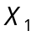 be 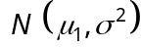 and 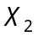 be 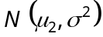, be two independent normal distributions with unknown variance. Find the confidence interval for 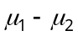.
6. (a) State and prove Neyam-Pearson theorem.
(b) Let 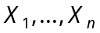 be a random sample of size 25 from a normal distribution 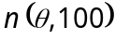. Find a uniformly most powerful critical region of size 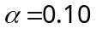 for testing 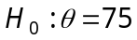 against 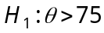.
7. (a) The following tables gives data on the hardness of word stored outside and inside. Test to see whether the variability of hardness is affected by weathering.
 | Outside | Inside
Sample size | 40 | 100
Mean | 117 | 132
Sum of squares about the mean | 8655 | 27244
(b) Explain the one way classification.
8. (a) Write notes on chart and chart.
(b) Explain the single and double sampling plan.
(c) During an examination of equal length of cloth, the following are the number of defects observed :
2, 3, 4, 0, 5, 6, 7, 4, 3, 2.
Draw a control chart for the number of defects and comment whether the process in under control or not.
————————
DE–4467
21
DISTANCE EDUCATION
M.Sc. (Mathematics) DEGREE EXAMINATION,
DECEMBER 2008.
COMPLEX ANALYSIS
Time : Three hours Maximum : 100 marks
Answer any FIVE questions.
All questions carry equal marks.
1. (a) Describe the stereographic projection and find the distance between the stereographic projections of z and z¹ in the plane.
(b) Prove that the real and imaginary parts of an analytic function are Harmonic.
2. (a) Prove that the power series 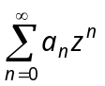 converges absolutely inside the circle of convergence and diverges outside the circle of convergence.
(b) Show that the cross ratio 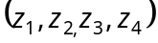 is real if and only if the four points lie on a circle or on a straight line.
3. (a) If r is a piecewise differentiable closed curve not passing through the point a , show that 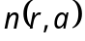 is constant in each of the regions determined by r and zero in the unbounded region.
(b) Let f(z) be analytic at z₀ and 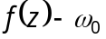 have a zero of order n at z₀. Prove that if 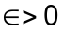 is sufficiently small, then there exists a corresponding 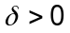 such that for all a with 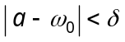 the equation 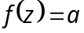 has exactly n roots in the disc 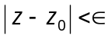.
4. (a) State and prove Cauchy’s theorem for a rectangle.
(b) Let r be a closed curve in an open disc and 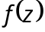 be analytic in . Prove that 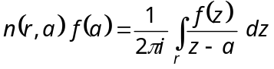 where a is a point not on r.
5. (a) State and prove Rouche’s theorem.
(b) Find the most general entire function having zeros 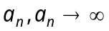.
6. (a) Derive 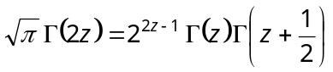.
(b) Prove that 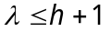 where is the order of an entire function and h is its genus.
7. (a) Derive 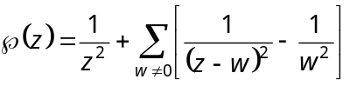.
(b) Derive 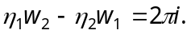
8. Show that :
(a) 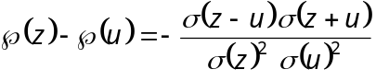.
(b) 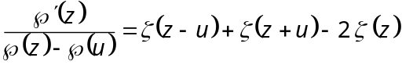.
(c) 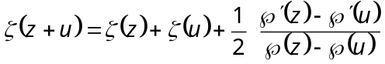.

––––––––––––––––
DE–4468
22
DISTANCE EDUCATION
M.Sc. (Mathematics) DEGREE EXAMINATION,
DECEMBER 2008.
TOPOLOGY AND FUNCTIONAL ANALYSIS
Time : Three hours Maximum : 100 marks
Answer any FIVE questions.
Each question carries 20 marks.
1. (a) If 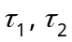 are topologies on a non-empty set , show that 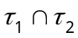 is also a topology. Is the union 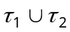 topology? Justify your answer.
(b) Let be a topological space and . Then prove that 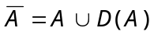 and also prove that A is closed iff 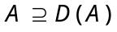.
(c) Show that a subset of a topological space is closed iff it contains iff boundary.
2. (a) Show that every separable metric space is second countable.
(b) Prove that any closed subspace of a compact space is compact.
(c) Prove that continuous image of a compact space is compact.
3. (a) Prove that every closed and bounded subspace of the real line is compact.
(b) State and prove Tychonoff's theorem.
4. (a) Prove the following conditions are equivalent :
(i) is compact
(ii) is sequentially compact
(iii) has the Bolzano Weierstrass property.
(b) Show that a closed subspace of a Normal space is Normal.
5. (a) Prove that a metric space is compact iff it is complete and totally bounded.
(b) State and prove Uryshon Lemma.
6. (a) Let be a regular space. Prove that there exists a compact Hausdorff space 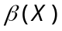 with the following properties :
(i) is a dense subspace of
(ii) Every bounded continuous real valued function defined on has a unique extension to a bounded continuous real function defined on .
(b) Show that the product of any non-empty class of connected spaces is connected.
7. (a) State and prove Schwarz inequality.
(b) If  is a closed linear subspace of a Hilbert space 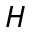 then show that 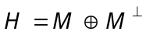.
(c) Let 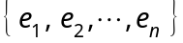 be a finite orthonormal set in a Hilbert space . If 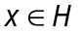 then 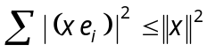 and 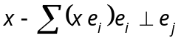 for each j.
8. (a) State and prove Bessel's inequality.
(b) Show that an operator T on H is normal iff its real and imaginary parts commute.
(c) If 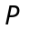 and  are the projections on closed linear subspaces and  of then show that  iff 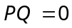 iff 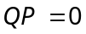.
———————
DE–4469
23
DISTANCE EDUCATION
M.Sc. (Mathematics) DEGREE EXAMINATION,
DECEMBER 2008.
GRAPH THEORY
Time : Three hours Maximum : 100 marks
Answer any FIVE questions.
All questions carry equal marks.
1. (a) Prove the following :
(i) A simple graph G is complete if and only if 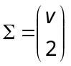.
(ii) A graph is bipartite if and only if it contains no odd cycle.
(iii) With usual notation show that 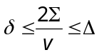.
(b) Define the terms walk, path, cycle, tree and connected graph.
2. (a) If e is a link of G, then prove that, 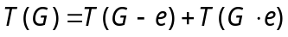 where 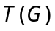 be the number of spanning trees of G.
(b) Prove that 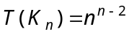.
(c) Explain Kruskal’s algorithm with example.
3. (a) Prove that a graph G with 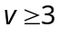 is 2. Connected if and only if any two vertices of G are connected by atleast two internally disjoint paths.
(b) Prove that a nonempty connected graph is eulerian if and only if it has no vertices of odd degree.
4. (a) Prove that a simple graph is Hamiltonian if and only if its closure is Hamiltonian (Prove all the required results).
(b) Prove that if G is a nonhamiltonian simple graph with 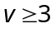, then G is degree – majorised by some 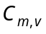.
5. (a) State and prove Ramsey’s theorem.
(b) If G is a connected simple graph and is neither an odd cycle nor a complete graph, then prove that 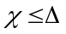, where 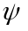 is the chromatic number and is the maximum degree.
6. (a) Prove that for any positive integer k, there exists a k-chromatic graph containing no triangle.
(b) Prove that if G is 4-chromatic, then G contains a subdivision of 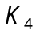.
(c) If G is simple, then prove that 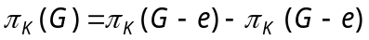 for any edge e of G.
7. (a) Define a planar graph. Show that a graph is planar if and only if each of its blocks is planar.
(b) If G is connected plane graph, then prove that 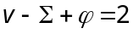.
(c) Prove that if two bridges overlap, then either they are skew or else they are equivalent 3-bridges.
8. (a) Prove that a diagraph D contains a directed path of length 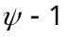.
(b) State and prove the Max-flow Min-cut theorem.

————————
DE–4470
24
DISTANCE EDUCATION
M.Sc. (Mathematics) DEGREE EXAMINATION,
DECEMBER 2008.
PROGRAMMING IN C/C++
Time : Three hours Maximum : 100 marks
Answer any FIVE questions.
All questions carry equal marks.
1. (a) What are the basic concepts of object-oriented programming? Explain them. (10)
(b) Explain the following in C with example. (10)
(i) # include
(ii) return.
2. (a) Discuss the different types of constants in C with illustration. (10)
(b) Explain different types of user-defined data types in C++ with example. (10)
3. (a) Discuss various output functions in C with example. (10)
(b) Describe the input and output operators in C++ with example. (10)
4. (a) Explain the general form of user-defined functions in C with example. (10)
(b) How does a main() function in C++ differ from main() in C? (4)
(c) Distinguish with example between local and global variables. (6)
5. (a) Describe the logical and relational operators with example. (10)
(b) Discuss the Switch and while statements with illustrations. (10)
6. (a) Write a program to find the second largest element in an array. (10)
(b) Describe any four string handling functions with suitable examples. (10)
7. (a) With example explain structure definition in detail.
(10)
(b) How will you declare and initialize pointer variables? Explain with example. (10)
8. (a) Explain different types of input and output operators on files with example. (10)
(b) Write a program to read data from the keyboard, write it to a file called INPUT, again read the same data from the INPUT file and display it on the screen. (10)

————————
DE–4471
25
DISTANCE EDUCATION
M.Sc. DEGREE EXAMINATION, DECEMBER 2008.
Mathematics
DISCRETE AND COMBINATIONAL MATHEMATICS
Time : Three hours Maximum : 100 marks
Answer any FIVE questions.
1. (a) Prove the identity
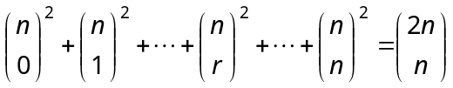.
(b) Using exponential enumerator, find the number of -digit quaternary sequences that contain an even number
of 0’s.
2. (a) Evaluate the determinant
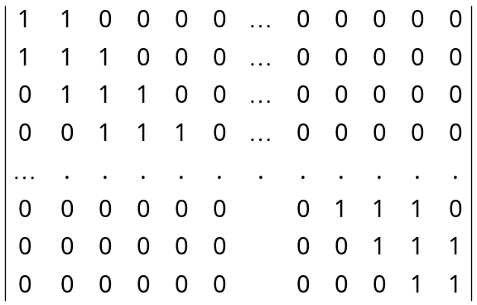
(b) State the tower of Hanoi problem and find a solution to this problem.
3. (a) State and prove the principle of inclusion and exclusion.
(b) Find the number of integers between 1 and 250 that are not divisible by any of the integers 2, 3, 5, and 7.
4. (a) Derive a more general formula for the number of objects that have exactly of the properties for 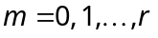.
(b) With usual notation, prove that
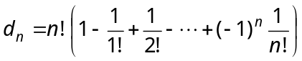.
5. (a) State and prove Burnside theorem.
(b) Define the cycle index of a permutation group  and find the cycle index for
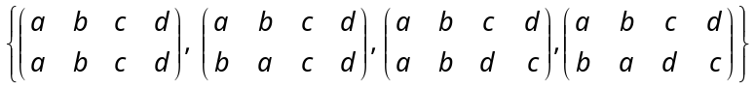.
6. (a) State and prove the generalization of Polya’s theorem.
(b) Find the number of ways of painting the four faces 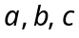 and of the pyramid with two colors of paints and .
7. (a) Determine which of the following lattices are modular.
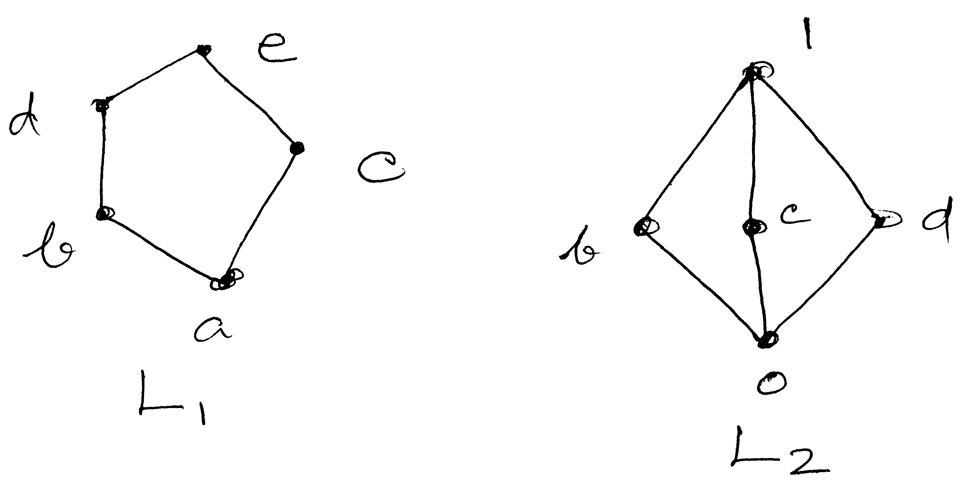
(b) Prove that every distributive lattice is modular. Show that the converse need not be true.
8. (a) Define NAND and NOR gates and express them by diagram.
(b) Prove that every chain is a distributive lattice.
(c) Write a short note on Karnaugh map.

————————

