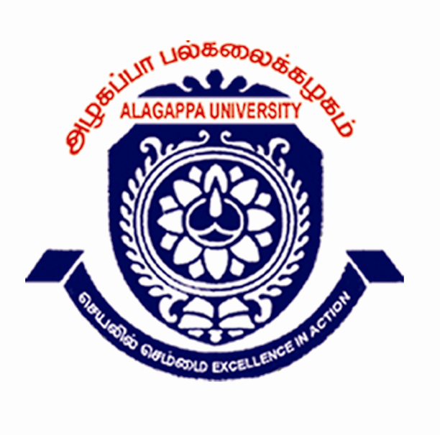  CORDIALLY INVITES YOU to Play a Part, Present a Paper & Direct a Drive  IN THE 3- Day INTERNATIONAL CONFERENCE  Business MoSaic: SA RI GA MA PA DA NI | Faculty of Management  ALAGAPPA UNIVERSITY Karaikudi- Tamilnadu  (A State University Accredited with ‘A’ Grade by NAAC) | 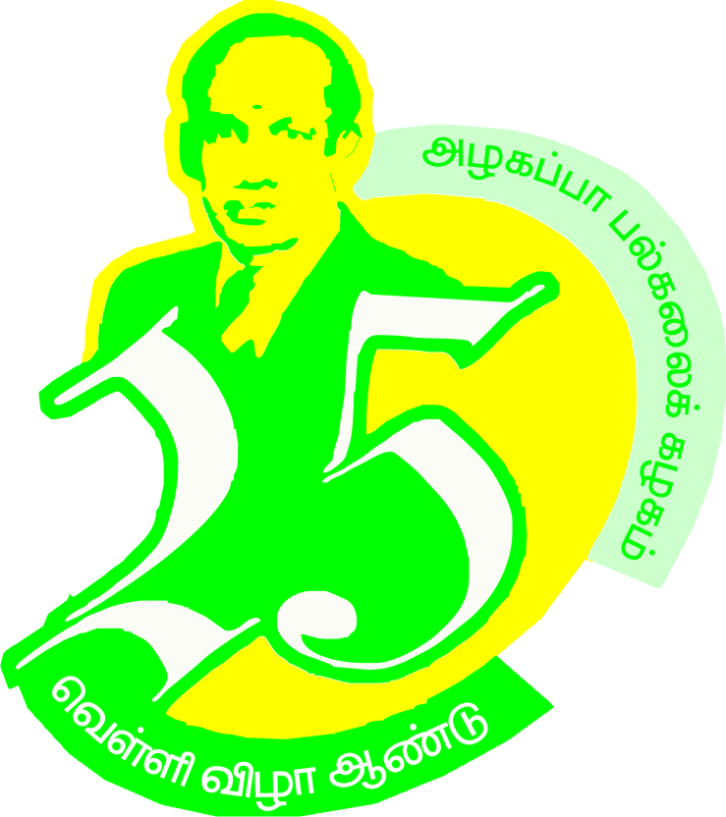

The themes | Strategic Aspects | Spiritual Aspects | 24th & 26th March 2011
The themes | Risk-Return Issues | Resource –R&D Issues | 24th & 26th March 2011
The themes | Governance Aspects | Growth Aspects | 24th & 26th March 2011
The themes | Marketing Aspects | Manufacturing Aspects | 24th & 26th March 2011
The themes | People Aspects | Productivity Aspects | 24th & 26th March 2011
The themes | Drive-Development Aspects | Design -Delight Aspects | 24th & 26th March 2011
The themes | Nuance-Niche Issues | Network-IT Issues | 24th & 26th March 2011

∗You May Please Note∗
Registration Fee Rs.750 payable by DD in favour of Registrar, Alagappa University, Payable at Karaikudi
No TA & DA will be given to participants. Working Lunch, Refreshments and Certificates provided
Mail your Text Paper, Abstract and PPT to ‘gpowerfour@gmail.com’; Last date for Paper Submission 21st March 2011. Time per Presentation 8 to 10 minutes through PPT. There may be Poster Presentation as well.
Venue: LCTL Palaniappa Chettiar Memorial Auditorium, Alagappa University. Cultural Show on 24th at 6.00 pm
»»»»»»»»»»» »»»»»»»»»»»

Program Coordinators | Dr.V.Balachandran, Director, DDE; 9842459477 | Dr.T.R.Gurumoorthy, Dean, CDC, 9442043535
Program Coordinators | Dr.GJeyapal, Prof. in Bank Magt. 9443175128 | Dr.S.Rajmohan, Prof. in AIM 9994590599

Program Secretaries | Dr.S.Kaliayamoorthy, Director, & Chair SoM 9443327542 Dr.S.Sathiyamoorthy, Prof. in Dept. IB&C 9486671819 | Dr.S.Annamalai, Prof. & Head, Dept. BM 9443136134
Program Secretaries |  | Dr.P.K.Muthappan, Prof. & Head i/c, Dept. CS. 9345149720

Program Director | Dr.M.Selvam, Dean, Faculty of Management : 9486671606

Chief Patron | Dr.S.Sudalaimuthu, Vice Chancellor

⇔∗⇔

