SWAMI VIVEKANANDA CENTRE FOR HIGHER RESEARCH AND EDUCATION
ALAGAPPA UNIVERSITY, KARAIKUDI- 630 003
(Re-accredited with ‘A’ Grade by NAAC)

Aim | 1. To impart the great teachings of Swami Vivekananda and inculcate the spirit of patriotism, discipline, dignity, intelligence and religious tolerance among the students in the Universities, Colleges and Schools.  2. To take the messages of Vivekananda among the public so as to cultivate the feelings of Universal Brotherhood in them.  3. To propagate Vivekananda’s Ideal “Healthy India Wealthy India for ushering in a Noble India” to be founded upon the cultural heritage of our nation.
Purpose | 1. To put into practice Swami Vivekananda’s fundamental educational ideas of imparting life-building, man-making and character-building skills through education, research and extension.  2. To organise Teams of Volunteers called Vivekananda Cadet Corps (VCC) in order to disseminate and sensitise the objectives of the Centre.

Name | Designation & Department/Division/College | Status
Ms. S.Chellam | Co-ordinator, Swami Vivekananda Centre for Higher Research and Education Alagappa University, Karaikudi | Co-ordinator
Dr. M.Vasimalai Raja | Associate Professor, Directorate of Distance Education, Alagappa University, Karaikudi | Deputy Co-ordinator
Dr. T.R.Gurumoorthy | Professor & Head i/c, Department of Commerce, Alagappa University, Karaikudi | Member
Dr. C. Yogalakshmi | Professor, Dept. of Bank Management, Alagappa University, Karaikudi | Member

Range of Activities  (Suggested) | Academic Activities:  I) Academic Programmes:  Offering Certificate / Diploma / Degree Programmes on Vivekananda Studies through Regular / Distance education mode in collaboration with Vivekananda Kendra, Kanyakumari.  II) Research programmes:  - Undertaking research projects on  - The Great ideals and thoughts of Swami Vivekananda, Contribution of Swami Vivekananda towards National and Social awakening, Philosophy and Youth Development and Leadership.  - Providing financial assistance to encourage research scholars engaged in research on Swami Vivekananda studies.  - For the post-graduate students in the Department of Education, English and Tamil, the best project award is to be instituted for encouraging research in Vivekananda Studies.
III) Seminar / Conference / Workshop
i) A National Seminar on “Swami Vivekananda and the Youth”
is to be organised for the students of Alagappa University and its
Affiliated Colleges.
ii) International Conference on Swamiji’s thoughts on Youth
Development and Leadership targeting the professors of the
University and its Affiliated Colleges and the students is to be
organised.
iii) National Conference on the contribution of Swami Vivekananda
is to be organised.

IV) Capacity Building Programme
- Capacity Building Programme on Value Education for college professors in collaboration with Vivekananda Kendra, Kanyakumari.
- Capacity Building Programme on Leadership for college principals.
- Capacity Building Programme on youth and service for the NSS students of Alagappa University and affiliated colleges.
- Training programmes for the NSS coordinators in affiliated colleges of Alagappa University for developing service attitude.
- Organising cultural competitions namely, essay writing, elocution, music, drawing competitions for the students of Alagappa University and its affiliated colleges.
- Organising special lecture programmes on Swami Vivekananda in the University and its affiliated colleges.
- Establishing a library containing the books on the messages of Swamiji and research reports and journals.

Activities carried out:

Year |  | Description of Activity | Date | Participants/ Beneficiaries
2014 |  | Special lecture on personality development – Swami Vivekananda’s Perspective organised for the Students of Alagappa University at the University Convocation Hall. | 18.03.2014 | Prof.S.Kaliyamoorthy, Convener, Officiating Committee of the Vice-Chancellor. Dr.R.Illango Retd., Vice-Principal, Vivekananda College, Madurai.  Beneficiaries - 500 students  and100 professors.
2014 |  | Special lecture on “Vivekananda’s Call to the Youth” was organised in association with Sri Sarada Niketan College for Women, Amaravathipudur on 20-03-2014 at the college campus for the benefit of the students of 8 affiliated colleges. | 20.03.2014 | Mr.A.Subrmanian, Retd., Prof & Head, Dept.of History, Arumugampillai Seethaiammal College, Thiruppathur  Beneficiaries - 400 students  and 25 teachers of the affiliated colleges concerned
2014 | The third lecture was organised by the Centre in association with Dr.Umayal Ramanathan College for Women, Karaikudi on 21-03-2014 for the benefit of the students of 6 affiliated colleges. |  | 21.03.2014 | Dr.V.Manickavasagam  Registrar, Alagappa University  Dr.R.Srinivasan, Prof of Management,SAASTRA University,Thanjavur.  Beneficiaries - 300 students and 50 teachers of the colleges  concerned
2014 | The fourth lecture programme was organised on 26-03-2014 by the Centre in Collaboration with Government of Arts College, Paramakudi on the college premises for the benefit of the students of 6 affiliated colleges of the University. |  | 26.03.2014 | Dr.R.Raju, Principal, Govt. Arts College, Paramakkudi.  Mr.S.Raju, Prof. in English and  NSS Co-ordinator, Madurai Kamaraj University.  Beneficiaries - 500 students and 10 teachers of the colleges  concerned
2014 | Orientation Programme on Work Ethics for the Junior Assistants of Alagappa University was organised on 21st & 22nd September 2014 in collaboration with Vivekananda Kendra, Kanyakumari |  | 21.09.2014  &  22.09.2014 | Mr.S.Senthilkumar, Co-ordinator,Swami Vivekananda Kendra, Kanyakumari.  Beneficiaries - 40 Junior Assistants of the University
2015 | National Youth Day was organised jointly with the Computer Centre, Alagappa University, Karaikudi |  | 12.01.2015 | Dr.V.Manickavasagam  Registrar, Alagappa University  Mr.S.Senthilkumar,Co-ordinator,SwamiVivekananda Kendra,Kanyakumari.  Beneficiaries - 300 Students and 25 Faculty members
2015 | Established a Library for the Centre |  | June 2015 | Students and Staff
2016 | National Youth Day Celebration was organised |  | 12.01.2016 | Swami Sathyaprabhananda Maharaj, Ramakrishna mutt,  Chennai. Ilakkia Megam Sri.N.Srinivasan,Devakottai  Beneficiaries - 250  Students and 50 Faculty members
2016 | Special Lecture on “The Vision of Swami Vivekananda” was delivered by the Co-ordinator. |  | 04.07.2016 | The Co-ordinator  Beneficiaries – 200 Students, and 50 Faculty Members
2016 | Swami Vivekananda and Art of living |  | 04.08.2016 | Mr.S.Senthilkumar, Co-ordinator,Swami Vivekananda Kendra, Kanyakumari.  Beneficiaries - 250 Students and 50 Faculty Members
2016 | Independence - 70 Celebration – (Honouring the patriots at their residence programme)  Quit India Event / Rally/ Flag Hoisting ceremony etc., |  | 09.08.2016  to  23.08.2016 | Prof.S.Subbiah  Vice-Chancellor, Prof.V.Balachandran  Registrar i/c., Prof.A.Rajaram,  Professor, Dept of Tamil  (NSS) Co-ordinator,  Dr.K.Krishnamoorthy  H.O.D. i/c., Department of  History.  Beneficiaries - 1000 Students and 200 Faculty Members
2016 | World Brotherhood Day |  | 12.09.2016 | Swami Chandrasekarananda of Sri Ramakrishna Tapovanam, Thiruppurayathurai, Prof.V.Balachandran  Registrar i/c.,  Prof. A.Narayanamoorthy  Prof & Head, Dept.of Economics & Rural development.  Dr.C.Sekar, Director, Centre for International Relations, Alagappa University.  Beneficiaries - 300 Students and 50 Faculty Members.
2016 | Village Placement Programme  “Strength of Village” – Somasundaram Chettiar Middle School, Maruthangudi  VPP at Vairavanpatti |  | 23.09.2016  to  25.09.2016 | Prof. A.Narayanamoorthy  Prof & Head, Dept.of Economics & Rural development.  Ms.S.Chellam, Co-ordinator,  SVCHRE, ALU  Beneficiaries - 300 Students, 50 Faculty Members and the Villagers
2016 | Youth Awakening Day in association with NSS |  | 15.10.2016 | Mr.S.Ganasambantham,  All India Radio, Madurai  Beneficiaries - 300 Students and 50 Faculty Members
2016 | Special Lecture on “Role of Youth” at Seminar Hall, Department of Corporate Secretaryship |  | 18.10.2016 | Prof .V.Manickavasagam Dean Faculty of Management  Dr.C.Ganesha Moorthy  Professor, Dept. of Mathematics  Beneficiaries -100 Students and 10 Faculty Members
2016 | A special lecture on the “Role of teachers towards man-making education” |  | 20.10.2016 | Dr.M.Sundar  Principal, Alagappa University college of Physical Education  Beneficiaries -100 Students and Scholars, Faculty Members
2016 | Special Lecture on “Universal Brotherhood” at the Bharat Scouts and Guides Training Camp at Sri Vishalakshi Hr.Sec.School, Thekkur |  | 23.10.2016 | The Co-ordinator and  Assistant commissioner (Guides)  The District Secretary Devakottai (Bharath Scouts and Guides)  District Secretary (Scouts) Training Officers  Beneficiaries - 200 School Students, 100 Teachers & Public.
2016 | National Conference on “Swami Vivekananda: A Youth Icon” |  | 24.10.2016 | Dr.S.Sachchithanantham, Institute International des Etudes Superiors, Paris, France. Prof.V.Alagappan, Member of Syndicate, Alagappa University.  Beneficiaries - 350  Students, Research Scholars and 50 Faculty Members
2016 | National Education Day |  | 10.11.2016 | Thiru.S.Arunachalam  Head Master, Alagappa Model Hr.Sec.School, Karaikudi.  Beneficiaries - 200 Students, 10 Teaching & Nonteaching Staff members
2016 | Special Lecture on “Vision of Vivekananda” |  | 17.11.2016 | Dr. N.Sengutuvelan  Asst. Prof., DDE, Alagappa University, Karaikudi.  Beneficiaries -100 DDE Students and 10 Faculties
2016 | Visit to Ramakrishna Mission & Deenathayal Library in Delhi |  | 27.11.2016 and 28.11.2016 | Data collection on Swami Vivekananda
2016 | Visit to Ramakrishna Mission at Mylapore and Vivekananda Illam, Chennai. |  | 29.11.2016 and 30.11.2016 | Data collection on Swami Vivekananda
2016 | Special Lecture on “Vivekananda’s Call to Youth” |  | 15.12.2016 | Sister.S.Sundaravalli, Principal,  Sri Sarada Vidyalaya Matriculation School, Amaravathipudur, Karaikudi.  Beneficiaries – 250 Students and 15 faculty members
2016 | Training of Trainers (ToT) |  | 21.12.2016 | Prof.V.Alagappan, Member of Syndicate, ALU  Beneficiaries – 300 Students and Faculty members
2017 | Visit to Sri Ramakrishna Mission – Yadavagiri, Mysuru  The Bharat Scouts & Guides  17th National Jamboree – Mysuru, Karnataka – Tamil Nadu Day Celebration |  | 01.01.2017  to  03.01.2017 | National Chief Commissioner  State Chief Commissioners,  The Bharat Scouts & Guides, Tamil Nadu and Karnataka.
2017 | National Youth Day celebration:  Dr.Umayal Ramanathan College for women, Karaikudi. |  | 11.01.2017 | The Principal  Beneficiaries – 300 Students and 10 Faculty members
2017 | National Youth Day Celebration Collaboration with NSS |  | 12.01.2017 | A.L.Ramanathan  Former General Manager  Pandiyan Grama Bank  Beneficiaries –200 Students and 20 Faculty members
2017 | National Youth Day Celebration in collaboration with NSS, YRCW, H.R.D Cell & Department of Youth Welfare |  | 31.01.2017 | Dr. S.Ramuthai,  Principal, Seetha Lakshmi Aachi College for women – Pallathur.  Beneficiaries –1000 Students and 30 Faculty members
2017 | Special Programme:  “Swami Vivekananda in Tamil Nadu” |  | 01.2.2017 | Dr. N. Anbazhagan, Professor & Head, Department of Mathematics  Beneficiaries – 100 Students and  10 Faculty members
2017 | “Vivekananda on Human Rights” a street play enacted by Vivekananda Cadet Corps in the Training of Trainers (TOT) programme organised by Department of Social Work in collaboration with Rajiv Gandhi National Institute of Youth Development,(Ministry of Youth Affairs and Sports, Govt.of Taminadu) Sriperumpudur, Tamilnadu |  | 09.02.2017 | Dr. M.Veluchamy  Assistant Prof.  Dept.of Social Work.  Beneficiaries – 60 Students and 5 Faculty members
2017 | Village Development Day – Conducted by  Seethalakshmi Achi College for Women, Pallathur |  | 16.02.2017 | Dr.R.Nageswari, Associate Professor, Head, Department of Economics, Seethalakshmi Achi College for Women, Pallathur.  Ms. A.Carolin Amalraj, Co-ordinator, Makkal Pathai, Sivagangai Dist.  Beneficiaries – 70 Students, 5 Faculty members and the villagers.
2017 | EMPOWERMENT OF YOUTH |  | 18.02.2017 | Dr.M.Senthil  Prof & Head  Dept.of Logistic Management,  Beneficiaries –60 Students and 3 Faculty members.
2017 | International Mother Language Day Celebration.  (MATRIBHASHA DIWAS)  By Swami Vivekananda Centre for Higher Research and Education, Centre for Tamil Culture, Alagappa University |  | 21.02.2017 | Dr.S.Senthamizhpavai, Director, Centre for Tamil Culture  Selvi. Agastae, Rwanda, Teacher  Beneficiaries –60 Students and 3 Faculty members
2017 | Women’s Day Celebration  Skit on Nivedita by Vivekananda Cadet Corps (Student Volunteers) |  | 08.03.2017 | Mr.Thangammoorthy, Correspondent, Venkateswara Matric Higher Sec. School, Pudukkottai  Ms.S.Chellam, Co-ordinator,  Beneficiaries – 900 Students and 50 Faculty members
2017 | Alagappa University - NSS Residential Camp at Kandanur - Paalaiyur “Vivekananda’s messages for religious harmony and Universal peace” |  | 10.03.2017 | Ms.S.Chellam, Co-ordinator,  Prof.S.Rajaram,  NSS Co-ordinator,  Dr.V.Palanichamy, Prof & Head, Department of Computer Application  Beneficiaries – 100 Students and 5 Faculty members and the Villagers
2017 | “Thoughts of Vivekananda for Today and Tomorrow” |  | 11.03.2017 | Dr.T.R.Gurumoorthy, Head, Department of Commerce, Alagappa University.  Dr. M.Durai, Professor,Department of Tamil.  Dr.S.Murugesan, Associate Professor, Department of Tamil, Alagappa Govt. Arts College  Beneficiaries – 100 Students and 10 Faculty members

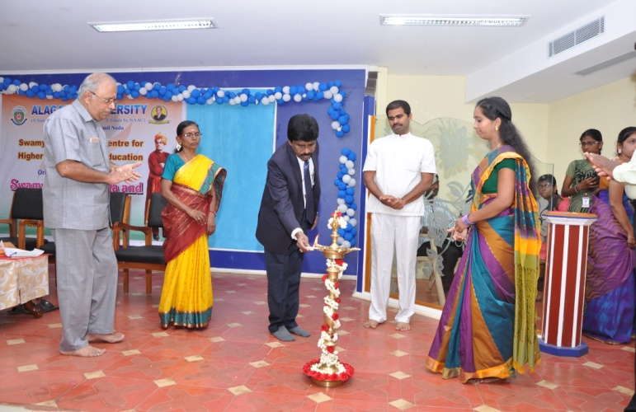
Orientation Programme on World Brotherhood Day Celebration
“Swami Vivekananda and Art of Living”
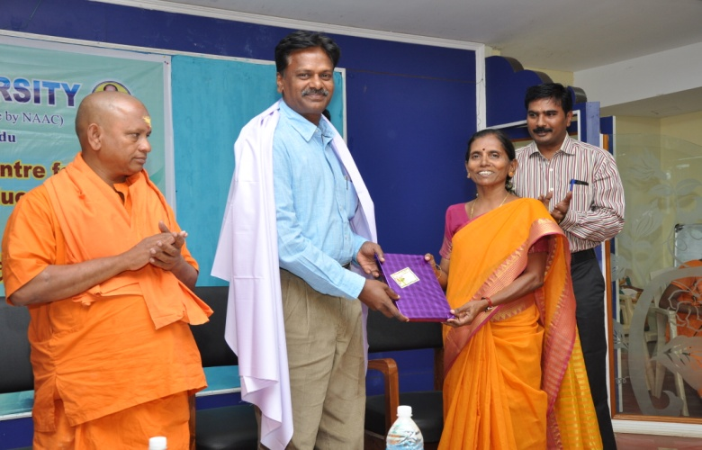
Independence – 70 Celebration National Conference on
Honouring the patriots at their residence “Swami Vivekananda : A Youth Icon”
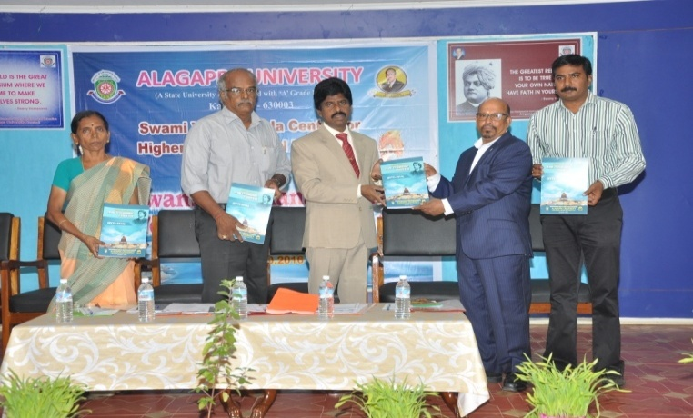
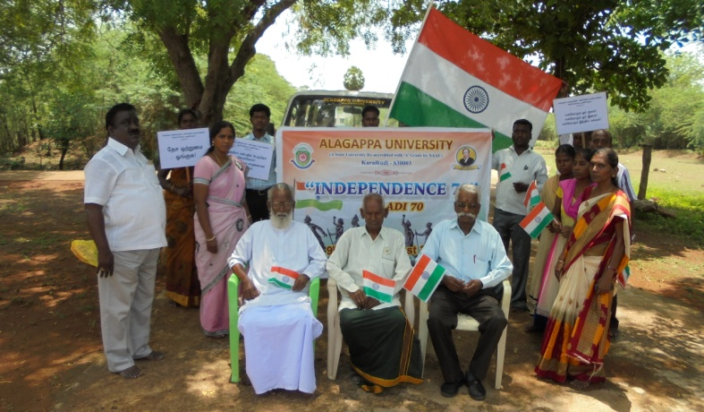
Special Lecture on National Youth Day Competition
““Vivekananda Call to Youth” Mime
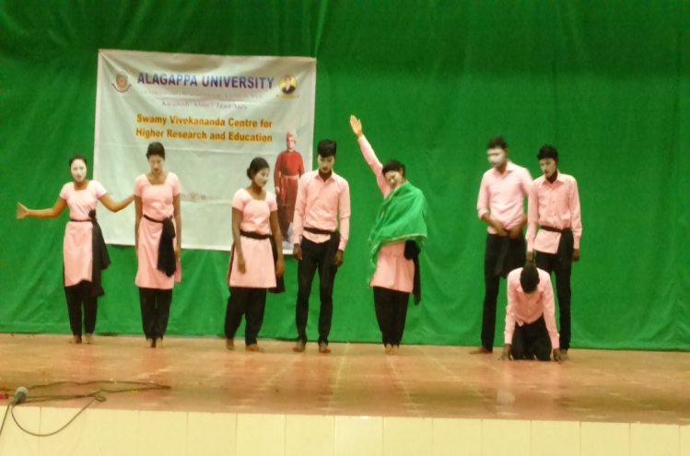
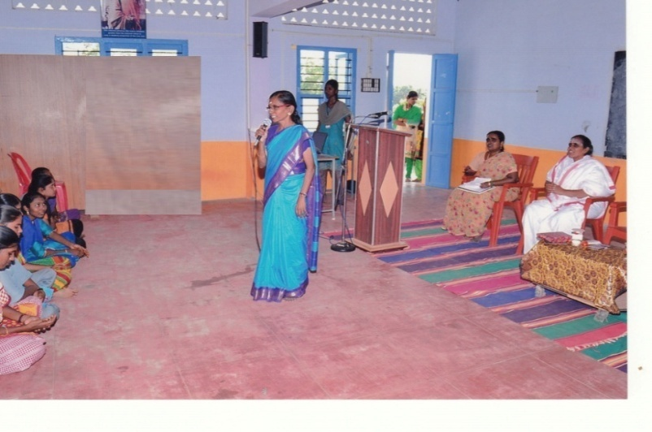

National Youth Day Celebration National Youth Day Celebration in
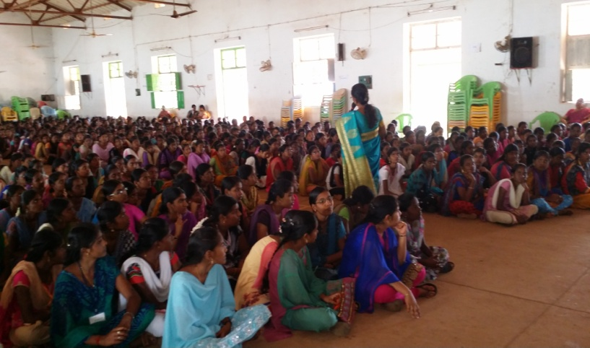
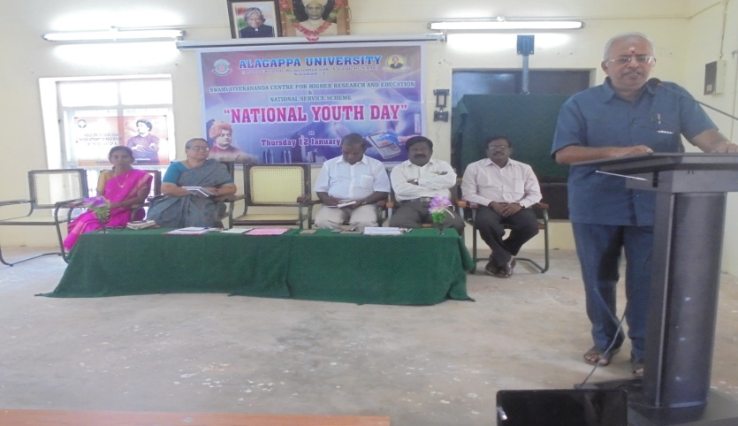
Seethalakshmi Achi College, Pallathur

“Nivedita” (Skit) by Vivekananda
Cadet Corps on Women’s Day Celebration NSS Special Camp at Yeluvankottai
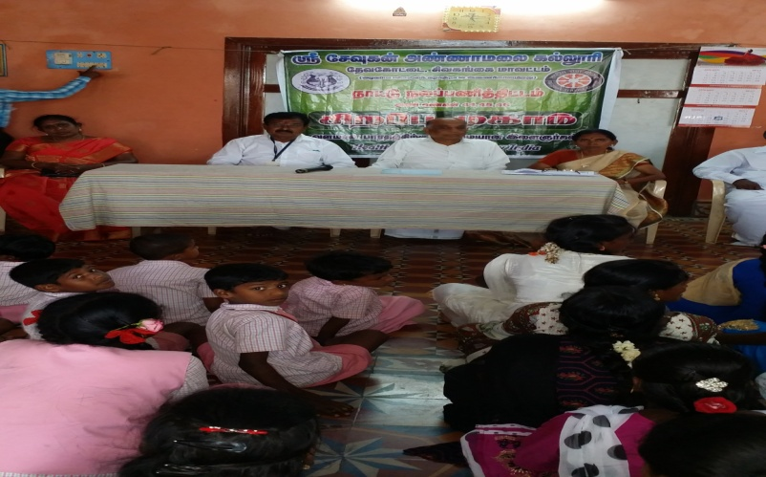
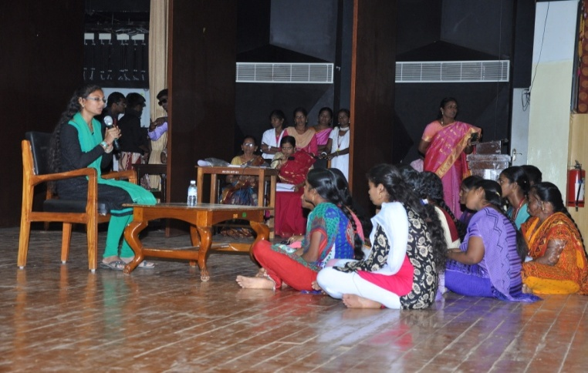

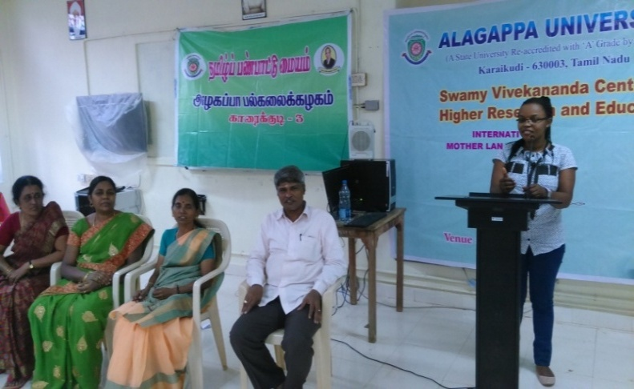
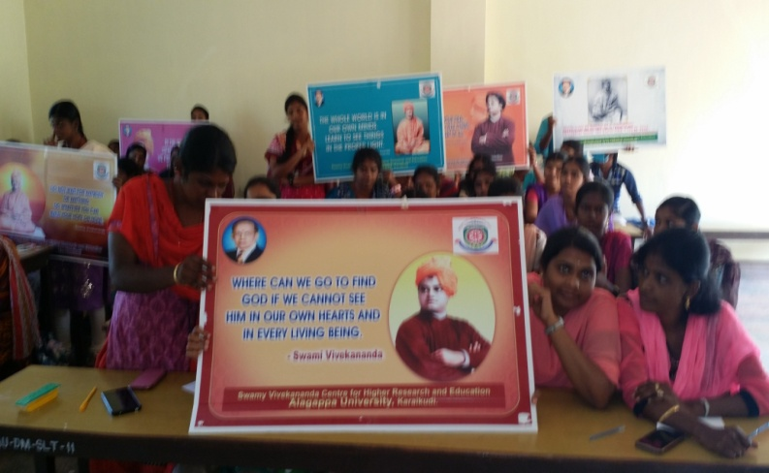
Swami Vivekananda in Tamil Nadu International Mother Language Day
@@@

