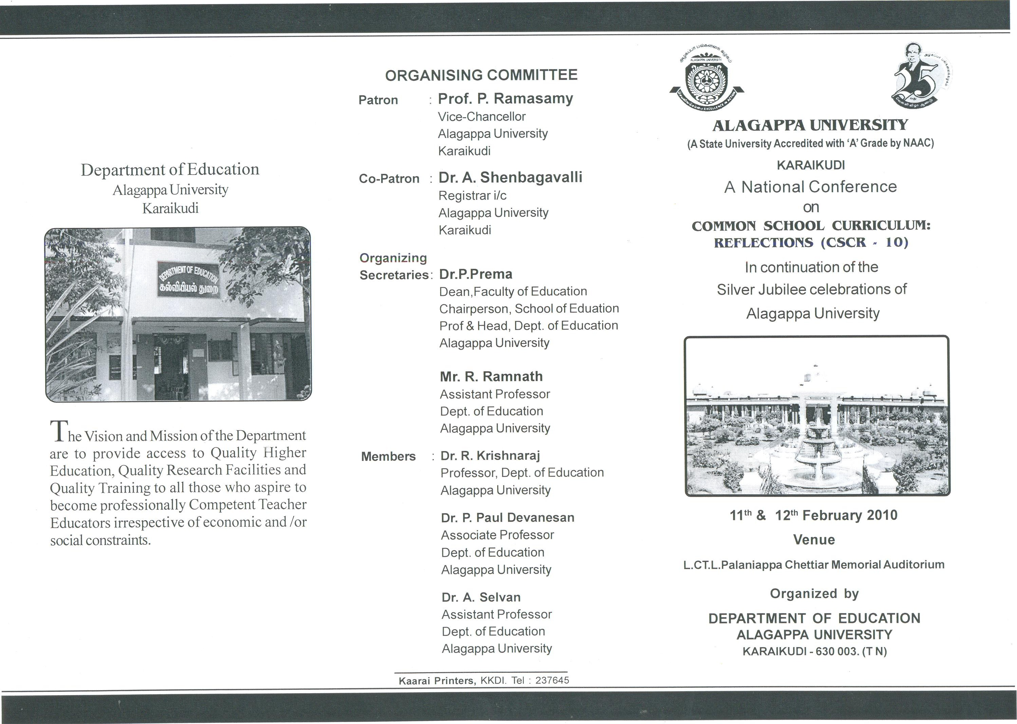

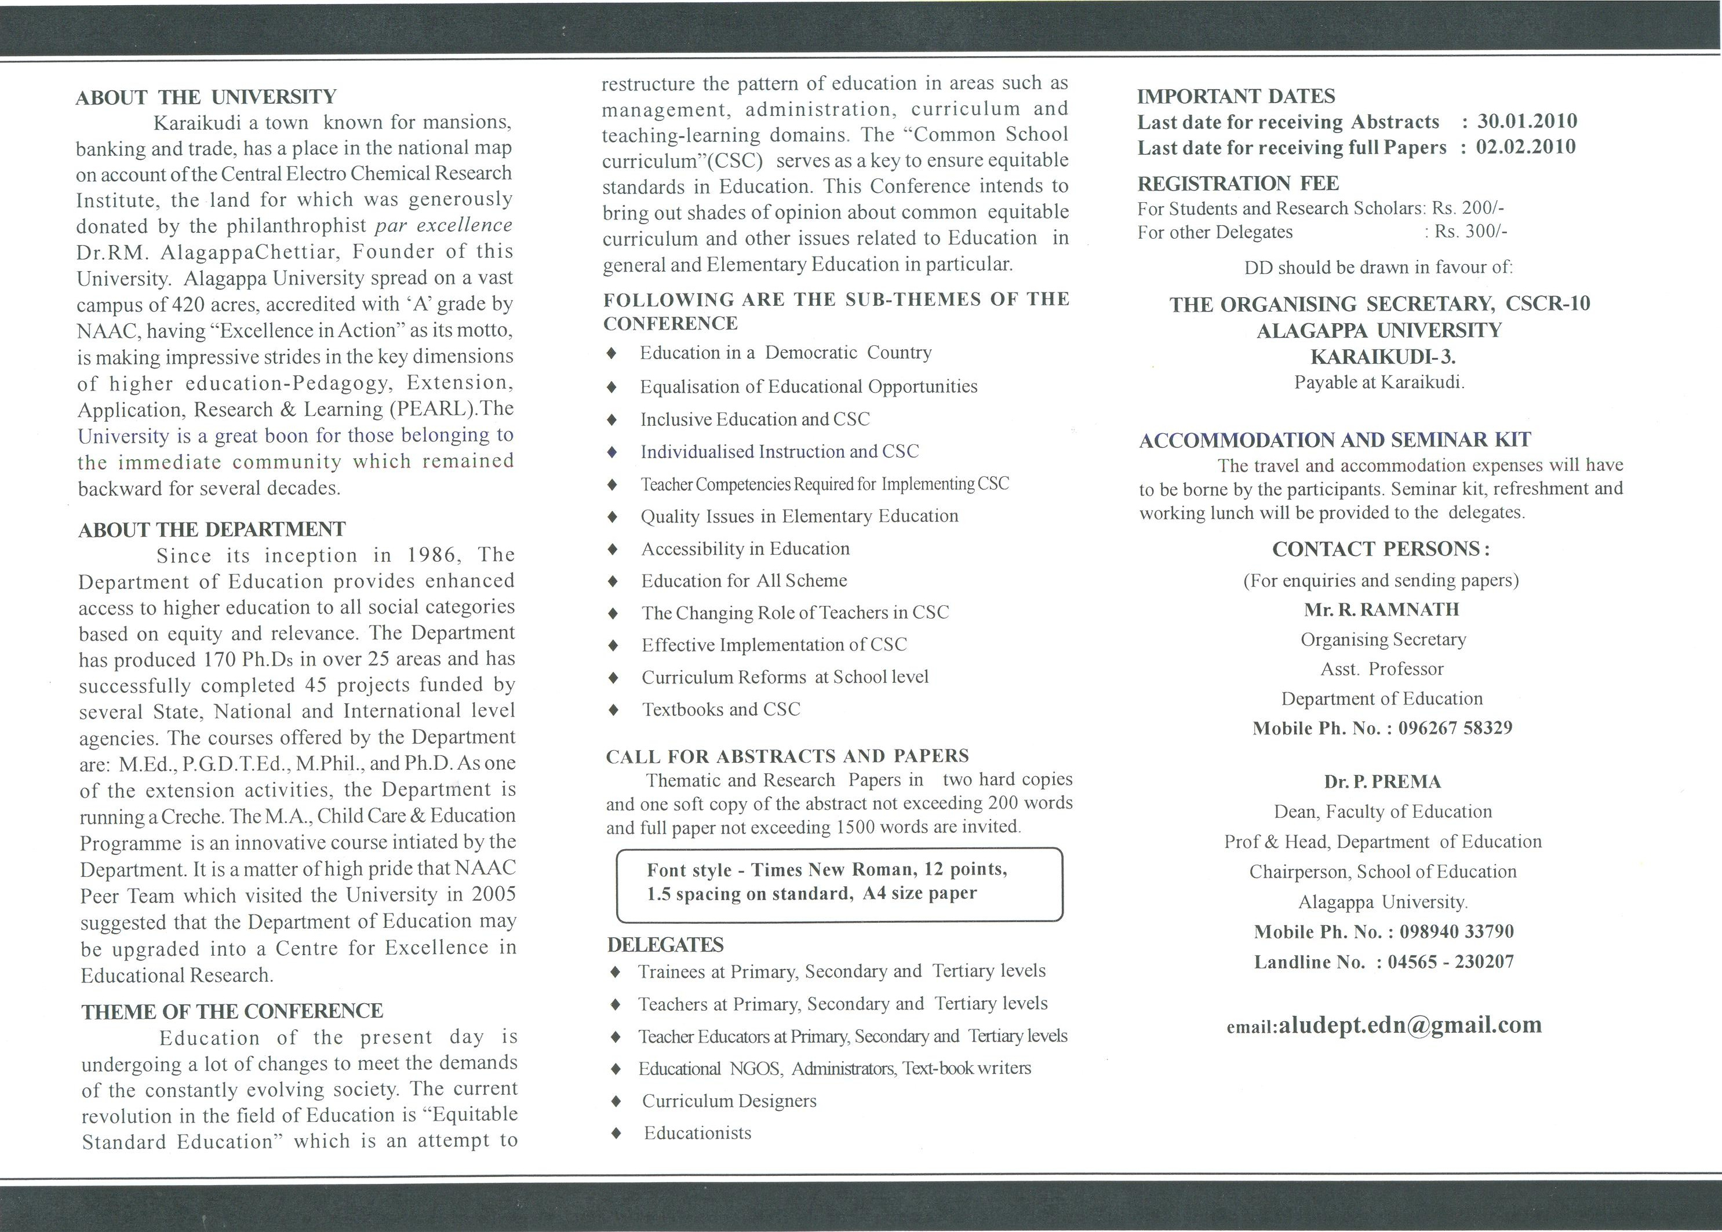
National Conference
On
COMMON SCHOOL CURRICULUM:
REFLECTIONS (CSCR-10)
11TH & 12TH Feb.2010

REGISTRATION FORM

NAME (Block Letters) :
Designation :
Gender : M/F
Organisation :
Postal Address :
e-mail :
Contact No (Mobile) :
Title of the Paper/Participation :

Sub theme :
Presentation : Oral / OHP /LCD
Details of the Payment :
Amount in Rs. :
DD No & Date :
Name of the Bank :
Date :

Signature

