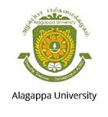 |  | ALAGAPPA UNIVERSITY  (Reaccredited with “A” Grade by NAAC)  KARAIKUDI – 630 003 | 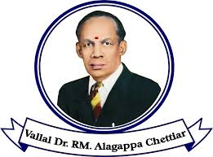
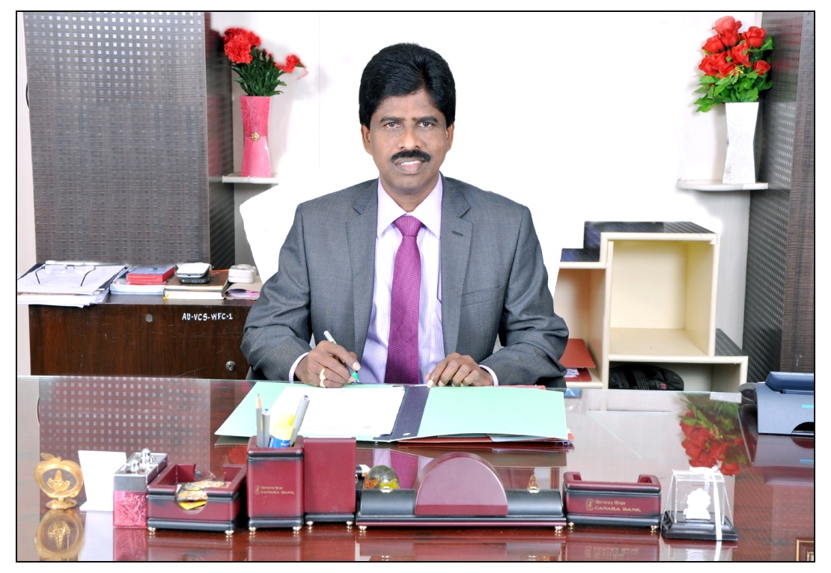
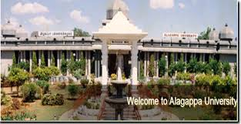
 | ALAGAPPA UNIVERSITY  (Reaccredited with “A” Grade by NAAC)  KARAIKUDI – 630 003 |  | 
EQUAL OPPORTUNITY CELL

PERFORMANCE REPORT OF ACTIVITIES
2012 -2017

EQUAL OPPORTUNITY CELL

Aim and Purpose  (Suggested) | - To ensure non-discrimination at the institutional level
 | - To promote diversity and inclusive practices in the campus.

Name | Designation & Department | Status
Dr. C. VETHIRAJAN | Professor,  Dept. of Corporate Secretaryship,  Alagappa University,  Karaikudi | Co-ordinator
Dr.M.PANDI | Professor & Head  Dept. of Tamil  Alagappa University  Karaikudi | Member
Dr.A.MUTHUSAMY | Professor,  Dept. of International Business  Alagappa University  Karaikudi | Member
Dr.A.MORARJI | Professor,  Dept. of Corporate Secretaryship,  Alagappa University,  Karaikudi | Member

Grants received during 2014-15 | As no fund was allotted during 2014-15 there were no activities under this cell.
Number of beneficiaries | ----
Special achievements during 2014-15 | ----
Further Plan (if any) | Proposed to conduct Communication skills  Topic  1. Speaking skills,  2. Communicative skills,  3. Tips for effective communication,  4. Writing skills and Reading skills and Employability Skills for the student of SC/ST, OBC (Non- creamy layer), and Minorities.

LIST OF ACTIVITIES

S.No | Period | Activity | Place | No. of Participants
1 | 29th & 30th April 2013 | Coaching programme for Management students | Management Block, Conference Hall | 100
2 | 19th September 2013 | Coaching programme on Employability skill for Science students | Science Block  Dept. of Physics  Seminar hall | 75
3 | 1st & 2nd March 2017 | Training programme on Campus Interview Skills for Management & Tamil students | Management Block, Conference Hall | 120

ACTIVITIES NO. 1
REPORT FOR THE YEAR 2012-13.
A two day coaching programme for School of Business Management students was organised under the ageis of Equal Opportunity Cell of Alagappa University, on 29th & 30th April 2013. The co-ordinator Dr.C.Vethirajan, Professor, Department of Corporate Secretaryship welcomed the gathering.
Prof.S.Sudalaimuthu, Vice-Chancellor of Alagappa University, Karaikudi, inaugurated the coaching classes on 29th Morning. In his presidential address he emphasized the students involvement in such coaching programme besides to regular teaching. He appealed to all students and scholars to develop the communication skill, soft skill, and aptitude analysing skill. The programme can focused on a logical reasoning and positive attitude. There are nearly 2000 Computer Managerial Schools all over India nearly and 18,000 Business Schools at present. Roughly 70% to 80% pass out from a Business School. Every year 1.5 lakh graduates roll out from each Business Schools. The course trainer Ms.N.Hema Sitrarasu, Managing Director, Amazing Institute of Management, Madurai, in her key note address pointed out the phases of coaching into logical reasoning, creative thinking, and numerical ability and the like.
The session ended with the formal of vote of thanks delivered by Dr.M.Upaulthus Selvaraj, Professor, Department of Corporate Secretaryship, Alagappa University.
Coaching programme for Management Students.
Sl.No | Date | Time/ Batch | Activities | Students Participated
1. | Day 1  29.4.2013 | Fore noon Batch 1 | Logical reasoning | 55
 |  | After Noon  Batch 2 | English Language | 45
2 | Day 2  30.4.2013 | Fore noon  Batch 1 | Numerical Ability | 55
 |  | After noon  Batch 2 | General Awareness | 45

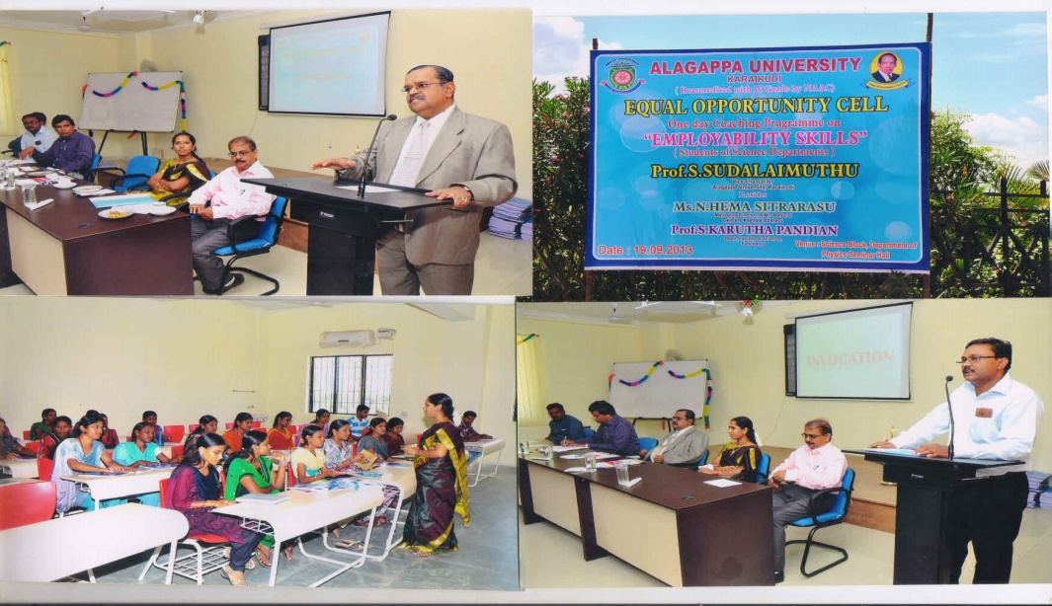

ACTIVITIES NO. 2

REPORT FOR THE YEAR 2013-14.
Equal opportunity cell of Alagappa University organized one day coaching programme on "Employability Skill" for the students of science department of our university on 19th September 2013. Prof.S. Sudalaimuthu, Vice Chancellor of Alagappa University, inaugurated the coaching classes and in his presidential address exhorted the students to hone their soft skills to become fit for jobs.
Employability Skills for Science Departments
Sl.No | Date | Time/ Batch | Activities | Students Participated
1. | 19.9.2013 | Fore Noon  Batch 1 | Problem solving skills | 45
 |  | Batch 2 | Communication Language | 30
2. | 19.9.2013 | After Noon  Batch 1 | Group Discussion | 45
 |  | Batch 2 | Interview Test | 30

This kind of programme (EOC) will develop their inter personnel skill and also proper aptitude. In science/ management/arts programmes the content is only 20% on knowledge and 70% on behaviour parts. 100% in subject matter will not lead to success he added. Earlier the EOC co-ordinator, Dr. C. Vethirajan welcomed the gathering. Dr.P.K.Muthappan, Professor and head, Department of Corporate Secretaryship proposed vote of thanks.

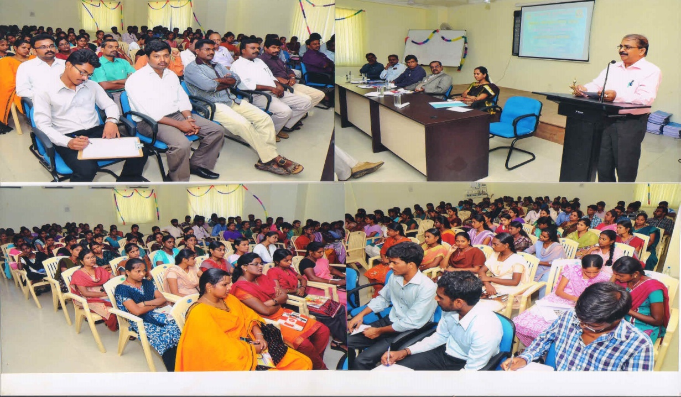
ACTIVITIES NO. 3

REPORT FOR THE YEAR 2016-2017
A two day training programme on “Campus Interview Skills” was organized by the Equal Opportunities Cell and Placement Cell of Alagappa University.
Training programme schedule Date: 1st & 2nd March 2017
S.No | Date | Batch / Time | Activities | Students Participated
1 | Day 1  1.3.2017 | Batch 1  Forenoon | SWOT Analysis & Resume Buildings | 60
 |  | Batch 2  Afternoon | Group Discussion & Interview skills | 60
2 | Day 2  2.3.2017 | Batch 1  Forenoon | SWOT Analysis & Resume Buildings | 60
 |  | Batch 2  Afternoon | Group Discussion & Interview skills | 60

Presiding over the function, Prof.S.Subbiah, Vice-Chancellor exhorted the students to make use of the training offered by the University to prepare themselves to get employment in Corporates. He complemented the Placement Cell for the effective functioning in arranging various activities besides preparing the Placement brochure for the University. He added that it is more fitting that the EOC whose main aim is to ensure indiscrimination among the students in every aspect is organizing the programme. He gave a word of caution that those indulging in any sort of discrimination in the University Campus will be seriously dealt with.
Prof.V.Manickavasagam, Dean, Faculty of Management in his felicitation address pointed out that the interview which is basically a personality test is arranged to ascertain the skill, experience, personality, confidence level, willingness and ability to learn of the interviewees discloses the sound grasp of the academics, self awareness, clarity of goals and well rounded personality of the candidates. He appealed to the II year MBA Corporate Secretaryship, Dept. of Tamil, II year MBA International Business and M.Com students to fully utilize the sessions.
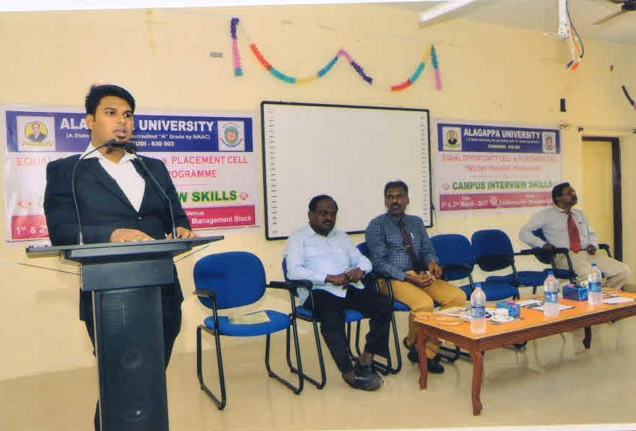
Mr.S. Ameen, Principal trainer inn his key note address said that a candidate must show various skills like communication, aptitude, attitude, computer skills etc. apart from curriculum. He is expected to show decent corporate etiquette at the time of interview itself, and hence training becomes very vital for graduates. He further said that the two days are segregated into 4 sessions on SWOT Analysis, Resume Building techniques, Group Discussion and Interview Skills. By the end of this two day training program students will be completely aware of the interview process and able to perform well in Group discussion and Interview.
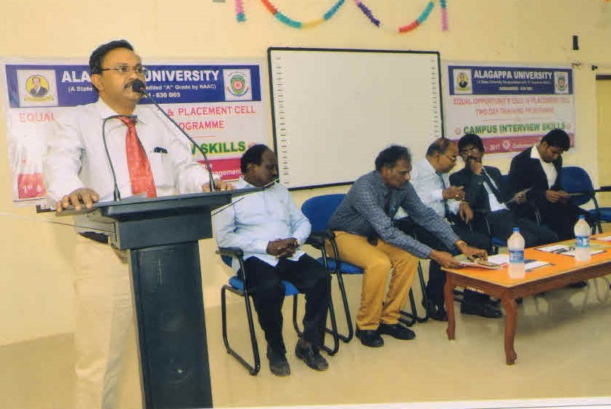
Earlier Dr.C.Vethirajan, Coordinator, EOC welcomed. Dr.K.Uthayasooryan, Coordinator PC gave the thematic address. Dr.M.Pandi, Head of the Dept. of Tamil proposed the vote of thanks.

