Alagappa University, Karaikudi – 630 003
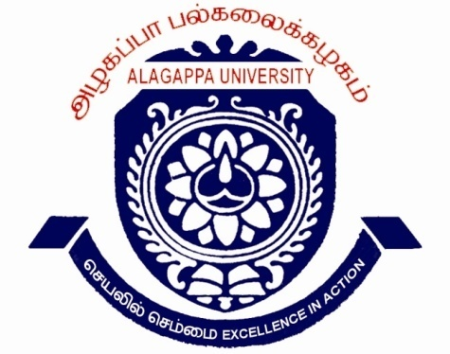
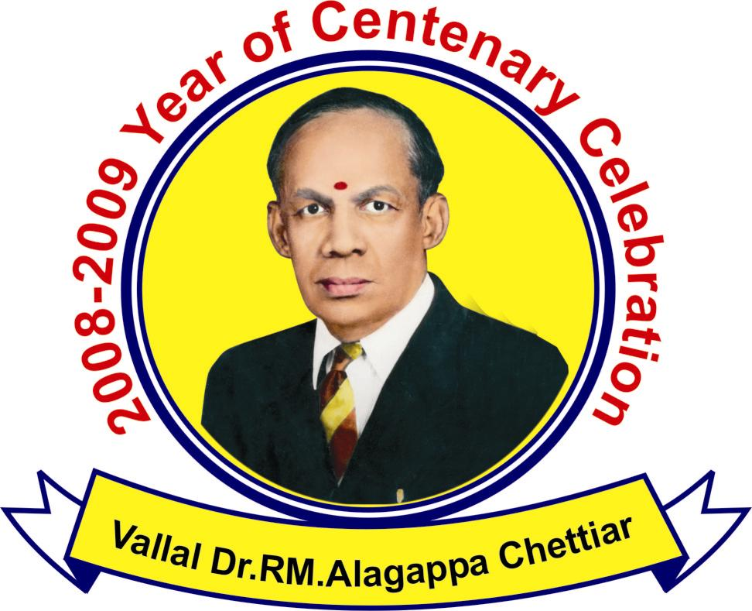
Tamil Nadu, India
INTERNATIONAL CONFERENCE
‘ GLOBAL ECONOMIC ASCENDANCE REALM
UPSCALE PROPULSION TO UPGRADE PROGRESS - ‘GEAR UP 2 UP’
31st March – 2nd April, 2009 | REGISTRATION FORM

Name: Prof./Dr./Mr./Ms. _________________________________________________

Gender (M/F): ______ Designation: _____________________________________________

Institution _________________________________________________________

Department ________________________________________________________

Mailing Address: ____________________________________________________________

___________________________________________________________________________

Phone: Landline____________________ Mobile ___________________________________

E-mail____________________________________Fax ______________________________

Purpose: (Please “√ “ mark} I intend to participate only I intend to make presentation

Title of the Paper: ___________________________________________________________

Main Theme--------------------------------------------Sub-theme----------------------------------------
Please specify the Accommodation needed by a tick mark in the adjacent column on the right.
[1] Hotel (with indicative tariff per day) |  |  |  | [2] Hostel
Non-Air Conditioned |  | Air Conditioned
(a) Single Bed Room (Rs. 200 + tax)) |  | (d) Double Deluxe Room (Rs. 800 + tax) |  | Charges for Hostel (Rs. 50 per day)
(b) Double Bed Room (Rs. 400 + tax)) |  | (e) Double special Deluxe Room (Rs.1400 + tax) |  | Charges for Hostel (Rs. 50 per day)
(c) Triple Bed Room (Rs. 600 + tax)) |  | (f) Triple Room AC (Rs.900 + tax) |  | [3] Not Required
Demand Draft Details: No. Date:
Drawee Bank: Issuing Bank:

Signature of the Applicant
NB: Photocopy of the format may also be used. Date:
For further details:
Dr.M.Selvam | seldrvam2004@yahoo.co.in |  | Dr.T.R.Gurumoorthy |  | kirthigurum@yahoo.co.in
Dr.V.Balachandran |  | dr_vbc@rediffmail.com | Dr.S.Sudalaimuthu | sudalaimuthu.s@gmail.com

