Alagappa University Hostels (Men)

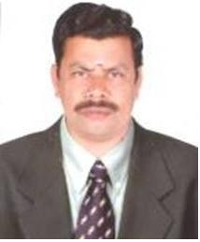

Warden Deputy Warden
Dr. K. Kuppusamy Dr.V. A. Anand
Mobile : 94430 05711 Mobile : 95852 69710

ALAGAPPA UNIVERSITY, KARAIKUDI
POST GRADUATE HOSTEL ( MEN)

The University understands that most of the students moving away from home feel out of place; it is strived to make the transition as smooth as possible by offering comfortable and safe stay in the University campus. There are Two Hostels namely Mankombu Andi IyerHostel (MAH) Post Graduate Hostel and Veerappa Amman Hostel (VAH) Research Scholars Hostel. In each block 42 rooms are available and provision to accommodate 120 students in MAH and 80 scholars in VAH. The hostel rooms are furnished and well ventilated. Study chairs and Tables are provided to all the students in the Hostel. In each hostel, there is one Reading Room ( News paper and TV) and one Computer Lab with Broadband Net connectivity. In the recreation room Carom and Chess Boards are provided for recreation of the residents of the hostels. There is enough space for undertaking Sports and Games activities in the hostel premises.

Hostel Mess

The hostel runs its own mess on sharing basis. The mess is completely run by the Students Mess Committee under the guidance of the hostel warden. The student representatives from all departments are included as members in various committees to look after the mess activities including the kitchen materials, purchasing and issue of groceries and vegetables. The menu is decided by the students themselves on consensus to provide hygienic food and healthy to the hostel inmates and the expenses are divided equally. The committee on rotation basis facilitates the activities related to cleanliness, discipline, water saving, gardening, and controlling of food wastage etc.,
Facilities Provided
- Comfortable rooms and toilet facilities
- Rooms designed to provide adequate moving space and proper ventilation
- Water dispenser to provide Hot and Cold drinking water to the residents
- Computing facilities to the hostel inmates.
- The healthcare facility is available at free of charge to all our University students.
- Sports and Recreation facilities are provided for the students such as Carom Boards,
Chess, Ball Badminton ,Volley Ball and Cricket
- Gym is established for physical fitness of Hostel inmates.
- Bio-Gas plant for generating cooking gas.
- The modern banking facility and post office near the hostel premises (in walk-able
distance)

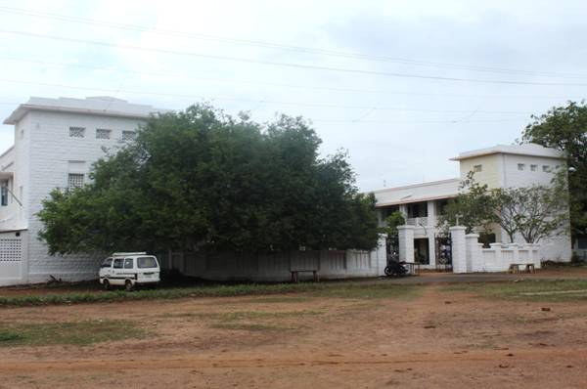
Research Scholar Hostel (Men)

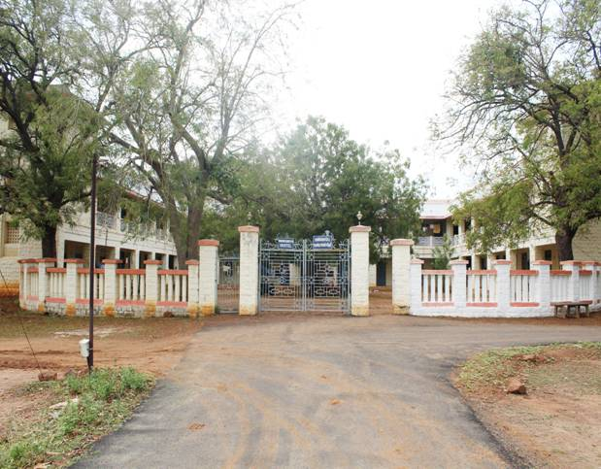
PG Hostel (Men)

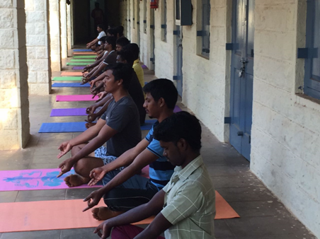
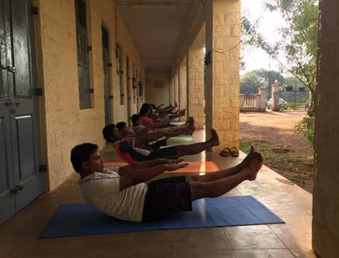
Yoga class being organized for hostel inmates at Alagappa University Research Scholars Hostel (Men) and Post graduate Hostel (Men)

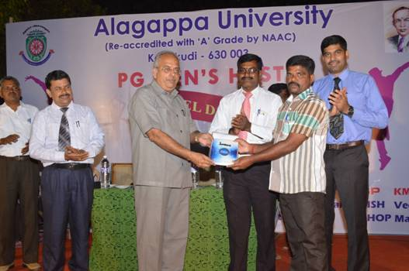
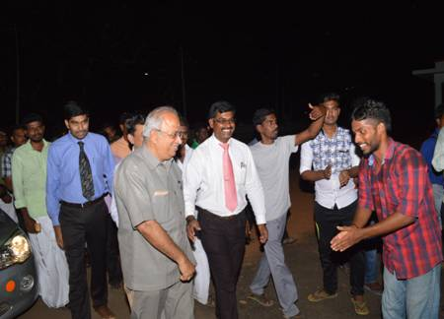
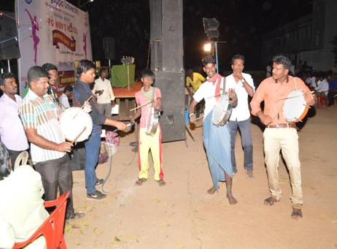
Hostel Day was celebrated on 1st April 2017; Picture 1- Hostel students welcomes dignitaries for Hostel Day function, Picture -2 Part of cultural programmes, Picture-3 Prof V Balachandran (Registrar i/c), Alagappa University offered gift to Hostel Staff.
From left to right Prof, N. Palanisamy (Dean- Student Affairs), Prof. K Kuppuchamy (Warden), Prof. V, Balachandran (Registrar (/c)) , Prof. P. Shakkthivel (Chief Warden), Dr.V. A. Anand (Dy Warden)

