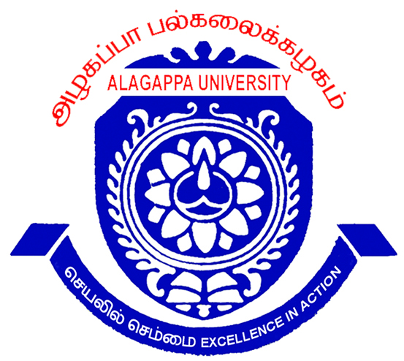
ALAGAPPA UNIVERSITY
(A State University Re-Accredited with ‘’A’’ Grade by NAAC)
KARAIKUDI – 630 003
Admission is still open for the following programs offered in the University Departments for the academic year 2013-14
01. M.C.A (Week-End)  02. M.Sc. Energy Science  03. M.Sc. Marine Biology  04. M.Sc. Bioinformatics  05. M.Sc. Nanoscience & Technology | 06. M.Sc.Bio-electronics  07. M.A.Tamil  08. M.S.W.(Social Work)  09. M.A.Economics  10. M.L.I.Sc (2 Years)
- Cost of Application Rs.300/- for Others, Rs.150/- for SC/ST applicants.
- Application can be downloaded from the website www.alagappauniversity.ac.in
- Downloaded filled in application should be accompanied by a D.D. drawn in favour of “The Registrar, Alagappa University” payable at “Karaikudi”.
- Filled in application must be sent to the REGISTRAR, ALAGAPPA UNIVERSITY, KARAIKUDI – 630 003.

Contact Phone Numbers: 04565-223112,223113

Last Date for Receipt of filled in application extended upto: 31.07.2013

Karaikudi Prof.V.Manickavasagam
21.06.2013 REGISTRAR

