ALAGAPPA UNIVERSITY – IL&FS INSTITUTE OF SKILLS (AU-IIS)
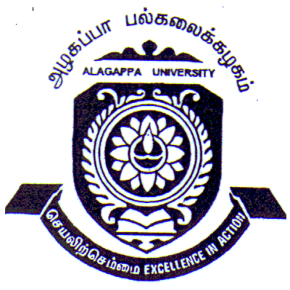ALAGAPPA INSTITUTE OF SKILL DEVELOPMENT
ALAGAPPA UNIVERSITY, KARAIKUDI
(Re-accredited with ‘A’ Grade by NAAC)

Aim and Purpose | To offer Skill / Vocational based curriculum adheres to the National Occupational Standards (NOS) in consultation with respective Sector Skill Councils (SSC), Industries and Academia.
Aim and Purpose | To act as catalyst for promoting and strengthening industry ready skills of youth through teaching, practical training, dissemination of knowledge and industry exposure.
Aim and Purpose | To inculcate the youth with Technical, Generic, Industry and Life Coping Skills for better employment possibilities and open avenues for self-employment.
Aim and Purpose | To uphold the holistic development of youth in terms of career goals, decision making and livelihood options.

Academic Committee

Name | Designation & Dept./Division/College. | Status
Dr. B. Dharmalingam | Professor & Director  Alagappa Institute of Skill Development | Coordinator
Dr. TR. Gurumoorthy | Professor & Head  Department of Commerce | Member
Dr. P. Eswaran | Assistant Professor  Department of Computer Applications | Member
Dr. S. Paramasivam | Assistant Professor  Dept. of Oceanography & Coastal Area Studies | Member
Ms. M. Muthulakshmi | III B.Voc. Fashion Technology Student | Member
Ms. P. Priyadarsini | III B.Voc. Software Development Student | Member

Staff members at AU-IIS

S.No. | Name | Designation
1 | Dr. B. Dharmalingam | Coordinator
2 | Mr. B. Maharaja | Centre In-charge
3 | Mr. B. Sathiyaprakash | Electrical Trainer
4 | Mr. G. Jerome Castro | CNC Trainer
5 | Mr. Arul.P | Welding Trainer
6 | Mr. D. Satheesh | Mechatronics Trainer
7 | Ms. A. Mercy | Value Added Modules Trainer
8 | Ms. A. Bala Hepzibah | Patient Care Assistant Trainer
9 | Mr. N. Senthil Kumar | Mobilization Coordinator
10 | Mr. I. RaviKumar | Solar Trainer
11 | Mr. T. Vimal | Mechatronics Trainer / Marketing Coordinator
12 | Mr. A. Shik Azarutheen | Mechatronics Trainer
13 | Mr. S. Manikandan | Mechatronics Trainer
14 | Mr. P. Tamilselvan | CNC Trainer
15 | Mr. S. Sitharthan | MIS Coordinator

Range of Activities | Offering placement linked short-term Skill / Vocational courses adhere to the National Occupational Standards (NOS)
Range of Activities | Along with University Academic activities implementing curriculum alignment and Skill assessment by National Skill Development Corporation (NSDC) approved industry endorsed Sector Skill Councils (SSC)
Range of Activities | Industry involvement in every element of Skills value chain
Range of Activities | Placement and Post-placement support for the trainees

Placement linked short-term programmes offered in AU-IIS

S.No. | Course | Duration
1. | Diploma course in CNC operator | 3 Months
2. | Diploma course in Electrician / Solar P.V. Technician | 3 Months
3. | Diploma course in Advance Welding | 3 Months
4. | Diploma course in Patient Care Assistant | 3 Months
5. | Certificate / Post-Graduate Diploma course in Mechatronics | 3/6 Months

Placement linked short-term programmes to be offered in AU-IIS
S.No. | Course | Duration
 | Certificate course in Application Development in Android | 3 Months
 | Certificate course in Front end Design and Development | 3 Months
 | Certificate course in Assistant Mason | 3 Months
 | Certificate course in Banking Executive | 3 Months

Activities Carried out
S.No | Description of the Activity | Place | Date | Chief Guest / Resource person(s) | No. of Participants
1 | Soft Skill/ Motivation Speech | AU-IIS Campus | 25.10.’13 | Mr. Kannan | 85
2 | NGO’s Meeting | AU-IIS Campus | 12.11.’13 | Dr. Arungangadhar | 15
3 | Children’s Day function | LCTL Memorial Auditorium | 13.11.’13 | Mr. Kaliyamoorthy, Dr.V.Manickavasagam & B.Namasivayam | 350
4 | Job Fair | Femina Thirumana Mandabam | 08.12.’13 | Raja Ganesh, Rajkumar… | 40
5 | Job Fair | Paakudi, Pudukottai dt | 02.02.’14 | Raja Ganesh, Rajkumar | 25
6 | Welding Workshop | AU-IIS Campus | 20,21 & 22.03.14 | Mr.Vijayan & Mr.T.Pathmanabhan | 30
7 | Certificate Distribution | Old Auditorium | 28.03.’14 | Mr.Kaliyamoorthy | 120
8 | Mastery | AU-IIS Campus | 15.4.’14 to 18.4.’14 |  | 12
9 | Job Fair | Singampunari | 22.06.’14 | Raja Ganesh, Rajkumar | 20
10 | Job Fair | Ramanathapuram | 28.06.’14 | Conducted by Mahalir Thittam | 45
11 | Job Fair | Seethalakshmi Aachi College for Women | 13.07.’14 | Rajkumar & Parameswaran | 32
12 | Certificate Distribution | Old Auditorium | 01.10.’14 | Dr. M.Selvam, Dr V.Manickavasagam & Mr. K.M.Rajan | 85
13 | Children’s Day Celebration | LCTL Memorial Auditorium | 14.11.’14 | Prof.S.Kaliyamoorthy & Mr.K.Joseph Zacharia | 375
14 | Job Fair | Old Auditorium | 14.12.’14 | Raja Ganesh, Rajkumar… | 45
15 | Joy of Learning English | Skill Development Centre | 31.01.’15 | Sheela P.Karthick | 50
16 | Kalvi Kankatchi | Kannadasan Mani mandabam | 02.05.’15 | AU-IIS Team | 500
17 | Nurses Day | AU-IIS Campus | 12.05.’15 | Dr.B.Dharmalinagm & Mr.Rajaganesh | 20
18 | Mechatronics Inaugration | AU-IIS Campus | 14.05.’15 | Dr. Elango V.P ACCET | 22
19 | Mechatronics Guest Lecture | AU-IIS Campus | 20.06.’15 | Nandhakumar Dhavalikar | 22
20 | World Youth Skill Day Celebration | Old Auditorium | 15.07.’15 | Mr. Subbaiah | 90
21 | World Youth Skill Day Celebration | KIT & KIM College | 15.07.’15 | Mr K.M.Rajan | 130
22 | Certificate Distribution | Seminar Hall | 14.08.’15 | Mr Badrinath, Axles India Pvt Ltd | 130
23 | Campus Interview | AU-IIS Campus | 03.09.’15 |  | 60
24 | Electrician Guest Lecture | AU-IIS Campus | 23 to 26.09.15 | Mr. Sreenivaasan | 25
25 | World Awakening Day | AU-IIS Campus | 15.10.’15 | Dr. B.Dharmalingam | 40
26 | Light Lamping | Old Auditorium | 19.10.’15 | Dr. B.Dharmalingam | 75
27 | Children’s Day Celebration | LCTL Auditorium | 13.11.’15 | Mr Subbaiah, M.Raja Sekar, Mr K.M.Rajan Dr.TR.Gurumoorthy | 450
28 | Sivagangai Dist. level Job mela | Kannadasan Mani Mandabam | 04.12.’15 | Sivagangai Collector | 300
29 | Banking Operations awareness Program | AU-IIS Campus | 09.03.’16 | Mr. Maruthupandi | 45
30 | International Yoga day | AU-IIS Campus | 21.06.’16 | Ramesh | 120
31 | Skill @ Colleges | Sri Raaja Raajan Engg. College | 13.07.’16 | Mr. K.M.Rajan | 90
32 | Alumni Day | AU-IIS Campus | 05.08.’16 | Dr. B. Dharmalingam | 65
33 | Electrical Association Meeting | Power Ulagam, Kalanivasal | 07.08.’16 | K.Rajkumar | 15
34 | Grama Sabha Meeting | Kothamangalam | 15.08.’16 | Kothamangalam Panchayat Office | 20
35 | Grama Sabha Meeting | Surakudi | 15.08.’16 | Surakudi Panchayat Office | 40
36 | Grama Sabha Meeting | Oonaiyur | 15.08.’16 | Oonaiyur Panchayat Office | 75
37 | Grama Sabha Meeting | Amaravathypudur | 17.08.’16 | Amaravathypudur Panchayat Office | 35
38 | Pudhu Vazhu Job fair | Sivagangai PVP office | 25.08.’16 | Rajkumar & Senthil kumar | 35
39 | Yes Bank Walk-in Interview | AU-IIS Campus | 28.08.’16 | Mr.K.M.Rajan | 40
40 | Children’s Day Celebration | University Convocation Seminar Hall | 14.11.’16 | Prof. S. Subbiah  Vice-Chancellor, ALU  Dr. A.M. Moorthy  VC, TNPESU | 200
41 | Job Fair | Singampunari | 16.11.’16 | Faculty of AU-IIS | 150
42 | Free Health camp for the Public | Alagappa University Healthcare Centre | 4.12.’16 | Prof. S. Subbiah,  Vice-Chancellor, ALU  Dr. Venkatachalam & Team  Apollo Reach Hospitals, Kraikudi | 350
43 | Solar Technician course Inauguration & Placement Order Distribution Ceremony | AU-IIS Campus | 13.01.’17 | Prof. S. Subbiah  Vice-Chancellor  Prof. V. Balachandran  Registrar  Mr. K.M. Rajan | 70
44 | Job Fair | Sivagangai Collectorate | 03.03.’17 | Faculty of AU-IIS | 100
Any other
Alagappa University-IL& FS Institute of Skills (AU-IIS) is the joint venture of Alagappa University and IL&FS Institute of Skills, New Delhi to impart quality job-oriented Vocational / Skill training programmes in order to create Industry ready skilled youth. AU-IIS was established in October, 2013, as India’s first Skills Institute offering University recognized and NOS compliant placement linked short term High-end employable Technical training programmes across several sectors and handhold support to start Income Generating Activities on various trades. The courses offered at AU-IIS are mapped to the NOS designed by the industry / NSDC-led Sector Skill Councils (SSC).
AU-IIS is functioning under Alagappa Institute of Skill Development (AISD). AISD is a pioneering initiative of the Government of Tamil Nadu and Alagappa University among the Universities and other Higher Educational Institutions of our Country to discharge its social responsibilities and Community developments. It was transmuted as a permanent Department in May, 2015 from the previously known, Skill Development Centre (SDC). To adhere to the vision of our founder, the great philanthropist and educationist Padmabushan Vallal Dr. RM. Alagappa Chettiar, the University formed several Centres to uplift the social and knowledge wealth of the rural based younger generation. The Skill Development Centre is one among them. It was established in April, 2013 to implement the objectives of the following vision statements and policies,
- Hon’ble Chief Minister of Tamil Nadu’s ‘Vision 2023’ Document
- National Policy on Skill Development, 2009 (revised in 2015)
- National Occupational Standards (NOS)
- National Skill Qualification Framework (NSQF)

The AISD/AU-IIS, within a short period of its establishment has climbed to great statures through its commendable Skill Development programmes offering in AU-IIS.

The details of performance record and placement details of the short-term Skill training programmes offering through AU-IIS is as shown in the following table and figures:
PERFORMANCE RECORD OF THE SHORT-TERM SKILL TRAINING PROGRAMMES 2013 – ’16
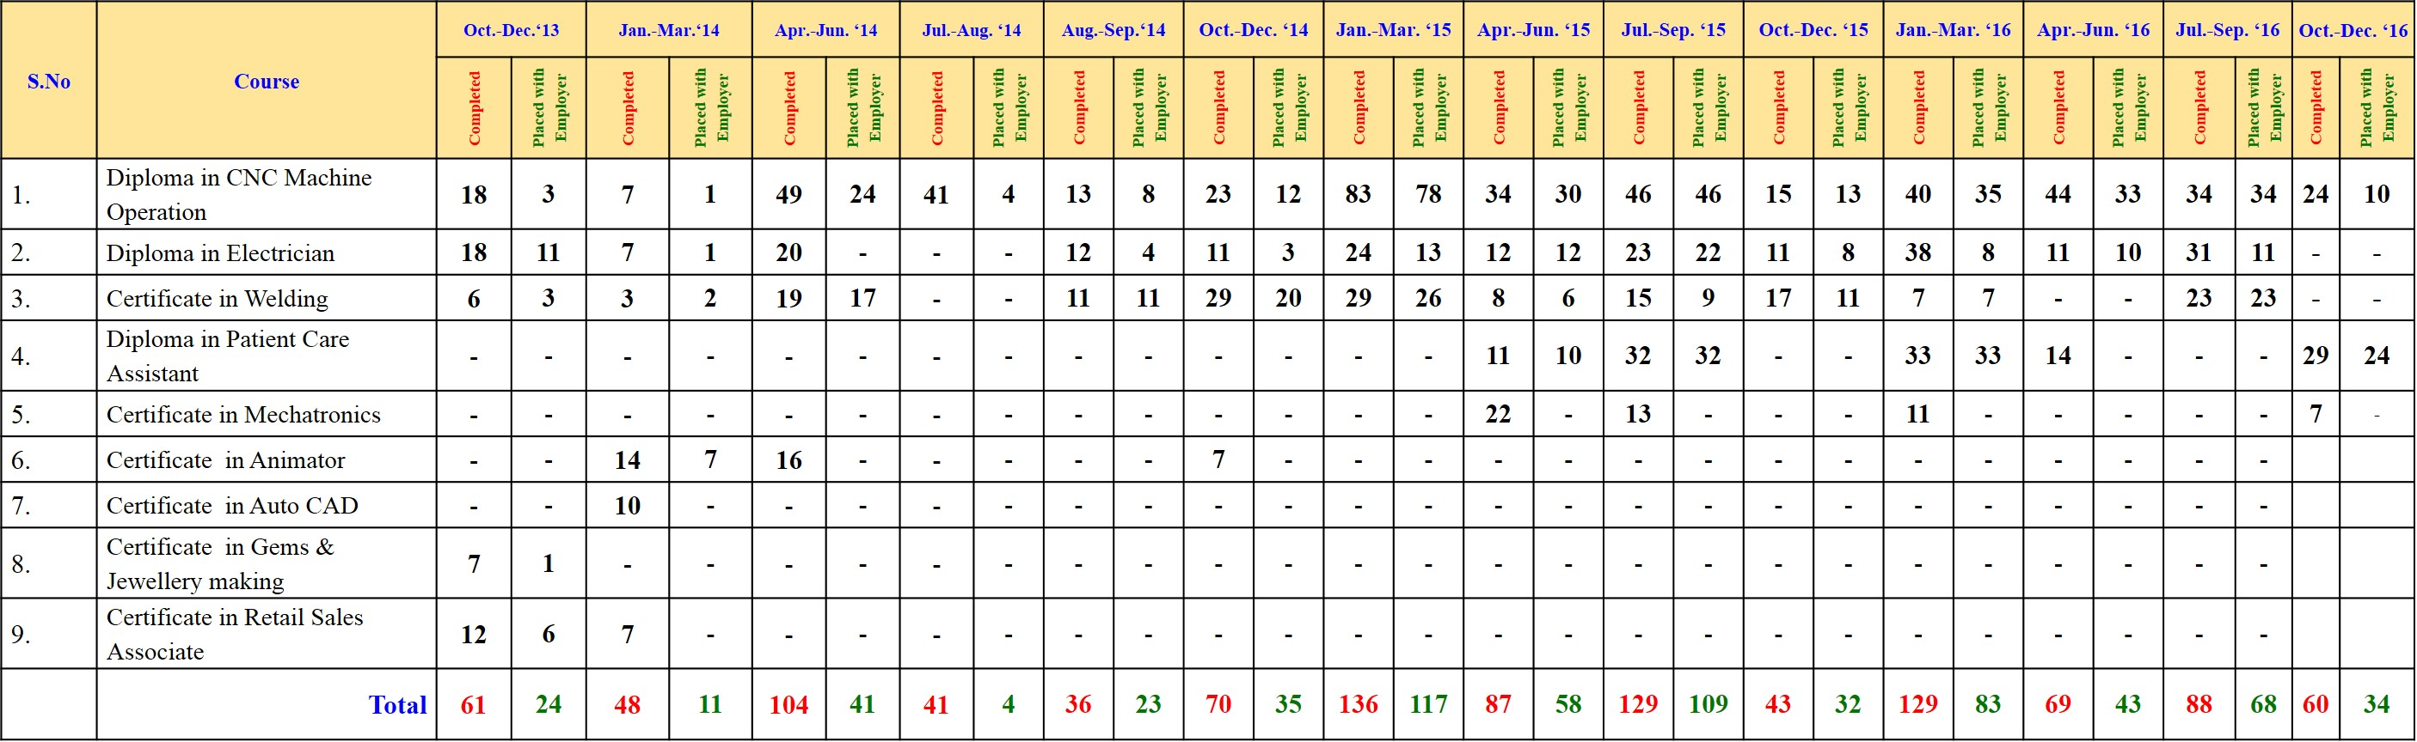

Total Completed (AU-IIS) : 1101 + On-Going 98*
Total Placement with Employer : 682
Total Self Employed : 132
Total gone for higher studies : 19
Total upgradtion of Skills : 59
Total Employability : 892

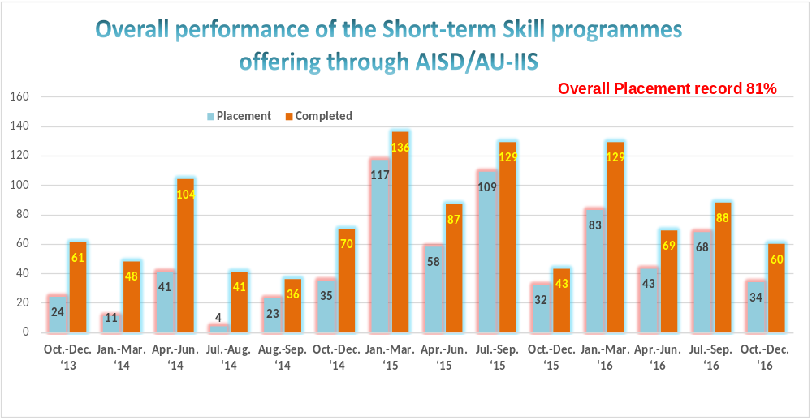

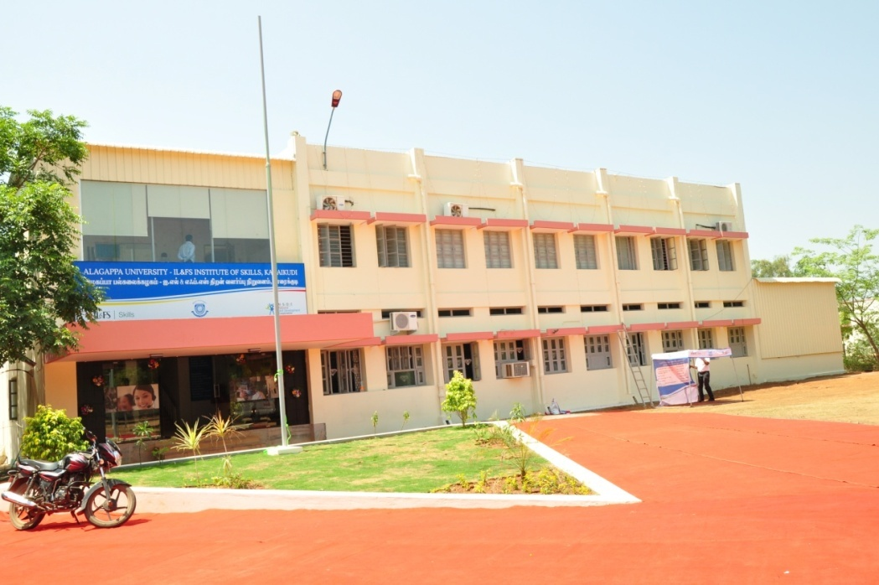

Building view of AISD / AU-IIS

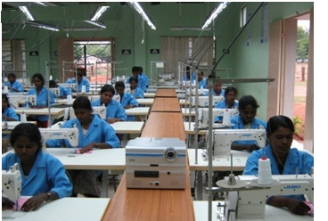
Garment training unit
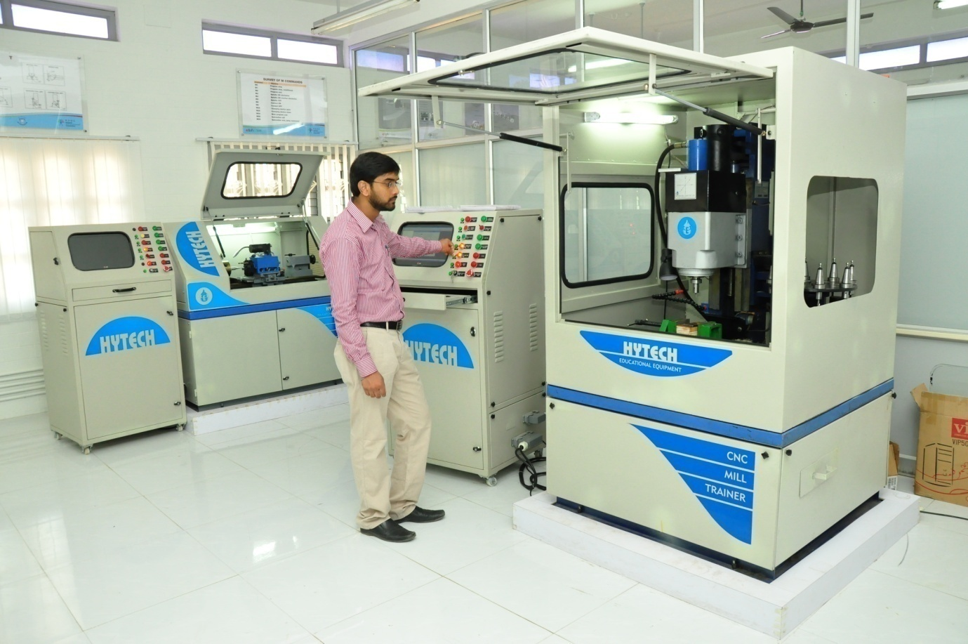
Computer Numeric Control (CNC) machine

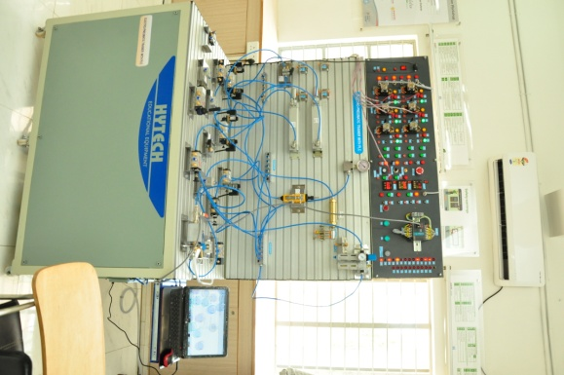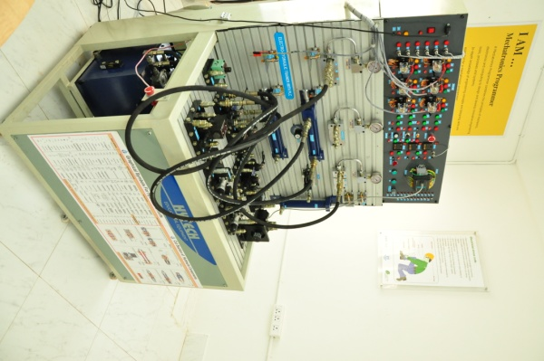
Mechatronic machines

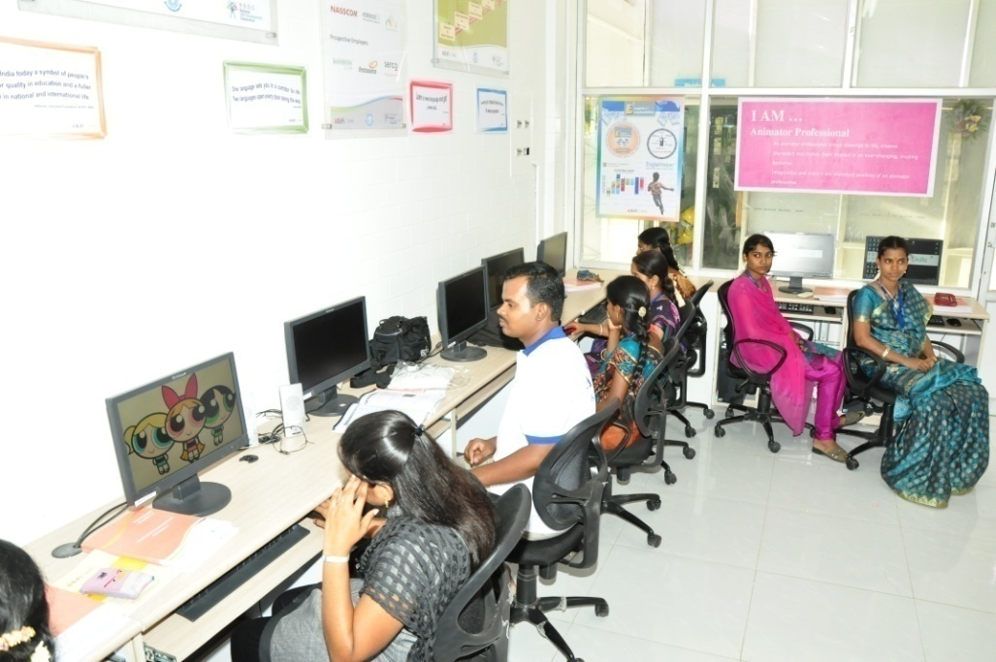
2D – Animation training Laboratory

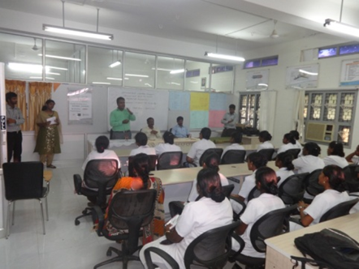

Celebration of Nurses Day

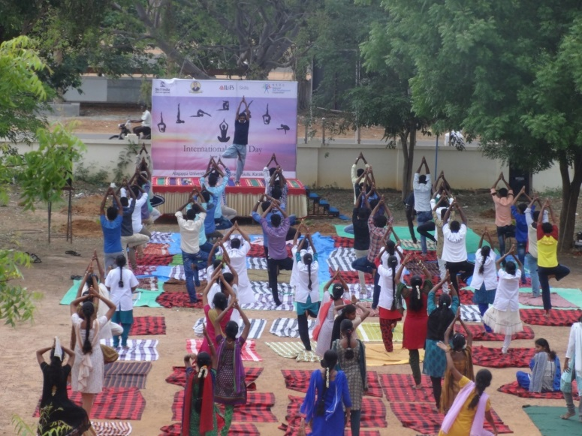

Celebration of International Yoga Day

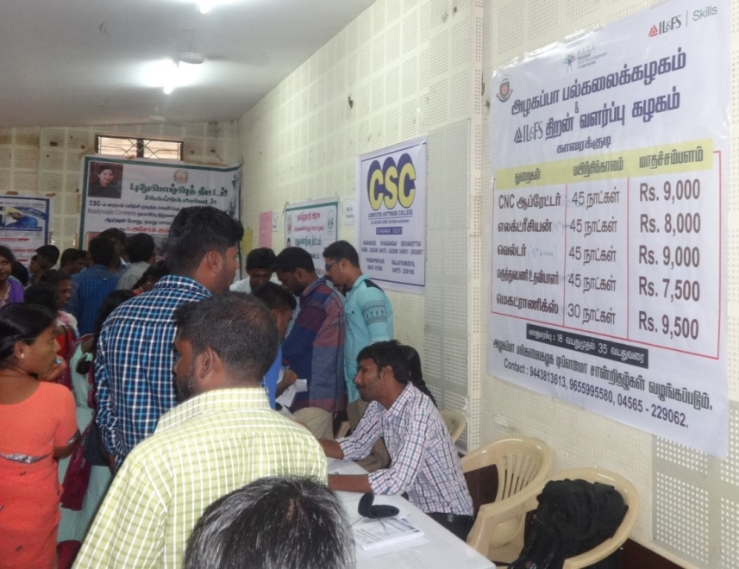
Job Fair

Alumni Meet

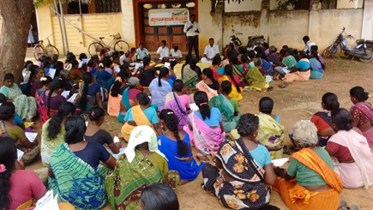
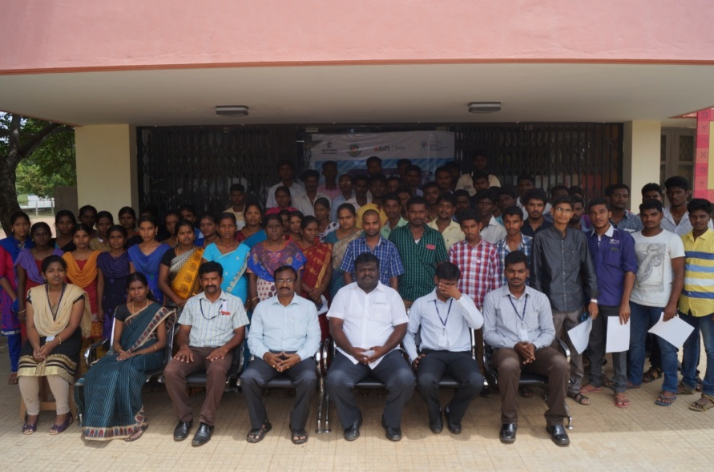
Grama Saba Meetings

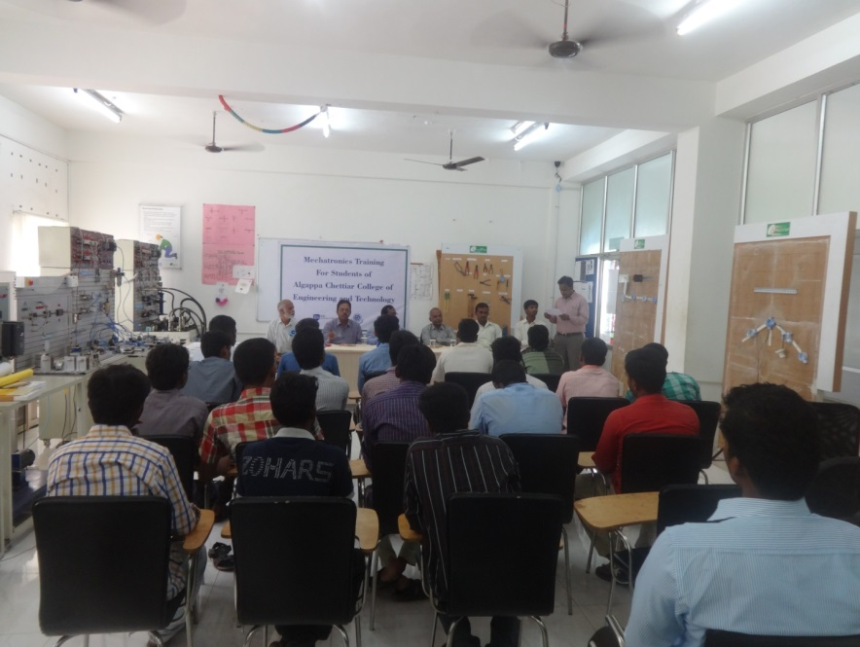

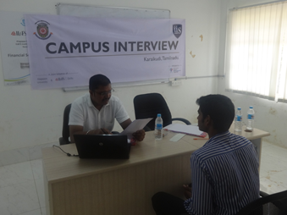
Mechatronics Workshop to ACCET students

Campus Recruitment

