CENTRE FOR SWACHH BHARATH AND SWASTH BHARATH

Aim and Purpose | - To propel idea of Swachh Bharat – Swasth Bharat through 4Cs (Clean Mind, Clean Body, Clean Environment and Clean Society)
 | - To inculcate the norms of clean and healthy living society amongst the youth.
 | - To create awareness about the responsibility to live healthy and keeping the environment cleans for sustainable growth and development.

Name | Designation & Dept./Division/College. | Status
Faculty | Dr. R. Rajan, Associate Professor, Department of Lifelong Learning | Coordinator
Faculty | Dr. S. Sudhamathi, Assistant Professor Department of Logistics Management | Member
Faculty | Mrs. Pio Albina, Assistant Professor,  Alagappa university College of Education | Member
Faculty | Dr. K. Ramesh Kumar, Assistant Professor  Department of Economics and Rural Development. | Member
Student Representative | - | Member
Student Representative | - | Member

Range of Activities
(Suggested)
- Sensitization Programmes for the Heads/ Principals and Faculty / Students on Swachh Bharat and – Swasth Bharat.
- Street Play Training for Student representatives and performance in nearby villages to create awareness on cleanliness, healthy living, planting of trees, plastic free environment, rain water harvesting, sanitation facilities, including toilets, solid waste disposal systems and safe and adequate drinking water etc.,
- Arranging Rallies in the District/ Block Head Quarters/ selected or adopted villages to create awareness on cleanliness, healthy living, planting of trees, plastic free environment, rain water harvesting, sanitation facilities, including toilets, solid waste disposal systems and safe and adequate drinking water etc.,
- Conducting Essay, Elocution, Drawing competitions for University/ college and school students on the theme Swaach Bharat and Swasth Bharat
- Organizing cleaning Activity in campus of University/College/ school and Public Places like Railway Station, Bus Stand and Hospital etc,.

Activities Carried out
Year | Description of Activity | Date | Participants/  Beneficiaries
2014-15 | World Aids Prevention Day | 01.12.2014 | 250
 | International Day for Disabled | 03.12.2014 | 120
 | Blood Donation Camp | 05.12.2014 | 150
 | International Human Rights Day | 10.12.2014 | 250
 | National Energy Conservation Day | 12.12.2014 | 200
 | Tree Plantation | 17.12.2014 | 100
 | Cleaning Campaign | 19.12.2014 | 225
 | Awareness through street play | 24.03.2015 | 210
2015-16 | - Socio – Economic Survey  - Tree Plantation  - Health / Medical Camp  - Cleaning of School Campus, Hospital,Ponds and Temple premises  - Training in Yoga  - Conduct of Games / Sports to the School Students.  - Awareness Rally on Cleanliness and Ill effects of Plastic, Tobacco and Alcohol. |  | 314
2016-17 | - Socio – Economic Survey  - Tree Plantation  - Health / Medical Camp  - Cleaning of School Campus, Hospital, Ponds and Temple premises  - Training in Yoga  - Conduct of Games / Sports to the School Students.  - Awareness Rally on Cleanliness and Ill effects of Plastic, Tobacco and Alcohol. | 23.09.2016-25.09.2016 | 929
Jan2017 to Mar 2017 | - Sensitisation Programme for SwachhattaSenai Volunteers  - ‘One Student one Tree Scheme’ Tree Plantation Programme  - Voters Awareness Day  - Facilitation for conducting Gramasabha Meeting &Enrolement of New voters in Adopted villages by Alagappa University  - National Energy Conservation Day  - Alagappa University – Campus Cleaning Campaign | 05-01-2017  10.01.2017  10.02.2017  20.02.2017  25.01.2017  26.01.2017  14.02.2017  04.03.2017 | 500  1000  1100  1100  200  50  120  900

Any other:Under graduate level, one course on Environmental Education has been implemented in affiliated colleges of Alagappa University. As part of the co curriculum activities, awareness programmes and invited Lectures/speeches are arranged periodically to the students on SwachhBharath and SwasthBharath.

Selected Photographs
Village placement programme - 23.09.2016-25.09.2016
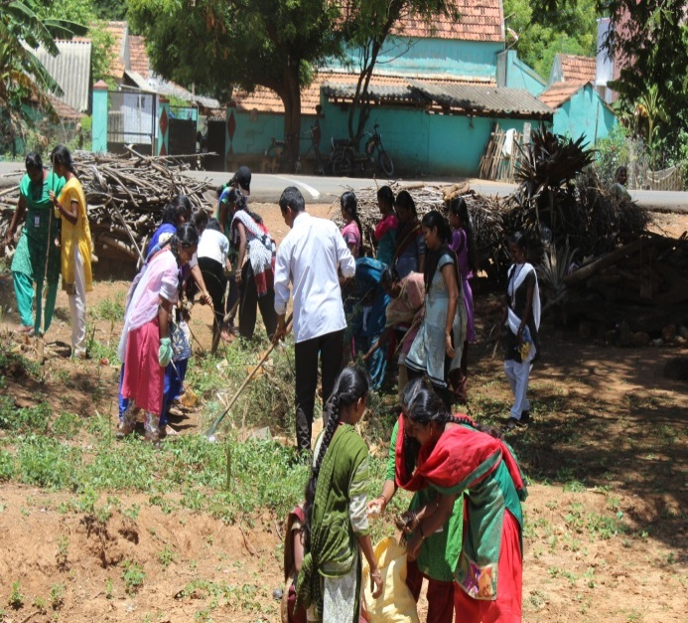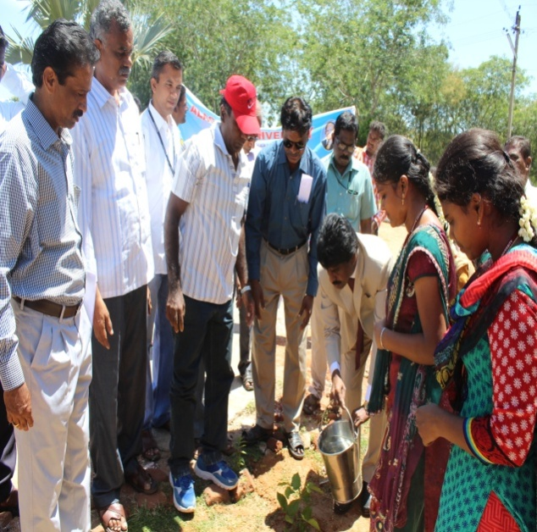

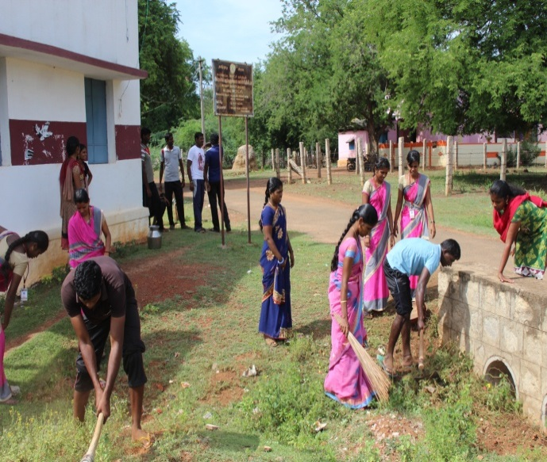

Cleaning Campaign - 19.12.14

‘One Student one Tree Scheme’Tree Plantation Programme - 10. 01. 17
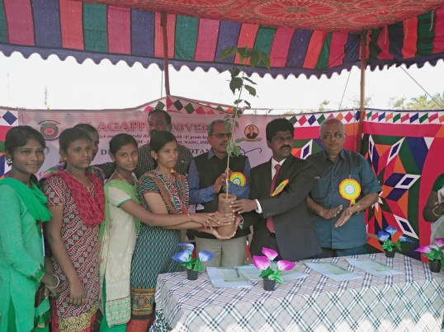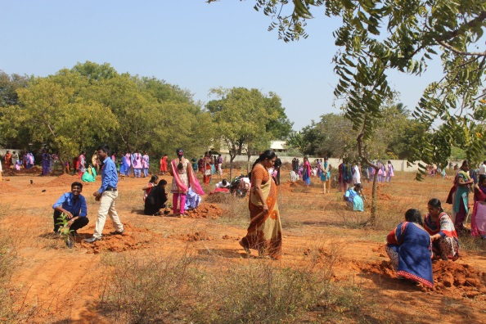
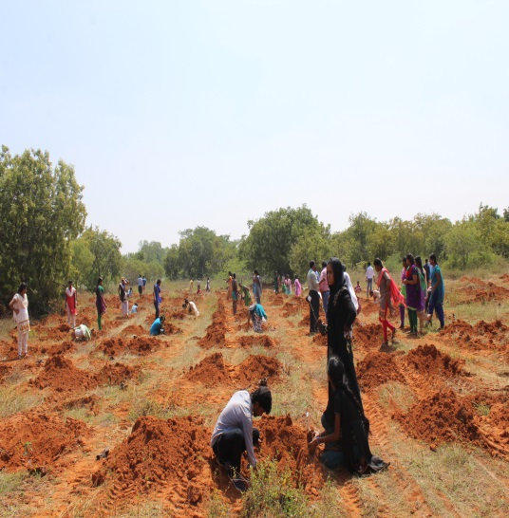

Sensitisation Programme for Swachhatta Senai Volunteers-05. 01.17

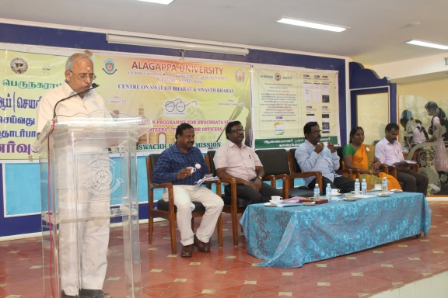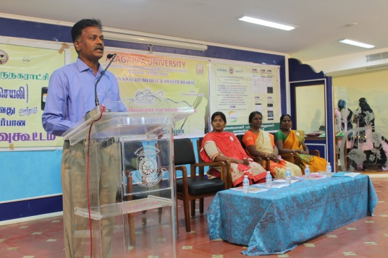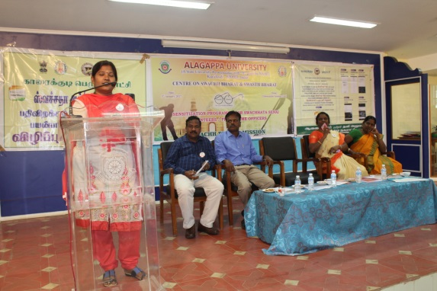

Voters Awareness Day-25. 01.2017

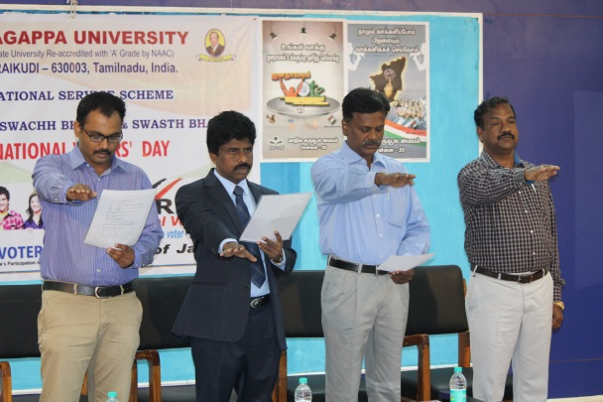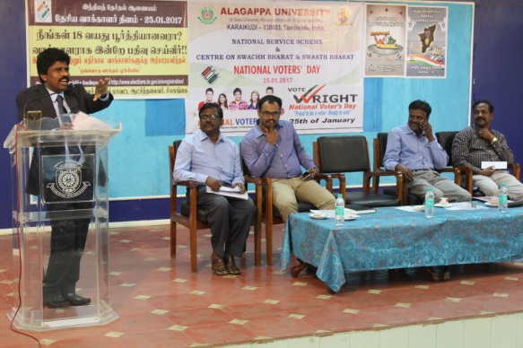

‘One Student one Tree Scheme’Tree Plantation Programme 20.02.2017

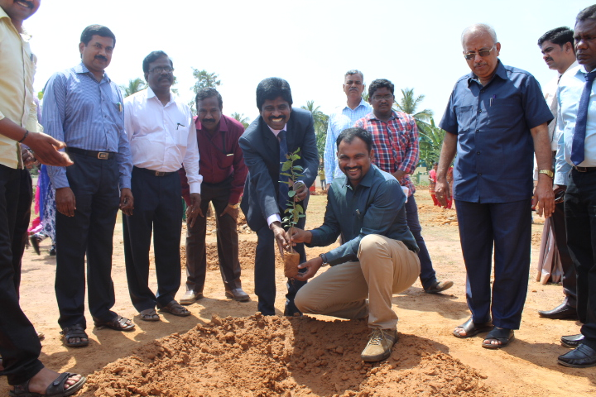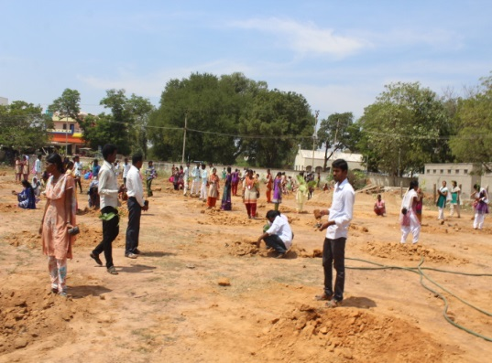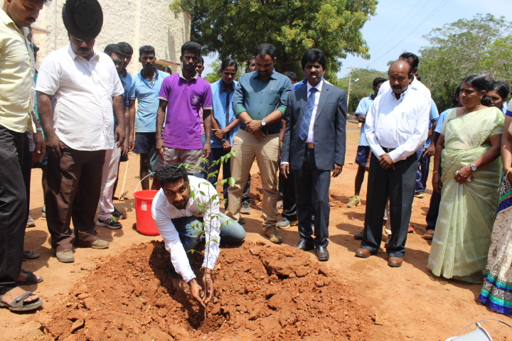

Alagappa University – Campus Cleaning Campaign 04.03.2017

