
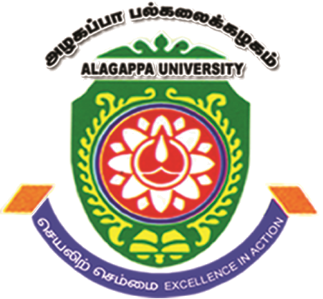
ALAGAPPA UNIVERSITY
(A State University Reaccredited with ‘A’ Grade by NAAC)
KARAIKUDI – 630 004, TAMIL NADU, INDIA

International Conference on Recent Trends in Biosciences
(ICRTB 2016)
07th – 09th April, 2016

REGISTRATION FORM
(To be filled in block letters)
Name:_________________________________________________________________________________________________
Gender: ________________________ Designation:_____________________________________________
Institutional Affiliation with Postal Address: ______________________________________________________
_____________________________________________________
_____________________________________________________
Tele/Mobile: ___________________________ Email: _____________________________________________________
Poster
Mini-Oral
Participate
Presenting/Attending:
Title of the Paper: ___________________________________________________________________________________
_________________________________________________________________________________________________________
_________________________________________________________________________________________________________
Yes
No
Accommodation needed (Please tick):
If YES, Hotel
University Faculty Guest House

Particulars of Fee:
Amount Rs.___________________________ DD No: ______________________________________
Date: ___________________________ Name of the Bank: ______________________________________________

Applicant Signature Department Head/ Research Supervisor

Note: Abstract has to be accompanied by duly filled in registration form along with DD. The DD should be drawn in favour of ICRTB - 2016, payable at Karaikudi.

