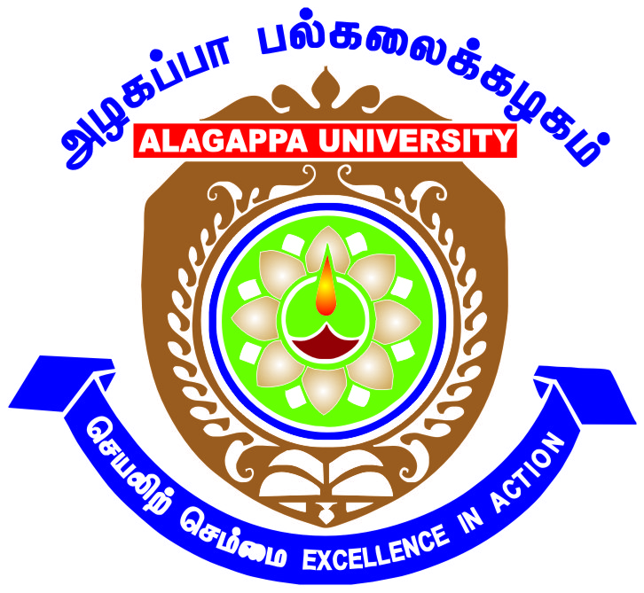
Career Guidance and Counselling Cell
ALAGAPPA UNIVERSITY KARAIKUDI 63003
Aim and Purpose | Informing, Educating, Facilitating and Supporting Career focused student development activities through Seminars and Workshops.
 | Counselling the needy students on personality development related and academic related problems / issues.
 | Extending the Career Guidance Activities to the needy student communities in Schools and Colleges

 | Designation & Dept./Division/College. | Role
 | Dr. G. Nedumaran, Associate Professor,  Department of Commerce | Coordinator
 | Dr. G. Ilankumaran, Assistant Professor, AIM | Coordinator
Members of the Cell | Dr. KR. Murugan, Professor and Head i/c,  Department of Social Work | Advisor
 | Dr. A. Veeraravi, Associate Professor,  Department of Biotechnology | Member
 | Dr. G. Sivakumar, Assistant Professor,  Alagappa University College of Education | Member

Under the General Development Assistance by the UGC during the XI Plan, the Career Guidance and Counselling Cell was established at Alagappa University to help and nurture the students with respect to career and personal development needs.
As indicated by the UGC, Career and Counselling cell helps the students with appropriate guidance to establish linkages with the world of work and locate career opportunities vis-à-vis the realities and job profiles in the context of highly competitive emerging occupational patterns. The gaps in perception about the market demands and individual expectations could be bridged through psychological and confidence building measures. Vocational guidance and campus based interviews have become a common practice. These could be taken care of through the active liaison of the Career and Counselling Cell with the recruiting agencies and HR personnel of reputed firms. The active participation of institutional experts from these gives greater on site experience in search of suitable candidates. In this exercise, the alumni of the University, for positive help, are also involved. They also undertake an affordable training programme to acquaint the students with the high demand market areas and invoke industry-institution linkages.
OBJECTIVES
Along with the academic and administrative processes of the University, Career and Counselling Cell is a dispensation of well-informed and interested teachers. It supports the students in the development of soft skills and communication ability to challenge the rigors of competitive tests and on-job-training in add-on or vocational courses. As a purveyor of healthy inter and intra personal relations, it inculcates social values and ability to think independently for carrying out social responsibilities. There is a team of teachers with different subjects and interests and thereby create a homogeneous group to translate this vision and carry out its healthy functions as an institutional imperative.
The guidance and counselling cell in the University is a resource centre of information, guidance and counselling with free accessibility and internet based global connectivity and exchange of information on professional placements.
FUNCTIONS OF CAREER AND COUNSELLING CELL
a) To gather information on job avenues and placements in different institutions and concerns related to the courses that the University offers.
b) To analyze information in the local, regional and national contexts to explore it relevance and utility for the students in their placements and on job-training.
c) To organize seminars and guidance workshops for informing students about the emerging professional trends and events, job profiles, leadership roles, entrepreneurship, market needs and risks and implementation of national socio-economic policies and to impart training in soft skills.
d) To promote discipline, healthy outlook and positive attitudes towards for national integration and removal of narrow provincial preferences and prejudices.
The Career Guidance and Counselling Cell is constituted to provide to students community all possible assistance in choosing the appropriate avenues. To enable the students to realize their primary ambition, it has become imperative to counsel and encourage them to set definite goals. The cell provides guidance and training by briefing about various avenues during the time of admission.
- Organizing talks and seminars regarding different job oriented and vocational courses.
- Inviting career counsellors to inform students about job prospects of different• subjects. Conducting aptitude tests, mock interviews and group discussions.
- Arranging personal development programmes.
- Encouraging the students to participate UPSC and TNPSC Examinations
- Organizing career talks and seminars with the help of experts
- Updating the students with latest information on Industry and Economic Trends
Activities Carried out
Year | Description of Activity | Date | Participants/  Beneficiaries
2017 | Two Day Workshop on Employability Skills | 13/03/2017 to 14/03/2017 | 400 Students of PG Final Year from All the Departments of our University
2016 | Five-day Training Programme on Cambridge English Language Assessment | 05/12/2016 to 10/12/2016 | 50 students
2016 | Mock Test for TNPSC Group -2A (Non- Interview) posts | 10/01/2016 | 165 students
2014 | Career Guidance and Counselling for Rural School Students of VIII and IX std | 03-02-2014 to 13-03-2014 | 1000 students of 10 schools
2014 | Career Guidance Program Series | 12.2.2014 to 27.03.2014 | 800 students of University Departments
2013 | Aptitude Examination Training | 21/01/2013 to 24/01/2013 | 700 students
2012 | Skill Modular Training | October 2nd Week of 2012 | 700 students
2012 | Analytical, Verbal and mathematical ability tests to final years students – Phase III | 27/09/2012 to 29/09/2012 | 700 students
2012 | Empowering Young Leaders Seminar | 29/03/2012 | 180 students
2011 | Careers and Self Leadership Workshop | 20/09/2011 | 250 students

PHOTO GALLERY 2016 - 2017
Two Day Workshop on Employability Skills organized from 13/03/2017 to 14/03/2017

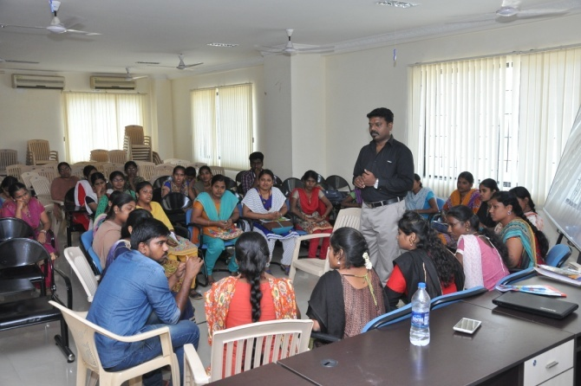

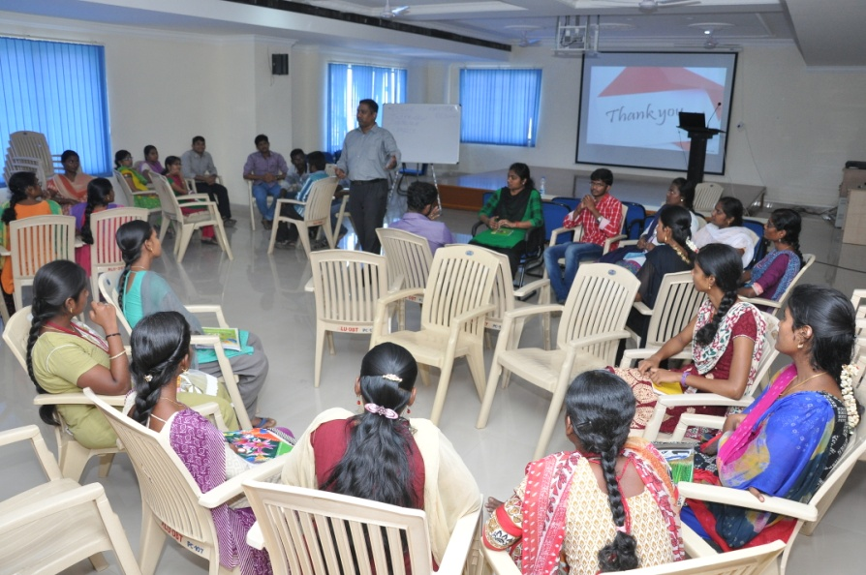
The inaugural function of a Five-day Training Programme on Cambridge English Language Assessment was held on 5.12.16 at Alagappa University under the joint auspices of the Department of English and Career Guidance and Counselling Cell of the University.
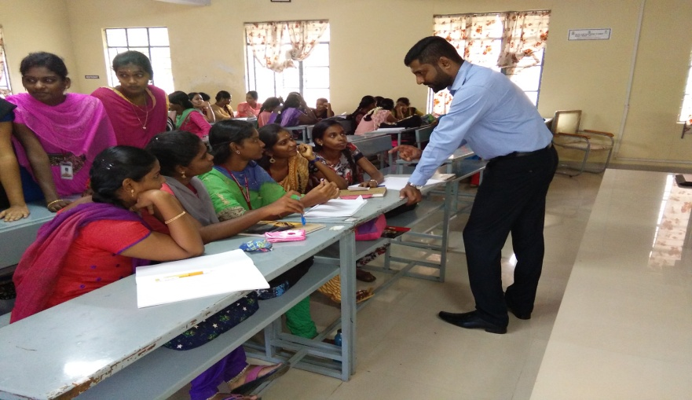
CAREER GUIDENCE AND COUNSELLING CELL (CG & CC)
Report 2015 – 2016
(CG & CC) has conducted a Mock Test for TNPSC Group -2A (Non-Interview) posts on 10.01.2016 between 10AM to 1PM in our College of Education Campus. This program was conducted in collaboration with Dr. P. Suresh Kumar, Director, Alagappa University study Circle, Alagappa University, Karaikudi. The test session was started with the introductory speech by the co-ordinator Dr.G.Paruthimal Kalaignan, Professor, Department of Industrial Chemistry, Alagappa University and Dr. P. Suresh Kumar, Director, Alagappa University study Circle, Alagappa University, Karaikudi. Mock Test question papers were prepared both in Tamil and English. Registration of the Mock Test was started at 9AM on 10. 01.2016. In this Mock Test program, 165 students have participated from all over Tamilnadu. 19 students have written the Mock Test in English and rest of them in Tamil. Number of Men and Women participant were 81 and 84 respectively. Participants were coming from 12 districts of Tamilnadu. Higher number of participants from Sivagangai, that is 104, 23 from Ramnad and 13 from Madurai. Total number of participants in district wise was given in Table.
After completing the Mock Test at 1 PM, immediately the answers were announced and corrected the OMR answer sheets with the help of participants. After the lunch break, once again participants were assembled in a hall at 2PM for discussion session to clear the doubts raised by the participants in the mock test question paper. The discussion session was over by 5PM on 10.01.2016.
All the participants were happy and appreciate our program. Finally, the Co-Ordinator thanks the Vice Chancellor, Registrar and Finance Officer of our University and the participants for the successful conduct of the Mock Test program.
During the Mock Test, photographs have been taken by the Mayil Studio, Karaikudi. I have included some of the important photographs in the report.
Dr.G.Paruthimal Kalaignan
Co-ordinator
Career Guidance and Counselling Cell

CAREER GUIDENCE AND COUNSELLNG CELL (CG&CC)
Mock Test for TNPSC Group -2A (Non- Interview) posts
Date: 10.01.2016 & Venue: College Of Education, Alagappa University, Karaikudi.
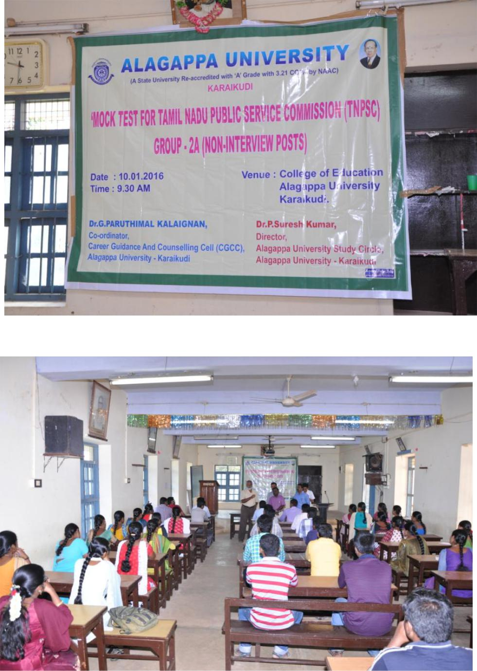

Career Guidance & Counseling Cell
Report for 2013 – 2014

Co-ordinator – Dr.H.Gurumallesh Prabhu,
Professor, Department of Industrial Chemistry

Dr. H. Gurumallesh Prabhu, Co-ordinator of CG&CC conducted a series of lectures for the 20 department students of Alagappa University, Karaikudi under the UGC XII Plan Development Assistance Scheme for the year 2013-2014 from 12.2.2014 to 27.03.2014. Valedictory function was conducted in the last day activity (27.03.2014).
Details of Programs conducted during 2013-14
Date | Department | Expert
12.02.2014 | Physics | Dr. S. Dhanuskodi, Prof. & Head, Dept. of Physics, Bharathidasan University, Trichy
15.02.2014 | Mathematics | Dr.M.Marudai, Prof.& Head, Dept. of Mathematics, Bharathidasan University, Trichy.
17.02.2014 | Industrial Chemistry | Dr. G. Sethuraman, Professor, Dept. of Chemistry, Gandhigram  Rural Institute, Gandhigram
17.02.2014 | Computer Sci. & Engineering | Dr. P. Shanmugavadivu , Associate Professor , Dept. of Computer, Gandhigram  Rural Institute, Gandhigram
19.02.2014 | Biotechnology | Dr.K.Natarajaseenivasan, Professor & Head, Dept. of Microbiology, Bharathidasan University, Trichy
20.02.2014 | Women’s studies | C.X.Elango, Director, New-213/Old-143,Valluvarkottam High Road, Nungambakkam, Chennai -600034
20.02.2014 | Bank Management | Mr.N.Krishnamoorthy, Visiting faculty, Sri Saradaniketan College for Women, Amaravadipudur
24.02.2014 | AIM | Mr.Jacob, Director, Kriate HR Consultants Pvt Ltd, Ashok Nagar,
24.02.2014 | AIM | Ms.P.Bhamini, Director, Kriate HR Consultants Pvt Ltd, Ashok Nagar,Chennai-83
25.02.2014 | Animal Health & Management | Dr.S.Pushparaj, Assistant Professor, Dept. of Econometrics, Madurai Kamaraj University, Madurai
28.02.2014 | Dept of Education | Dr. Kokila. S. Thangasamy, Director, Centre for Educational Research, Madurai Kamaraj University, Madurai
05.03.2014 | Corporate Secretaryship | Rn. Senthi Kumaran, JAYCEES National Trainer, 13/1 RTS Illam, Kalanivasal, Karaikudi
05.03.2014 | Corporate Secretaryship | R.R.Ganesan, Career Trainer, 612, Periyar Nagar, Rajagopalapuram Housing Unit, Pudukottai
05.03.2014 | Corporate Secretaryship | S.Alakappan, Career Trainer, No.1, Mena  Veethi, Head Post Office Opp. Pudukottai
08.03.2014 | International Business & Commerce | Mr.D.Rajendran, Managing Director, MRT Chemicals, Karaikudi
12.03.2014 | English & Foreign Languages | Dr. P. Suresh Kumar,  Former Regional Director (Employment)  Employment Office, Tiruchirapalli
14.03.2014 | Economics & Rural Development | Dr. S. Iyyampillai, Senior Professor and Head, Department of Economics  Bharathidasan University, Kajamalai Campus  Mobile: 98424 4883  Tiruchirapalli – 620 024., E-mail: sipillai@yahoo.com
19.03.2014 | Corporate Secretaryship | Mr.Lakshmanan, Karaikudi
 |  | Mr.Venkatesh, Karaikudi
 |  | Mr.Sathyanarayanan, Chennai
24.03.2014 | Tamil | Dr. M. Elangovan, Assistant Professor, Department of Tamil,
25.03.2014 | Library & Information Science | Dr. K. Elavazhagan, Librarian & Chief Knowledge Officer, Indian Institute of Management, NIT Campus Trichy
27.03.2014 | Bioelectronics & Biosensors | Dr. V.Ganesh, Scientist, CSIR-Central Electrochemical Research Institute, Karaikudi
27.03.2014 | Industrial Chemistry | Dr.P.Thomas Muthiah, Prof. & Head, Dept. of Chemistry, Bharathidasan University, Tiruchirapalli
27.03.2014 | Valedictory | Dr.P.Thomas Muthiah, Prof. & Head, Dept. of Chemistry, Tiruchirapalli

Dr. N. Arunachalam, Professor & Head, Department of Life Long Learning, Alagappa University conducted Career Guidance & Counseling programme for VIII and IX std rural school students from 03.02.2014 to 04.03.2014.
Career Guidance & Counseling Cell
Report for 2012 – 2013
Co-ordinator – Dr. J. Jeyakandan,
Professor & Head,
Department of Bioinformatics,
Dr.J.Jeyakandan, Co-ordinator of CG&C conducted the I, II & III phase of carrier guidance (i.e, Analytical, Verbal and mathematical ability tests to final years students). M/S Transtaff Solutions Pvt. Ltd., Chennai, has been assigned to conduct aptitude and soft skills training to the final year students of Alagappa University. Accordingly, the following three phases of events were completed by them.
I Phase – Motivation and orientation to students on 27th -29th September 2012.
II Phase – skill modular training to students during Second / Third week of October 2012.
III Phase – Aptitude Examination to students was conduct from 21st -24th January 2013.
Career Guidance and counseling training programme was conducted for the final year post graduate students from various Departments of Alagappa University during the Village Placement Programme (VPP) which was held from 27.09.2012 to 29.09.2012 at various VPP centers.

Career Guidance & Counseling Cell
Report for 2011 – 2012
Co-ordinator – Dr. M. Senthil, Dean, CDC

UGC sponsored workshop on “CARRERS AND SELF-LEADERSHIP” was organized by Dr. M. Senthil on Tuesday 20th September 2011at 10.30 AM at University Convocation seminar hall. The president of the workshop was Dr. R. Krishnaraj, syndicate member, Alagappa University. The chief guest of the function was Dr. K. S. Chandrasekar, Dean, Faculty of Management, University of Kerala, Kerala. Mr. K. Joesph Zachariah, Director, Vikaasa School, Madurai was delivered the key note address. Dr. M. Selvam, Dean School of Management & Dr. S. Kaliyamoorthy, Dean Student affairs have delivered the felicitation address.

UGC sponsored workshop on “EMPOWERING YOUNG LEADERS” was organized by Dr. M. Senthil on Thursday, 29th March 2012, 10.00AM at AIM conference hall. The president of the workshop was Dr. S. Sudalaimuthu, Vice Chancellor, Alagappa University. Mr. S. Ravindran, Director-HR, Nokia Ltd released the placement brochure of MBA (CS) and delivered the key note address. Dr.V.Manickavasagam, syndicate member felicitated the one day workshop.

