DE–3382
11
DISTANCE EDUCATION
M.Sc. (Maths) DEGREE EXAMINATION, MAY 2008.
ALGEBRA
Time : Three hours Maximum : 100 marks
Answer any FIVE questions.
All questions carry equal marks.
- (a) State and prove Cauchy's theorem for Abelian groups.
(b) Prove that 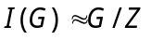 where 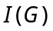 is the group of inner automorphism of G and Z is the centre of G.
- (a) State and prove Sylow's Theorem.
(b) Find the possible number of 11-sylow, 7-sylow and 5-sylow subgroups in a group of order 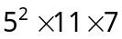.
- (a) Prove that 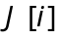 is a Eucliden ring.
(b) Prove that the ideal 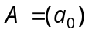 is a maximal ideal of the Euclidean ring R if and only if 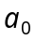 is prime element of R.
- (a) State and prove Einstein Cirterion for irreducibility of polynomials.
(b) If R is an Integral Domain, prove that 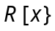 is also an Integral Domain.
- (a) If V and W are vector spaces of dimensions m and n respectively over F, then prove that 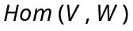 is of dimension mn over F.
(b) If V is finite dimensional and W is subspace of V, then prove that 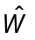 is isomorphic to ◊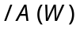 and 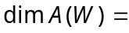.
- (a) If V is finite-dimensional over F, then prove that 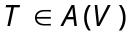 is invertible if and only if the constant term of the minimal polynomial for T is not O.
(b) If 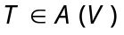 is Hermitian, then prove that all its characteristic roots are real.
- (a) If L is a finite extension of K and K is a finite extension of F, then prove that L is a finite extension of F. Moreover 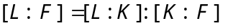.
(b) Let 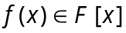 be of degree 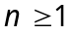. Then prove that there is an extension E of F of degree at most n! in which 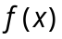 has n roots and so a full complement of roots.
- (a) Prove that K is a normal extension of F if and only if K is the splitting field of some polynomial over F.
(b) Show that if K is a finite extension of F, then 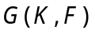 is a finite group and its order, 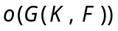 satisfies 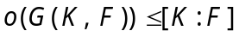.
————————
DE–3383
12
DISTANCE EDUCATION
M.Sc. (Maths) DEGREE EXAMINATION, MAY 2008.
REAL ANALYSIS
Time : Three hours Maximum : 100 marks
Answer any FIVE questions.
All questions carry equal marks.
- (a) State and prove the Bolzano Weierstrass Theorem.
(b) Explain open balls and adherent points.
- (a) Prove that if has a limit at then this limit is unique.
(b) Prove that the fixed point theorem for contractions.
- (a) Explain the chain rule and partial derivatives.
(b) State and prove the Rolle’s theorem.
- (a) Define Directional derivative and the total derivative.
(b) State and prove the Implicit function theorem.
- (a) If is continuous on 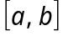 then 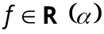 on .
(b) Prove that 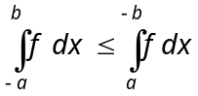.
- (a) Explain the inter changing the order of integration and sequence of functions.
(b) Suppose 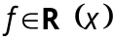 on 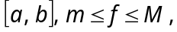 is continuous on 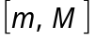 and 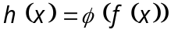 on . Then 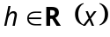 on .
- (a) State and prove Lusin’s theorem.
(b) State and prove Egoroff’s theorem.
- (a) State and prove Monotone Convergence Theorem.
(b) State and prove Bounded Convergence Theorem.
——————
DE–3384
13
DISTANCE EDUCATION
M.Sc. DEGREE EXAMINATION, MAY 2008.
Mathematics
DIFFERENTIAL EQUATIONS AND NUMERICAL METHODS
Time : Three hours Maximum : 100 marks
Answer any FIVE questions.
All questions carry equal marks.
- (a) Let be any solution of 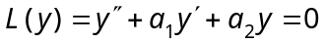
on an interval I containing a point 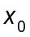. Then for all x
in I, 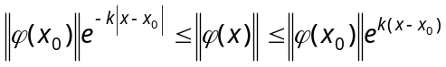 where 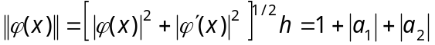.
(b) Compute the Wronskian of four linearly independent solutions of the equation 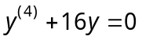.
- (a) Find the solution of the initial value problem 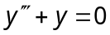, 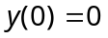, 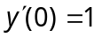, 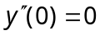.
(b) Find a particular solution of 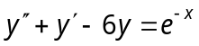 first by under mined coefficients and then by variation of parameters.
- (a) Explain Cauchy's method of characteristics.
(b) Find a complete integral of the equation 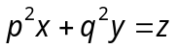.
- (a) Reduce the equation 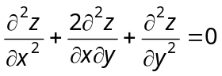 to canonical John and solve it.
(b) Explain Separation of variables.
- (a) Explain Newton's method.
(b) Try to solve the system 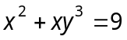, 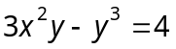 by fixed point iteration.
- (a) Explain briefly data fitting.
(b) Describe the relaxation method.
- (a) Explain some basic rules in numerical integration.
(b) Derive the forward different formula in numerical differentiation.
- (a) Find the general solution of the equations 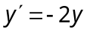.
(b) Find the general solution of the difference equations 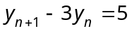.
———————
14
DE-3385
DISTANCE EDUCATION
M.Sc. (Mathematics) DEGREE EXAMINATION, MAY 2008.
OPERATIONS RESEARCH
Time : Three hours Maximum : 100 marks
Answer any FIVE questions.
- (a) Solve by simplex method
Maximize 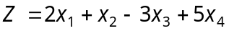
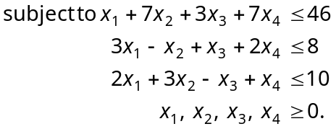
(b) Find the optimum integer solution to the following linear programming problem :
Maximize 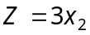
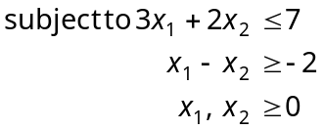
and are integers.
- (a) Find the optimum solution to the following linear programming problem and discuss the effect on optimality of the solution when the objective function is changed to 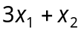.
Maximize 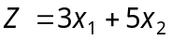
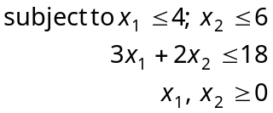
(b) Solve the following linear programming problem by dynamic programming approach :
Maximize 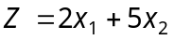
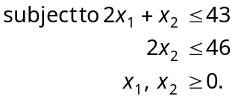
- (a) Solve the game whose payoff matrix is given by
 |  | Player B
 |  | 1 | 2 | 3 | 4
 | 1 | 8 | 2 | 9 | 5
Player A | 2 | 6 | 5 | 7 | 18
 | 3 | 7 | 3 | –4 | 10
(b) Solve the following payoff matrix by
(i) Laplace criterion
(ii) Maximin criterion
(iii) Savage criterion
(iv) Hurwicz criterion (assume = 0.5.)
 | ₁ | ₂ | ₃ | ₄
a₁ | 5 | 10 | 18 | 25
a₂ | 8 | 7 | 8 | 2
a₃ | 21 | 18 | 12 | 21
a₄ | 30 | 22 | 19 | 15
- (a) Obtain Wilson's economic lot size formula.
(b) The daily demand for a commodity is approximately 100 units. Everytime an order is placed, a fixed cost of $ 100 is incurred. The daily holding cost per unit inventory is $0.2. If the lead time is 12 days, determine the economic lot size and the reorder point.
- (a) Define the terms :
(i) Dummy activity
(ii) Critical path
(iii) Total float and free float.
Find the critical path and the expected time for the following project :
Activity | Immediate predecessors | Estimated time (weeks)
A | - | 2
B | A | 3
C | A | 4
D | B, C | 6
E | - | 2
F | E | 8
(b) Compute the total and free floats for the critical and non-critical activities in the following network.
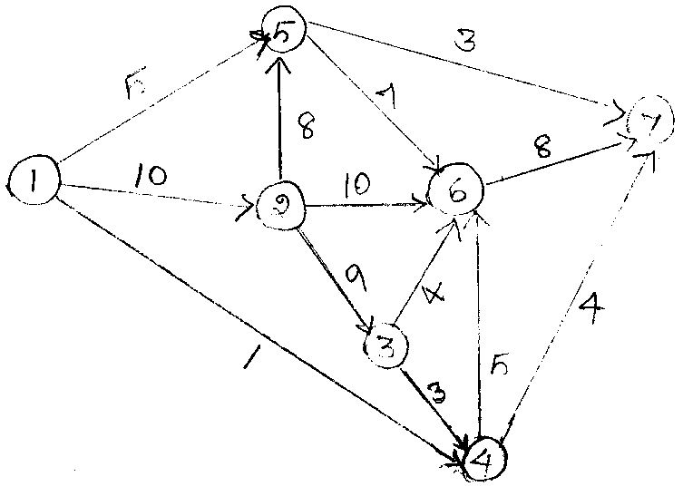
- (a) A project schedule has the following characteristics :
Activity | Estimated times  (a, b, m) | Activity | Estimated times  (a, b, m)
(1, 2) | (2, 1, 3) | (5, 7) | (5, 4, 6)
(2, 3) | (2, 1, 3) | (6, 7) | (7, 6, 8)
(2, 4) | (3, 1, 5) | (7, 8) | (4, 2, 6)
(3, 5) | (4, 3, 5) | (7, 9) | (6, 4, 8)
(4, 5) | (3, 2, 4) | (8, 10) | (2, 1, 3)
(4, 6) | (5, 3, 7) | (9, 10) | (5, 3, 7)
(i) Construct the project network
(ii) Find the expected duration and variance for each activity
(iii) Find the critical path and project length.
(b) Find the different minimum - cost schedule that can occur between normal and crash times are as given below :
Activity | Normal |  | Crash
 | Duration | Cost | Duration | Cost
(1, 2) | 8 | 100 | 6 | 200
(1, 3) | 4 | 150 | 2 | 350
(2, 4) | 2 | 50 | 1 | 90
(2, 5) | 10 | 100 | 5 | 400
(3, 4) | 5 | 100 | 1 | 200
(4, 5) | 3 | 80 | 1 | 100
- (a) Consider a six-period inventory model with the following data
i | D_{i} | K_{i} | h_{i}
1 | 10 | 20 | 1
2 | 15 | 17 | 1
3 | 7 | 10 | 1
4 | 20 | 20 | 3
5 | 13 | 5 | 1
6 | 25 | 50 | 1

The purchasing cost per unit is 2 for all the periods.
(b) A super market has two girls running up ales at the counters. If the service time for each customer is exponential with mean 4 minutes and if people arrive in a Poisson fashion at the rate of 10 an hour
(i) What is the probability of having to wait for service?
(ii) What is the expected percentage of idle time for each girl?
- (a) Explain the queueing model :
(M/M/1) : (GD/N/)
(b) In a car wash service facility, informations indicates that cars arrive for service according to a Poisson distribution with mean 4/hour. The time for waiting and cleaning each cars varies but it is found to follow an exponential distribution with mean 10 minutes/car.
The facility cannot handle more than one car at a time. Suppose that the facility has a total of four parking spaces. If the parking lot is full, newly arriving cars balk to seek service elsewhere.
Compute :
(i) The number of cars, the facility loses on 8-hour day service
(ii) The expected total time from the moment of arriving until a car is washed
(iii) The probability that an arriving car will start service immediately upon arrival
(iv) The expected number of parking spaces occupied
(v) The expected waiting time until a service starts.

———————
DE–3386
15
DISTANCE EDUCATION
M.Sc. DEGREE EXAMINATION, MAY 2008.
Mathematics
MATHEMATICAL STATISTICS
Time : Three hours Maximum : 100 marks
Answer any FIVE questions.
All questions carry equal marks.
- (a) Let 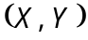 be two-dimensional non-negative continuous r.v. having joint p.d.f.
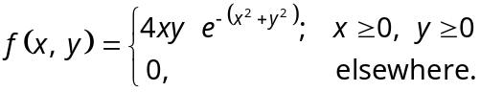
Find the density function of 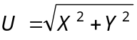.
(b) Joint p.d.f. of two r.v. are given by 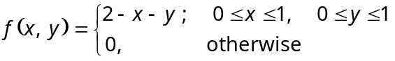
Find 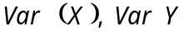 and covariance between
 and 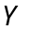.
- (a) Find the M.G.F. and first four moments for Poisson distribution.
(b) Define Beta distribution of first kind and obtain the constants.
- (a) Derive distribution.
(b) State and prove central limit theorem.
- (a) Show that if 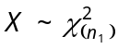 and 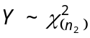 then 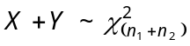.
(b) Obtain M.L.E. of in 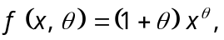 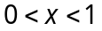, based on an independent sample of size . Examine whether this estimate is sufficient for .
- (a) What are simple and composite statistical hypotheses? Give examples.
(b) Explain the concepts of Type I and Type II errors, with examples and bring out their importance in Weyman and Pearson theory.
- Explain how will you test for the equality of means of two normal populations.
- Analyse the variance in the following Latin square of yield (in kgs) of paddy where A, B, C, D denote the different method of cultivation.
D 122 | A 121 | C 123 | B 122
B 124 | C 123 | A 122 | D 125
A 120 | B 119 | D 120 | C 121
C 122 | D 123 | B 121 | A 122
Examine the different methods of cultivation have given significantly different yields.
- (a) In a factory producing spark plugs, the number of defectives found in the inspection of 15 lots of 100 each is given below. Draw the control chart for the number of defectives and comment on the state of control.
Sample No. (i) : | 1 | 2 | 3 | 4 | 5 | 6 | 7 | 8 | 9 | 10 | 11 | 12 | 13 | 14 | 15
Number of defective (np) : | 5 | 10 | 12 | 8 | 6 | 4 | 6 | 3 | 4 | 5 | 4 | 7 | 9 | 3 | 4
(b) The following data give the average life in hours of
12 samples each of 5 lamps. Construct 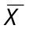 and 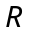 charts and comment on the state of control.
: | 120, | 127, | 152, | 157, | 160, | 134, | 137, | 123, | 140, | 144, | 120, | 127
R : | 30, | 44, | 60, | 34, | 38, | 35, | 45, | 62, | 39, | 50, | 35, | 47
——————
DE–3387
21
DISTANCE EDUCATION
M.Sc. DEGREE EXAMINATION, MAY 2008.
Mathematics
COMPLEX ANALYSIS
Time : Three hours Maximum : 100 marks
Answer any FIVE questions.
All questions carry equal marks.
- (a) Describe the Riemann sphere and prove that any circle on the sphere corresponds to a circle or straight line in the z plane.
(b) If 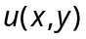 and 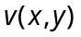 have continuous first order partial derivatives satisfying Cauchy Riemann equations, show that 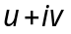 is analytic.
- (a) Prove that if 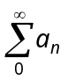 converges then 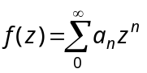 tends to f(1) as z approaches 1 in such a way that 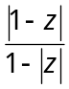 remains bounded.
(b) Discuss the mapping 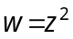.
- (a) If 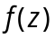 is defined and continuous on a closed bounded set E and analytic on the interior of E, prove that the maximum of 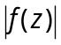 on E is assumed on the boundary of E.
(b) State and prove Schwarz Lemma.
(c) Show that a function which is analytic and bounded in the whole plane reduces to a constant.
- (a) If is analytic in a region , show that can be written in the form
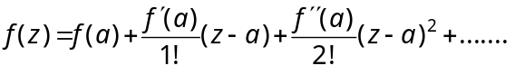 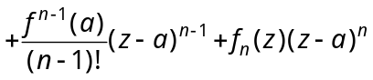 where 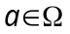 and 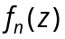 is analytic in .
(b) State and prove Cauchy's theorem in a disc.
- (a) Let be meromorphic in with poles 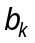 and zeros 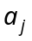 and r be a cycle in which is homologous to zero and does not pass through any of the zeros or poles. Prove that 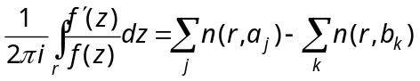.
(b) State and prove Mittag Leffler's theorem.
- (a) Derive 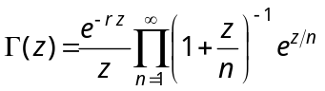.
(b) Derive Jensen's formula.
- (a) Show that any two bases of the same module are connected by a unimodular transformation.
(b) Prove that the zeros 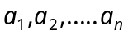 and poles 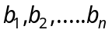 of are elliptic function satisfy the condition .
- (a) Derive 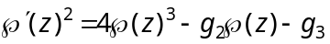.
(b) Show that any elliptic function with period 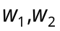 can be written as 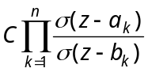 where C is a constant.

–––––––––––
DE–3388
22
DISTANCE EDUCATION
M.Sc. DEGREE EXAMINATION, MAY 2008.
Mathematics
TOPOLOGY AND FUNCTIONAL ANALYSIS
Time : Three hours Maximum : 100 marks
Answer any FIVE questions.
All questions carry equal marks.
- (a) Let X be a second countable space. Prove that if a non-empty open set G in X is represented as the union of a class of open sets then G can be represented as a countable union of sets from the same class.
(b) Show that every second countable space is separable. Prove the converse for a metric space.
- (a) Prove that the product of any non-empty class of compact spaces is compact.
(b) Show that a metric space is sequentially compact if and only if it has the Bolzano Weierstrass property.
- (a) State and prove Urysohn’s lemma.
(b) Show that every compact Hausdorff space is normal.
- (a) Prove that a topological space X can be written as the disjoint union of maximal connected subspaces each of which is closed.
(b) Is every connected space, locally connected? Justify your answer.
- (a) Let M be a closed linear subspace of a normed linear space N. Prove that  is a normed linear space under the norm 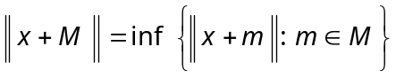. When is it complete?
(b) Let 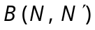 denote the set of all continuous linear transformations of N into 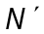 where N and are normed linear spaces. Prove that is a normed linear space under the norm 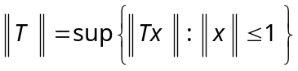. If is a Banach space prove that is also a Banach space.
- (a) If B and 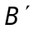 are Banach spaces and if T is a linear transformation of B into , prove that T is continuous if and only if its graph is closed.
(b) State and prove the Uniform Boundedness Theorem.
- (a) Show that the parallelogram law holds in a Hilbert space.
(b) Prove that in a Complex Banach space in which parallelogram law is satisfied an inner product can be defined under which it becomes a Hilbert space.
(c) If M is a closed linear subspace of a Hilbert space H, show that 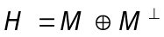.
- (a) Show that if T is an operator on H for which 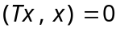 for all x then 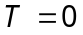.
(b) Show that if P and Q are the projections on closed linear subspaces M and N of H, then 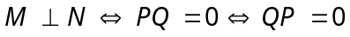.
(c) If 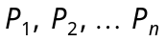 are the projections on closed linear subspaces 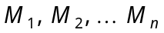 of H, then 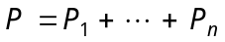 is a projection if and only if the 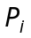’s are pairwise orthogonal.
————————
23
DE-3389
DISTANCE EDUCATION
M.Sc. DEGREE EXAMINATION, MAY 2008.
Mathematics
GRAPH THEORY
Time : Three hours Maximum : 100 marks
Answer any FIVE questions.
All questions carry equal marks.
- (a) Show that 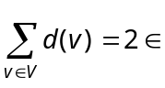.
(b) Show that, in any group of two or more people, there are always two with exactly the same number of friends inside the group.
(c) Show that 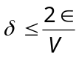 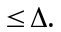
- (a) Show that if 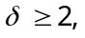 then G contains a cycle.
(b) Write down Dijkstra's algorithm.
(c) State and prove Sperner's lemma.
- (a) Prove that 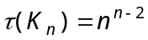.
(b) Write down Kruskal's algorithm.
(c) Prove that any spanning tree constructed by Kruskal's algorithm is an optimal tree.
- (a) Prove that a non-empty connected graph is Eulerian if and only if it has no vertices of old degree.
(b) Prove that 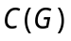 is well defined.
(c) State the Chavatal's theorem and prove it.
- (a) State and prove Vizing's theorem.
(b) Describe the time tabling problem.
- (a) Prove that for any two integers 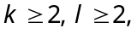 . Furthermore, if 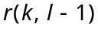 and 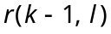 are both even, then show that strict in equality holds.
(b) Show that 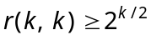.
- (a) If G is K-critical then show that 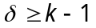.
(b) State and prove Dirac's theorem.
(c) Let G be a K-critical graph with a 2 vertex cut 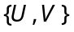. Then prove that 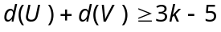.
- (a) State and prove Euler's formula.
(b) If G is a simple planar graph then show that 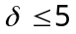.
(c) Show that 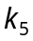 and 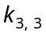 are non-planar graphs.

———————
DE–3390
24
DISTANCE EDUCATION
M.Sc. (Mathematics) DEGREE EXAMINATION,
MAY 2008.
PROGRAMMING IN C/C++
Time : Three hours Maximum : 100 marks
Answer any FIVE questions.
- (a) Explain the features of C language. (10)
(b) Explain any five header files with example. (10)
- (a) What are the various steps in program development? (10)
(b) Discuss the operators in C language. (10)
- (a) Explain function that are used to read and write characters in standard I/O devices with example. (10)
(b) Write the various ways to format various data types in C. (10)
- (a) Explain for loop and while loop statements with example. (10)
(b) Write a program to print first 20 terms of fibonacci series using while loop. (10)
- (a) Write a program to multiply two matrices. Check the compatibility. (10)
(b) Explain any two categories of functions with example. (10)
- (a) Write a program in C to sort the set of names in alphabetical order. (8)
(b) Write a program using structure to process the marks obtained by the students and declare the result. Assume necessary conditions. The members of the structure are name, regno, mark1, mark2, mark3, and mark4. (12)
- (a) Write a program to count the number of words, sentences and lines in a file containing one paragraph. (10)
(b) Explain different file organizations supported by C.
(10)
- Write short notes on the following : (4 × 5 = 20)
(a) Compilers and Interpreters.
(b) Static variable.
(c) Nested-if statement.
(d) fprint( ) and feof( ) statements.
————————
DE–3391
25
DISTANCE EDUCATION
M.Sc. (Mathematics) DEGREE EXAMINATION, MAY 2008.
DISCRETE AND COMBINATORIAL MATHEMATICS
Time : Three hours Maximum : 100 marks
Answer any FIVE questions.
All questions carry equal marks.
- (a) Show the ordinary generating function of the sequence 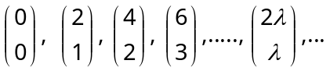 is 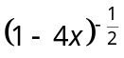 and deduce that 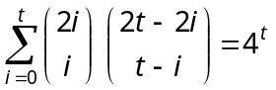.
(b) Find the ordinary generating function of the numbers of partions of integers into exactly in unequal parts.
- (a) Define the recurrence relations, Fibonacci numbers and linear recurrence relation. Obtain the recurrence relation for the Fibonacci sequence.
(b) Prove that
for 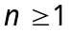, 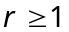.
- (a) Find the number of n-digit ternary sequences that have an even number of 0's.
(b) In how many ways can the integers 1, 2, 3, 4, 5,
6, 7, 8, and 9 be permuted such that no odd integer will be in its natural position?
- (a) Define the rook polynomial and derive the expansion formula for 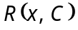.
(b) Find the number of permutations of the letters 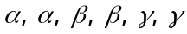 so that no appears in the first and second positions, no 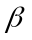 appears in the third and fourth positions and no appears in the fifth and sixth positions.
- (a) Find the number of distinct bracelets of five beads made up of yellow, blue and white beads.
(b) Eight people are planning vacation trips. There are three cities they can visit. Three of these eight people are in one family and two of them are in another family. If the people in the same family must go together, find the ways the eight people can plan their trips.
- Define pattern Inventory. State and prove Polyas fundamental theorem.
- (a) Define lattice, modular lattice, distributive lattice, Boolean algebra and chain.
(b) Show that a lattice is modular if and only if it has no sublattice isomorphic to 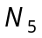.
- (a) Explain the Boolean function 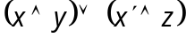 in a product of maxterm form.
(b) Simplify the Boolean function by the Karnaugh Map method.
————————

