DE–3552
11
DISTANCE EDUCATION
M.Phil. DEGREE EXAMINATION, MAY 2008.
Mathematics
COMMUTATIVE ALGEBRA
(Upto 2006 batch)
Time : Three hours Maximum: 100 marks
Answer any FIVE questions.
(5 × 20 = 100)
- (a) Define nil radical. Prove that the nil radical of  is the intersection of all the prime ideal of .
(b) Explain Tensor and Flat modulus.
- (a) Define primary. Let be a p - primary ideal and 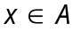. Then
(i) If then 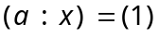;
(ii) If then 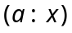 is p-primary and 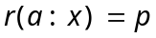.
(iii) If 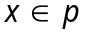 then 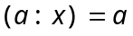.
(b) State and prove that the uniqueness theorem.
- (a) If 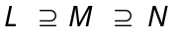 are -modulus then 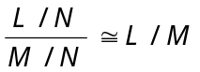
(b) If 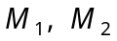 are submodulus of  then
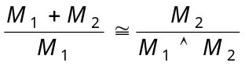.
- Let be an exact sequence of -modules. Then
(a) is Noetherian 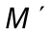 and 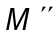 are Noetherian.
(b) is Artinian and are Artinian.
- (a) Define Length.
Let be a ring in which the zero ideal is a product 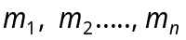 of (not necessarily district) maximal ideals. Then is Noetherian iff is Artinian.
(b) State and prove Jordan Holder Theorem.
- (a) State and prove Going-up Theorem.
(b) Let 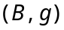 be a maximal element of . Then 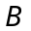 is a valuation ring of the field 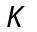.
- State and prove Norther’s normalization theorem.
- (a) Define Discrete valuation ring.
(b) Let be a Noetherian local domain of dimension
1, m its maximal ideal and 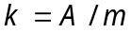 its residue field. Then the following are equivalent.
(i) is a discrete valuation ring.
(ii) is integrally closed.
(iii) is a principal ideal.
(iv) 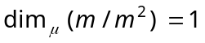
(v) Every non zero ideal is a power of .
(vi) There exists such that every non zero ideal is of the form 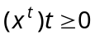.
––––––––––––
DE–3553
12
DISTANCE EDUCATION
M.Phil. (Mathematics) DEGREE EXAMINATION, MAY 2008.
MEASURE THEORY
(upto 2006 batch)
Time : Three hours Maximum : 100 marks
Answer any FIVE questions.
Each question carries 20 marks.
- (a) State and prove Lebesque monotone convergence theorem.
(b) (i) If 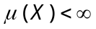 and 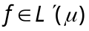, S is closed in the complex plane and 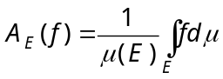 lies in S for each 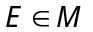 with 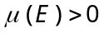 then 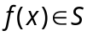 for almost all 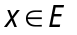.
(ii) If 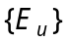 are measurable for 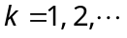 and 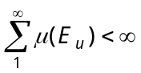 then almost all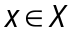 lie in atmost finitely many 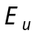's.
- Explain briefly integration of complex functions.
- If 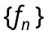 is a sequence of complex measurable functions on X such that 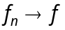 pointwise and 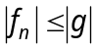 where 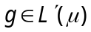 then 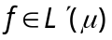 and 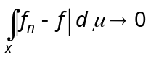 as and so 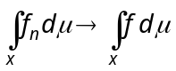.
- State and prove Jensen's inequality.
- (a) Define conjugate exponents.
(b) State and prove Schwarz's inequalities.
- (a) If 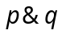 are conjugate components 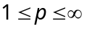 and if 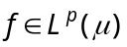 and 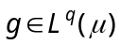 then 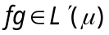 and 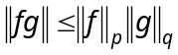.
(b) Suppose and , 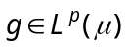 then 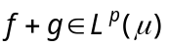 and 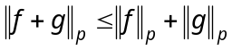.
- Let S be the class of all complete measurable simple functions on X such that 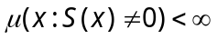 then S is a dense in 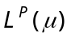.
- (a) State and prove Radon-Niscodyin theorem.
(b) Explain product measures.
———————
DE–3554
13
DISTANCE EDUCATION
M.Phil. DEGREE EXAMINATION, MAY 2008.
Mathematics
TOPOLOGICAL VECTOR SPACES
(Upto 2006 Batch)
Time : Three hours Maximum : 100 marks
Answer any FIVE questions.
Each question carries 20 marks.
- (a) Let  be a topological vector space. Prove the following
(i) If 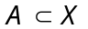 then 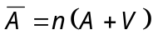, where 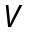 runs through all neighborhoods of .
(ii) If and 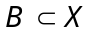 then 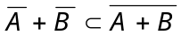.
(iii) If 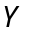 is a subspace of , so is 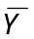.
(b) Prove that every locally compact topological vector space has finite dimension. (10 + 10)
- (a) In a topological vector space , prove the following
(i) every neighborhood of contains a balanced neighborhood of and
(ii) every convex neighborhood of contains a balance convex neighborhood of .
(b) Suppose is a subspace of a topological vector space and is locally compact, in the topology inherited from . Prove that is a closed subspace of . (10 + 10)
- (a) Suppose is a convex absorbing set in a vector space . Prove the following
(i) 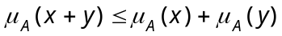
(ii) 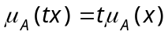 if 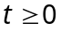
(iii) 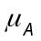 is a seminorm if is bounded
(iv) If 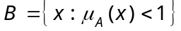 and 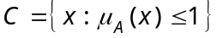 then 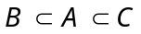 and 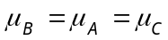.
(b) Prove that a topological vector space is normable if and only if its origin has a convex bounded neighborhood.
(12 + 8)
- (a) State and prove the category theorem.
(b) State and prove the Banach–Steinhaus. (10 + 10)
- (a) State and prove the closed graph theorem.
(b) Suppose 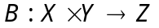 is bilinear and separately continuous, is an F-space and and  are topological vector spaces. Prove that 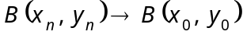 in when ever 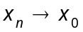 in and 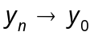 in .
- State and prove the Banach-Alaoglu theorem.
- (a) Suppose and are normed space. Associate to each 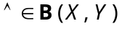 the number 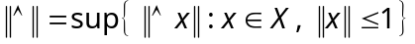. Prove that if is a Banach space, so is 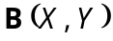.
(b) If is a separable topological vector space, if 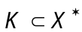 and if is weak∗–compact prove that is metrizable, in the weak∗–topology. (10 + 10)
- (a) If is a locally convex space and 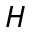 is the convex hull of a totally bounded set 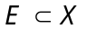. Prove that is totally bounded.
(b) Let 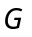 be a compact group, suppose 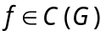 and define 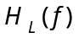 to be the convex hull of the set of all left translates of . Prove that
(i) f is uniformly continuous and
(ii) is a totally bounded subset of 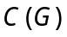. (8 + 12)
- (a) Suppose is the closed unit ball of a normed space . Define 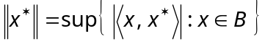 for every 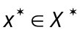. Prove the following :
(i) This norm makes 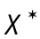 into a Banach space.
(ii) Let 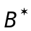 be the closed unit ball of . For every 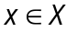 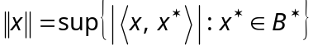. Consequently 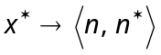 is a bounded linear functional on , of norm 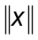.
(iii) is weak∗–compact.
(b) (i) If 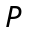 is a continuous projection in a topological vector space prove that 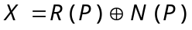.
(ii) Conversely, if is an F-space and if 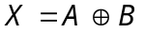 prove that the projection with range and null space is continuous. (10 + 10)
———————
DE–3555
14 A
DISTANCE EDUCATION
M.Phil. (Mathematics) DEGREE EXAMINATION, MAY 2008.
FUNDAMENTALS OF DOMINATION IN GRAPH
(Upto 2006 batch)
Time : Three hours Maximum : 100 marks
Answer any FIVE questions
All questions carry equal marks.
(5 × 20 = 100)
- For any graph T show that the following are equivalent
(a) T is connected and acyclic
(b) T is connected and 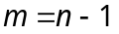
(c) T is acyclic and
(d) For any two vertices and in
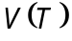 there exists a unique path.
- (a) State and prove ORE theorem on dominating set.
(b) Show that every connected graph of order 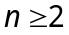 has a dominating set whose complement 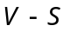 is also a dominating set.
- Show that if a connected graph satisfies 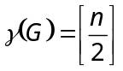 then 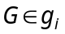 for some 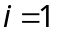 to 6.
- Show that if a graph has 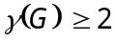 then 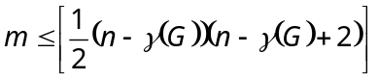.
- (a) Show that for any graph and hereditary
property , 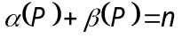
(b) Show that for any graph , 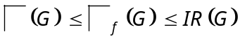.
- Show that for any graph , 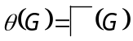.
- Assume that the degrees 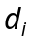 of vertices 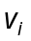 of a graph satisfy 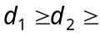.... 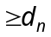. Show that if t is the largest integer for which 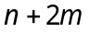 where 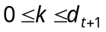 then .
- For any graph , show that
(a) If is connected then 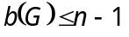
(b) If is connected then 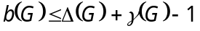
(c) If 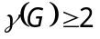 then 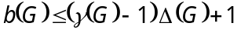.

————————
DE–3556
14 B
DISTANCE EDUCATION
M.Phil. (Mathematics) DEGREE EXAMINATION, MAY 2008.
DATA STRUCTURES AND ALGORITHMS
(Upto 2006 Batch)
Time : Three hours Maximum : 100 marks
Answer any FIVE questions.
All questions carry equal marks.
- (a) Describe the concept of polymorphism with an example. (10)
(b) Explain the following concepts with suitable example.
(i) Dynamic binding
(ii) Message passing. (5 + 5)
- Explain the various statements available in C++ with suitable examples. (20)
- (a) Explain how a multi-dimensional array can be implemented in a computer memory. (10)
(b) (i) Explain the structure of singly linked list. (5)
(ii) Write an algorithm to insert a node at the front of the linked list. (5)
- (a) Explain doubly linked list concepts and its application. (10)
(b) Write short notes on circularly linked list with example. (10)
- (a) Write down the stack operations with example. Discuss the applications of stack. (10)
(b) How are stacks used in evaluating a given numerical expression? Illustrate with example. (10)
- (a) Write algorithms to do the following :
(i) delete an element from the queue. (5)
(ii) insert an element into the queue. (5)
(b) Explain the following :
(i) Priority queue (5)
(ii) Circular queue. (5)
- (a) Write an algorithm for converting general trees to binary trees. (10)
(b) Write an algorithm for postorder tree traversal with example. (10)
- (a) Explain the travelling salesman problem using BFS technique. (10)
(b) Write and explain Kruskal’s algorithm to find a minimum cost spanning tree. (10)

————————

