Physical Education Hostels (Women)
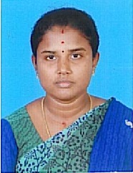
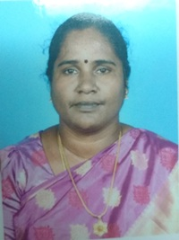

Warden Deputy Warden
Dr. D. Raaja Lakshmi Dr. K. Divya
Mobile : 98418 39790 Mobile : 82204 36393

Alagappa College of Physical Education (Women) was started in 1956, after the inception of Alagappa University in 1986, the name of the Hostel was renamed as Alagappa University College of Physical Education Women Hostel. New renovated building has 31Rooms with all the latest amenities such as Computer Lab with internet facilities, Stationary, Dinning cum recreation Hall with Dish connected TV, Purified drinking water dispenser and Yoga facilities for all the students living in our Hostel.

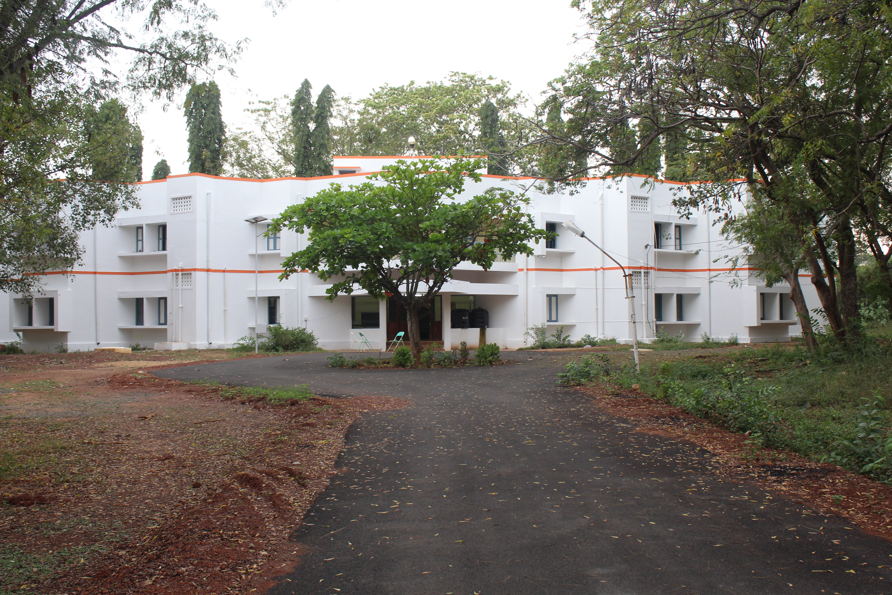
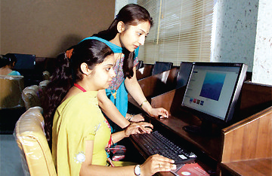

TV and Computer Lab with Internet

